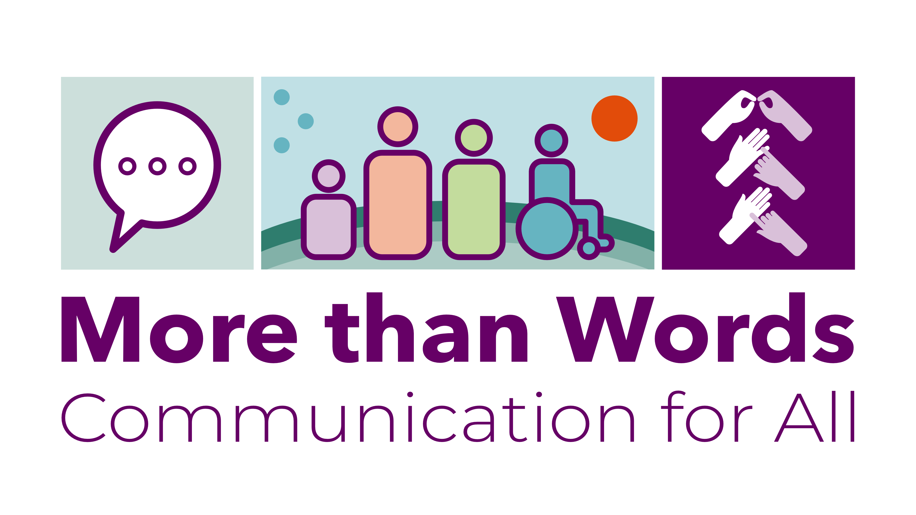
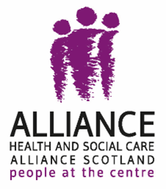

The Health and Social Care Alliance Scotland
(The ALLIANCE)

More than Words

How inclusive communication is provided by public bodies in Scotland
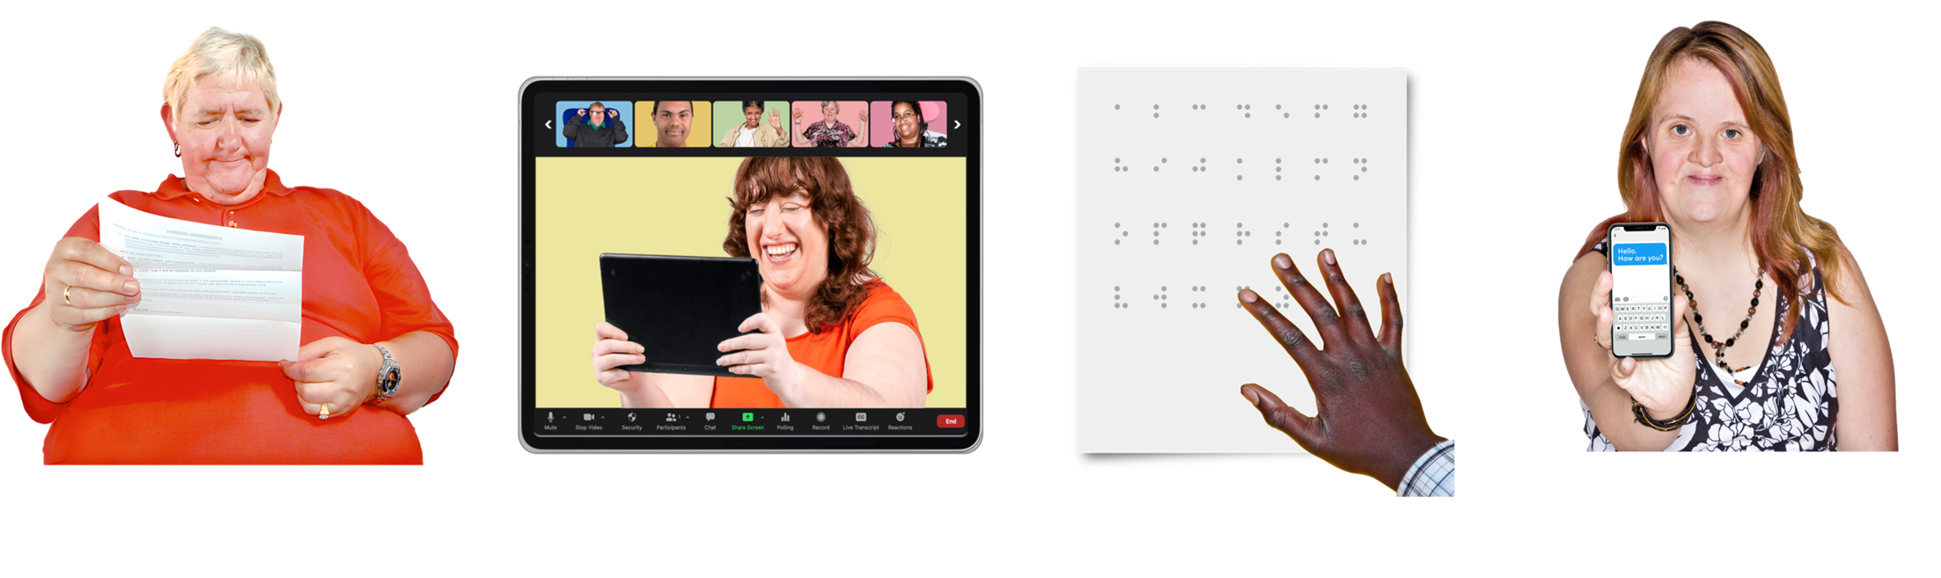

Easy Read




Introduction
   | Inclusive communication:  - means everyone gets information in a way that meets their needs  - means everyone feels included and able to understand the information  - makes services more accessible for everyone  - supports people to live more independently and to take part in everyday life
  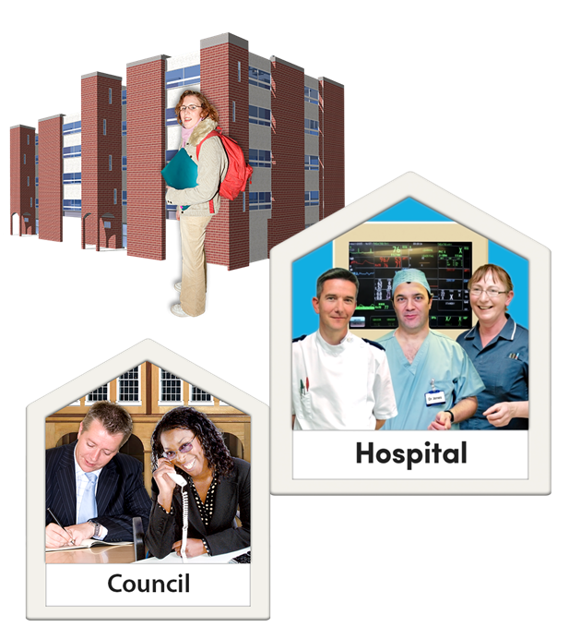 | Public bodies are organisations that work for the Government and provide services we all use like schools, hospitals and councils.  Inclusive communication means communication for all - sharing information in a way that everybody can understand.
    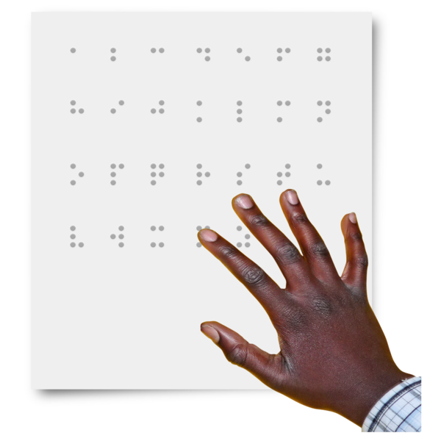  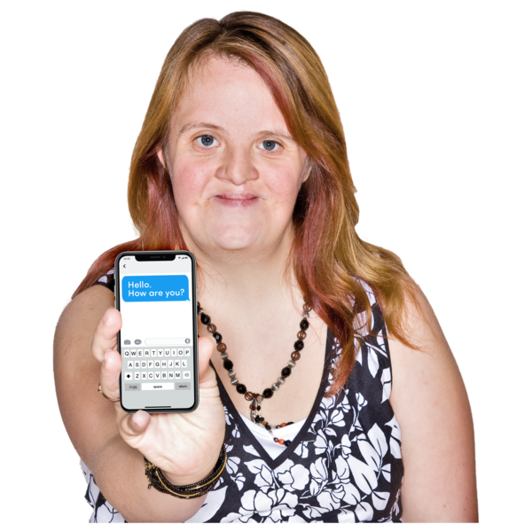 | Communication for all includes:  - written  - online  - phone calls  - face to face  It makes sure everyone can get and use different ways of communicating like:  - BSL - British Sign Language interpreters  - captions – words on the screen that show what people are saying  - Braille - raised dots you read by touch, for people who are blind  - being able to text instead of phoning for an appointment
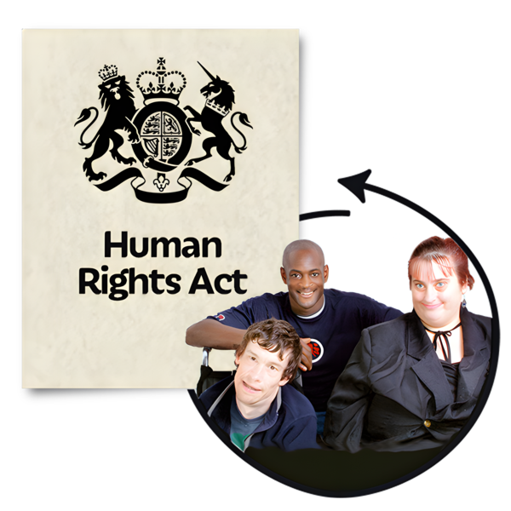 | The ALLIANCE believe that inclusive communication is a way to making sure people get their human rights.
  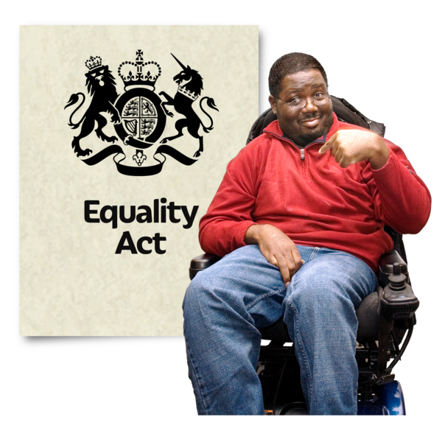 | Scotland does not have clear laws about inclusive communication although it is included in:  - the Equality Act 2010  - the BSL (Scotland) Act 2015  People with communication support needs are not treated equally.
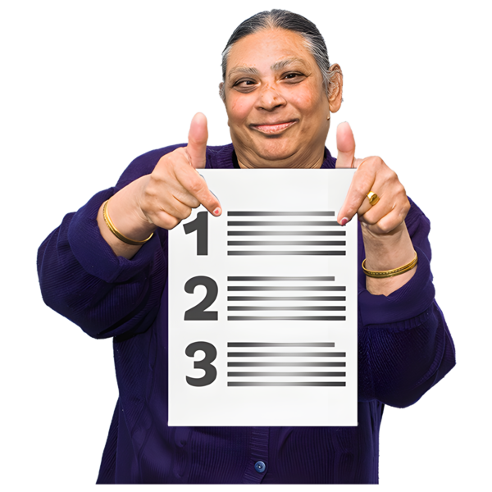 | This report:  - checks if inclusive communication is provided by public bodies  - gives examples of when it has been provided well  - shows what could be done better

Response rate – how many replies did we get?
 | A FOI is a Freedom of Information request.  This means a person or organisation has a legal right to get information from a public body.
   | In March and April 2025 we:  - sent FOI requests to 101 Scottish public bodies - 84 replied  - had 3 interviews with equalities leads:  - 2 from local councils  - 1 from a college  Respondents are organisations that replied to the FOI request.
   | Before the legal limit of replying before 20 working days had passed,17 public bodies had not replied.  It is worrying that many Health Boards did not reply, including the 4 that represent most of the Scottish population.  - 64 per cent of Health Boards replied  - 81 per cent of local authorities replied  - 90 per cent of universities and colleges replied  - 87 per cent of other public bodies replied
   | Departments and staff who manage FOI requests should:  - get inclusive communication training  - have ways to check if online systems work well particularly for:  - screen reader accessibility  - the use of online forms
   | No respondents’ websites gave information about how to:  - put in an FOI request in alternative formats  - get information in ways that meet your communication needs – like Large Print or BSL  We recommend that public bodies make their FOI process more inclusive and offer alternative formats.

Keeping information about support requests
   | We asked - do you keep information about requests for communication support?  Of the 84 organisations that replied:  - 63 per cent do not keep information  - 15 per cent keep information  - 21 per cent keep some information
 | Without collecting and checking data on inclusive communication requests it is impossible for public bodies to check:  - if they are supporting people to take part in public life  - if some groups of people can access their rights less than other groups
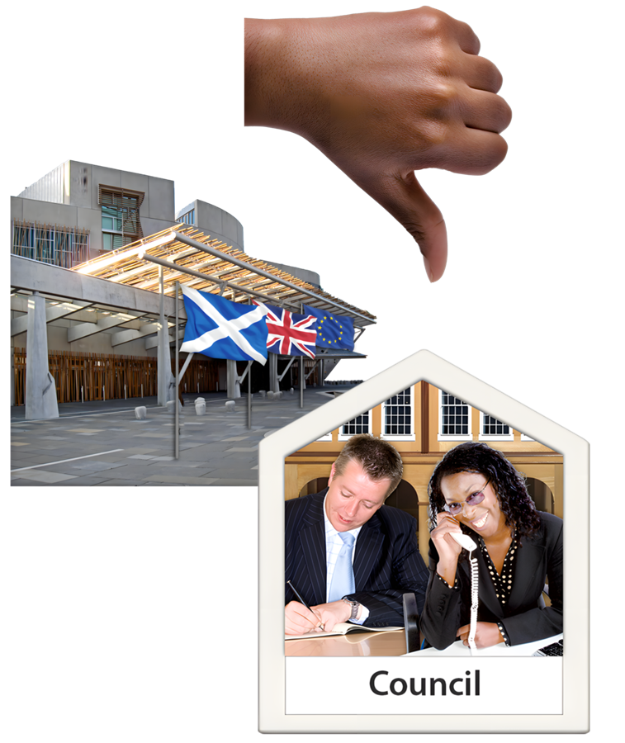 | It is worrying that:  - only 15 per cent of respondents collect all the information they need about accessible information requests  - the Scottish Parliament and many Health Boards and councils do not collect information
Many local councils, universities and colleges do not keep their information on a central database.

This means they could not easily check the information we asked about.
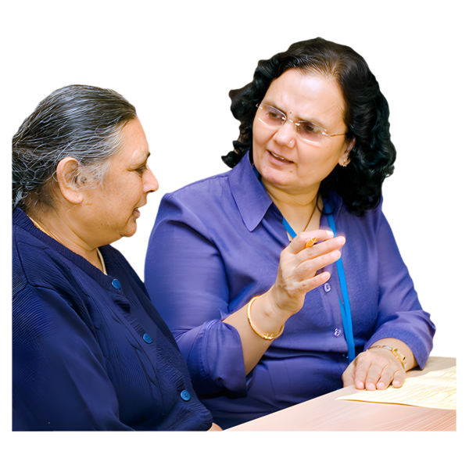 | BSL translation and interpretation was the most mentioned type of inclusive communication recorded by public bodies.  The BSL (Scotland) Act and local BSL plans has meant that tracking of this information has got better.
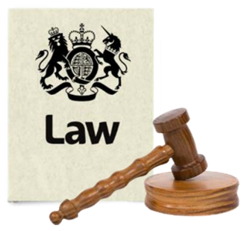 | We think this shows that:  - laws about inclusive communication do work– in this case about BSL  - there should be laws about inclusive communication
 | We recommend that all public bodies:  - keep inclusive communication request information in one central place  - check their support for people to take part in community life and get services  - report information so anyone can see how work on accessible information is getting better  - share information with lived experience panels and networks
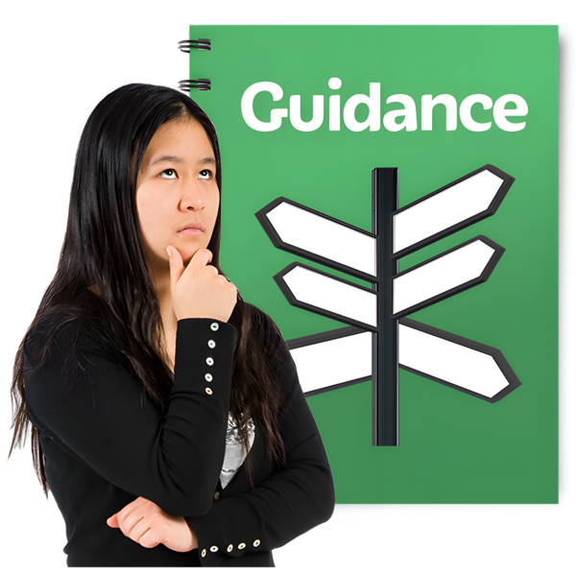 | We believe there should be clear rules:  - in guidance  - in any new laws  to make sure everyone is included in communication.

Number of support requests
 | We asked - how many requests for inclusive communication support did you get in 2020 to 2024?
 | Of the 84 organisations that replied:  - 48 (57 per cent) said they do not have this information  - 24 (29 per cent) gave information  - 12 (14 per cent) gave information on:  - some inclusive communication support requests  - requests in a shorter time period
 | It is worrying that:  - more than half of respondents do not keep data on inclusive communication requests  - they do not know if support is provided or improvements made
 | It is good that nearly half of respondents collected some form of data.  Some organisations gave very detailed information like:  - the University of Edinburgh  - City of Glasgow College  - Edinburgh City Council  - Social Security Scotland
 | The Improvement Service and Scottish Government should share examples of guidance and what works well on inclusive communication data collection and provision.
 | The ALLIANCE recommends that:  - public bodies have a single place to collect and keep track of information  - there should be a new law to give everyone in Scotland a right to inclusive communication support if they need it

Number of requests that were given information
   | We asked - how many requests for inclusive communication support made to you in 2020 to 2024 were given information?  Of the 84 respondents:  - 43 (51 per cent) did not keep this information  - 28 (33 per cent) gave full information  - 13 (15 per cent) gave some information  It is not good that more than half of respondents do not have information on how many support requests were given information.
 | Organisations must have better ways to collect information about inclusive communication to make sure that people’s support needs are met.
 | We think there should be inclusive communication networks across each sector:  - to share problems and solutions  - to improve:  - how work is checked  - how information is shared  - how services are given  There should be a law that public bodies must report information about inclusive communication requests.

Types of support requests
We asked - what types of inclusive communication support request did you get from 2020 to 2024?

Of the 84 organisations that replied:

- 43 (51 per cent) do not keep this information

- 31 (37 per cent) gave information

- 10 (12 per cent) gave some information
   | Knowing the types of inclusive communication support requests made to each public body means:  - organisations can make sure there is enough money for inclusive communication support  - the right services can be provided
 | 90 per cent of organisations that collected data said they provide BSL interpretation and translation.
 | There was a lot less awareness about other kinds of support:  - 56 per cent of respondents said they provided alternative formats  - 44 per cent provided Braille  - 39 per cent provided Large Print  - 25 per cent had requests for assistive reading and listening technology, captions, and electronic notetakers
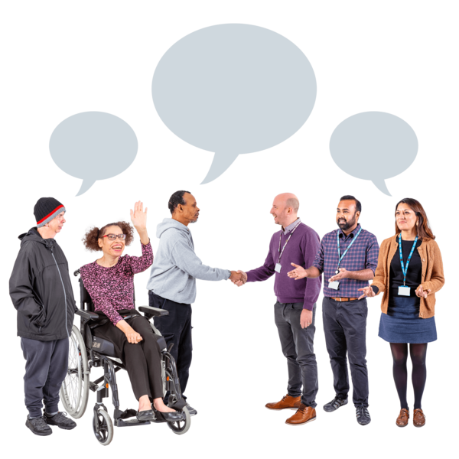 | Universities and colleges collected more detailed information than most other respondents.  Some respondents said councils, universities and colleges working together gave good support and better inclusive design and planning.

Complaints that organisations get and resolve - deal with
 | We asked: How many complaints did you get about a lack of inclusive communication between 2020 to 2024?  Of the 84 organisations that replied:  - 56 (67 per cent) gave full information  - 6 (7 per cent) gave some information  - 22 (26 per cent) gave no information
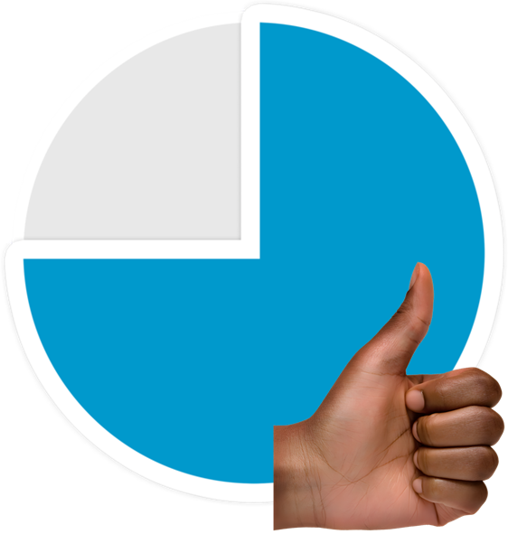 | It is good that nearly 3 in 4 respondents collect some complaints data.  It is worrying that 1 in 4 could not give any information.
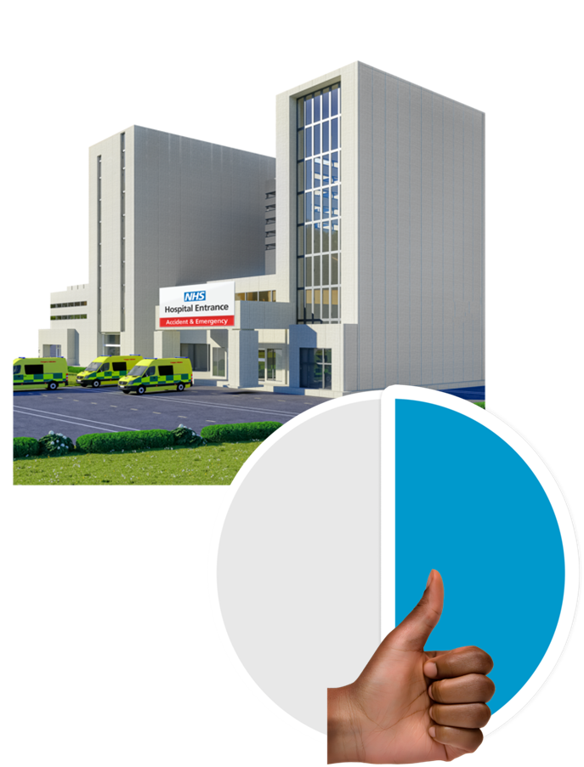  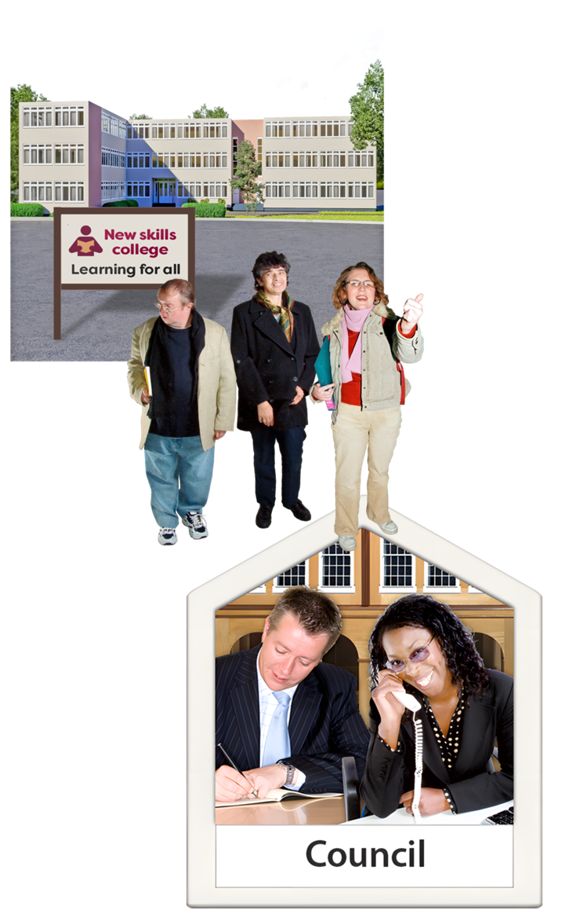 | Health Boards have the lowest rate of data collection on complaints.  Just over half (55 per cent) of responding Health Boards collected any information.  Universities, colleges and councils keep the most detailed information about inclusive communication complaints.  Complaint information is kept by:  - 78% of universities and colleges  - 77% of councils  - 69% of other public bodies  Having this information means they can use it to make services better.
We asked - how many complaints about inclusive communication made between 2020 and 2024 have been resolved?

All 16 council complaints (from 3 councils) were resolved.

NHS Fife reported that all complaints were resolved.

NHS Western Isles reported that both the number of complaints and resolutions was less than 5 but gave no more information.

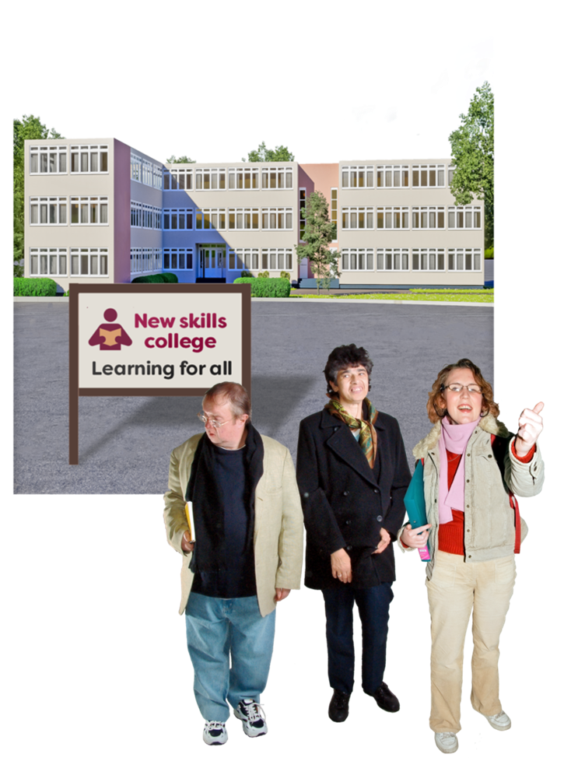 | Across the universities and colleges that reported inclusive communication complaints:  - 16 complaints (62 per cent of all complaints) were dealt with  - 3 complaints (12 per cent) were partly dealt with  - 7 complaints (27 per cent) were not dealt with
   | It is good that:  - most recorded complaints were dealt with  - several respondents had information about the supports that were then put in place after complaints were made  This showed they learned from complaints.

Staff training
   | We asked: do you offer your staff training on inclusive communication?  Of the 84 respondents to this question:  - 32 (38 per cent) offer training  - 22 respondents (26 per cent) offer training on some kinds of inclusive communication  - 30 respondents (36 per cent) do not offer any training
   | It is good that:  - nearly 2 out of 3 respondents offer training around some types of inclusive communication  - most training is open to all staff  Respondents who run training every 2 months collected better data and had less complaints.
 | It is not good that several respondents thought that inclusive communication was the same thing as BSL, captions or visual impairment awareness training.
Several respondents said it was important to do the training in partnership with accessibility working groups.

Very few respondents said that most staff had completed training offers.

 | We asked – can all staff get your training on inclusive communication?  83 per cent of respondents offer inclusive communication training to all staff.
   | Some organisations had high completion rates for inclusive communication training, for example:  - 100 per cent - Police Investigations and Review Commissioner and Standards Commission for Scotland  - 93 per cent - Dundee and Angus College  - 91 per cent - West Lothian College  - 63 per cent - Social Security Scotland  Some respondents said less than 2 per cent of their staff have done any inclusive communication training.  Very few respondents said that most staff had completed training offers.
 | It is probably easier for smaller organisations to make sure their staff complete training.  Most staff in public bodies had not had any training.

Conclusion
 | We want there to be a law about inclusive communication for public bodies, including data collection and staff training.  There should be laws to protect people’s right to inclusive communication so their human rights are protected.  Good inclusive communication is good for everyone.

