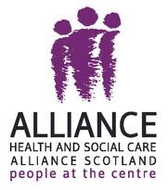
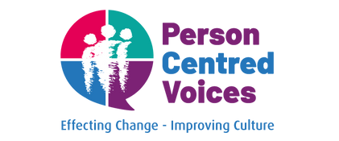

Person Centred Voices
Highlights Report



Introduction

Few words from Irene Oldfather and Tommy Whitelaw

Outreach
3
4
5

Partnerships
Table of Contents
7
- Effecting Change
- Art in care homes: partnership with Glasgow City HSCP
- Partnership with Social Security Scotland
- Partnership with Fife HSCP
- Partnership with Perth and Kinross HSCP
- Concert for Caring
- PCV beyond Scotland
Films and videos 16
Final thoughts and next steps 19

2

Introduction

In 2023, The ALLIANCE Carer Voices project changed its name to Person Centred Voices to reflect its growing engagement work across the public sector; exploring the culture change required to embed more person- centred practices within organisations and services.

Person Centred Voices is an ALLIANCE project that works to promote person centred practices in public sector organisations; that is, to advocate for personalisation, empowerment and shared decision making across all areas of care and support.

Focusing primarily on health and social care delivery and leadership, the project engages with teams to explore the culture change required to implement this approach, and drive improvement in the lives of people and their families.

Led by National Lead Tommy Whitelaw, Person Centred Voices (PCV) delivers talks and workshops to health and social care professionals
and students; public sector leaders and managers; third sector organisations; and government departments across Scotland, to explore what person centred practice might look like across different teams and care settings.

Throughout this engagement, the project promotes the values and principles of ‘What Matters to You?’, ‘Intelligent Kindness’ and ‘Civility Saves Lives’ – movements that identify active listening, kindness, and person centredness as key to providing inclusive support and care to all individuals, as well as healthy work environments.

This report aims to showcase the breadth of work and highlight the impact of the PCV outreach over the past couple of years, as the programme strives to embed person centred practices at both national and international levels.

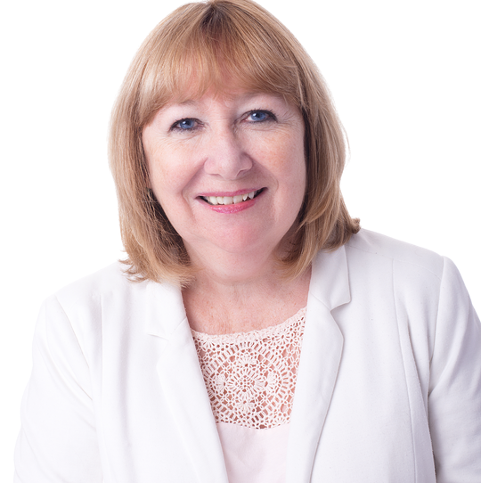
The difference it makes when we listen to learn

Dr Irene Oldfather
Director of Strategic Partnerships, External Affairs and Outreach
The ALLIANCE
The depth and breadth of the case
studies featured in this report reflect not only the expansive reach of the PCV programme, but also the lasting relationships built with partners across Scotland, the UK and abroad.


At the heart of this work is the power of asking ‘What Matters to You?’ and the difference it makes when we listen to learn. The programme’s ethos is about creating safe, inclusive, and reflective spaces where people feel heard, valued, and motivated to act.

The work of the PCV team shows that small actions can make a difference. When we reflect on our practice through the lens of kindness and compassion, we begin to transform our workplaces. What follows is not just improved practice, but improved lives- people supported in ways that truly matter to them.

Tommy Whitelaw’s role as National Lead has been central to this journey. His ability to connect with people and honour their stories has inspired thousands to reflect, to act, and to lead with empathy.

The beauty of people and relationships
Since 2023, it has been a true privilege for our PCV team to engage directly with more than

Tommy Whitelaw, BCAh
National Lead,
Person Centred Voices The ALLIANCE
people doing remarkable things. Together, we are building great places to work, deliver, or receive

24,500 colleagues across Scotland.

Through over 550 workshops, we’ve explored the core principles of person-centred care, Intelligent Kindness, ‘What Matters to You?’, self-care, and active listening and we have witnessed remarkable
advice, support, or care.

A big thanks to all we have met, those we are yet to meet, and some we might never meet, who get up every day to make care better for all.

Outreach

24,500+
workshop participants


9,000+
followers on social
media

550+
workshops

18,500+
views



960
Subscribers
10
short films



Over the past years, the PCV team has had the opportunity to form partnerships and engage with individuals, health and social care processionals and organisations, students and third sector colleagues about the role WTMY ethos can play in creating
great places to work, study and live.
In order to create positive workplace culture and enhance the importance of delivering person-centred care, there is a clear need to engage with health and social care students.



Impact in 2024

13,000 people

310 workshops

5,000 healthcare professionals
4,400 health and social care students
2,700 social care professionals

13 Scottish Local Authorities

They are the future of health and social care and they have the power to change things for the better.
For that reason, the PCV team hosts regular sessions with first year Nursing students at Glasgow Caledonia University as well as workshops with health and social care students from universities and colleges across Scotland and the UK, including: Edge Hill University, City of Glasgow College, Edinburgh Napier University, Robert Gordon University, Glasgow Clyde College, Plymouth University and Oxford
Brookes University.

PCV workshops have been delivered across Scotland in:
Glasgow
Edinburgh and the Lothians Aberdeenshire
Forth Valley
Highlands and Islands Perth and Kinross
Fife
Angus Stirling
Ayrshire Dundee


In 2024, Person Centred Voices hosted over 310 workshops and engaged with nearly 13,100 people, at Scottish, national and international level.

Partnerships

Effecting Change

The ‘Effecting Change’ publication was a milestone for ALLIANCE’s PCV programme as it captured the learning and experience of six years’ work in partnership with health and social care, third sector, and public sector organisations to encourage person centred practice.
From 2016 to 2022, the project reached over 250,000 individuals through more than 1,700 events, sharing key messages on Value- Based Reflective Practice, Intelligent Kindness, WTMY, and Civility Saves Lives.

The publication aimed at evaluating the impact, capturing the work of a number of partners in promoting culture change within their teams and organisations.

In working with each partner, the ALLIANCE witnessed and was inspired by the impressive
outcomes achieved within each organisation.

The Effecting Change publication provided an opportunity to celebrate this work and share examples of good practice that any organisation can adopt to foster an environment of kindness and wellbeing for staff,

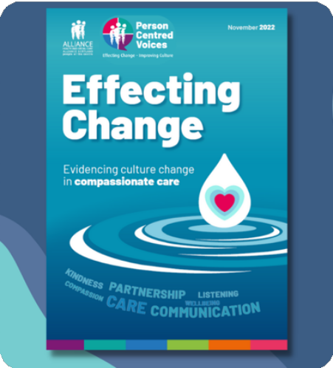

clients, service users, people who receive care, their families, and carers.

Partners featured in Effecting Change include:
Social Security Scotland
Chest Heart & Stroke Scotland Glasgow City Health and Social
Care Partnership
Scottish Ambulance Service NHS Ayrshire and Arran
NHS Lothian
Riverbank Day Centre
Sheffield Teaching Hospital, Integrated Community

Art in care homes: partnership with Glasgow City HSCP

Glasgow City Health and Social Care Partnership (HSCP) operates five residential care homes for older people across the city, all of which were significantly impacted by the COVID-19 pandemic.

As restrictions began to be relaxed, and the care homes moved to a position of recovery, the HSCP began a partnership with the ALLIANCE to reflect staff’s experiences and express this through art, led by PCV National Lead, Tommy Whitelaw, and the
ALLIANCE Artist in Residence, Xuechang Leng.

The aim of the artworks was to create a permanent testament to the staff’s resilience, in keeping residents and colleagues supported during the pandemic and the challenges that it brought. Tommy and Xuechang ran a number of workshops with staff and residents, to reflect on their own unique experiences of the last two and a half years and translate this into the artwork.


Artworks produced for Glasgow’s care homes

It’s great to see the staff able to participate and create something that really matters to them; a lasting legacy that reflects the incredible work they did to keep people safe during the pandemic.
Dr Irene Oldfather Director of Strategic Partnerships,
External Affairs and Outreach The ALLIANCE
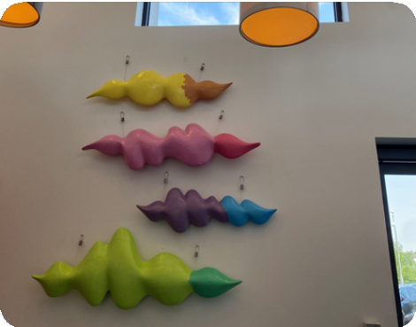
Artwork placed in one of the participating care homes

The HSCP produced a short film, that follows the development of the concept for the artwork with staff, to the final artwork which will be displayed in each home’s public spaces. It also features how care home staff supported one another, residents and their families during the pandemic.
Creating this visual representation of what mattered in people’s lives served as a reminder of unifying the power of kindness and compassion.

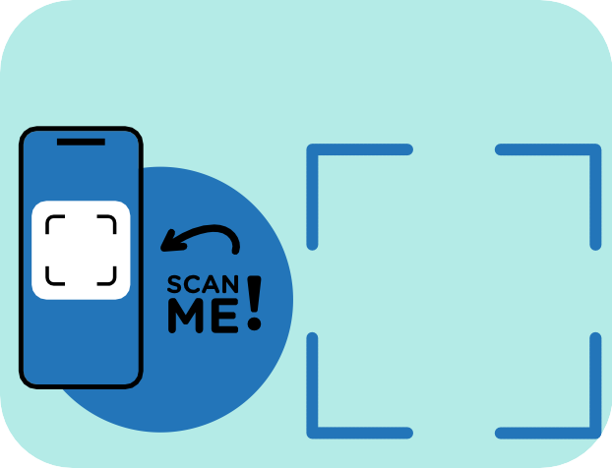

The concept for the artwork was to capture the most common words shared by staff about what is important to them, such as ‘love’, ‘care’, ‘family’, and represent these words as soundwaves.
Watch the film ‘Covid Resilience in Our Care Homes’

Partnership with Social Security Scotland

Over the years, ALLIANCE’s PCV programme has developed expertise in supporting staff to deliver change and a substantial cultural shift. Every single person can make a difference by treating others with dignity and respect.

The PCV team worked with Social Security Scotland to promote WTMY principles and advocate for the difference kindness, compassion and active listening can make in both organisations and individuals.

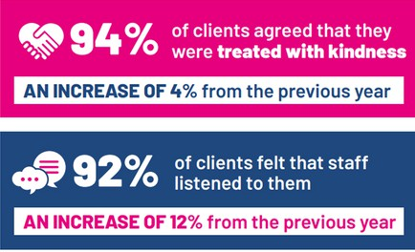
Effecting Change, p.15
As part of the partnership, the team hosted more than 100 talks and workshops in Social Security Scotland and engaged with over 2,500 staff. The ‘Effecting Change’ publication highlighted the positive results of the partnership with Social Security Scotland:
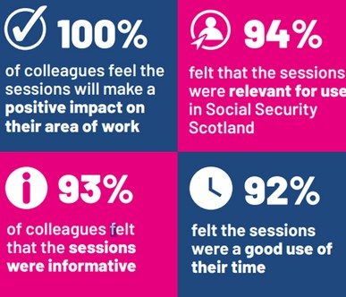
Effecting Change, p.15

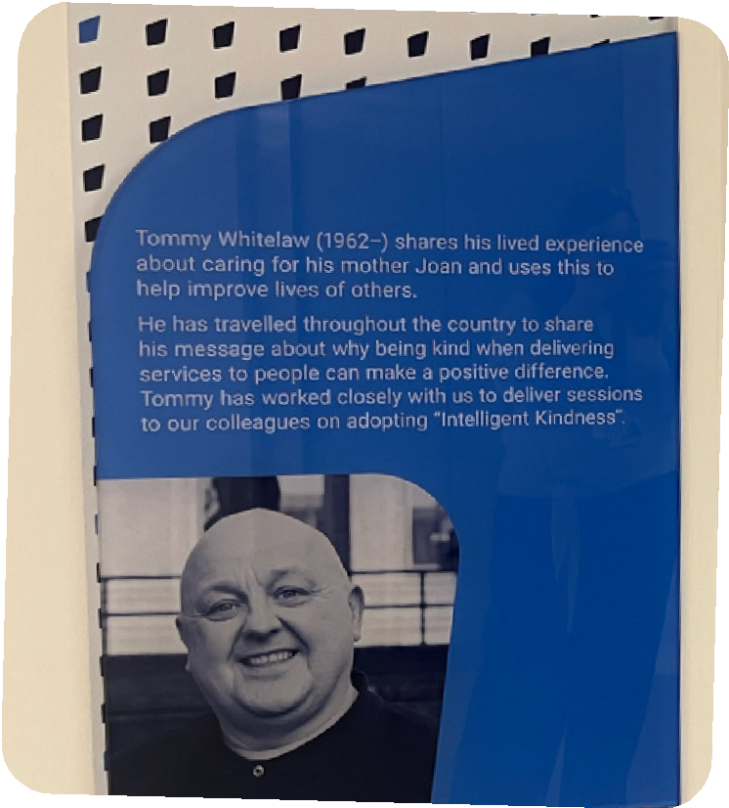
A testament to the impact of this work and the fantastic results achieved through the partnership was the launch of a training room at Social Security Scotland headquarters in Glasgow, named
after PCV Lead Tommy Whitelaw. Tommy Whitelaw plaque at Social Security Scotland


Tommy Whitelaw from the ALLIANCE was chosen for the
impact he has had on the organisation, having delivered intelligent kindness sessions to thousands of our colleagues. We are committed to creating a culture where we treat our clients and colleagues with kindness.
Social Security Scotland

Partnership with Fife HSCP

Over the course of two years, the PCV team engaged with 970 people across Fife Health and Social Care Partnership (HSCP).

In May 2023, PCV Lead Tommy Whitelaw was invited to be keynote speaker at the first meeting of the newly formed Integration Leadership Team (ILT). Following the session with 150 managers who attended this ILT meeting, Fife HSCP received numerous requests asking if Tommy would speak to their teams. In response to this, a partnership was formed, which resulted in a series of in-person and online workshops across Fife in October and November 2023 and in March 2024.
college students and senior school pupils who were undertaking Health and Social Care qualifications, whether this was an HNC, HND or Foundation Apprenticeship. With the effective collaboration of Fife HSCP and STAND in Fife as well as other local carer organisations, evening sessions were hosted in order to address unpaid carers.

In 2024, the PCV programme delivered workshops and engaged with staff, residents, and families at Napier House in Fife. These workshops aimed at supporting the development of a workplace culture where kindness and compassion shape every interaction, creating a great place to live and work.

In addition, the Fife HSCP team organised, in partnership with Education, sessions for local

The short film, ‘The power of 'What Matters To You?': Napier House in Fife’, feutures the experience of those who took part in this journey. Diane Roth, OD and Culture Specialist at Fife HSCP, reflects on how all began and the impact of person-centrrednes. Staff share how the WTMY approach has benefited relationships, and the care provided, while a family member highlights the importance of asking people, like her father, what truly matters to them.

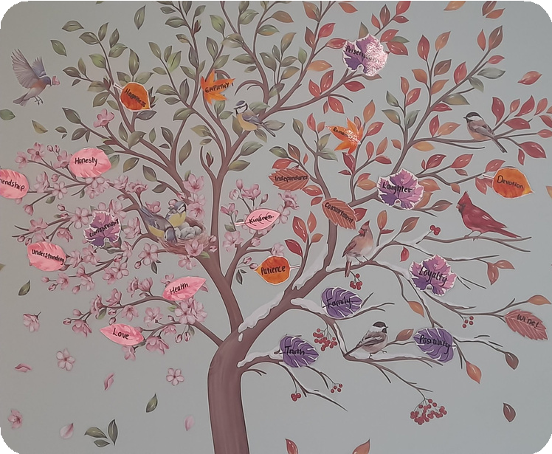
WTMY tree at Napier House

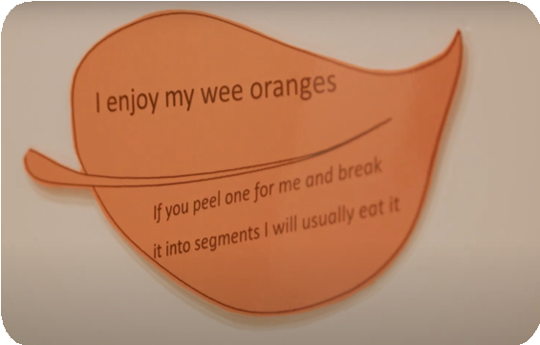


WTMY leaf at a resident’s room
Watch 'The power of 'What Matters to You?: Napier House in Fife'

Partnership with Perth and Kinross HSCP

From February 2023 to March 2024, the ALLIANCE, in partnership with Perth and Kinross HSCP, conducted around 75 learning and development sessions.

These sessions, inspired by the WTMY movement, reached almost
1500 people across the region, emphasising the importance of compassion, active listening, and intelligent kindness in health and social care.

In Summer 2024, a joint report celebrating people and the impact

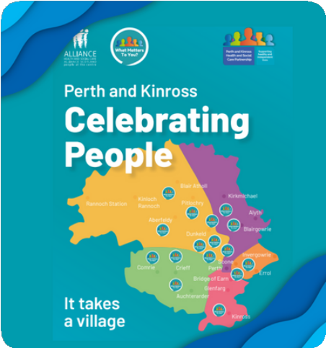

of the WTMY Movement in Perth and Kinross was launched. A celebration event organised at Perth Royal Infirmary, highlighted the publication’s 10 success stories, which demonstrate the positive impact of person-centred approaches in various organisational contexts, from care homes to prison services. These stories serve as a testament to the transformational power of asking a simple question: ‘What Matters to You?’
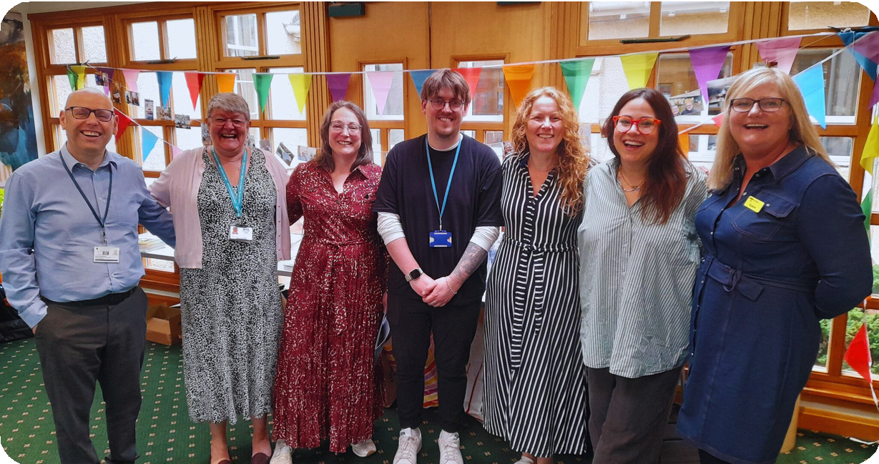
Perth and Kinross HSCP and ALLIANCE colleagues at the celebration event in Perth

Concert for Caring

In 2023, the ALLIANCE hosted the third Concert for Caring, which was an opportunity to celebrate the immeasurable work of unpaid carers and the contribution of health and social care staff, as well as third-sector organisations that
support people to lead fulfilling lives.
Following the success of two previous concerts in 2014 and 2019, the ALLIANCE brought together 1750 people from across Scotland, providing a space for shared experiences and connections.

In January 2024, the ALLIANCE and the PCV team were proud to launch the first film, ‘The ALLIANCE Concert for Caring Highlights - September 2023', which featured some highlights of the evening and took us back to the positive and special moments we shared with Scotland’s caring community.




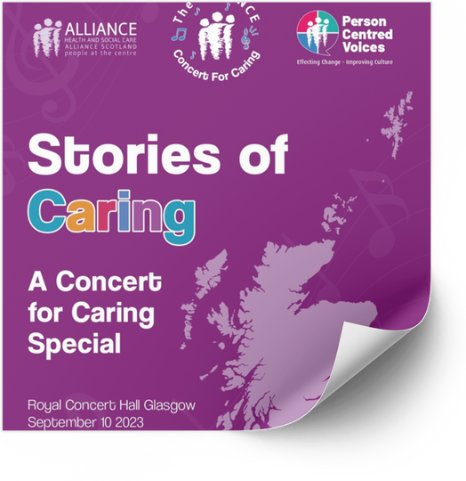
The same year, in partnership with ALLIANCE’s Humans of Scotland project, the team was also pleased to publish our second video, Stories


Concert for Caring, September 2023

of Caring (A Concert for Caring), which provided a glimpse into the lives of the people who attended and their stories of love, caring, and being cared for.
Watch the
Concert of Caring Highlights
Watch the
'Stories of Caring' film

Read the ‘Stories of Caring’ publication

PCV beyond Scotland


As part of the PCV programme’s continued outreach and effective partnership working, in 2024, PCV Lead, Tommy Whitelaw engaged with 350 people, travelled 240 miles, and delivered 17 events at 8 venues in Lincolnshire.

The impact of Tommy's visit was profound. Attendees reported feeling inspired and empowered by his story, with many noting the importance of listening to people and understanding their needs. The sessions provided an opportunity for staff to reflect on their practice and the culture within their teams. Tommy's expressions of gratitude and positive reinforcement significantly improved staff morale.

Tommy Whitelaw's Inspiring Visit to Lincolnshire: A Summary Report
The PCV Lead spoke at the ‘It’s all about people’ podcast about the WTMY movement and the impact of listening and kindness internally as well as on the people health and social care professionals engage with on a daily basis.


Watch a short video about Tommy’s tour in Lincolnshire and hear from the people who attended the ‘You
Make a Difference’ talk.

In the US, the PCV programme engaged with over 700 people in New York through six talks at Montefiore Medical Center, Bronx, and reached 350 individuals in Boston, where the PCV National Lead was the keynote speaker at the Patient Experience Symposium and delivered talks and workshops in hospitals across the city.
Tommy’s ability to connect with his audience is unparalleled - he inspires healthcare workers to see
the profound impact they have on the lives of those they care for. His message is clear and heartfelt: what you do matters, and the small acts of kindness and compassion can make all the difference.
Tommy’s unwavering commitment and genuine encouragement leave everyone feeling inspired and reminded of the true purpose of their work.

Laura Cooley, PhD,
Editor-in-Chief, Journal of Patient Experience Chairperson, Patient Experience Symposium Boston, MA USA

Videos and films

As part of PCV’s strategic objectives relating to the creation and development of resources on person-centred practices, personalisation, and the WTMY approach, the team has worked on, collaborated on, or been involved in some way with over ten films. In addition to the videos mentioned above, here are some more.
The ALLIANCE documented the process of Artist in Residence, Xuechang Leng, working with individuals from the centre to create an interactive piece of art. In the video, Riverbank staff talk about what the tree will mean to the relationships between everyone at the centre and the painting’s potential to help build understanding.

After speaking with staff and attendees at the Riverbank Resource Centre and learning about the old oak tree that once stood on the grounds, Tommy Whitelaw proposed the idea of painting a mural of the tree in the Centre's café.
Watch the short film on ‘Creating connection with art and kindness’
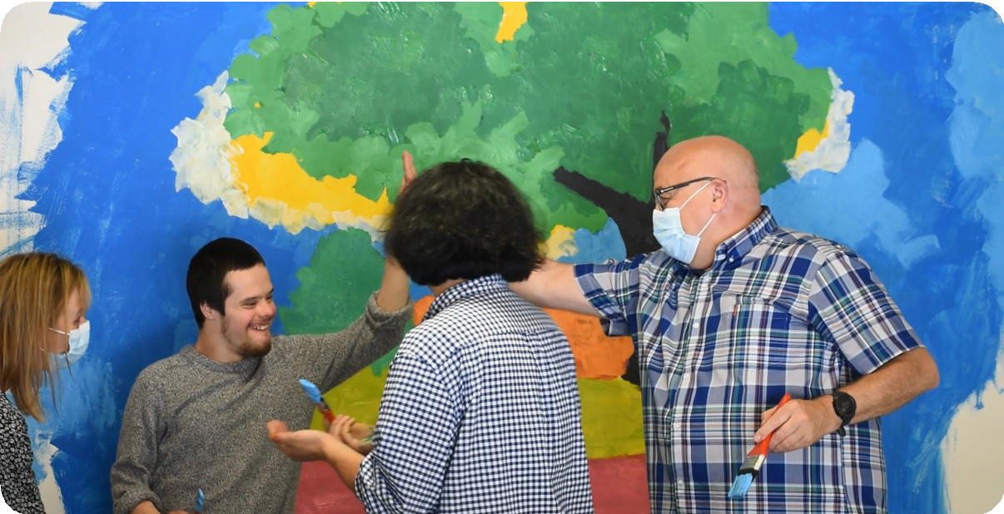
Tommy Whitelaw and Xuechang Leng during the creative process

When the project changed its name from Carer Voices to Person Centred Voices, the PCV team, supported by ALLIANCE Live colleagues, launched a short video highlighting the project’s work and objectives. This video is pinned on social media channels and has been viewed over 13,000 times, demonstrating the effectiveness of the messaging conveyed.

Over the past couple of years, the ALLIANCE and the PCV programme have engaged with the Scottish Government to learn about Getting It Right for Everyone (GIRFE), a new approach that aims to place individuals at the heart of every decision regarding their health and social care. GIRFE is a proposed multi-agency model of support and services that spans from young adulthood to end-of-life care.

This engagement culminated in the creation of two short films about GIRFE.
In the first film, ‘An Introduction to Getting It Right for Everyone’, the ALLIANCE spoke with the Minister for Social Care, Mental Wellbeing and Sport, Maree Todd MSP, as well as the four GIRFE professional leads within the Scottish

Watch ‘Person Centred Voices - an ALLIANCE Project’
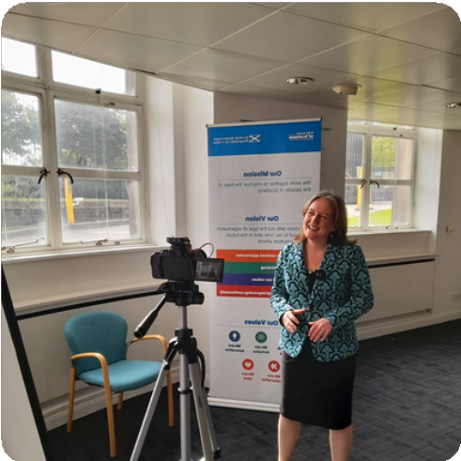
Minister for Social Care, Mental Wellbeing and Sport, Maree Todd MSP during shooting of the second film

Government, to explore what GIRFE is all about.

In the second film, ‘An Introduction to Getting It Right for Everyone (GIRFE) – Part 2’, the ALLIANCE
delves into the co-design process, featuring perspectives from both individuals with lived experience and professionals shaping GIRFE.


IIn 2024, Person Centred Voices National Lead, Tommy Whitelaw, was invited to officially open the Reflection Corridor for Wards F5 and F6 at Horton Wing, St Luke’s Hospital in Bradford.
Watch the first GIRFE video


This followed previous PCV work and engagement with people across across the hospital on the importance of compassion, kindness and asking a simple question: 'What Matters to You?'
Watch the second GIRFE video



The long corridor linking elderly care wards F5 and F6 was transformed into a brightly-coloured ‘Reflection Walk’ to inspire people living with dementia and memory loss to remember their stories and special moments in their lives.

We know that when we create a space that creates time to help people reflect, that’s the key to high-quality health care. And when we create that space, it encourages us to slow down a bit, it helps us keep a pulse – I’m more encouraged to say ‘”how you doing today?” or “is there anything I can help you with?”

PCV National Lead Tommy Whitelaw
Watch a short film about the Reflection Corridor

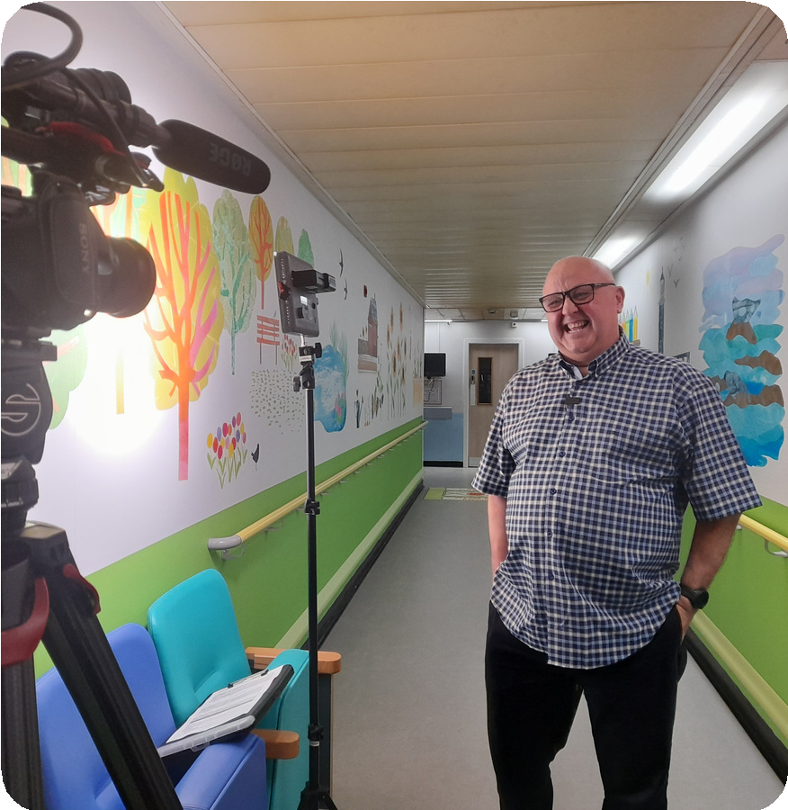
Tommy Whitelaw during filming at the ‘Reflection Corridor’

In June 2025, the ALLIANCE and PCV launched a short film showcasing the work of staff at Ninewells Hospital at NHS Tayside embedding a ‘What Matters to You?’ approach in everyday practice.
The film was a partnership between the ALLIANCE, NHS Tayside and Healthcare Improvement Scotland. The short film followed workshops delivered by Tommy Whitelaw on kindness and compassion. Over four days and 20 sessions, Tommy reached over 300 people at NHS Tayside.


Watch our Ninewells Hospital film
This film showcases how everything started, the steps taken to make this a reality and the real-life impact on individuals.

Final thoughts and next steps

This report highlights the significant impact of the PCV programme in creating a culture of kindness, active listening, and person centred care across health and social care settings.

Over the past two years, the programme has engaged with thousands of professionals, students, and individuals through talks, workshops, and partnerships, both in Scotland and internationally. Key achievements include delivering over 550 workshops to
more than 24,500 participants, expanding outreach efforts to the US and across the UK, and developing meaningful partnerships with organisations such as Social Security Scotland, Fife Health and Social Care Partnership, and Glasgow City HSCP.
A key takeaway from this report is that kindness and person centeredness are not abstract ideals but practical, implementable approaches that can create a great place to live and work.

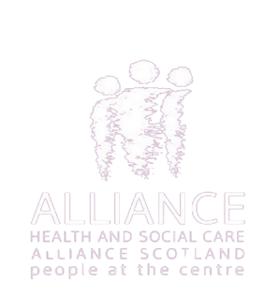
About the ALLIANCE

The Health and Social Care Alliance Scotland (the ALLIANCE) is the national third sector intermediary for a range of health and social care organisations. We have a growing membership of over 3,600 national and local third sector organisations, associates in the statutory and private sectors, disabled people, people living with long term conditions and unpaid carers. Many NHS Boards, Health and Social Care Partnerships, Medical Practices, Third Sector Interfaces, Libraries and Access Panels are also members.

Our vision is for a Scotland where people of all ages who are disabled or living with long term conditions, and unpaid carers, have a strong voice and enjoy their right to live well, as equal and active citiens, free from discrimination, with support and services that put them at the centre.

Contact
Person Centred Voices personcentred@alliance-scotland.org.uk

Tommy Whitelaw - Person Centred Voices National Lead tommy.whitelaw@alliance-scotland.org.uk

ALLIANCE is supported by a grant from the Scottish Government. The ALLIANCE is a company registered by guarantee. Registered in Scotland No.307731. Charity number SC037475. VAT No 397 6230 60.

