Start of document

Optimising Women’s Health: A visual resource
Pelvic health, bowel health, heart health and healthy aging
In support of the Scottish Government’s Women’s Health Plan

About this document
The Health and Social Care Alliance Scotland (the ALLIANCE) hosted a series of webinars on various important topics related to women’s health. These sessions looked at certain areas that aren’t often talked about from the perspective of women’s health, or that still carry stigma and embarrassment when talking about them. Being aware of these areas of health is important for women to maintain good health in the long-term and feel confident and comfortable both physically and mentally.
These webinars were run in partnership with the Scottish Government, and in support of the Scottish Government’s Women’s Health Plan. This booklet brings together four graphic resources that were produced to summarise the discussions of each webinar. The links to watch these webinars are located towards the end of this document. The graphics present central points raised by panellists, as well as key themes. The graphics were created by Clare Mills of Listen Think Draw.
In this booklet you will find graphics related to:
- Pelvic health
- Bowel health
- Heart health
- Healthy aging

How can I use this visual resource?
- Learn more about these areas, including how to maintain good health and optimise health in the long-term, or how to manage symptoms and get support should you have concerns
- Share the graphics with friends, family and colleagues to help them understand your experience, and help you to vocalise your symptoms and what support you might need
- Use as conversation points with a group – whether that be of friends, an employee network, a peer support group, or community group
- Share on social media to raise awareness of women’s health and keep the conversation going
Join our mailing list: email whp@alliance-scotland.org.uk
Follow and tag us on social media:
X @ALLIANCEScot
LinkedIn The ALLIANCE
For more information on women’s health see NHS Inform: www.nhsinform.scot/healthy-living/womens-health

Image one – Pelvic health
The following image features three colourful boxes each including text and small drawings related to women’s pelvic health. Along the bottom of the graphic are illustrations of five people of different ages and ethnicities.
The first box includes information about the pelvis and the pelvic floor. The pelvic floor is a small group of 14 muscles that support the pelvic organs. In the box is information about common concerns that might mean someone would seek support from a pelvic health physiotherapist. This includes issues like urinary incontinence and prolapse.
The second box, which is light blue, contains information and illustrations about how to maintain good pelvic health. This includes how to do pelvic floor exercises and what lifestyle factors can be changed to minimise the risk of issues.
The third box, which is orange, contains answers to questions that were put to the speaker from the audience. This includes how to access physiotherapy, which you can do by approaching your GP for a referral or finding one in your local area via www.thepopg.co.uk
For detailed information on the content of this graphic see NHS Inform https://www.nhsinform.scot/healthy-living/womens-health/middle-years-around-25-to-50-years/pelvic-health/pelvic-floor-muscles/

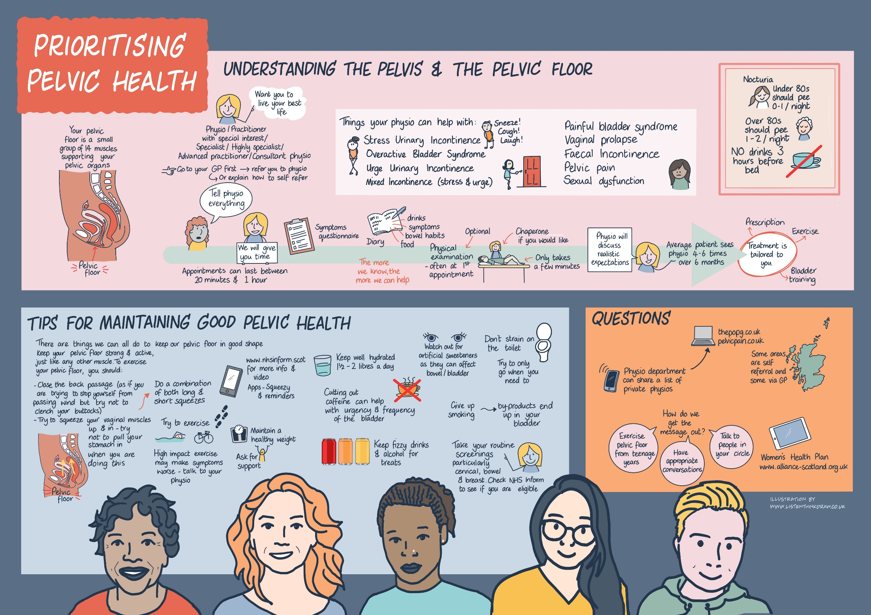

Image two – Bowel health

The following image features several boxes which surround text in the middle which says ‘Women’s bowl health: Let’s talk about Poo’. Each box focuses on certain areas of women’s bowel health and common bowel conditions that women experience and includes text and illustrations. This includes incontinence, IBS, piles/haemorrhoids, constipation, diverticulitis, and bowel cancer. There is also information on how to support other people with their bowel issues, and how to maintain good gut health.
For detailed information on the content of this graphic see NHS Inform: https://www.nhsinform.scot/illnesses-and-conditions/stomach-liver-and-gastrointestinal-tract/bowel-incontinence/

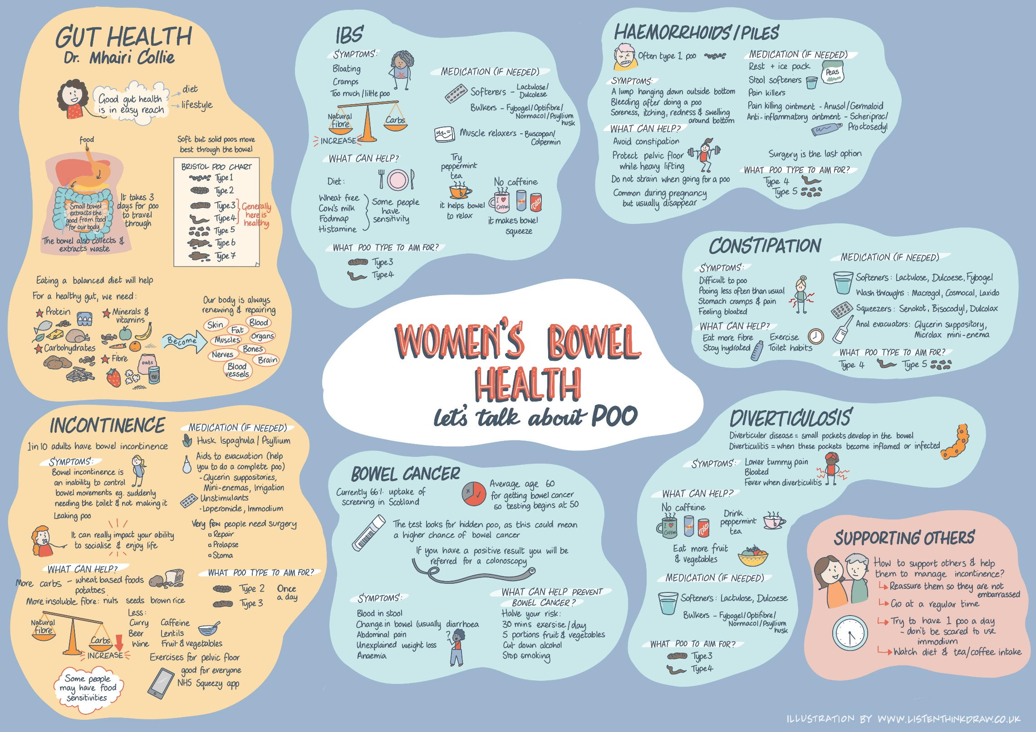

Image three – Heart Health
The following image is split into three sections, with text along the bottom reading ‘Mythbusting Women’s heart Health’.
The first section includes information and illustrations about myths around heart disease in women, and information that debunks them. This includes that women are at the same risk factors as men for heart disease, plus sex-specific factors that can add risk.
The second section includes information and illustrations about support available from third sector organisations, Chest Heart and Stroke Scotland and British Heart Foundation.
The third section is about why women’s heart health is a priority for the Women’s Health Champion, Professor Anna Glasier.
For detailed information on the content of this graphic see NHS Inform: https://www.nhsinform.scot/healthy-living/womens-health/middle-years-around-25-to-50-years/womens-heart-health/womens-heart-health

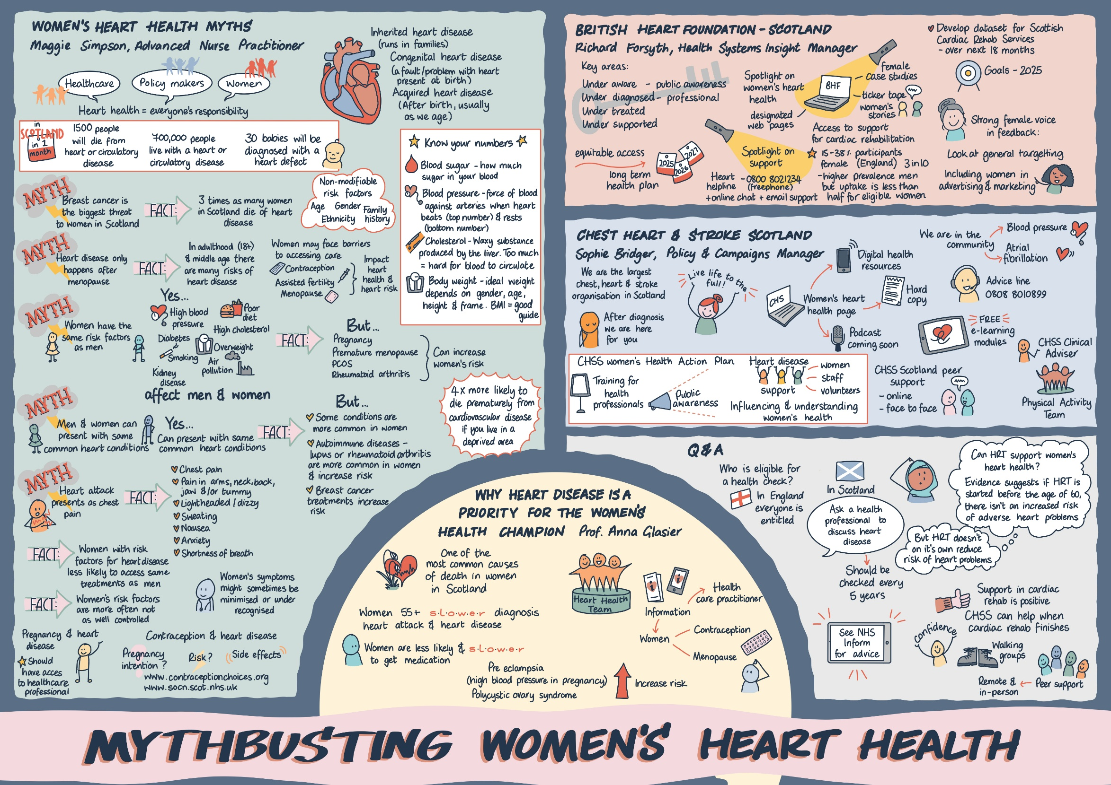

Image four – Healthy aging
The following image features several boxes with text and illustrations, which surround text in the centre which says ‘Optimising future health: supporting women’s long-term health and wellbeing’
The boxes at the topic of the graphic are under a small heading ‘Embrace healthier habits for a better tomorrow’. The information and graphics are focused on lifestyle factors that can support long-term health such as healthy diet, exercise, sleep, reducing harmful substances, stress management and healthy relationships.
The boxes at the bottom of the graphic are under a small heading ‘Optimising future health’. The information and graphics are focused on key areas where women may experience concerns as they age, and how they can maintain good health and manage symptoms. These areas are bone health, heart health and pelvic health.

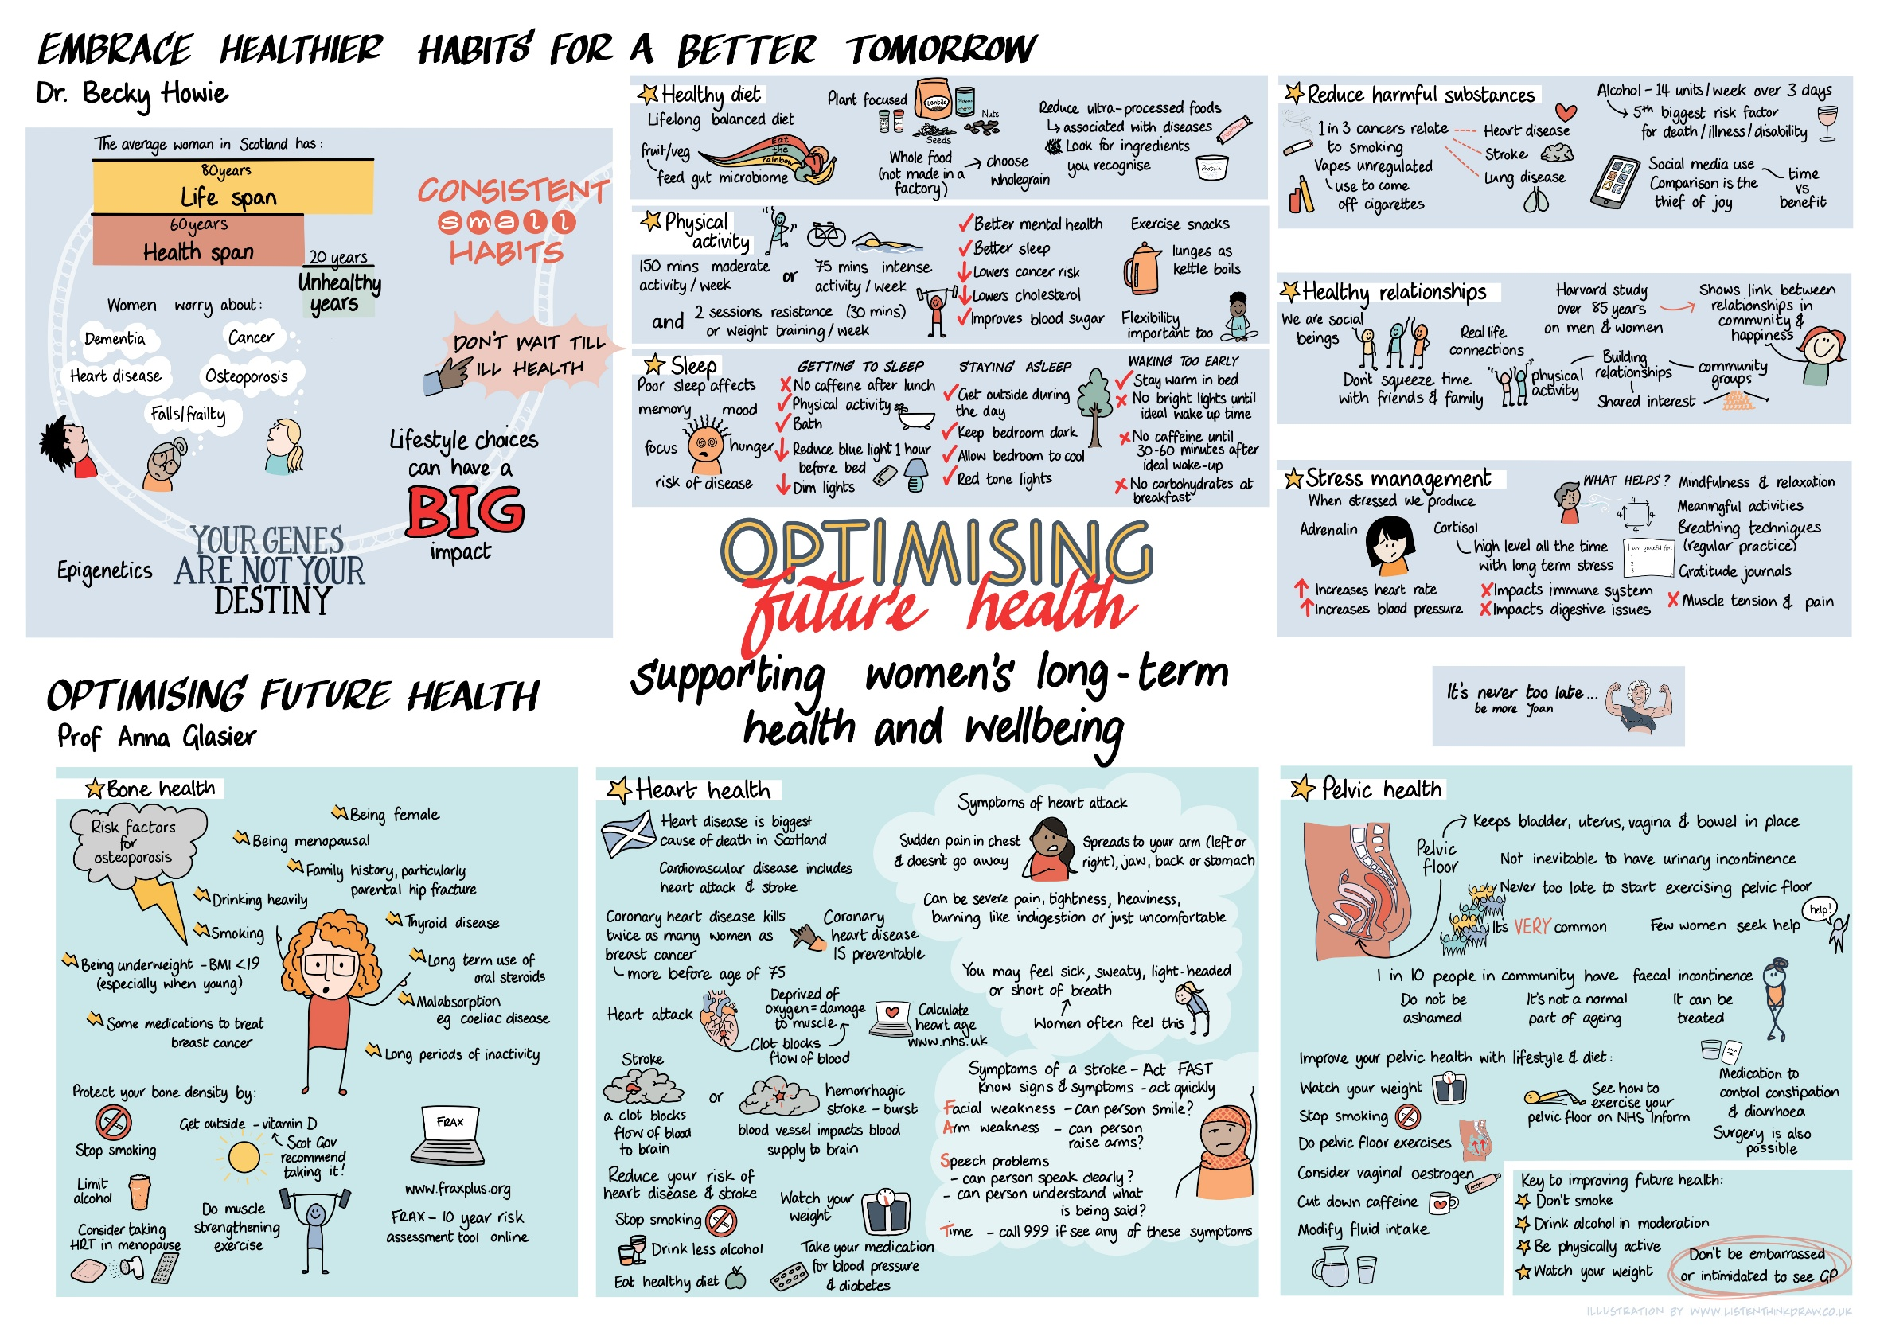

Information
- Prioritising pelvic health
The webinar explains the function of the female pelvic floor muscles, as well as outlining how to prevent, self manage or seek support for symptoms of bladder and bowel incontinence, and prolapse. Speaker: Jenny Munro (NHS Highland)
Watch the webinar on Youtube: https://youtu.be/T1067k4G3JI
- Taking care of your bowel health
This webinar explores women’s bowel health, including what we can all be doing to look after our gut and what we can do if we have a concern. The webinar explores some lifestyle factors that can support bowel health at any age (including specific foods and diets), as well as some bowel issues that can affect women including faecal incontinence, rectal prolapse, IBS and bowel cancer. Speaker: Dr Mhairi Collie (NHS Lothian)
Watch the webinar on Youtube: https://youtu.be/5B4QHSZ44gw
- Mythbusting women’s heart health
This webinar raises awareness of women’s experiences of heart conditions, and the specific risk factors that women need to be aware of. The session busts some myths about heart disease and provides clear advice to help you look after your heart health. Panel: Professor Anna Glasier (Women’s Health Champion), Maggie Simpson (NHS Greater Glasgow and Clyde), Richard Forsyth (British Heart Foundation), Sophie Bridger (Chest, Heart and Stroke Scotland)
Watch the webinar on Youtube: https://youtu.be/9BuD3KY7o78
- Optimising future health
This webinar looks at key areas such as nutrition, exercise, sleep and how to navigate these with a view to healthy aging (no matter what age you currently are!). The session also focuses on common experiences for older women such as bone health, heart health and pelvic health. Panel: Dr Becky Howie (NHS Lanarkshire), Professor Anna Glasier (Women’s Health Champion)
Watch the webinar on Youtube: https://youtu.be/F0Out3gi_bs

The Health and Social Care Alliance Scotland (the ALLIANCE) is the national third sector membership organisation for health and social care in Scotland, bringing together over 3,500 individuals and organisations committed to ensuring everyone has a strong voice and the right to live well with dignity and respect.
You can find out more on our website: www.alliance-scotland.org.uk
Address: Health and Social Care Alliance Scotland (the ALLIANCE), 310 St Vincent Street, Glasgow G2 5RU
Phone: 0141 404 0231
X: @ALLIANCEScot
Email: info@alliance-scotland.org.uk
The ALLIANCE is funded under a Strategic Partnership Agreement with Scottish Government. Health and Social Care Alliance Scotland is a company registered by guarantee. Registered in Scotland No. 307731 Charity number SC037475

End of document

