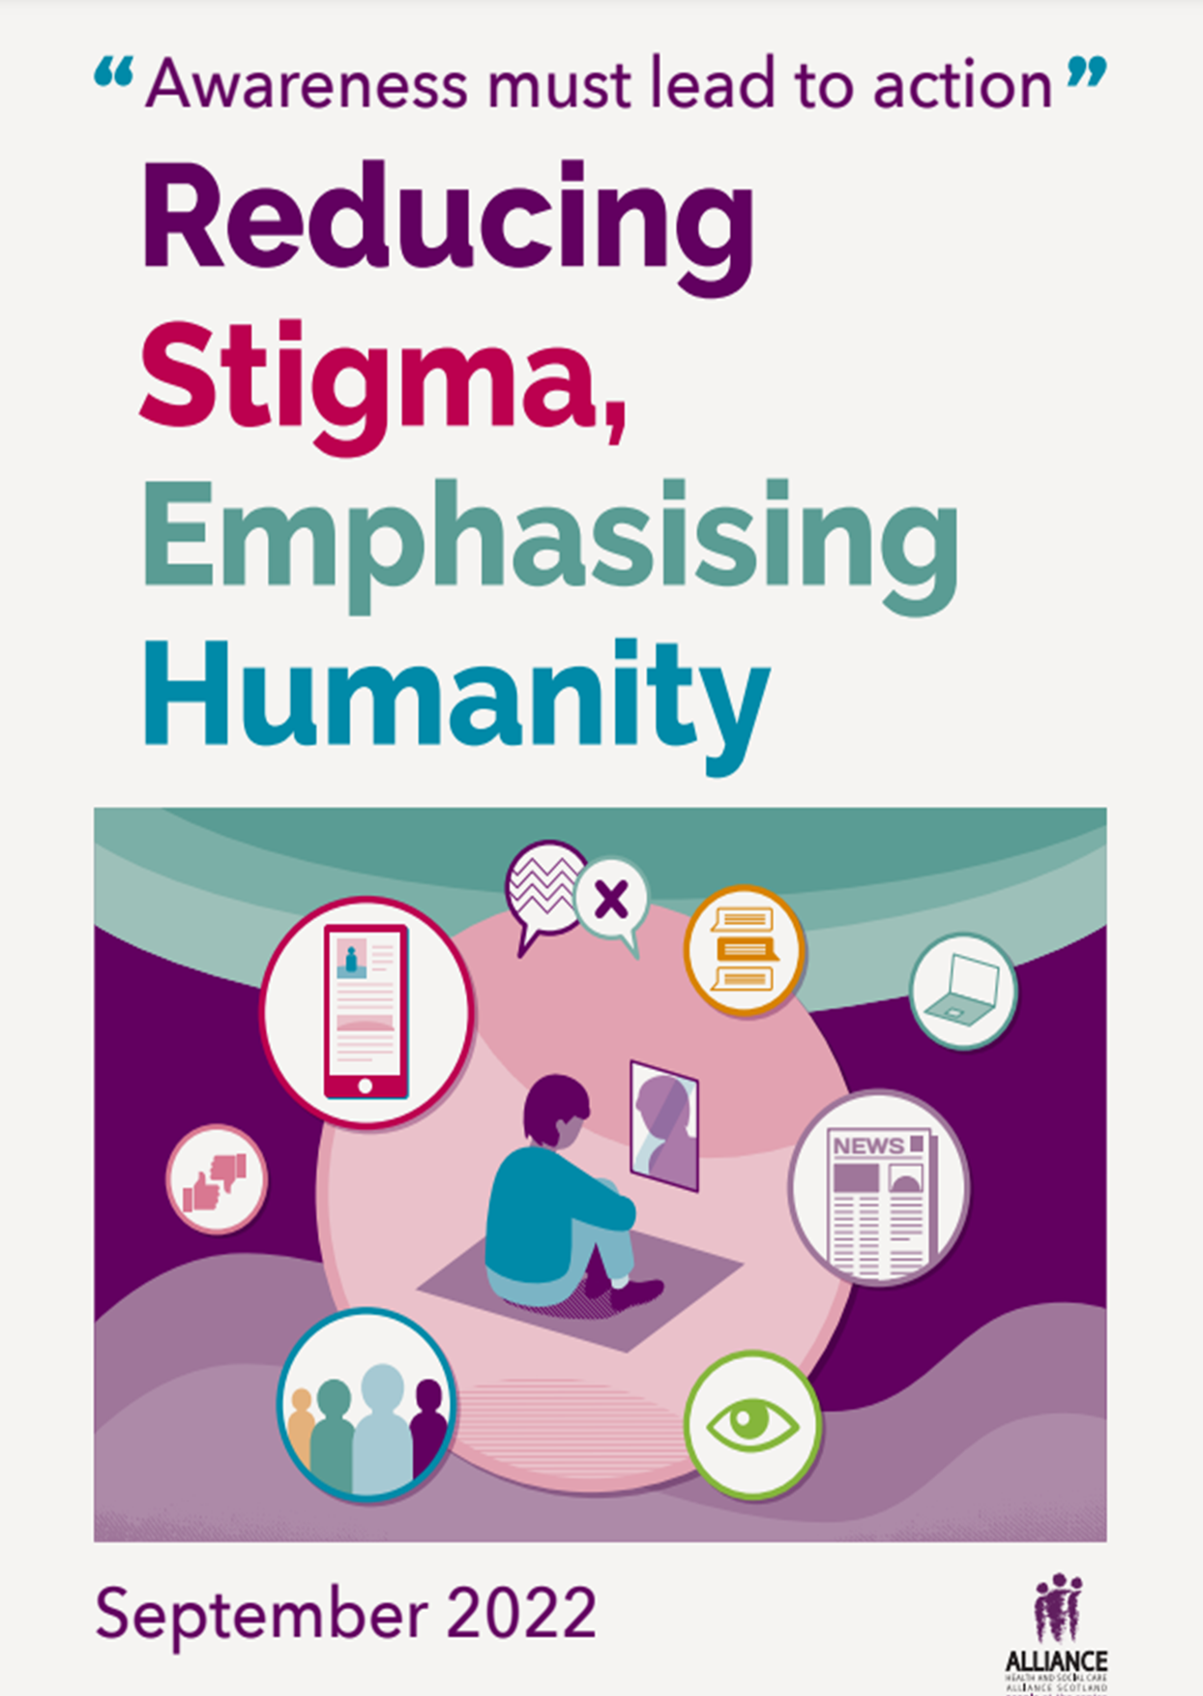

“Stigma. A small six letter word with a punch. A blow so powerful as to cause an end to a life, yet also invisible to others unaware of the fight another is undergoing. Bit too dramatic? I don’t think so.”
– Heidi Tweedie, Moray Wellbeing Hub CIC Director and Champion
The ALLIANCE’s Health and Social Care Academy, Self Management and the Scotland Reducing Gambling Harms programmes wanted to explore the impact of stigma. We hear from organisations and people with lived experience that stigma can be a barrier to accessing treatment and support, as well as making people feel isolated in their experiences and exacerbating already difficult circumstances.

Stigma has been highlighted in areas such as mental health, weight, gambling harm, problem substance use, homelessness, suicide and physical health conditions.

Recognising the prevalence of stigma, the ALLIANCE collaborated to explore this topic in greater detail, exploring people’s experiences, key learning, current work being done to tackle stigma and practical tools, tips and resources for this.
Over the course of a year, the ALLIANCE organised an online event series, ‘Reducing Stigma, Emphasising Humanity’ (RSEH), bringing together speakers with lived experience and third sector colleagues to talk about their experiences of, and work to tackle stigma.
11th June 2021
- John McCormack, consultant for the Violence Reduction Unit
- Wendy Halliday, Director, SeeMe
- Tommy Kelly, SeeMe Champion
- Martin Paterson, Director of Machine Zone and Gambling Harms Activist
- Shirley Windsor, Public Mental Health Lead, Public Health Scotland
1st October 2021
- Neil Cowan, Policy and Campaigns Manager, Poverty Alliance
- Susan McKellar, Operations Manager, Scottish Women’s Convention
- Suzanne Connelly, National Implementation Advisor, Public Health Scotland
22nd February 2022
- Nick Jedrzejewski, Communications and Public Affairs Manager, SeeMe
- Dawn Getliffe, See Me Volunteer
- Ly Kerr, Freelance Writer and Activist
From the speakers and participants, four key themes emerged:
- Stigma and the media
- Lived experience and co-production in tackling stigma
- Stigma on an interpersonal level
- The culture of stigma.
This report explores these themes and five areas for action, with supporting recommendations, for the future directions of travel; informed by the presentations, experiences and discussions people shared as part of ‘Reducing Stigma, Emphasising Humanity’.

Contents

Recommendations 5
Stigma and the media 7
Top tips from delegates on using media to tackle stigma: 9
Lived experience and co-production in tackling stigma 10
Safe spaces for conversation 10
Beyond storytelling 10
Listen and believe – give stories and personal experience weight and space 11
The role of co-production 11
Key principles for meaningful involvement of people with lived experience 12
Stigma on an interpersonal level 13
Tackling self stigma 13
Societal stigma reinforces self stigma 14
The culture of stigma 15
Environmental perpetuation of stigma 15
Understanding stigma intersectionally 15
Challenging the culture of stigma; awareness, education, training and creativity 16
Conclusion 18
About the ALLIANCE 19
About Health and Social Care Academy 20
About Self Management 20
About Scotland Reducing Gambling Harm 20
Appendix One: Cultural Context 21
Understanding Stigma 21
Appendix Two: Opinion Pieces 21
Appendix Three: Further information and resources 22
Appendix Four: Relevant ALLIANCE consultation responses 23

Recommendations
These recommendations outline steps which can be taken by policy and decision makers, funders, the media, employers and the public to reduce the impacts of stigma.
Encourage and facilitate open conversations across society to speak about stigma and shame.
- Frontline staff should create safe spaces for conversation and trusting, meaningful relationships, especially in health and social care settings. Spaces which are inclusive, open and without barriers or prejudice.
- The media should work to develop a person centred approach to media in Scotland, where people are aware of and adhere to best practice reporting guidelines, such as the current NUJ guidelines for reporting on mental health. Further best practice reporting guidelines for other stigmatised areas should also be developed.
- Commissioners should fund further information, awareness and media campaigns which challenge stigma.
- Employers, trainers and educators, especially those working in health and social care, education, criminal justice and the third sector, should support frontline staff to be trauma-informed and trauma-skilled.

Coproduce anti stigma work and campaigns with people with lived experience
- Scottish Government should acknowledge the role people with lived experience play in coproducing quality services publicly, starting at a national policy level.
- All stakeholders should create more opportunities for people with lived experience to lead and/ or meaningfully get involved in anti-stigma work and campaigns. Underpinned by access to high quality wellbeing support and empowering capacity building opportunities, such as media training.
- Funders and commissioners should provide sustainable financial investment into peer led change, including the development of further peer networks and accessible, inclusive resources to support individuals who experience stigma, including self-stigma and stigma by association.

Provide anti stigma training to individuals and health and social care professionals
- Health and social care employers should provide anti stigma training to health and social care professionals.
- Funders and commissioners should fund the development of anti stigma training, codesigned with people with lived experience, aimed at both individuals and health and social care professionals. This training should actively promote non-stigmatising language to individuals, organisations and institutions as part of this.

Underpin anti stigma engagement work with a human rights and equalities approach
- All stakeholders should use creative methods of communication and outreach to ensure 'no one is left behind'.
- All stakeholders should embed inclusive communication practices in anti stigma work.
- All stakeholders should work to break down barriers and cede power to actively balance the power between professionals and people.

Prevent stigma by addressing its perpetuation
- Scottish Government should commit to a holistic, whole person, national approach to tackling stigma which involves people with lived experience in its design.
- Legislators should limit opportunities for private industries to profit from the perpetuation of stigma, such as ‘clickbait media’ and gambling marketing, working with people with lived experience to identify where this is needed. The appropriate regulators must then ensure effective implementation into practice.
- Funders and commissioners should increase investment in high quality services and preventative spending to tackle poverty and health inequalities.

Stigma and the media
As a man who has suffered an eating disorder of 20 years, I believe the media doesn’t help the stigma that surrounds eating disorders. They highlight women mostly, and very rarely men.
– Tommy Kelly, See Me Champion
The role of the media emerged frequently as having a significant impact on people’s experiences of stigma. It’s role in perpetuating stigma through the spread of misinformation and/ or negative stereotypes was often spoken about. However, it also emerged as an important tool in tackling stigma, by sharing human stories which people can connect and empathise with.
“Headlines can be powerful, but they can also be misleading” – Delegate
Delegates spoke about a viscous media cycle, where inflammatory or antagonising headlines are rewarded through increased online interactions or newspapers sales. Sensationalist stories and ‘poverty porn’ were raised as a key component of this, where people’s experiences are objectified, exploited, and used to generate income.
The representation of HIV was particularly mentioned, where much of the media discourse appears to be ‘stuck’ in an outdated, negative understanding of who is impacted, how it is transmitted and what life living with HIV is like. Adverts and messaging were also referenced frequently as stigmatising people experiencing gambling related harm. ‘Safer gambling’ messaging, such as ‘when the fun stops, stop’ puts the burden of responsibility onto the individual being harmed without acknowledging the role of the industry. It contributes to a stigmatising societal view that gambling harms are experienced because an individual ‘lacks self control’, rather than because gambling products are consciously designed and marketed to be attractive and addictive by a rich and powerful industry.
Media was highlighted as a powerful tool to tackle stigma when used in an informed sensitive way. The media has an important role in supporting social movement and developing societal and cultural attitudes.
Speaking their language:

In See Me’s slogan development with young people ‘it’s okay to feel crap’ changed to ‘it’s okay to feel shite’ as young people thought crap was an ‘old-person word’ which they didn’t relate to.
Campaigns were frequently mentioned as a tool which organisations can use to tackle stigma and raise awareness. Nick Jedrzejewski, See Me’s Communication Manager, spoke about some of the campaign work which See Me undertake to tackle mental health stigma. Nick shared the importance of co-creating campaign messaging with people with lived experience. This ensures that the campaign addresses people’s priorities and ‘speaks their language’.

Top tips from delegates on using media to tackle stigma:

- Hold people to account – misrepresentation of an issue in the media can be an opportunity to start a discourse, educate people and challenge viewpoints in a healthy way.
- Use lots of different channels to outreach – if messages are coming from only one source it can feel limited. Using different media forms, traditional and social, to reach a wide variety of people.
- Increase confidence and media skills - know what your organisations key messages are and use them to support and influence the media.
- Tell people when they have done it right – reward, congratulate and positively reinforce when people speak about an issue in a sensitive way.
- Recognise and use the different levels of media – local media can make content relevant to their areas and support relationship building. National media can reach a large variety of people and build momentum.

Example:

After learning about See Me volunteer Dawn Getliffe’s new activity ‘Pass the Parcel’ at a Reducing Stigma, Emphasising Humanity event, the organisation MS Mid Argyll started utilising the approach in their local community. This activity was then picked up by the local press, celebrating their work whilst also promoting the approach more widely.

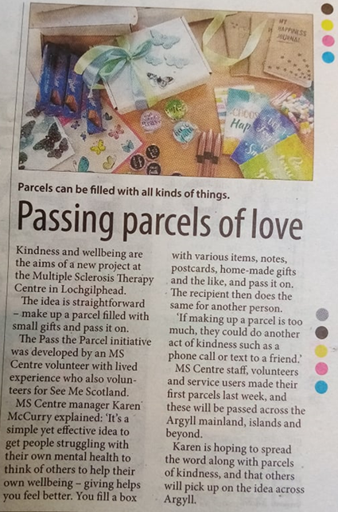

Lived experience and co-production in tackling stigma
Discussions about the role of lived experience shaped the event series. People discussed how placing lived experience at the centre of anti-stigma work and campaigns challenges self-stigma, empowers individuals, and increases knowledge around issues which are often hidden or seen as ‘taboo’.

Safe spaces for conversation
A key theme that emerged was the need to create safe, inclusive environments for people with lived experience to share their own experience.
This was highlighted by Susan McKellar, Operations Manager at the Scottish Women’s Convention, who spoke about the importance of creating women-only support spaces for women experiencing gambling harm. Susan highlighted that many women face increased stigma around the issue of gambling harm, as much of their experiences are tied into gendered expectations of women.
Susan also shared that women speaking about their experiences of gambling harm had a significant impact on encouraging other women to come forward and seek help and support. This idea of the importance of connection through story sharing was prominent throughout the series and across several issues.

Beyond storytelling
Throughout the series people with lived experience, individuals and professionals from across different sectors spoke about varying ways people with lived experience can inform change and challenge stigma, without explicitly sharing their personal experiences.
Disclosing personal experiences publicly can be a triggering process for individuals, and many do not feel comfortable doing this widely. Beyond sharing stories and experiences, it was described how people with lived experience can challenge stigma through:
- Joining a peer support network
- Taking part in activism and awareness raising campaigns
- Informing policy and projects
- Creating and promoting anti-stigma resources
- Delivering and facilitating anti-stigma training
Example:

Dawn Getliffe, a lived experience volunteer with See Me and chair of the See Me Volunteering Steering Group uses her lived experience of mental ill health to challenge mental health stigma and discrimination in different ways.

As well as co-creating the ‘See Me Value Me’ tool for health and social care professionals, Dawn used her own experiences to create ‘Pass the Parcel,’ a project which aims to open up conversations about mental health in response to COVID-19.
“The idea of this project is to pass on parcels between individuals and have conversations about how people are feeling. The person receiving the parcel would then pass on another parcel to a friend, colleague, neighbour, etc and the process would continue to challenge the stigma surrounding mental ill health.”
- Dawn Getliffe, See Me Volunteer
The parcels include: a reusable card, personalised relaxation resource (such as handmade soap), a stress ball, two teabags to encourage the recipient to sit down and have a cuppa with someone, and resources for having good conversations about mental health.

Listen and believe – give stories and personal experience weight and space
When people feel safe and confident to talk about their experiences, they then must be listened to, taken seriously, and understood.
Ly Kerr, freelance writer and activist, spoke about her personal experience of not being taken seriously by health professionals because of her weight. Medical professionals consistently focussed on Ly’s weight rather than listening to her experiences, leading to extensive delays in getting treatment and support for other issues.
‘Change [..] diet, lose some weight and things will improve. I tightened up my already drastic diet and continued to lose weight.
My symptoms did not improve. In fact, they worsened.
- Delegate
Dismissing personal experiences has detrimental health impacts and perpetuates feelings of shame and internalised stigma. Feeling listened to, however, helps break down feelings of being “unworthy” of receiving support.

The role of co-production
The importance of rights-based, person-centred co-production strategies was a key priority for delegates attending RSEH events.
Research from Mind mental health charity suggests that when mental health services are co-produced, people experience reduced stigma when accessing services, and face less public stigma from their wider community and health professionals.
Discussions around co-production focussed on respecting the experiences and stories of people. Providing appropriate spaces for people to share their lived expertise is needed to inform future practice, service development and design, including being able to have an influence on decision-making.
One suggestion from Wendy Halliday, Director at See Me, to support this was to ensure the Scottish Human Rights PANEL Principles; Participation, Accountability, Non-Discrimination and Equality, Empowerment and Legality are applied at a national level. This would ensure people are involved in shaping the decisions which affect them, and embed the holistic approach that people’s voices, expertise, and rights drive policy and the improvement of services.
Tokenism refers to the perfunctory or symbolic engagement of people with lived experience, where they in fact do not actually have much influence.
However, a key concern from discussions around co-production was the need for engagement with lived experience to be meaningful and not tokenistic. To ensure co-production moves away from tokenism, there needs to be an equal power balance between all partners involved, characterised by core values of trust, human rights principles and approaches, and transparency.

Key principles for meaningful involvement of people with lived experience
Throughout the RSEH event series, the following principles were identified as key in enabling meaningful involvement of people with lived experience:
- Ensure engagement and co-production creates an equal power balance between all partners.
- Set clear boundaries, principles, and values for the co-production group.
- Develop systems that can support the equitable renumeration of people with lived experience.
- Commit to building trust and meaningful relationships, underpinned by a trauma-informed approach.
- Provide effective wellbeing supports and safeguarding measures for people with lived experience.

Stigma on an interpersonal level
Self-stigma was a prominent theme discussed throughout the series. This was characterised by individuals internalising feelings of guilt or shame about themselves, their behaviour, or a combination of both.
Participants spoke about self-stigma as a key barrier when trying to access help and support. Individuals may be reluctant to seek support due to low self-esteem and feelings of unworthiness. They may feel concerned that others will look down on them, leading to distress and embarrassment and people choosing to avoid situations which could be further stigmatising, or even retraumatising.
Stigma influences how people perceive and understand themselves. It was shared that stigma can be co-occurring and interact with other forms of social identity. The event series touched on many different forms of stigma including those linked to mental health, weight, poverty, gambling harms, addiction, homelessness, suicide, physical health conditions and how these can intersect.
From these discussions, it is clear that an intersectional approach must be taken to address stigma.

Tackling self stigma
There aren’t the appropriate resources or support mechanisms available to help people manage negative feelings associated with self-stigma. Shame was emphasised by participants as an issue that society needs to address and confront. The work of researcher Brené Brown was highlighted as a good starting point for exploring this further. She characterises shame as “the intensely painful feeling or experience of believing that we are flawed and therefore unworthy of love and belonging” and suggests that it correlates with “addiction, depression, violence, aggression, bullying, suicide and eating disorders”.
Shame is a taboo topic across society; participants suggested that we need to have open conversations to consider ‘Who feels shame?’ ‘Why do people feel shame?’ and ‘How do people deal with shame?’.
“There is no one single solution to ending stigma – particularly the ‘vicious cycle’ of self-stigma that prevents people accessing support in the first place. But ensuring that services are underpinned by a right-based, compassionate approach and are available and responsive when people do open up is vital.”
-Lewis Macleod, Policy Officer, Includem

Relationships were cited as crucial to challenge feelings of self-stigma; particularly between individuals experiencing stigma, and the importance of peer support such as See Me’s peer networks.
Participants highlighted the importance of developing relationships underpinned by trust, and that it can be with health and social care professionals where these trusting relationships are established. An example was shared where a GP supported someone to confront their feelings of self-stigma around their mental health and this then enabled them to identify and receive appropriate support.

Societal stigma reinforces self stigma
Commercial determinants of health are the private sector activities that affect people’s health positively or negatively.
The private sector influences the social, physical and cultural environments through business actions and societal engagements; for example, supply chains, labour conditions, product design and packaging, research funding, lobbying, preference shaping and others.
Stigma can shift responsibility and ‘blame’ onto individuals and away from wider policy, social and economic factors. In some cases, people spoke about stigma being actively produced to suit certain agendas. The relationship between commercial determinants of health and stigma was discussed, such as the role of multi-million-pound gambling corporations in perpetuating stigma, with industry giants avoiding responsibility by pushing a narrative of individual blame.
During the first event Martin Paterson, Director of Machine Zone and gambling harm activist, spoke about his own experience of internalised stigma and suggested that this was reinforced by a lack of understanding from healthcare professionals.
There are many different layers to the systemic stigma which people experience, such as stigma encountered when; engaging with public services, through political discourse, the media and interactions with others.
These often intensify self-stigmatisation, rather than challenge the structural issues which are beyond people’s control.

The culture of stigma
Stigma is deep rooted and embedded across our society, challenging it requires a range of different approaches which need to take place over a long period of time.
‘transformation requires patience: it takes time to forge relationships, to embed change and realise long term benefits.’ –
Nurturing Transformation, one of five provocations from The Health and Social Care Academy

Environmental perpetuation of stigma
To explore culture, the series looked at the clustering of ‘environmental bads’ like betting shops, off licenses and fast food outlets, in areas of deprivation and the impact these have on people’s lives and their experience of stigma.
Susan McKellar, Operations Manager, Scottish Women’s Convention spoke about links between poverty, gambling, stigma and women. The gambling industry is known to target communities experiencing poverty. This leads to those impacted by gambling harms being doubly stigmatised due to experiencing poverty and being perceived as choosing to engage in harmful behaviours. Susan highlighted that public perception often fail to consider that poorer communities are being deliberately targeted by a billion-pound industries and whether current regulations are working to protect individuals and communities from these commercial harms.
“Working class gambling is stigmatised a lot more. For instance, more affluent people may attend racetracks such as Ascot which is viewed as desirable, but people using betting shops are demonised and portrayed as irresponsible.”
Scottish Women’s Convention Gambling Harm Report ¹³

Understanding stigma intersectionally
Suzanne Connelly from Public Health Scotland shared work being done to develop a weight stigma e-learning resource. She highlighted the clear links between poverty and higher weight, which is often seen as an issue of personal responsibility. This can have negative implications for individuals who can experience discrimination both in society and in healthcare.
More attention needs to focus on underlying and deep-rooted societal issues, including addressing poverty and health inequalities, rather than on individual behaviours. This may include investing in high quality accessible public services, preventative spending, and income-based policies such as the exploration of implementing a Universal Basic Income.
The Primary Care Health Inequalities Short-Life Working Group highlighted how stigma and other health inequalities interact.

“Barriers can include institutional discrimination and stigma due to many characteristics, such as disability, ethnicity and sexual orientation, body weight, as well as poverty and social exclusion. Initiatives to address health inequity need therefore to both address the challenges experienced by geographical communities identified as experiencing ‘deprivation’ and the less visible but, nevertheless important, health inequity impacting on many other individuals and families throughout Scotland.”

Delegates also shared that identity characteristics, such as gender, can compound the stigma an individual encounters. Ly Kerr, a weight campaigner, spoke about being dismissed “as a hysterical woman” leading to prolonged trauma and pain. Additionally, Tommy Kelly, a community champion with See Me, spoke about being male with an eating disorder and the lack of understanding which led to delays in receiving appropriate treatment.
These personal experiences underline the need for an intersectional approach to tackling stigma which should be incorporated into staff education and awareness training.

Challenging the culture of stigma; awareness, education, training and creativity
One area highlighted which could help tackle stigma, was via the provision of better education, awareness, training and capacity building for those working in the health and social care sector.
"We're calling for investment in the workforce, both for their own mental health and wellbeing, but also practitioners understanding of stigma and how it can create a barrier for people."
Wendy Halliday, Director See Me
Breaking down labels like patients and professionals was suggested as a way to counteract power dynamics, and support the workforce to take a person centred, trauma informed and rights based approach. A trauma informed approach recognises the importance of “safe, effective and empowering relationships”.
Adopting a trauma informed approach supports practitioners and professionals to view individuals holistically and encourages more effective signposting to other services and supports. As has been highlighted individuals may experience multiple issues and associated forms of stigma at the same time. As a result, it is important that people are treated based on their individual needs and circumstances to receive appropriate support.
Throughout the series, people also spoke about using creative approaches to challenge stigma. The arts have been shown to be an impactful tool to challenge prejudiced public attitudes towards a range of issues, including mental illness. Being involved in creative projects can also be therapeutic and reduce the likelihood of people experiencing self-stigma, while also strengthening the recovery process.
Example: Machine Zone and Reverie Film’s ‘One Last Spin’ is a powerful documentary which exposes the harm gambling can cause through four real life experiences. The film tackles stigma around gambling harm by helping people to understand the issue. This challenges existing public prejudices, but also supports people who are experiencing gambling harm to recognise they are not alone.

“Such a powerful film, providing insight into people’s journeys into gambling addiction, the damage caused to them & loved ones, how they got help. Let’s increase awareness, reduce stigma, ask, listen, support and inform. It’s a social justice issue.” – Film audience member

Conclusion
Challenging stigma across society has the potential to be transformational for everyone. Stigma makes people feel isolated and ashamed and can stop people accessing support. It contributes to the silencing of experiences which are less accepted by society.
It is something often experienced and described at an individual level, however, this does not mean it is an individual issue.
The Reducing Stigma, Emphasising Humanity series has explored stigma on a broad scale; showing its impact across a variety of issues and topic areas. Peoples’ experiences of stigma are unique depending on their personal circumstances, but throughout our events commonalities have become clear.
People have spoken about how our media, our systems, and our cultural attitudes shape the stigma that individuals experience. About how misconceptions, lack of understanding and harmful stereotypes drive stigmatisation.
So how do we tackle this?
Throughout the series people and organisations have shared work they are already involved in to tackle stigma which can be upscaled, emulated and or learned from. Examples of these are highlighted throughout the report, but further resources are also available in Appendix Three. The importance of peer led change, of national campaigns and awareness raising activities have all been highlighted. There is, however, still much to be done.
Stigma must be addressed at multiple levels, from the interpersonal to the societal and systemic. Our recommendations set out some ways in which stigma can be reduced. These highlight some of the key actors who need to be involved in driving change; the media, health and social care, the general public, and individuals who experience stigma.
Recommendations include encouraging open conversations across society to speak about stigma and shame, co-producing anti stigma work with people with lived experience and providing appropriate information and training.
As well as tackling stigma, we must also prevent it.
This report highlights that through relationships and compassion, internalised feelings of shame and stigma can be prevented. We must also consider how we can prevent our society contributing, reinforcing and perpetuating stigmatisation.
We must connect with one another, regulate corporate profiteering from stigma, have open, honest discourse at all societal levels, and develop policies and systems which understand and support people. The societies we live in shape and influence our behaviour, attitudes, and beliefs. Therefore, we must ensure they are built on kindness, empathy, and acceptance,
Emphasise humanity. Reduce stigma.

About the ALLIANCE
The Health and Social Care Alliance Scotland (the ALLIANCE) is the national third sector intermediary for a range of health and social care organisations. We have a growing membership of over 3,000 national and local third sector organisations, associates in the statutory and private sectors, disabled people, people living with long term conditions and unpaid carers.
Many NHS Boards, Health and Social Care Partnerships, Medical Practices, Third Sector Interfaces, Libraries and Access Panels are also members. The ALLIANCE is a strategic partner of the Scottish Government and has close working relationships, several of which are underpinned by Memorandum of Understanding, with many national NHS Boards, academic institutions and key organisations spanning health, social care, housing and digital technology.
Our vision is for a Scotland where people of all ages who are disabled or living with long term conditions, and unpaid carers, have a strong voice and enjoy their right to live well, as equal and active citizens, free from discrimination, with support and services that put them at the centre.
The ALLIANCE has three core aims.
We seek to:
- Ensure people are at the centre, that their voices, expertise and rights drive policy and sit at the heart of design, delivery and improvement of support and services.
- Support transformational change, towards approaches that work with individual and community assets, helping people to stay well, supporting human rights, self management, co-production and independent living.
- Champion and support the third sector as a vital strategic and delivery partner and foster better cross-sector understanding and partnership.

Contacts:

Georgina Charlton, Scotland Reducing Gambling Harm Programme Manager
Georgina.charlton@alliance-scotland.org.uk
Jane Miller, Academy Programme Manager
Jane.miller@alliance-scotland.org.uk
Grace Beaumont, Self Management Development Officer
Grace.beaumont@alliance-scotland.org.uk
T: 0141 404 0231 W: www.alliance-scotland.org.uk

About Health and Social Care Academy

The Health and Social Care Academy (the Academy) is an ALLIANCE programme that helps drive positive and radical change in Scotland’s health and social care, through the voice of disabled people, people living with long term conditions, and unpaid carers. The Academy’s ‘Five Provocations for the Future of Health and Social Care’ was created based on the vision from the Think Tank of Scottish senior leaders from across the public sector, third and independent sector leaders, and people who use health and social care services.

About Self Management
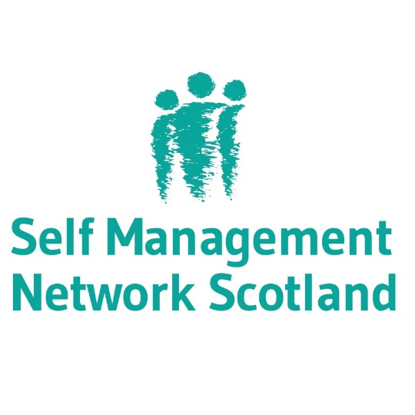
The ALLIANCE Self Management Team supports knowledge-sharing around Self Management in Scotland.
Self management supports and encourages people living with long term conditions to access information and to develop skills to find out what’s right for their condition and, most importantly, right for them.
The ALLIANCE Self Management Team work to embed this approach across Scotland through their work:
- The Self Management Fund for Scotland, currently funding 49 projects
- The Self Management Network Scotland, a network of over 800 organisations and individuals
- Delivering events to explore and support self management

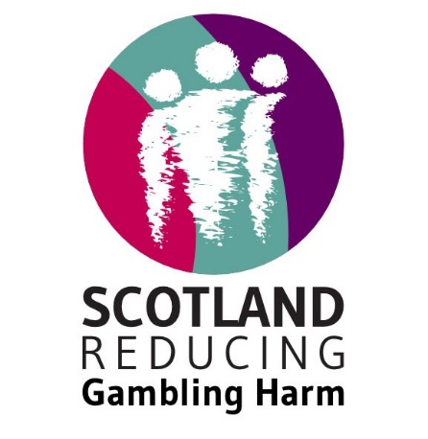
About Scotland Reducing Gambling Harm
The Scotland Reducing Gambling Harm programme works directly with people with lived experience to shape action and influence policy to reduce gambling harms in Scotland. The Lived Experience Forum to reduce gambling harms work with key stakeholders and decision makers to inform this work.
Scotland Reducing Gambling Harm’s work is driven by the National Strategy to Reduce Gambling Harms. The three-year strategy calls for combined efforts to deliver two strategic aims:
- Prevention and Education
- Treatment and Support

Read the programme’s response to the Review of the Gambling Act 2005, and a report on engagement work carried out in Greater Glasgow.

Appendix One: Cultural Context

Understanding Stigma
Stigma is widely understood to be negative attitudes or beliefs based on preconceptions, or stereotypes which could be associated with identity, culture, social status, or health. There are different forms of stigma which can be mutually reinforcing including: self-stigma, public stigma, structural and cultural stigma, and stigma by association.
The relationship between public stigma and self-stigma is important to highlight. Public stigma refers to the stigmatising perception of an issue endorsed by the general population through negative attitudes and beliefs. Public stigma can have a detrimental impact on people as it can lead to stereotyping, prejudice, and discrimination. Public stigma can have a harmful impact on a person’s sense of self, and can lead individuals to internalising public stigma to have negative attitudes and perceptions of their self, including low confidence and feeling like a burden to others. We heard from people with lived experience that stigma can prevent many from reaching out for help, support, and treatment. Stigma has also been identified as ‘especially problematic’ for people living with long term conditions as it can create barriers to accessing necessary social and structural supports, which intensifies feelings of self-stigma. This is an example of structural and cultural stigma.

Appendix Two: Opinion Pieces
As part of the Reducing Stigma, Emphasising Humanity event series a number of supporting Opinion Pieces were also written. These are available to read on the ALLIANCE’s website:
- “When weight stigma is life threatening”, Ly Kerr, Activist
- “Call for action – challenging self-stigma through collective peer support” Heidi Tweedy, Moray Wellbeing Hub CIC Director and Champion
- “Call for action – how should we destigmatise eating disorders in the media?” Tommy Kelly, SeeMe Champion, SeeMe
- “Reducing stigma, emphasising humanity” – Lewis Macleod, Policy Officer, Includem
- “Reducing stigma around mental health” – Michelle Stebbings, Head of Outreach and Engagement, Gambling With Lives

Appendix Three: Further information and resources
PHS Challenging Weight Stigma Learning Hub
A learning hub dedicated to challenging weight stigma has launched on Public Health Scotland’s (PHS) virtual learning platform.
The hub is an evidence based online resource, aimed at increasing awareness of weight stigma and the impact it has on individuals, as well as identifying actions that can be taken to address it.
It has been informed by people with lived experience of higher weight and weight stigma, who share how their lives have been affected by bias and discrimination based on body weight and size.
Aimed primarily at those who work in health and social care, public sector, third sector and community-based organisations; the hub provides content in sections with animations, video and support to take the learning into practice.
The Health and Social Care Academy was a member of the short life working group which helped inform the development of the learning hub.
The Fat Doctor
Dr Asher Larmie (they/them) is a Transgender Non Binary GP and fat activist who is campaigning for an end to medical weight stigma.
- #noweigh campaign
- Blog Series
- The Fat Doctor Podcast
CVS Inverclyde Resilience Network Challenge Stigma Event Series
- John’s story – Available on YouTube
- Rouzin’s story - Available on YouTube
- Kevin’s story - Available on YouTube
See Me
- Find out more about stigma and discrimination and the impact it can have on people experiencing mental health problems.
- Download and print resources and materials for 'Pass the Parcel' and help start conversations around mental health.
- See Us the movement to end mental health stigma and discrimination across Scotland.
Scottish Drug Deaths Taskforce:
- A Strategy to Address the Stigmatisation of People and Communities Affected by Drug Use

Waverley Care
- Smash HIV, hepatitis C and sexual health stigma, through diverse and tailored training programmes for professionals, community groups and organisations across Scotland.
Diabetes UK
- Calling for research applications that aim to better understand stigma experienced by people with diabetes, including people with different types of diabetes and from different communities.
Scottish Drugs Forum
- Stigma and substance use
Wider reading and watching:
- Helen Salisbury: Health, Poverty and Stigma, article in the British Medical Journal on stigma from a GPs perspective.
- “Reversing the stigma” by NY OASAS. A New York Emmy-nominated documentary that highlights the work being done in New York State to combat addiction.
- “Beyond Silence” “A film providing a glimpse into people, their lives and their diagnoses, including bipolar disorder, schizophrenia, depression and anxiety, ultimately weaving together a story about how speaking up is key to living well.
- “Nadiya Hussein: Anxiety and Me” In this raw documentary, Nadiya Hussein paints a vivid picture of what it’s like to secretly struggle with panic attacks and documents her efforts to pinpoint the cause by seeking treatment. Available on BBC.
- “THIN” A documentary following the journey of four women as they detail their experience with eating disorders, like anorexia and bulimia. Throughout the film, they detail their struggle to overcome these conditions and discuss how their body image issues affected their emotional and psychological health.

Appendix Four: Relevant ALLIANCE consultation responses
The ALLIANCE, ‘ALLIANCE respond to poverty-related stigma inquiry’ (March 2022). Available at: ALLIANCE-Response-Poverty-Related-Stigma-Inquiry.pdf (alliance-scotland.org.uk)
The ALLIANCE, ‘ALLIANCE responds to the Scottish Mental Health Law consultation’ (May 2022). Available at: ALLIANCE response to the Scottish Mental Health Law Review - Health and Social Care Alliance Scotland (alliance-scotland.org.uk)

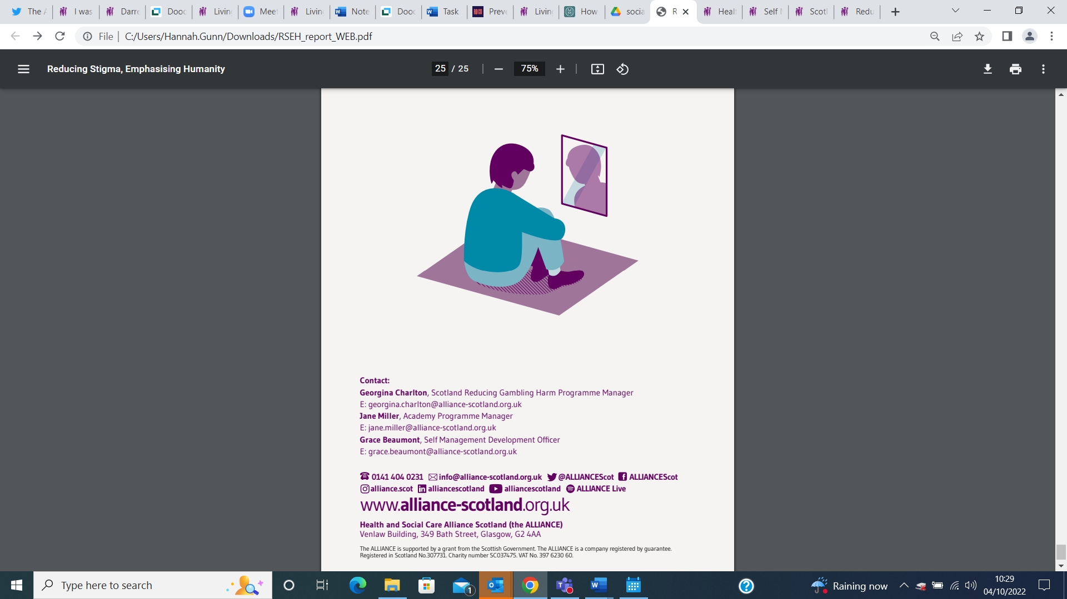

‘Poverty Porn’ refers to the exploitation of people in poverty in order to generate the necessary sympathy for selling a product (e.g. newspapers), or increasing charitable donations (or general support) for a given cause. This tactic can be in any type of media, whether it written, photographed, or filmed.
https://www.scottishwomensconvention.org/files/gambling-roundtable-report.pdf
https://www.seemescotland.org/media/10088/see-me-value-me-a4_final.pdf
https://www.seemescotland.org/movement-for-change/pass-the-parcel/
https://www.alliance-scotland.org.uk/blog/opinion/when-weight-stigma-is-life-threatening/
https://www.mind.org.uk/information-support/your-stories/co-production-in-mental-health-why-everybody-wins/
https://www.scottishhumanrights.com/media/1409/shrc_hrba_leaflet.pdf
Hahn, D.L et al. (2017). Tokenism in Patient Engagement. Family Practice, (34)3, 290- 295.
Stigma and intersectionality: a systematic review of systematic reviews across HIV/AIDS, mental illness, and physical disability | BMC Public Health | Full Text (biomedcentral.com)
Brené Brown: Listening to shame | TED Talk
https://www.who.int/news-room/fact-sheets/detail/commercial-determinants-of-health
gambling-roundtable-report.pdf (scottishwomensconvention.org)
ALLIANCE-Response-Poverty-Related-Stigma-Inquiry.pdf (alliance-scotland.org.uk)
http://www.healthscotland.scot/health-inequalities/fundamental-causes/income-inequality/income#TripleI
Basic_Income_report_2021_(alliance-scotland.org.uk)
Report of the Primary Care Health Inequalities Short-Life Working Group
Quinn, Neil & Shulman, Amanda & Knifton, Lee & Byrne, P. (2011). The impact of a national mental health arts and film festival on stigma and recovery. Acta psychiatrica Scandinavica. 123. 71-81. 10.1111/j.1600-0447.2010.01573.x.
Corrigan, P. (2004). How stigma interferes with mental health care. American Psychologist, 59, 614 – 625. doi:10.1037/0003-066X.59.7.614
https://citeseerx.ist.psu.edu/viewdoc/download?doi=10.1.1.656.3782&rep=rep1&type=pdf
The ALLIANCE (2021). Reducing Gambling Harm in Greater Glasgow: A Community Conversation. https://www.alliance-scotland.org.uk/wp-content/uploads/2021/06/Reducing-Gambling-Harm-A-Glasgow-community-conversation.-ALLIANCE-report.pdf
Jackson-Best, F., Edwards, N. Stigma and intersectionality: a systematic review of systematic reviews across HIV/AIDS, mental illness, and physical disability. BMC Public Health 18, 919 (2018). https://doi.org/10.1186/s12889-018-5861-3

