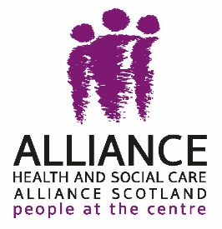

ALLIANCE Code of Conduct for Events
Purpose
The ALLIANCE aims to create spaces where everyone feels respected, safe and able to contribute. By attending an ALLIANCE meeting or event, you agree to follow this Code of Conduct. If you are not happy with your experience, you can speak to the Programme Manager/Director or Chief Officer or use the ALLIANCE complaints policy (for issues relating to the event itself).

Diversity
All participants are expected to:
- Treat everyone with respect and avoid discrimination or exclusion
- Behave fairly and responsibly towards staff, volunteers and other participants
- Share any accessibility or support needs with the chair or facilitator in advance
Collective responsibility
By taking part, you agree to:
- Follow the direction of the chair or facilitator, listen respectfully and allow others space to contribute
- Raise points calmly and constructively
- Meet the behavioural expectations for the event (e.g. not interrupting or dominating discussion)
- Accept majority decisions, although formal request to the chair or facilitator can be made to record a differing opinion
- Contribute when invited and stay relevant to the discussion
- Challenge ideas, not individuals
- Avoid inflammatory and discriminatory language or behaviour
- Not attend under the influence of alcohol or illicit substances
- Report any health and safety concerns
Breaches of the code
If behaviour disrupts or threatens the event, the chair or facilitator may:
- Pause the event to restore order
- Remind the person or people of the expected standards of behaviour
- Ask the person or people to leave temporarily or for the remainder of the event
- Suspend or end the event if safety or order cannot be maintained
- Decide whether and when a person or people may return to the event
- Refer repeated or serious issues for further action.
Repeated breaches may result in suspension or permanent exclusion from ALLIANCE events, and may lead to removal of ALLIANCE membership.
Definitions
- Events include all ALLIANCE run or hosted activities (workshops, panels, training, conferences, etc.)
- Unnecessary or undue hindrance means un-asked for interruption or behaviour that delays or disrupts the event
- Interruption means suspension or repeated suspension of the event caused by an attendee
- Fear/intimidation/harassment/threatening includes behaviour that makes others feel unsafe or afraid to participate.

Updated May 2026.

End of document

