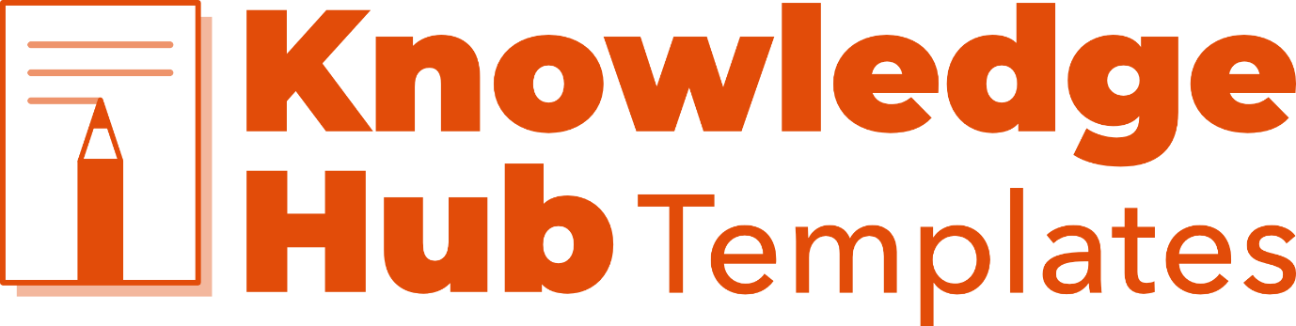Working Together Agreement

The purpose of a working together agreement is to outline the expectations, roles, and responsibilities of a team. It should be created collaboratively and agreed upon by all team members. The agreement should be clear and concise, and it should cover all aspects of the team's work.
This template is based on discussions held with a lived experience working group facilitated by the ALLIANCE. Please use this document as a starting point to think about your own approach, however, note that your organisation and members will have its own objectives and circumstances to consider – this agreement is not one-size-fits-all.

Purpose of the group

The purpose of the group is to integrate human rights into X policy/service development, implementation, monitoring and evaluation.
To do this, the group will develop a human rights-based approach, placing people and their human dignity and rights at the centre of all policy and decision-making.
The group has been established to co-design an Action Plan for the project. This will include list of your project’s activities.
For the group to achieve these outcomes, members must successfully work together. This Working Together Agreement has been created to support this. It is based on the views of group members and describes the values and principles the group want to embody, and what this might look like in practice.

Action Focused

The group strives to contribute to real, meaningful change for people affected by focus of the group (e.g. a problem, condition, or policy area). The group will be accountable for its work and actions, whilst also holding each other and the wider system to account.
The group will be led by good governance processes, with a clear workplan and timeline. Group Members will have access to relevant training and up to date information to support their membership, particularly in relation to subject area.

Inclusive

The group will foster an atmosphere of inclusion both internally and externally. All member’s voices will be valued, respected, given space, and heard.
The group will endeavour to reach beyond its members to hear and represent the views of our wider communities, particularly those who are, or have been, the most marginalised and stigmatised.
To support this, the group will have access to expenses, use accessible communication practices and challenge stigmatising language.

Integrity

The group commits to demonstrating, and acting with, integrity at all times. All group members will be treated, and treat each other, with fairness, dignity and honestly.

Collective Voice

The group will speak with an aligned, collective voice. This will enable the group to reach external audiences, shape attitudes and influence ways of working. This collective voice will be inclusive of all the voices of the group.
To do this the group will develop unified branding and a communication plan. This communication plan will aim to reach people where they are, making effective use of different media channels and social media.

Safe and Supportive

The group will treat each other with kindness, politeness, and respect at all times. It will be a safe space for people to share their views and experiences; where relationships are based on trust and support members to challenge one another respectfully.
The group ultimately aims to improve the quality of people’s lives, and this includes the members of the group themselves. Psychological, physical, and emotional safety will be prioritised.
Participation in activities and discussions will take place on an “opt in” basis with informed consent. Group member’s experiences and stories are their own to share, and people’s individual boundaries in relation to this will be respected.
Appropriate safeguarding and wellbeing processes will be developed and implemented, including access to safe spaces and wellbeing support.

Agreed Practices

- Internal written minutes kept and circulated after each meeting
- Agenda circulated in advance of each meeting
- Wellbeing check-in after sensitive conversations
- Circulate and share new, relevant information and research
- Have a safe space continue to be available
- Communicate inclusively: infographics, audio, plain English, easy read, not all written, social media.
- Meetings with take place under Chatham House Rules.

