Being a Change Maker: Gambling Harm
Welcome to the Scottish Gambling Harm Lived Experience Forum!
The following guide has been developed to support your involvement in the Forum’s work.
It aims to provide easy-to-read information about key areas relating to gambling harm in Scotland, and to your role as a member of the Forum.
We hope this following information is useful, and please don’t hesitate to get in touch if you have any other questions or if there’s anything else you’d like to know.

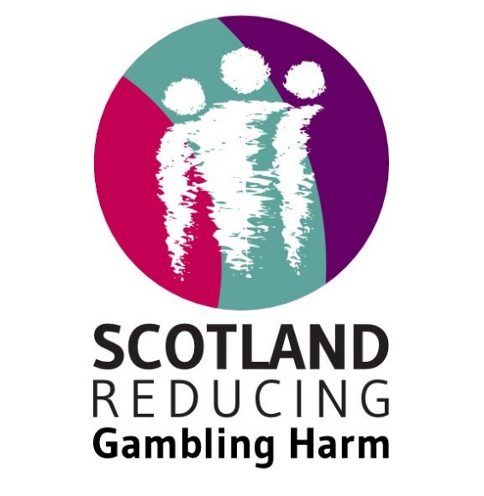

Contents:
What are gambling harms? 2
Policy, legislation, and gambling harm 3
Getting your voice heard 6
You and your story 9
The Scottish Gambling Harm Lived Experience Forum 13

What are gambling harms?
When a person gambles, they risk money or other valuables with an uncertain outcome in the hope of winning additional money or other valuables. Sports betting, horse betting, slot machines, casino games, lotteries, scratch cards, bingo, loot boxes and betting money with friends are all forms of gambling.
Risk is the common factor in all gambling products.
Gambling harms are harms caused by gambling. They include:
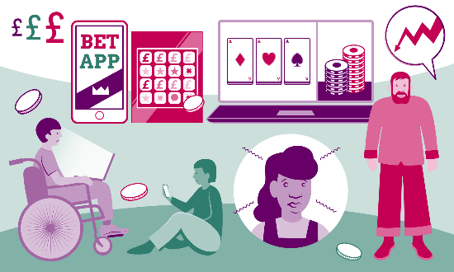
- Loss of money
- Negative impact on work and study
- Relationship problems
- Becoming involved in crime
- Negative impact on mental and physical health
- Substance use e.g. drugs or alcohol
- Housing impacts or homelessness
Gambling products are designed to keep people gambling. Design features, like speed of play encourage people to gamble for longer, with more money and to participate in additional types of gambling.
Gambling does not just harm individuals, it also negatively impacts families, loved ones, the wider community and society.
“People don’t understand it. […] It should be a public health issue. It should be about protecting our children and grandchildren. It should stop seeing the broken as people with ‘illness’ but recognise the cause of this misery as resting with the unregulated supply of addictive products.”
- Person with experience of gambling harm
In Scotland, it is estimated that more than 200,000 people are at risk of, or currently experiencing, harm related to their own gambling.
On average, six other people are affected around one person experiencing harmful gambling.

Policy, legislation, and gambling harm

To effectively reduce gambling harm, Scotland needs effective policies and laws. For these to work in practice, they must be informed and driven by those who know what it feels like to be harmed by gambling.
“As the days and months passed, I made a promise to myself that if I could go two years without gambling, I would help others who are struggling. Five years later, I’m well into that commitment.” - Person with experience of gambling harm.
Scotland is governed by both UK Government and Scottish Government.
The UK Government has power over reserved matters. The Scottish Government has power over devolved matters.
The regulation of gambling is governed at the UK level, by the Department of Culture, Media and Sport. The Gambling Commission is the body which licenses and regulates in accordance with this.
Gambling in the UK is currently regulated in accordance with the Gambling Act 2005.
In 2020 the Department of Culture, Media and Sport opened a Call for Evidence on the Gambling Act 2005.
This led to the publication of the Gambling Act White Paper Review in 2023, which included a number of new proposals and measures. These included things like:
- Introducing a statutory levy.
- Lowering stake limits.
- Altering physical premises licensing requirements.
- Restricting direct marketing.
These proposals were then opened for consultation throughout 2023 and early 2024.
You can find the responses from the ALLIANCE and the Scottish Gambling Harm Lived Experience Forum on our website.
Scottish Government does not have the power to regulate gambling, however, it does have the power to take action and implement policies as they relate to their devolved powers.
Some relevant devolved powers include:
- education and training
- equality legislation (some aspects)
- health and social services
- housing
- justice and policing
- local government
- planning
- sport and the arts

Governments are responsible for implementing policies and laws. Both the UK and Scottish Government are led by Ministers, and civil servants are responsible for delivering its activities.
Parliament is different and separate from government. It passes any laws and also scrutinises the work of the government and holds it to account.
Currently, the Scottish Government recognises and names gambling harm within a number of its mental health-related policies and strategies. However, there is no specific policy or strategy to address gambling harm.

Lived experience and policy making
The term ‘Lived Experience’ refers to the knowledge and understanding you gain when you have personally lived through something. Policies and systems are more effective when they are built for, and by the people who actually use them, so lived experience is crucial to effective policy development.
A Lived Experience Forum is one way in which people can come together to influence policy and practice. It is a group of likeminded people who come together to use their knowledge and expertise to push for change.
Also often known as Lived Experience Networks, forums are a great way of bringing people together around a shared purpose to co-produce a programme of work, and achieve long term, meaningful change. In addition to influencing policy and driving change, it provides an opportunity for shared understanding and peer support that they may not get in any other space.
Engaging with people with lived experience is supported through facilitating a lived experience forum, which has infrastructure in place to support long-term engagement, build the capacity of its members, and reflect the diversity and complexity of people’s lives.

Public Health Approach

The Forum advocates for a public health approach to tackling gambling harm.
A public health approach addresses issues by looking at them from a whole society point of view.

It considers the health and wellbeing of the entire population, rather than focusing on just the impact on individuals.

Taking a public health approach means focusing on:
- regulation
- prevention
- education
- treatment
- support

Key Stakeholders in Scotland to tackling gambling harm

- Scottish Government
- Public Health Scotland
- Local Authorities
- NHS Boards
- Health and Social Care Partnerships
- The third sector
- Academics

Getting your voice heard
Most people get involved with the Forum because they want to influence change or have a positive impact.
However, it can often feel challenging to find opportunities to be listened to and have your voice heard.
This section outlines some of the ways you can promote your voice and maximise your influence.
Politics and parliament:
Many of us have issues we care about. One of the ways to raise awareness of these issues is by connecting with politicians and parliament. There are several ways you can do this.

- Vote

Make sure your voice is heard in the democratic process by ensuring you are registered to vote: http://www.gov.uk/register-to-vote

- Contact your Member of Parliament, or Member of Scottish Parliament

Members of Parliament (MPs – UK) and Members of Scottish Parliament (MSPs - Scotland) can help their constituents in multiple ways. They can advise on and help resolve issues that relate to the work of government departments, and also raise issues in Parliament through actions such as asking questions, raising motions, or holding debates.

You can contact your MP or MSP by attending a local surgery or writing to them to discuss the issues you care about.

Everyone in Scotland has multiple parliamentarians they can contact:
- One Member of Parliament (UK) http://www.parliament.uk/findyourmp
- Eight Members of Scottish Parliament – one constituent MSP and seven regional MSPs https://www.parliament.scot/msps

Who you contact will depend on the nature of your issue. You should contact MPs about topics relating to reserved powers and MSPs about topics relating to devolved ones.

- Approach a Cross-Party Parliamentary Group (CPG) or All Party Parliamentary Group (APPG):

APPGs and CPGs are groups of parliamentarians and other people who have an interest in a particular topic area. They meet regularly to discuss and share information on these areas.

APPGs related to UK Parliament and CPGs related to Scottish Parliament.

You can join a CPG or APPG and present your interests or concerns.

A list of CPGs (Scottish Parliament) can be found here:
- https://www.parliament.scot/get-involved/cross-party-groups/current-cross-party-groups

A list of APPGs (UK Parliament) can be found here:
- https://www.parliament.uk/mps-lords-and-offices/standards-and-financial-interests/parliamentary-commissioner-for-standards/registers-of-interests/register-of-all-party-party-parliamentary-groups/

- Submit evidence to a committee:

Committees consider policy issues, scrutinise government work, expenditure, and examine proposals for primary and secondary legislation.

When a committee is considering an area, there are often opportunities to submit views to committee inquiries.

UK Parliament Committees and open inquiries can be found here: https://committees.parliament.uk/

Scottish Parliament Committees and open inquiries can be found here: https://www.parliament.scot/chamber-and-committees/committees

- Start a petition

Over 10,000 signatures receives a response from the UK Government. You can create an online petition at: https://petition.parliament.uk/
In Scotland, any person or organization can submit a petition, and MSPs can support them. There is no requirement for petitions to reach a certain number of signatures before they are looked at by the Citizen Participation and Public Petitions Committee. You can find out more about petitions here: https://www.parliament.scot/get-involved/petitions/about-petitions

- Connect with your Local Authority
It is also important to influence change at a local level. You can find and connect with your local councilors here: https://www.gov.uk/find-your-local-councillors.
Local authorities have powers to license gambling premises within their local area, as well as restrict the number of gambling licenses within this area.

- Connect with your local community
Use the ALISS website to find out about local services and organisations in your community, who may also be working to influence change: https://www.aliss.org/

Third Sector Interfaces (TSIs) provide a point of access for support and advice within local areas. You can find out more about your local TSI here: https://tsi.scot/tsi-directory/

Pace of change

Change takes time.

Opportunities to influence national level policy and legislation are not always readily available, and even when they are, it often takes years from policy development until you see real change in communities.

This means that trying to influence and improve systems can be frustrating.

Setting realistic expectations and celebrating our achievements along the way can be a helpful way to balance this.

It’s important to remember that whilst policy and systems change is slow, it has the possibility to have a significant, national impact when it does occur.

You and your story

One of the most common ways people try to promote change is by telling their stories. Stories are a powerful way to illustrate what issues look like for real people, and to allow others to emotionally connect to the area.
Some people also find it empowering to tell their story and use their experiences to try and influence change.
Storytelling can make people feel heard and in control of the narrative they want to share with the world.
However, people’s stories are exactly that, their own. People should not feel pressured to share. If people choose to share their story, they should have an active role in shaping how it is told.
Stigma can make it more challenging for people to feel comfortable to share their story, and there should always be options for people to remain anonymous should they choose to.
Setting boundaries
Sharing your own story is courageous, and at times it can be a nerve-wracking experience.
It is important to set boundaries in terms of what you are prepared to share with the world, and what you would rather not discuss. Informed consent is vital when sharing your story publicly and should be given at every stage of the editing process.
Consent can be withdrawn at any time.
Setting goals
When telling your story to influence change, it is important to think about your own personal development goals and what impact you would like to have.
Take time to reflect on the change you would like to see and make a step-by-step plan on how to get there.
Things you might want to consider are:
- Who are you speaking to?
- What would you like them to take away from your story?
- Do you have a key message?
- Is there anything you would like to challenge, encourage them to act on, or ask of them?
When telling your story, you might want to consider how you “frame” it.
Framing is the choices we make about what we say and how we say it. It ensures that when you tell your story it remains in context and supports the audience to draw the conclusion from your story that you want them to.
Telling personal stories can sometimes make topics seem like they only affect one person and can focus on the impact of individual actions.
However, if we “frame” stories appropriately they can be used to demonstrate a pattern of harm, and to identify where systems didn’t work for people.
Key elements to framing a story include:
- Identifying the core problem: how things were for the person, and what is it in broader society that made it that way.
- The solutions: what helped the situation? Or what could have helped but wasn’t available.
- So what? Why does this matter for all of society and for everyone?

Make sure to use context to bring in the bigger picture. This can help to see the role of systems failures and the impact this can have on people’s lives.

Opportunities to tell your story
Several of our forum members take part in activism, campaigning, and awareness raising projects out with being members of the Gambling Harm Lived Experience Forum.

- ALLIANCE Humans of Scotland series
The ALLIANCE works with people who want to share their own stories through the Humans of Scotland series. This campaign works to highlight the voice of people with lived experience, disabled people, those living with long term conditions, and unpaid carers.
You can read the Humans of Scotland gambling harm series here.
If you would like to tell your story through a Humans of Scotland piece, please get in touch.

- Connect with the media

Journalists often contact the Forum looking for people to interview or tell their stories.

Engaging with the media is a good way to reach a significant number of people across Scotland and to gain attention to the topic of gambling harm.

However, when engaging with the media you do not always have the same degree of control over how your story is told or how you are represented. It is important to know and communicate your boundaries.

As a member of the Forum, we will make you aware of any requests for interviews which we receive. We are also available to provide support, or help you develop your messaging if you choose to take part.

Lived Experience Forum members have frequently been interviewed by the media to share their own stories and influence change:

“It put me in a dark place, nothing else mattered but gambling” – Scott, a member of the Gambling Harm Lived Experience Forum, being interviewed by STV News.

- Support a local gambling harm campaign

Ad hoc opportunities to connect with organisations and events on the topic of gambling harm often arise throughout the year.
As a member of the Forum, we will make you aware of any opportunities we receive as and when they become available.

- Using the arts for activism
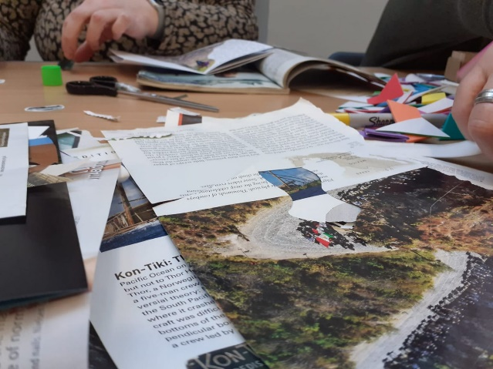
Creative activities are proven to contribute to physical and mental wellbeing. They are powerful, as they often bring people together and create communities.
Through arts (drawing, filmmaking, photography, dance, music, writing and so on) we can tell life experiences that are difficult to share and spread our message in an engaging way.
Experiencing art can also open us up to new ideas, understand differing points of views better and make us feel more connected.
Creative outputs can also be used to accompany a campaign or raise awareness of an issue.
‘One Last Spin’ is a film created by a Community Interest Company set up by one of the members of the Scottish Gambling Harm Lived Experience Forum, called the Machine Zone CIC. It depicts four real life experiences of gambling harm from across the UK in a highly impactful and thought-provoking way.
Watch it here: www.onelastspin.vision/


Complex issues can be explained simply with the aid of visuals, and complicated feelings can be captured in creative writing, as the example of ‘What’s at Stake’ shows. Four stories of harm and recovery were compiled by a writer, based on people with lived experience’s inputs, alongside comic-style posters.
Have a look here: www.whatsatstake.org.uk
Arts is increasingly used in academic research related to health and wellbeing. A good example of this is ‘photovoice’, a method which is using photos captured by research participants themselves. This way, the researcher sees the world through the eyes of the participants, who can use photography to communicate their environments, perceptions, visualise their feelings or document a specific process.

The Scottish Gambling Harm Lived Experience Forum

The Scottish Gambling Harm Lived Experience Forum is facilitated by the ALLIANCE Scotland Reducing Gambling Harm programme. The Forum is open to everyone in Scotland who has been affected by gambling harm in some way.
The Lived Experience Forum provides opportunities to share views and knowledge, hear from key speakers, and work with other people and organisations who are working to reduce gambling harm.
Work so far:
Since it began in 2020, the Forum has achieved a lot over the past four years, including:
- Influenced the planning and delivery of several roundtable events, which brought together people with lived experience, policymakers, and those working in the third sector to discuss key issues around gambling harm.
- Connected with the media to raise awareness of gambling harm.
- Developed and wrote responses to open consultations relating to the Gambling Act Review White Paper.
- Engaged with key stakeholders, including policy and decision-makers, on the development of activities to tackle gambling harm in Scotland.
- Shaped key reports and outputs on gambling harm in Scotland.

Key Dates
The Gambling Harm Lived Experience Forum meets every 6 weeks on Zoom. All sessions take place from 6pm – 7.30pm.
Future Forum dates for 2024 are highlighted below:
- 5th June
- 17th July
- 28th August
- 9th October
- 20th November

Glossary of useful terms

Gambling harm
The adverse impacts from gambling on the health and wellbeing of individuals, families, communities and society. Includes loss of money, negative impact on work and study, relationship problems, becoming involved in crime, substance use e.g. drugs or alcohol and housing impacts or homelessness.

Public health approach
The negative effects of gambling harm can be felt in wider society; therefore, many argue that gambling harm should be considered a public health issue. This approach would include increasing awareness and building screening and treatment capacity.
White paper
The white paper ‘High stakes: gambling reform for the digital age’ sets out the government’s plan for reform of gambling regulation following the review of the Gambling Act 2005. It covers topics such as online gambling, social responsibility, age verification, and the Gambling Commission’s role. It was published on 27 April 2023 and since then, seven connected consultations have been announced.
Gambling levy
A fee imposed on gambling operators to fund research, prevention, and treatment related to gambling harm. The levy ensures that operators contribute to addressing the negative consequences of gambling. So far, it has been voluntary, but the white paper sets out plans for a statutory (mandatory) levy.
Gambling strategy
A strategy highlights the most important work a government, or government body intends to deliver over a given amount of time. Creating a gambling strategy involves extensive engagement and input from a wide range of stakeholders with an interest in reducing gambling harms. Scotland currently doesn’t have a gambling strategy.
Gambling policy
Gambling policy is a statement of the government’s position, intent or action regarding the difference it wants to make in the gambling field. The tool a government uses to impose its policies is legislation. Creating and reforming the gambling policy is in the power of Westminster, but the Scottish Parliament has the power to make laws on a range of issues known as devolved powers. These include health and social services.
Gambling regulation
In the UK, the Gambling Commission licenses and regulates the individuals and businesses that provide gambling in Great Britain, including the National Lottery. They set out the License Conditions and Codes of Practice (LCCP) and enforce the legislation if there is a breach.
Treatment & support
Treatment and support for those affected by gambling harm can involve various services – information, online resources, self-help (e.g. Gamblers Anonymous), help with stimulus control, cognitive behavioral therapy (CBT) and other forms of counselling. Interventions require holistic or multi-agency approaches, which consider the person’s wider environment and relations. In England, there are specific NHS clinics who treat patients affected by gambling harm.
Gambling education
Gambling education projects aim for every young person to have access to gambling education and prevention opportunities, contributing to the reduction of harm. These support young people’s health and wellbeing by promoting awareness of gambling harms through training, peer education, arts, and more.
Whole system approach
A whole system approach in public health calls for considering, and modifying all parts of a system, an organisation or a place to build healthy, resilient, connected and empowered communities and therefore improve the health of the population. This approach involves many elements such as local public health leaders and place-based working across sectors and in partnership with communities.

Speed of play refers to how quickly you can repeatedly gamble on an activity. For example, the minimum time before someone can spin again on a slot machine.
Arnot (2018), Scottish Public Health Network gambling update
Goodwin et al. (2017), A typical problem gambler affects six others, International Gambling Studies, 17(2), 276–289.

