Draft Charter of Rights for People Affected by Substance Use: Consultation analysis and findings

Introduction
From December 2023 until June 2024 the National Collaborative held a public consultation to gather views on the Draft Charter of Rights for People Affected by Substance Use to inform its continued development. This public consultation was available to respond to via a range of different methods including an online survey, participation in community conversations, one to one meetings and feedback by email submission.
The National Collaborative also held a series of InterAction sessions. These sessions aimed to gather feedback from Duty Bearers to inform the practical use of the Charter and to interrogate its applicability across different services within the drugs and alcohol sector.

Public consultation: Responses, health boards and equality groups
In total the public consultation received feedback from 18 individuals and 35 community conversations with a total of 500+ participants.
The public consultation received feedback from four individuals in NHS Grampian, three individuals in NHS Greater Glasgow and Clyde (GGC), three from unknown health boards, two individuals from NHS Highland, NHS Lanarkshire and NHS Lothian and one individual from NHS Ayrshire and Arran and NHS Tayside.
Eight community conversations were conducted in NHS GGC, six community conversations were conducted across multiple health boards, four were conducted in NHS Lanarkshire, three were conducted in NHS Ayrshire and Arran, NHS Highland and unknown health boards, two were conducted in NHS Grampian and NHS Tayside and one community conversation was conducted in NHS Borders, NHS Fife, NHS Lothian and NHS Western Isles.
This is summarized in the table below.

 | A : Community Conversation | B : Individual
1 : Community Conversation | 35 | 0
2 : Individual | 0 | 18
3 : multiple | 6 | 0
4 : NHS Ayrshire and Arran | 3 | 1
5 : NHS Borders | 1 | 0
6 : NHS Dumfries and Galloway | 0 | 0
7 : NHS Fife | 1 | 0
8 : NHS Forth Valley | 0 | 0
9 : NHS GGC | 8 | 3
10 : NHS Grampian | 2 | 4
11 : NHS Highland | 3 | 2
12 : NHS Lanarkshire | 4 | 2
13 : NHS Lothian | 1 | 2
14 : NHS Orkney | 0 | 0
15 : NHS Shetland | 0 | 0
16 : NHS Tayside | 2 | 1
17 : NHS Western Isles | 1 | 0
18 : Unknown | 3 | 3
Community conversations were held by a range of different organisations, some of which represent the perspectives of specific equalities groups. The remit of each host organisation and the feedback transcripts of their community conversations were analysed to obtain a sense of representation across those conversations.
The majority of community conversations represented an intersectional perspective (17). The category of intersectional represents transcripts that referenced the perceptive of two or more equalities groups. Following this, six community conversations did not reference any specific equalities group and instead articulated their feedback in a more generalised manner. Four community conversations explicitly referenced rural perspectives, three explicitly referenced feedback from the lens of families, two provided feedback from an LGBTQIA+ perspective, one community conversation provided a carer’s perspective, one through the lens of poverty and deprivation and one grounded their feedback in the perspective of religion and belief. This is summarised in the chart below.
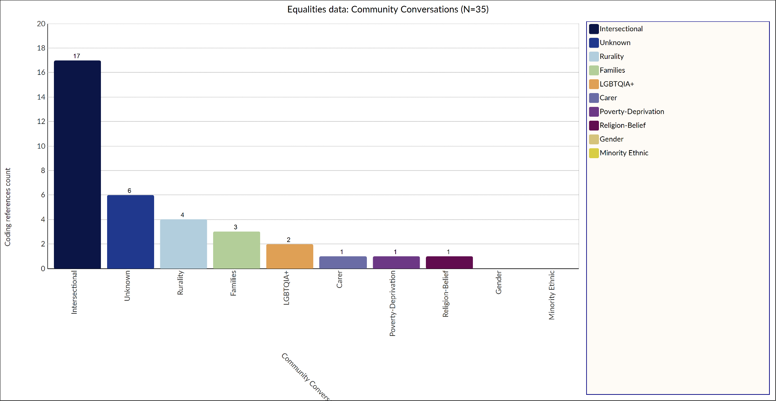
In order to protect participant identity, the equalities data for the 18 individual responses have not been included in this report.

Duty bearer InterActions: Sector representation
In total the National Collaborative hosted a series of three InterAction sessions. These sessions were attended by duty bearers from across various sectors including:
- The Scottish Government;
- Alcohol and Drug Partnerships (ADPs);
- Criminal Justice;
- Social work;
- Housing;
- Primary Care and the NHS;
- Police Scotland;
- Scrutiny bodies.

Method of analysis
To analyse the consultation feedback, the Change Team of the National Collaborative embarked on a method of collaborative thematic analysis led a member of the ALLIANCE support team. Collaborative thematic analysis is a widely used method to interrogate qualitative data sets and in particular, its use for lived experience involvement in analysis is gaining in popularity. Collaborative analysis provides the advantage of offering an additional layer of rigor, depth and richness due to the differing perspectives and standpoints shared during the analysis process (Richards et al, 2018; Sweeney et al, 2013). Consequently, members of the Change Team were able to use their myriad of experiences and perspectives both personally and professionally to interrogate the consultation feedback together as a group.

The Collaborative thematic analysis process
In preparation for conducting the analysis, the Change Team received an introduction to bias awareness and an overview of the fundamentals of thematic analysis. During this session, Change Team members were provided with copies of the raw data to familiarise themselves with the content ahead of coding.
The collaborative analysis process consisted of three core sessions led by the member of the ALLIANCE Support Team experienced in thematic analysis.

Background analysis
Prior to the first collaborative analysis session, the ALLIANCE staff member conducted preliminary coding of the consultation data by grouping the feedback into the most appropriate consultation topic, in order to streamline the forthcoming analysis sessions. The response topics consisted of:
- Feedback relating to improving the content of the Draft Charter
- Feedback relating to adding new content to the Draft Charter
- Feedback relating to what would support people to use the Draft Charter
- Feedback relating to any challenges and/or barriers to implementing the Draft Charter
- Feedback relating to solutions to challenges and barriers
- Outliers (feedback that was important but that did not relate to any of the consultation topics above)
This preliminary coding was conducted using the qualitative analysis software NVivo. Thereafter, the coded data was further refined to remove additional context about individuals and organisations to ensure the dataset was as succinct as possible.

Overview of the analysis sessions
Collaborative analysis session one
Session one consisted of coding the data and generating themes. Each consultation response topic was analysed by between three-four Change Team members. To ensure consistency of coding, each team created a coding definition chart. Thereafter, using this definition chart, codes that had commonality were grouped together into corresponding themes. Image one to the right hand side demonstrates this process.
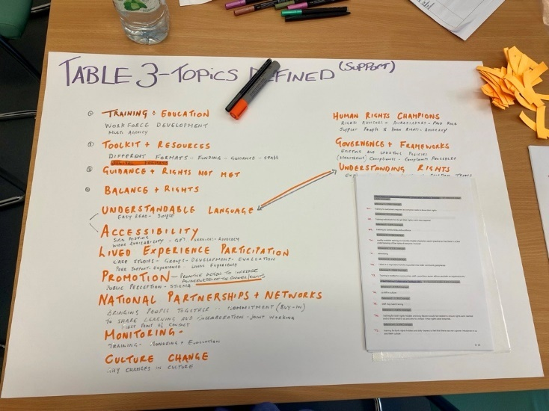
Image 1: Codes defined
Collaborative analysis session two
Session two consisted of a further interrogation of the themes created in session one. The focus of this session was to consider how to incorporate the feedback that had been analysed into the redraft of the Charter to support its improvement. This is demonstrated in a ‘you said, we did’ style document that is available separately. Some themes were considered to be outwith the scope of the re-drafted Charter. However, due to their importance the National Collaborative have addressed these themes at the end of this paper.

Collaborative analysis session three
Session three consisted of a feasibility analysis. This session focused on taking the outcomes and actions from session two, and considering what resources would be required to incorporate those improvements into the re-drafted Charter; while balancing this against the feasibility considerations of time, operational capacity and finance.
A feasibility matrix was created to visualize this with the outcomes grouped into the categories below:
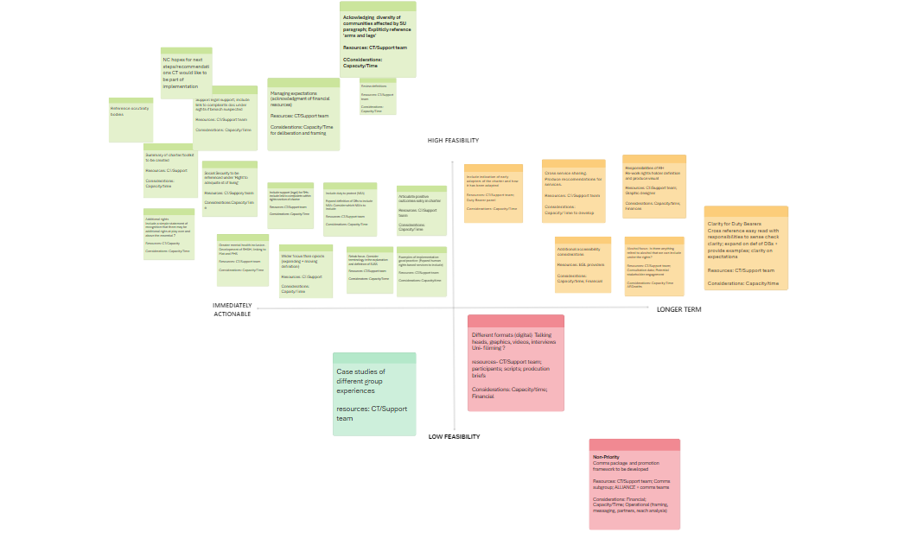
- Highly feasible and immediately actionable
- Highly feasible and longer term
- Less feasible and immediately actionable
- Less feasible and longer term
Image 2: Feasibility Matrix
An image demonstrating the feasibility matrix has been provided on the right hand side.

Thematic overview: What did you tell us?

Charter Improvement
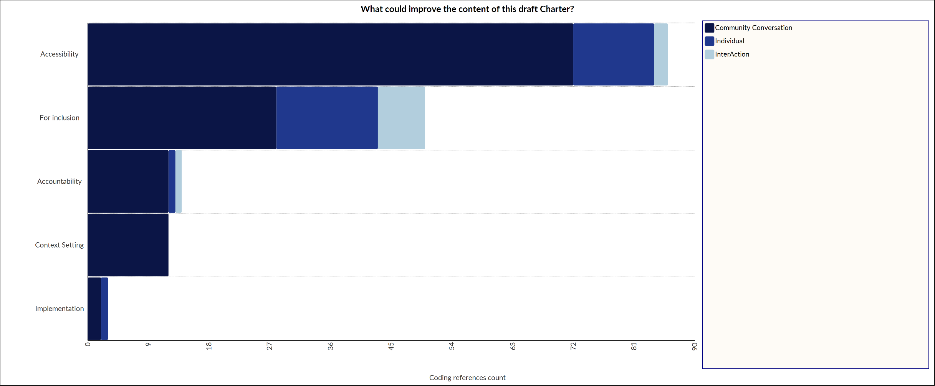
In answering the question ‘What could improve the content of this draft Charter?’ the most commonly reported themes across participants in the community conversations, by individuals and through the InterAction sessions are presented in the chart below.

Improving accessibility was the most common response to this question. A Charter that was ‘easy read’ and available in different formats, jargon free and not overly complex was referenced. Participants also provided feedback around the structure of the Charter, its tone and requested more definitions around the key rights to aid understanding.
The theme of ‘for inclusion’, related to aspects of the Charter which participants would like to see further developed. Participants requested greater inclusion of the aspect of mental health as it relates to substance use within the Charter. Feedback was also received that the Charter could be clearer that it applies to all substances rather than simply opioids. Including greater reference to advocacy services, revising and simplifying the toolkit and finally emphasizing/referencing the varying and intersectional experiences of specific populations were also points of feedback within this theme.
Within the theme of accountability, participants fed back that they would like reference to scrutiny bodies included within the Charter along with greater clarity around the responsibilities of duty bearers. Clarity around evaluation processes and complaints processes were also highlighted.
Within the theme of ‘context setting’, common responses included a desire to understand where the Charter fits within human rights in Scotland more generally, while ‘implementation’ related to comments concerning a desire to see further information about how the Charter will be implemented.

Charter Additions
In response to the question ‘Is there anything you would like to add to the draft Charter?’ the most popular themes by response number are provided in the chart below.
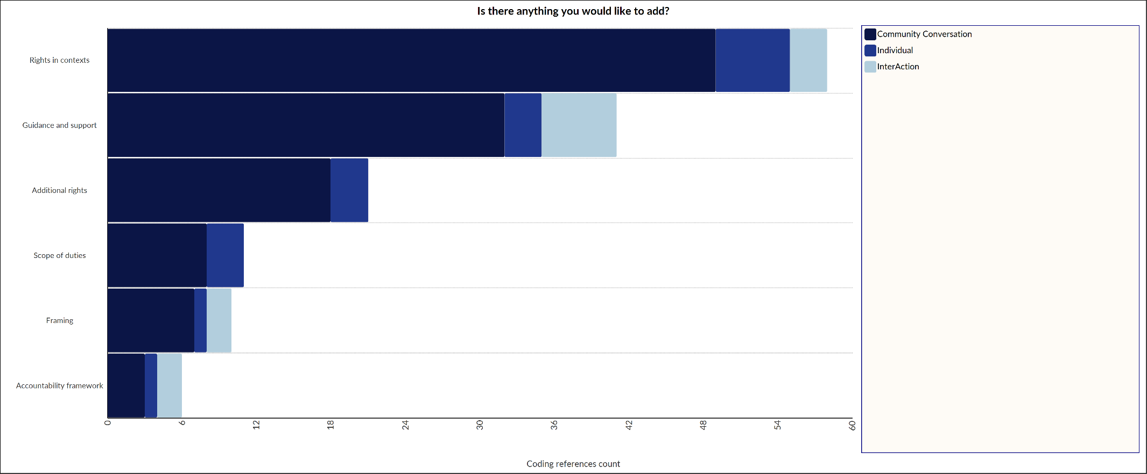
The most common theme of ‘rights in context’ related to feedback around a desire to understand how rights apply in different contexts and for different groups. These contexts included housing and criminal justice, while the different groups commonly included young people, women and the LGBTQIA+ community. Much of the feedback within this theme related to the desire to see specific examples and case studies for different population groups. The most significant piece of feedback within this theme related to the desire to see reference to alcohol and alcohol related harms included within the Charter to make it clearer who the charter relates to when it talks about substance use.
The theme of ‘guidance and support’ included feedback from participants who would like more information to help with using the Charter. Points of feedback within this theme included guidance on how to balance rights that may appear to be in conflict and where to find support when using the Charter.
A smaller amount of feedback was received concerning the inclusion of ‘additional rights’ within the Charter along with corresponding responsibilities for duty bearers. Related to this was the theme of ‘scope of duties’. This included feedback around the desire for clarity around who exactly the Charter impacts, along with including non-state actors within the definition of duty bearers.
In relation to the theme of ‘framing’ there was desire to see the Charter framed in a positive way with reference to other policies, standards and codes of practice, along with a brief and easy to understand overview of the Charter. Finally, with regards to the theme ‘accountability’, feedback focused on the desire to see an explanation of the relationship between the Charter and law both domestically and internationally, along with reference to how accountability will be monitored.

Supporting people to use the Charter
In response to the consultation question ‘What would support you to use the Charter in practice?’ feedback included the themes of implementation tools, assuring accessibility, stakeholder involvement, governance and oversight and awareness raising. This is demonstrated in the chart below.
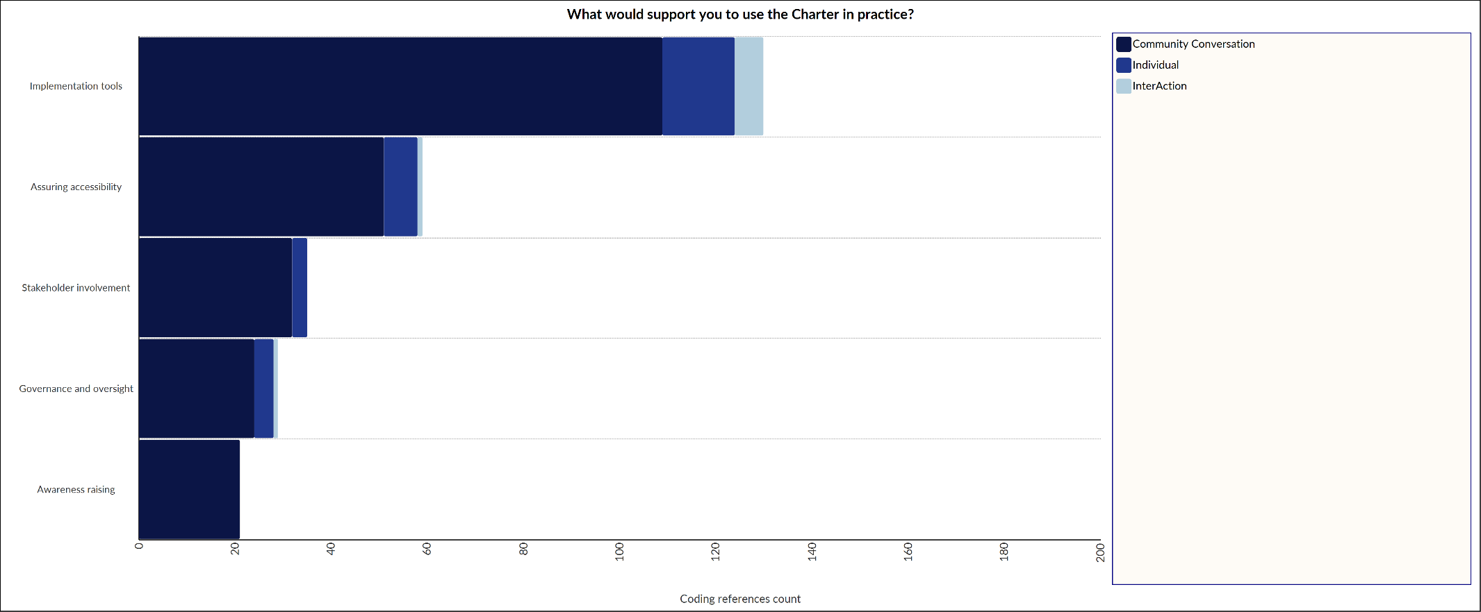
Toolkits to help implement and understand the charter were the most commonly referenced. This included training and education, additional resources, examples of good practice and guidance. Having access to an accessible Charter was the second most popular suggestion. Within this theme there was reference to the importance of being able to use various formats of the Charter including digital content, along with the importance of easy and understandable language.
Stakeholder involvement was the third most popular suggestion. This theme included comments that demonstrated that continuing to involve people with lived and living experience was important. Within this theme, participants also emphasised the importance of collaborative working within and across the sector as a supportive mechanism to using the Charter in practice.
Finally, participants highlighted awareness and understanding of the Charter itself to be important. For participants, having a good understanding of the charter in conjunction with strong governance frameworks and monitoring would allow for the Charter to become embedded in everyday practice much more effectively.

Charter Challenges and Solutions
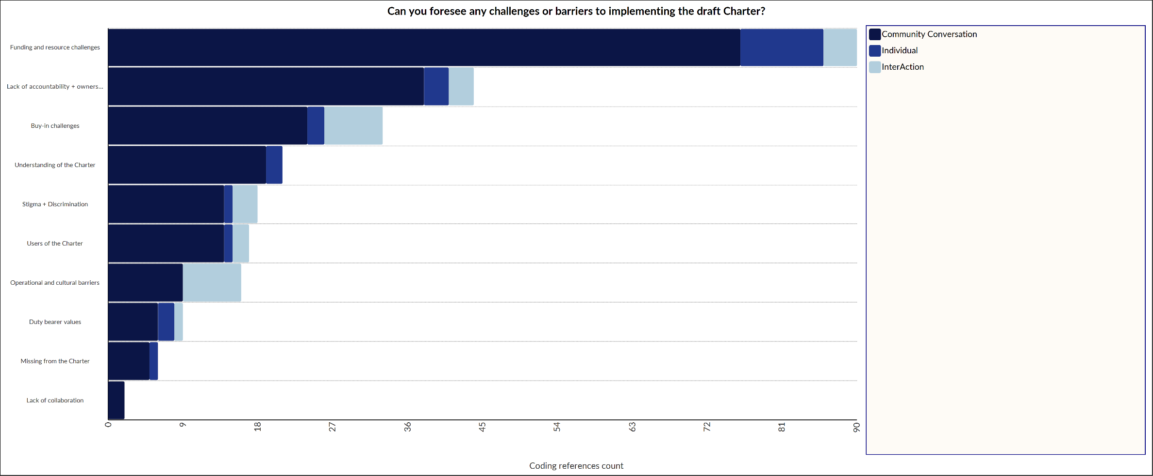
During the consultation and InterAction sessions we asked what the key challenges would be for implementing the draft Charter. These challenges are presented below.

In this consultation, the theme of funding and resource was reported to be a primary challenge to implementing the Charter. This included the topic of education and the concept of having the necessary skills to understand and work with the Charter. Within this theme, participants also felt that equity of resource would be a challenge, highlighting that resourcing and funding will be context dependent.
Following this, lack of accountability and ownership of the Charter was highlighted to be a challenge. Within this, concern was raised over the practicalities of determining Charter accountability and the potential for resulting inconsistency in applying the Charter.
Finally, the themes of lack of buy-in among staff and services, how well services and rights holders understand the Charter, the presence of stigma/discrimination and the operational challenges of using the Charter in services and by staff that have already high demands placed upon them, were highlighted to be central challenges to Charter implementation.
However, participants also provided possible solutions to some of the challenges shared above. These included:
- Training and education
- Implementation tools, guidance and frameworks
- Appropriate resourcing and staffing
- Relationship building
- Relatable communications/promotions about the Charter
- Regulation and security
- Political support
- Peer led initiatives
- Collaboration and cross sector working
- Leadership
- Human rights based commissioning
- Advocacy and awareness
- Culture changes

Areas of priority and concluding remarks
During the analysis of consultation feedback, several themes were determined to be outwith the scope of the Charter of Rights for People Affected by Substance Use, the Change Team and the National Collaborative more widely. As a result, the themes below are to be considered priority areas in the development of a national implementation plan of the Charter of Rights for People Affected by Substance Use.
- Training, education and resources;
- Cross sector buy-in, collaboration and leadership;
- The creation and application of an implementation and monitoring framework.
This paper has provided an overview of the consultation feedback from the Draft Charter of Rights for People Affected by Substance Use. To accompany this paper, we have produced a ‘You said, We did’ resource that is available by clicking this link. The National Collaborative and the Change Team would like to thank the 500+ people including rights holders and duty bearers across the sector, who took part in this consultation to inform the development of the Charter of Rights for People Affected by Substance use.
For further information on methods of analysis and findings, please contact the analysis lead and member of the ALLIANCE support team: sarah.dick@alliance-scotland.org.uk or people@alliance-scotland.org.uk

About the ALLIANCE
The Health and Social Care Alliance Scotland (the ALLIANCE) is the national third sector intermediary for a range of health and social care organisations. We have a growing membership of over 3,600 national and local third sector organisations, associates in the statutory and private sectors, disabled people, people living with long term conditions and unpaid carers. Many NHS Boards, Health and Social Care Partnerships, Medical Practices, Third Sector Interfaces, Libraries and Access Panels are also members.

The ALLIANCE is a strategic partner of the Scottish Government and has close working relationships, several of which are underpinned by Memorandum of Understanding, with many national NHS Boards, academic institutions and key organisations spanning health, social care, housing and digital technology.

Our vision is for a Scotland where people of all ages who are disabled or living with long term conditions, and unpaid carers, have a strong voice and enjoy their right to live well, as equal and active citizens, free from discrimination, with support and services that put them at the centre.

The ALLIANCE has three core aims. We seek to:
- Ensure people are at the centre, that their voices, expertise and rights drive policy and sit at the heart of design, delivery and improvement of support and services.
- Support transformational change, towards approaches that work with individual and community assets, helping people to stay well, supporting human rights, self management, co-production and independent living.
- Champion and support the third sector as a vital strategic and delivery partner and foster better cross-sector understanding and partnership.

(Richards, K. A. R., & Hemphill, M. A. (2018). A practical guide to collaborative qualitative data analysis. Journal of Teaching in Physical education, 37(2), 225-231.)
Sweeney, A., Greenwood, K. E., Williams, S., Wykes, T., & Rose, D. S. (2013). Hearing the voices of service user researchers in collaborative qualitative data analysis: the case for multiple coding. Health Expectations, 16(4), e89-e99

