

An Easy Read guide to…
Joined up planning for children, young people and young adults
Children and Young People version
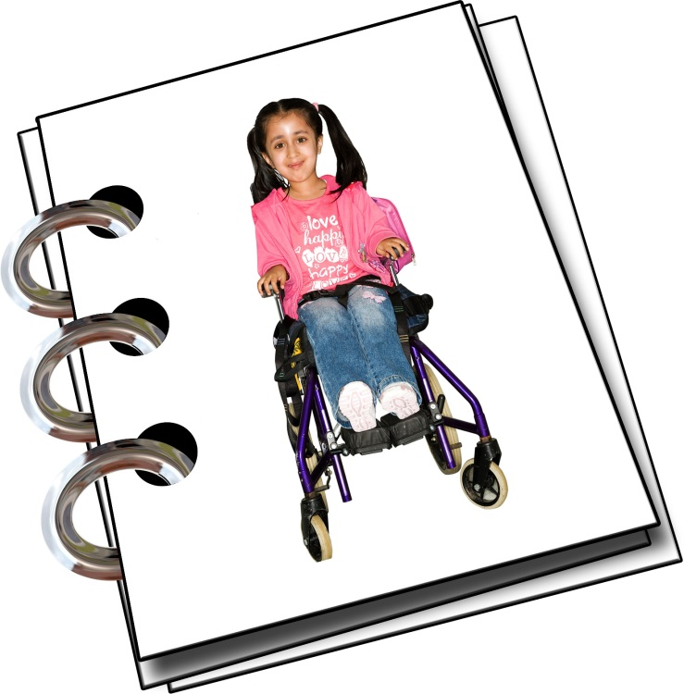

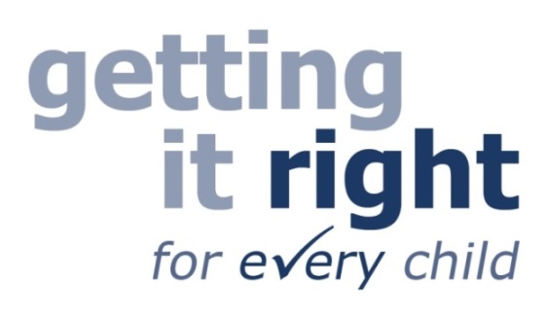
Joined up planning is part of Getting it right for every child
 | There is a way of working for people who work with children.  You might not have heard of this way of working before.
 | The way of working has been brought in to help children in Scotland have a good life.
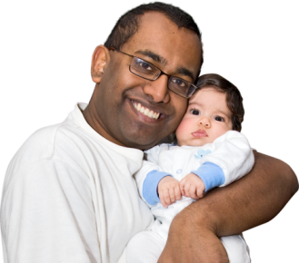 | It does not change how your parents should look after you.
 | But it does change how people who work with you and your parents can help.  People who work with you and your parents are people like…  - doctors  - nurses  - teachers  - social workers.
 | When these people talk to you about your wellbeing they will probably talk about this way of working.
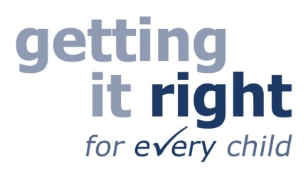 | This way of working is called Getting it right for every child.  Getting it right for every child is  sometimes shortened to GIRFEC.  It comes from the first letter of  each word in Getting It Right For  Every Child.
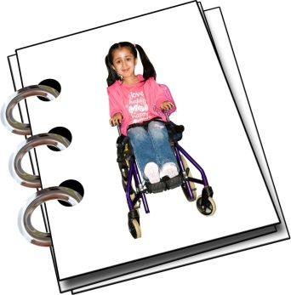 | One part of Getting it right for every child is called joined up planning.  This booklet is about joined up planning and what it means for you and your parents.
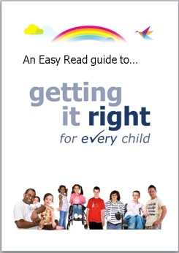 | There are also Easy Read booklets about other parts of  Getting it right for every child. These tell you about Wellbeing, Lead Professional and the contact or Named Person.

What is a joined up plan?
 | A joined up plan is a plan written about you, whether you are a child, young person or young adult.
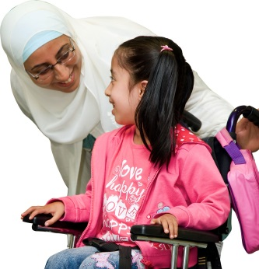 | The plan says what joined up support, from schools, health or perhaps social work you need to have a good life.

Why have a joined up plan?
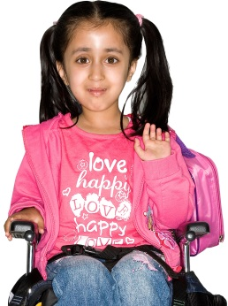 | You might need support from lots of different places. A joined up plan can help you to get the joined up support you need.
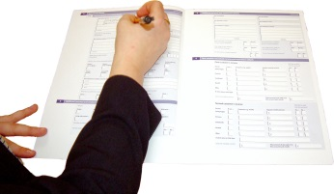 | All the joined up support needed is written down in the plan so everyone can be clear.
 | You, your parents and the people who work with your family will make the plan.
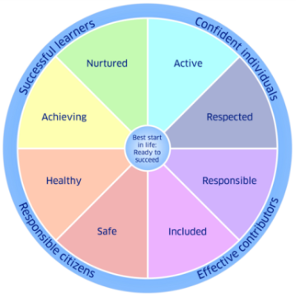 | The plan says what needs to be done to support your wellbeing.

Who gets a joined up plan?
Not every child, young person or young adult has a joined up plan.
You will only get this if you need lots of joined up support from different professionals or services. You will get this where the support will help best when it is joined up.

Joined up support could be things like…
- support from doctors and nurses
at hospital if you have
a health problem
- support from special teachers
if you need help at school or help to get to school
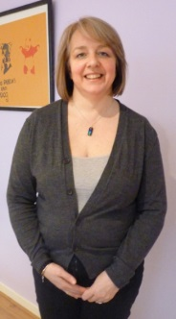 | - support from a social worker  for you and your family.

What is in a joined up plan?
A joined up plan says what support you need.
The plan says…
 | - who needs to support you and your family
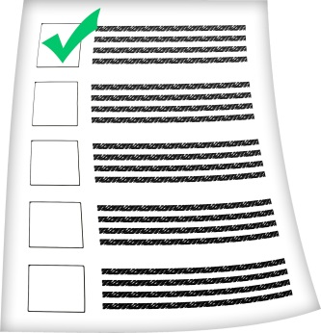 | - what they need to do  to support you and your family
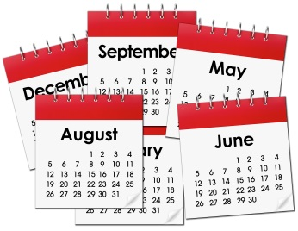 | - when they need to do it by.

How do you get a joined up plan?
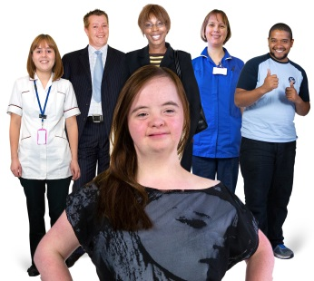 | You or your parents can ask for a joined up plan.
 | You or your parents can ask your contact person, sometimes called a named person, or another professional you know well to organise a meeting.  The contact person or another professional may also think a joined up plan would help.  You and your parents will be invited to the meeting.  Other people who work with your family will also be invited.
At the meeting everyone will talk about…

- what support is needed
- who needs to give the support
- what they need to do and by when.

It will get written down in the
joined up plan.

This is your plan. It should be made in partnership with professionals and be agreed by you and your family.

Usually, only the Courts or the Children’s Hearing can make you or your family accept a plan that you may not agree with.

Who organises the joined up plan?
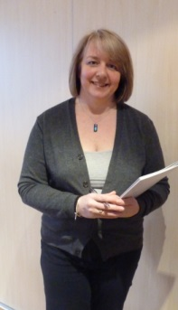 | Someone who works with you and your parents will organise the plan.
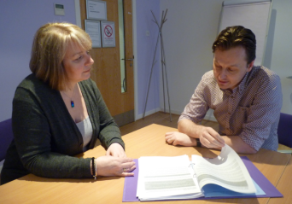 | It is important you and your parents are fully involved in making the plan.
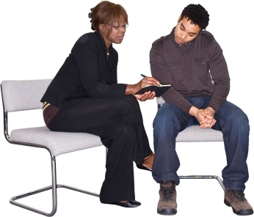 | People who work with you and your parents will have a say in what goes in the plan too.
 | Someone who works with you and your parents will write the plan down.
 | When they write the plan down  they should make sure it is  easy to understand. You and your parents should get a copy of the plan.

 | One person will help organise all of the support written in the plan.
 | This person is called the  lead professional.
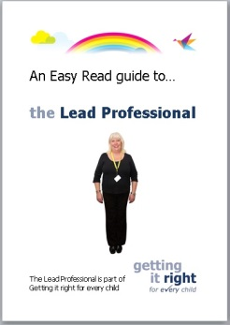 | There is an Easy Read booklet  with more information about the  lead professional.

When do you get a joined up plan?
 | A joined up plan can start when you need joined up support.
 | If you needed joined up support when you were born a plan could have started straight away.
 | But you might only need joined up support when you get older.  So a joined up plan can start when you need extra support.  That can include planning to help you as you grow up and become a young adult.

How long does a joined up plan last?
 | A joined up plan lasts as long as  it needs to.  It might only last for a few months.  Or it might last for many years.
The plan is checked now and again. You and your parents can ask for the plan to be changed.

All the people involved in the plan
will have a meeting to talk about it.

You and your parents will be a key part of this meeting.
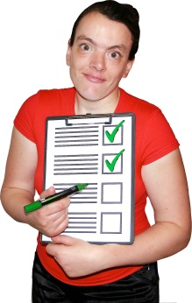 | You and your parents will talk about if the plan is working.
You and your parents will talk about if the plan needs to be changed to make it better.

You and your parents will talk about if the plan can finish or if it needs to carry on.

This guide was produced by the Health and Social Care Alliance Scotland (the ALLIANCE).
The ALLIANCE has been funded by the Scottish Government to run a project to help parents, carers and children understand Getting it right for every child. The project is called “Getting to Know GIRFEC: what Getting It Right For Every Child means for children and young people who are disabled or who live with long term conditions”.
This Easy Read guide forms part of the project and has been designed to be accessible to parents who have learning difficulties. The content of this guide is the responsibility of the ALLIANCE. It is not a full explanation of the law or GIRFEC Policy.
Registered in Scotland No307731 Charity Number SC037475
The ALLIANCE is supported by a grant from the Scottish Government
https://www.alliance-scotland.org.uk/blog/resources/children-and-young-people-easy-read-guides-same-as-the-adult-easy-read-guides-but-changed-to-the-childs-perspective/

