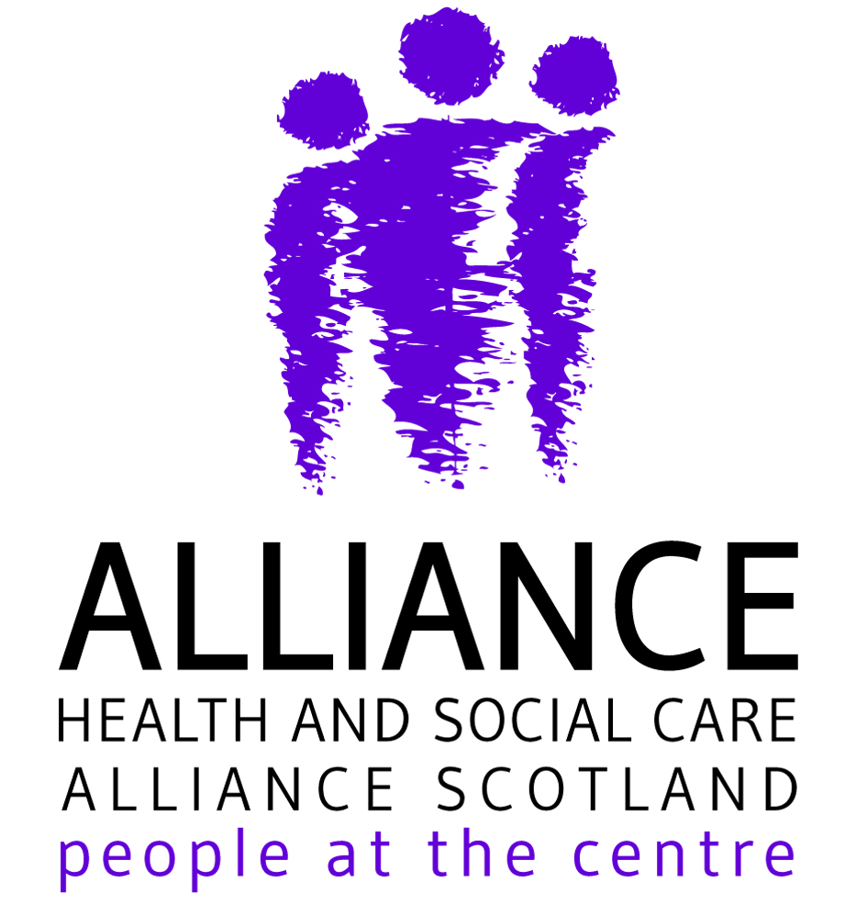
Health and Social Care Alliance Scotland
Cross-Sector Sensory Guidance during COVID-19
18th October 2020

Content

The Health and Social Care Alliance (The ALLIANCE) are working closely with partner organisations from across the Third Sector to produce guidance and information to support people living with sensory loss and their communication partners as lockdown restrictions vary across the country.

Measures to reduce spread of the infection present challenges which may affect groups of people in different ways, including people’s ability to communicate, gather information and move around their environment safely. It is important for the public to be aware of the challenges people with sensory impairment may face when measures are put in place including social distancing and the use of face coverings.

This guidance provides advice on how:

- the impact of these necessary measures can be safely observed for people living with sensory loss.
- to support people to access vital services such as shopping, travel and medical appointments safely.

Staying safe

To stay safe and protect others we must minimise the opportunity for Coronavirus (COVID-19) to spread from one person to another.

When we reduce our day-to-day contact with other people, we will reduce the spread of the infection.

Current regulations are still in place at the date of publication, including:

- stopping some types of gatherings.
- closing certain businesses, premises and venues.
- Working from home, where possible.

People, including those living with sensory loss, should wear face coverings whenever possible and adhere to the current designated guidance to protect others.

Every person in Scotland should comply with the measures that affect them.

Social distancing (outdoors)

For people with sight loss who have little or no vision of their surroundings, social distancing is extremely challenging or can be impossible. To help people with sensory loss manage social distancing:

  - Make sure you maintain two metres distance.
  - If it appears the person with sight loss needs assistance, offer to help by calmly asking if the person would like any support.
  - Remember to ask the individual if they would like you to stand in a specific place when communicating. Some people may have a preference and find it easier to understand you this way.
  - Provide help through describing the scene and clear verbal advice.
  - Be aware of the impact of traffic noise and other sensory barriers such as lighting levels and check back that the person has understood.
  - In extreme situations, such as when an individual’s safety may be at risk or if someone is requiring guided support during a fire evacuation, for example, PPE including gloves, face covering and gown should be worn where possible, and if appropriate. If not possible, hand sanitising measures and hand washing are encouraged.

Coronavirus (COVID-19): guidance for those providing guide support

Face Coverings

Clear advice from Scottish Government makes the use of face coverings mandatory in public spaces such as supermarkets and on public transport. This is of vital importance; however, face coverings can muffle sound and block access to both lip-reading and facial expression, both of which assist communication for people living with sensory loss.
In certain specific situations, people can remove face coverings if:
- They have an underlying medical condition.
- They need to remove the face covering for communication purposes. This may involve a public transport worker giving details of a delayed train for example, or a supermarket employee describing the new layout of a shop.
- People with sensory loss may require the person they are communicating with to remove their face covering if they:
- Communicate through Lip Reading.
- Use British Sign Language.
- Require seeing someone’s face to communicate.
If you need to remove your face covering for the above reasons, remember to maintain a two-metre distance where possible. If possible, ensure you are in an outdoor space. If required, it may be necessary to stand side-by-side, which can reduce risk.

https://www.gov.scot/publications/coronavirus-covid-19-phase-3-staying-safe-and-protecting-others/pages/face-coverings/

In certain cases, people who use hearing aids which will not work over a two-metre distance may require a one-metre temporary distance.

Coronavirus (COVID-19): guidance for those providing guide support

Social Distancing (Indoors) - ensuring premises remain accessible

Many premises such as supermarkets, shops, public transportation and public buildings may have displayed additional information which demonstrates how to keep safe and maintain social distancing. This could include posters, written information, floor stickers and other signage. Some premises may also be offering information to the public through loudspeaker systems. This information can be challenging for people with sensory loss to follow.
It is important that staff within these premises are aware of the challenges, the legal position and the best way to support people to keep safe without creating further barriers. Staff should be encouraged to:

      - Introduce themselves to people with sensory loss, if needed, and offer to help.
      - Where possible, display easy read versions of the information in prominent and accessible locations. This may be helpful for many people and include information such as a visual map of the new layout of the shop, or information on new opening times.
      - Reduce background noise, including piped music.
      - Ask the person what help they might want and advise of any changes which have been made to the premises or venue.
      - Provide advice or guidance with clear verbal indications, and check that the person has understood and is feeling confident to proceed.
      - Be patient and recognise a person with a sensory loss may well need longer to carry out what they wish to do in an environment which has been changed.
      - If you have limitations on numbers of people who can be in your premises to facilitate social distancing, you may need to allow flexibility for people with sight loss to be accompanied by a sighted guide.
      - Recognise that sensory loss can be an invisible disability and it may not be obvious when someone has a sensory loss.
      - Ensure that you have a Loop System that is working, and that people are aware of this.
      - Many people may use electronic devices such as phones and I-pads to aid communication and to orientate. Where possible, premises should ensure they have working WiFi which is not password protected to enable this.

Workplaces

Workers with sensory loss may face a range of challenges from travelling to work, social distancing and identifying safety signs and floor markings and maintaining a two-metre distance from others.

It is vital that employers:

- Make all staff aware of the challenges facing employees with sensory loss as measures remain in place at workplaces to restrict risk of infection.
- In-workplace opportunities should be given to employees with sensory loss, aiding the individual to get used to any new routes they may need to use within premises.
- Hand sanitiser, anti-viral wipes and latex gloves should be available for staff to minimise infection from tactile markers, and cleaning regimes should be adhered to.
- Recognise the challenges for people with sensory loss in using public transport through offering flexible shift patterns or alternative transport options for getting to work
- Offer home working where possible. For those working from home, employers should provide the right support and computer software if required. Access to Work funds are available to provide this support.
- Ensure that you have a Loop System that is working, and that people are aware of this.

Public transport

Transport providers should ensure:

- People with sensory loss are given priority in certain circumstances, for example, having a fast track queue, priority parking or asking some passengers to wait for the next bus or train if space is limited.
- The issue and replacement of concessionary travel permits has been affected by coronavirus; different arrangements for new and replacement cards are now in place in local authorities and operators should be considerate of the fact that people who can claim entitlement to travel free may not yet have received their card. NEC cards are now being issued and operators should allow passengers who do not have an NEC card but claim entitlement to travel free without one.
- Advice and support are given to people with sensory loss to assist them to negotiate any unfamiliar layouts or changes to facilitate physical distancing. This would include assistance to support someone to a seat which facilitates appropriate social distance from other passengers, for example.
- When personal assistance is being provided (for example with ramps or guiding people with sight loss), listen to your passengers about any help they need - they are the expert in their own personal needs. Some passengers may have a ‘Thistle Card’ or similar which describes any help they need.

Safe public spaces (Outdoors)

In many urban areas new cycle lines are being introduced as access to public transport is limited. These can create challenges for accessibility for people with sensory loss. If there are no tactile markers to demark cycle lines, people with sensory loss cannot tell where they are and will often not be able to see or hear cyclists approaching.

It is important that cyclists and pedestrians recognise the challenges for people with sensory loss in terms of social distancing, and that hearing loss and visual impairment can be an invisible disability. Mobility aids such as red and white canes for people who are deafblind, or white canes for people living with sight loss can get caught up bicycle wheels, which is a further hazard to both cyclist and pedestrians.

If local authorities are introducing new arrangements for cyclists and pedestrians it is important that:

- Shared spaces between cyclists and pedestrians are avoided. Blind and partially sighted pedestrians find it extremely difficult to detect cycles, while cyclists may not realise that a pedestrian has sight loss. People with Hearing Loss or who are Deaf or Deafened may have difficulty in hearing a bicycle bell, or an approaching cyclist.
- While retaining dropped kerbs at crossings for wheelchair users, kerbs should be kept in other areas, allowing people with sensory loss to safely find and navigate from the pavement edge.
- Existing controlled crossings should be maintained.
- Warning markings and signs must also be provided to instruct cyclists to stop when pedestrians are near or on the formal crossing.
- Many existing bus stops are inaccessible to people with sensory loss if these must be reached across cycle lanes - new bus stop arrangements introduced under the scheme must be accessible to people with sensory loss.

Touch

- Some people with sensory loss will require direct touch in order to communicate. This may involve tactile BSL, deafblind manual or other tactile forms of communication. It is important that people are aware that in specific circumstances people may need to be working with professional guide-communicators or other support staff to enable communication and orientation within the environment.
- Many people with sight loss or deafblindness will require touch to orientate and move safely around the environment. This may require the individual to touch doors, handles, backs of seats, supermarket items, public Braille on doorways and more. Whether at work, while using public transport or within the wider public domain, the use of gloves, hand sanitisers, hand washing and frequent cleaning of surfaces is paramount.

The Environment

The environment can be critical to successful communication. It is important to consider keeping the environment quiet and turning off music, televisions and other sources of noise. Visual distractions should also be lessened and, if possible, people can consider moving to a quiet, neutral environment with good lighting in order to communicate effectively.

Communication may take a little longer with someone with sensory loss, and space and time should be allowed for this.

In order to get the attention of someone who may have sensory loss:

- Try speaking in a calm clear voice and introduce yourself.
- Do not shout or slow your pace of speech.
- It may be possible to wave your hand to attract someone’s attention.
- Do not tap the individual on the shoulder or break the two-metre rule unless required. This may be in the case of someone who is deafblind for example.
- Do not approach or pet a guide dog when it has a harness or jacket on or is working.

Technology

A range of technology may be useful in helping people to communicate, gather information and move safely around the environment. It may be possible to use an online video interpreting service (BSL/English, Other Sign Language/English) via smart technology such as Contact Scotland-BSL.

Contact Scotland-BSL is Scotland’s national BSL Interpreting Video Relay Service
https://contactscotland-bsl.org

Apps such as Neatebox can help provide an excellent interface between venues and customer, ensuring accessibility and awareness: https://www.neatebox.com

Scottish Government Coronavirus (COVID-19) Guidance

https://www.gov.scot/collections/coronavirus-covid-19-guidance/

https://www.gov.scot/publications/coronavirus-covid-19-phase-3-staying-safe-and-protecting-others/pages/face-coverings/

https://www.gov.scot/publications/coronavirus-covid-19-phase-3-staying-safe-and-protecting-others/pages/shopping-eating-and-drinking-out/

https://www.gov.scot/publications/coronavirus-covid-19-guidance-for-those-providing-guide-support/

Additional links -
https://www.gov.scot/publications/covid-shielding/
https://www.gov.scot/publications/coronavirus-covid-19-test-and-protect/

Further Guidance and Advice

Below you will find links to further information, support and suggestions from a range of expert organisations. This advice is current at the time of publication, and will be updated regularly. The ALLIANCE is not responsible for the content of the below websites:

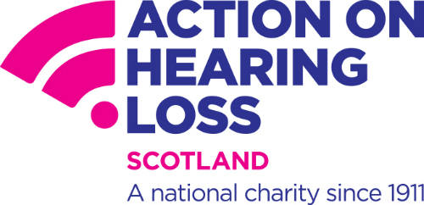

Action on Hearing Loss

https://actiononhearingloss.org.uk/coronavirus-response/



Deafscotland

https://deafscotland.org

https://deafscotland.org/covid-19-the-communication-virus/

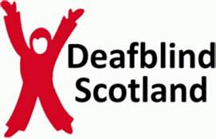

Deafblind Scotland

https://dbscotland.org.uk/covid-19-information-and-support/



Disability Equality Scotland

https://disabilityequality.scot/news/face-covering/

https://disabilityequality.scot


Guide Dogs Scotland

https://www.guidedogs.org.uk/news/social-distancing-and-sight-loss?utm_source=facebook&utm_medium=organicsocial&utm_campaign=BeThere

https://www.guidedogs.org.uk/covid19/support-for-people-with-sight-loss

Sight Scotland

www.sightscotland.org

https://sightscotland.org.uk/covid-19-response


RNIB Scotland

https://www.rnib.org.uk/scotland/rnib-scotland-useful-links-and-contacts

https://www.sightadvicefaq.org.uk/coronavirus-information/



Sense Scotland

https://www.sensescotland.org.uk

https://www.sensescotland.org.uk/resources/publications/coronavirus-information/



Visibility Scotland

https://visibilityscotland.org.uk



Visionary

https://visionary.org.uk

https://www.metroblindsport.org/wp-content/uploads/2020/07/RNIB_Helping-you-help-others.pdf

About the ALLIANCE

The Health and Social Care Alliance Scotland (the ALLIANCE) is the national third sector intermediary for a range of health and social care organisations. We have a growing membership of nearly 3,000 national and local third sector organisations, associates in the statutory and private sectors, disabled people, people living with long term conditions and unpaid carers. Many NHS Boards, Health and Social Care Partnerships, Medical Practices, Third Sector Interfaces, Libraries and Access Panels are also members.

Our vision is for a Scotland where people who are disabled or living with long term conditions and unpaid carers have a strong voice and enjoy their right to live well.

Contact

If you would like to discuss any of the topics raised within this briefing or to request any further information, please contact:

Name Jonathan Reid
Email jonathan.reid@alliance-scotland.org.uk

0141 404 0231
www.alliance-scotland.org.uk
@ALLIANCEScot

