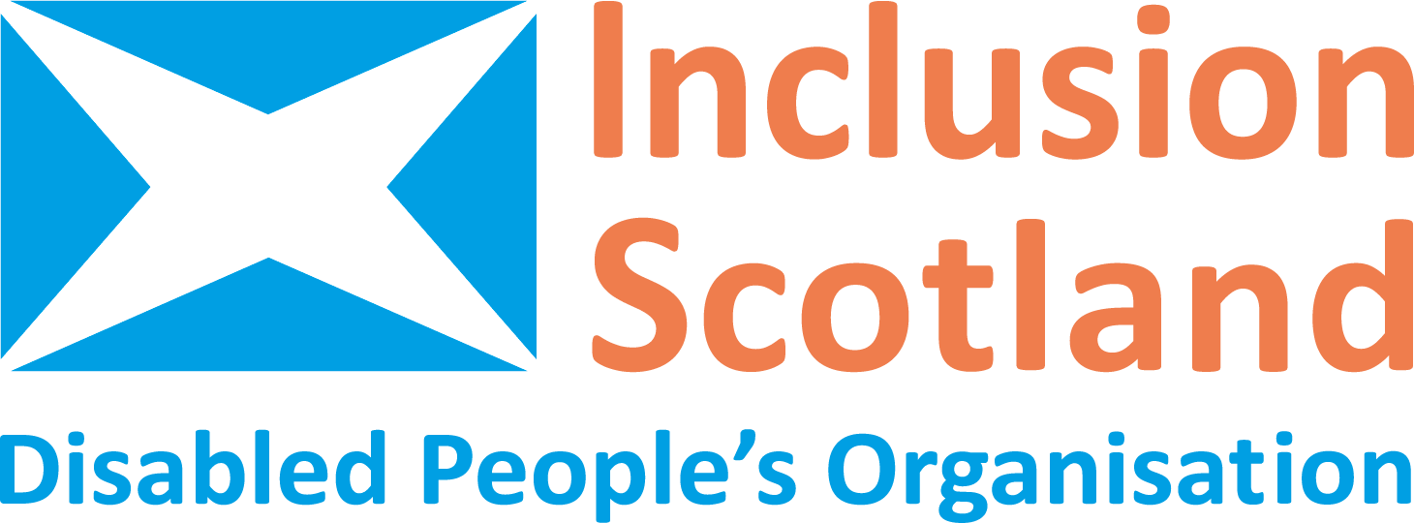 | 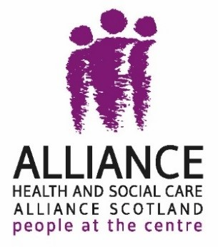

Inclusion Scotland and the Health and Social Care Alliance Scotland (the ALLIANCE)

Incorporating the United Nations Convention on the Rights of Disabled People (CRPD) in Scotland

Executive Summary (November 2020)

Author: Dr Kasey McCall-Smith*

Table of Contents

1. Introduction 3
2. National Context 4
3. Convention on the Rights of Persons with Disabilities 5
4. Different models of incorporation 6
5. Incorporating the CRPD into Scots Law 6
5.1 Direct incorporation 7
5.2 Indirect incorporation 8
5.3 Additional ways to entrench the CRPD 9
6. Summary 9

Introduction
Inclusion Scotland and the Health and Social Care Alliance Scotland (the ALLIANCE) have expressed their support for incorporation of the Convention on the Rights of Persons with Disabilities (CRPD) and other international human rights treaties into Scots law as a means to ensure that people’s rights are respected, protected and fulfilled. To inform their positions on incorporation, they jointly commissioned this report, which identifies and compares the benefits of different models of incorporation with specific reference to the CRPD.

The aim of this report is to provide information and opinion relevant to the opportunities to further entrench the CRPD in Scotland through incorporation and other methods of implementation. The report addresses the following considerations:
- Whether or not incorporation of the CRPD would be positive for the realisation and progression of disabled people’s rights in Scotland.
- Which model(s) of incorporation of the CRPD would be most beneficial for securing positive outcomes for disabled people in their everyday lives.
- What other legal mechanisms or duties could be created to ensure better realisation and / or justiciability of disabled people’s rights.

The report is intended to inform and increase the capacity of disabled people, Inclusion Scotland and the ALLIANCE in their efforts to inform and influence law and policy makers, including the Scottish Government, Scottish Parliament and the First Minister’s Task Force on Human Rights so that they recognise the benefits of and best models for incorporation of the CRPD and the realisation of disabled people’s rights.

National context
In response to Brexit, successive UK Governments’ public aversion to human rights and the current UK Government’s failures to secure minimal human rights protections for individuals during the ongoing COVID-19 pandemic, Scotland has taken the position to secure stronger legal human rights protection through incorporating a range of international human rights into Scots Law.
The First Minister’s Advisory Group on Human Rights Leadership (FMAG) published its ‘Recommendations for a new human rights framework to improve people’s lives’ (FMAG Recommendations) in December 2018. In 2019, the National Taskforce for Human Rights Leadership (HR Taskforce) was established to take forward the FMAG Recommendations and develop a statutory framework for incorporating international human rights into Scots law. Acknowledging that the Scottish Government’s Programme for Government 2020–21 pledges to actively consider incorporating the CRPD, this report aims to highlight why and how CRPD incorporation should be prioritised.
While Scotland does have a range of laws, policies and national strategies specific to the promotion of disabled people’s rights, such as the Social Care (Self-directed Support) Act 2013 and A Fairer Scotland For Disabled People 2016–2021 Delivery Plan, implementation is patchy at best and has failed to enable disabled people to exercise some of their most fundamental human rights and fully participate in their communities. The international framework offered by the CRPD reinforces a holistic understanding of how disabled people must be enabled to activate all of their existing rights under the social model for disability.

Convention on the Rights of Persons with Disabilities
The UK ratified the CRPD in 2009 and through the Scotland Act 1998 the Scottish Government and Parliament are able to implement law and policy to give effect to CRPD rights. The UK’s dualist legal system does not permit the direct invocation of international treaties unless they have been expressly incorporated into the national legal system. There are a number of ways in which states and sub-state/devolved political entities, in this instance Scotland, can bring the CRPD to life, including:
- Fully recognise the rights of disabled people in existing law through the following:
  - Include and ensure a general guarantee of equality;
  - Non-discrimination laws that expressly prohibit discrimination on the basis of disability;
  - Revise existing constitutions or laws to include protections for disabled people;
  - Include explicit provisions to ensure proactive protection of rights for disabled people;
  - Revise language of all law and policy to refer to disabled people;
  - Ensure all relevant legislation explicitly references the CRPD.
- Adopt new legislation directly incorporating the CRPD and ensuring its enforceability before the courts;
- Adopt secondary legislation to implement incorporation of the CRPD as necessary;
- Ensure that an effective mechanism for consulting disabled people and/or representative organisations is created and utilised at the law-making level.
These steps will only make a difference in the lived experiences of disabled people if all parts of the government, including local authorities, health boards, public service providers and all other publicly funded bodies, are accountable and actively involved in the implementation of disabled people’s rights in Scotland. The focus of this report is to highlight how different models of incorporation can entrench CRPD rights and to identify further mechanisms that could and should support the legalisation of CRPD rights.

Different models of incorporation
To ensure a common basis for the following incorporation discussion it is necessary to define the term. Incorporation is a legal starting point for human rights treaty implementation leading to comprehensive protection of internationally recognised human rights. Incorporation is the process that makes an international treaty, such as the CRPD, part of national law and is a crucial first step toward changing the way that society looks at different human rights. Implementation is a holistic term used to identify the diverse range of legislative, administrative, policy and other measures that make international human rights real in practice and not simply words in a document. There are three primary models of incorporation: direct, indirect and sectoral or piecemeal.
In light of the existing gaps and opportunities that currently exist in Scots law and policy, it is timely to explore how the variable options for incorporation could help strengthen CRPD rights both now and into the future.

Incorporating the CRPD into Scots Law
There is no doubt that Scotland could incorporate the CRPD into Scots law. The question is how?

5.1 Direct incorporation
Incorporation of the CRPD through a new Act of the Scottish Parliament (ASP) should capitalise on the well-understood tri-partite formula – respect, protect and fulfil – employed by the HRA 1998 in legalising ECHR rights. This includes:
- Respect – A negative obligation on public authorities to not act incompatibly with the CRPD (which triggers a right of action to determine whether they have acted incompatibly);
- Protect – A proactive/positive obligation on public authorities and courts to take account of and abide by the Convention in all decision-making and to ensure access to all CRPD rights;
- Fulfil – Ensure justiciability of CRPD rights in Scots law by ensuring that courts have the power to determine the compatibility of actions, or inaction, with the CRPD and to deliver effective remedies.
Fulfilling CRPD rights would drive change in the daily, lived experiences of disabled people by holding all arms of the government accountable if they fail to respect and protect these rights.
Further elements that could strengthen direct incorporation:
- A stronger interpretive feature would require public authorities, Scottish Ministers and courts to take account of the interpretive materials (jurisprudence) produced by the CRPD Committee in order to define the basic level of protection or minimum core required to deliver different CRPD rights. This means expressly outlining that interpretive materials over and above the text and preamble of the treaty may be relied upon in determining breaches of CRPD rights. This also means including disabled people in the interpretation processes in a way that supports their right to active and informed participation in public life and decision-making;;
- The strongest justiciability option would include a strike-down power for an incompatible Act of Scottish Parliament pre-dating the new CRPD Incorporation Act. This is the approach taken in the proposed UNCRC (Incorporation) Scotland Bill (s20);
- A duty to comply is essential. The duty of due regard alone has proven untenable in the pursuit of progressing and activating people’s rights.

5.2 Indirect incorporation
Until direct CRPD incorporation can be achieved, there are a number of indirect incorporation options that could ensure that CRPD standards guide the implementation of any new human rights incorporation legislation when disabled people’s rights are considered, assessed or adjudicated.
- Amend current laws to ensure compliance with the CRPD.
- Placing a due regard duty to consider the CRPD on Scottish Ministers.
- CRPD Impact Assessments. Any form of pre-legislative review should be supported by human rights impact assessment directly linked to the CRPD.
- Identifying a parliamentary mechanism for reviewing the potential implications for CRPD rights in line with the minimum core of each right outlined at the international level, e.g. the Equality and Human Rights Committee.
- Post-enactment reviews. Human rights impact assessments do not stop simply because a new piece of legislation is enacted. To fully realise CRPD rights, consistent periodic review procedures should be written into new legislation.
- Identifying the range of interpretive tools to be utilised when examining rights of disabled people under any new legislation should include a specific reference to the CRPD as well as the interpretations delivered by the CRPD Committee.

5.3 Additional ways to entrench the CRPD
In addition to the different opportunities for incorporation, there are a number of options that could further support the development of CRPD rights in Scotland: increased CRPD training resulting in development through the common law (judicialisation); human rights budgeting; national action plans and strategies; and the use of international mechanisms.

Summary
At present, opportunities for enforcing disabled people’s rights in Scotland are extremely limited and tethered to violations under either the HRA 1998, the Equality Act 2010 or other relevant common law or legislation, such as the SDS Act. Even where avenues to enforcement exist, the long-standing barriers to accessing justice – understanding about how to navigate the system, knowledge of the law, financial costs – prevent most disabled people from pursuing enforcement of their rights. Incorporation presents the opportunity to cure the existing limitations in Scots law.
Current progress in developing other ASPs that incorporate international human rights clarify the following:
- Direct incorporation of the CRPD is possible to the maximum extent permissible under the current devolution settlement;
- A range of indirect incorporation measures are available to support stronger CRPD rights recognition until direct incorporation can be achieved, including a duty to take account of the CRPD during law and policy development;
- Even without incorporation, further CRPD training and judicialisation of the CRPD, political pressure to clarify human rights budgeting priorities, strengthening national action plans and strategies to ensure clear objectives and measurable outcomes, and engaging with international mechanisms as a means of remedial monitoring all have a role in raising the visibility of the CRPD and smoothing the path for future incorporation.
To activate disabled people’s rights the Scottish government must not only amend laws and move to incorporate the CRPD, it must underpin all legal efforts with effective engagement with disabled people and also work to raise the visibility of CRPD rights and the barriers that disabled people face in their communities.

About Inclusion Scotland

Inclusion Scotland’s mission is to achieve positive changes to policy and practice, so that we disabled people are fully included throughout all Scottish society as equal citizens. We do this by influencing decision-makers, supporting disabled people to be decision-makers, and developing capacity, awareness and engagement. Inclusion Scotland is run by disabled people. This is important because disabled people know best about the barriers that prevent our full inclusion into Scottish society. We experience them every day. But we cannot remove them by ourselves. We need allies and supporters. We need those in power to hear disabled people’s voices and work with us to remove these barriers.

Phone: 0131 370 6700
Email: info@InclusionScotland.org
Twitter: @InclusionScot
Website: www.inclusionscotland.org
Address: 22–24 Earl Grey St, West End, Edinburgh EH3 9BN

Inclusion Scotland is a company registered by guarantee. Registered in Scotland No. 243492. Charity Number SC031619.

About the Health and Social Care Alliance Scotland (the ALLIANCE)

The Health and Social Care Alliance Scotland (the ALLIANCE) is the national third sector intermediary for a range of health and social care organisations. The ALLIANCE has around 3,000 members including large, national support providers, small, local volunteer-led groups, and people who are disabled, living with long term conditions or providing unpaid care. Our vision is for a Scotland where people of all ages who are disabled or living with long-term conditions, and unpaid carers, have a strong voice and enjoy their right to live well, as equal and active citizens, free from discrimination, with support and services that put them at the centre.

Phone: 0141 404 0231
Email: info@alliance-scotland.org.uk
Twitter: @ALLIANCEScot
Website: www.alliance-scotland.org.uk
Address: Venlaw Building, 349 Bath Street, Glasgow, G2 4AA

The ALLIANCE is a company registered by guarantee. Registered in Scotland No. 307731 Charity Number SC037475

For further information or to request this report in a different format please contact –

Heather Fisken
Head of Policy and Research Team
Inclusion Scotland

Email: heather@inclusionscotland.org

Lucy Mulvagh
Director of Policy and Communications
Health and Social Care Alliance Scotland (the ALLIANCE)

Email: lucy.mulvagh@alliance-scotland.org.uk

* Senior Lecturer in Public International Law, University of Edinburgh Law School, kasey.mccall-smith@ed.ac.uk.
https://www.ohchr.org/en/hrbodies/crpd/pages/conventionrightspersonswithdisabilities.aspx
https://humanrightsleadership.scot/wp-content/uploads/2018/12/First-Ministers-Advisory-Group-on-Human-Rights-Leadership-Final-report-for-publication.pdf.
https://www.gov.scot/groups/national-taskforce-for-human-rights-leadership/.
Scottish Government, Protecting Scotland, Renewing Scotland: The Government's Programme for Scotland 2020–2021, p 107 at https://www.gov.scot/publications/protecting-scotland-renewing-scotland-governments-programme-scotland-2020-2021/. Note, the Programme for Government does not use the official name of the UN Convention.
https://www.gov.scot/policies/disabled-people/#:~:text=Legislation%20to%20protect%20the%20rights,support%20more%20choice%20and%20control.
UN Handbook for Parliamentarians on the CRPD, ch 5 at https://www.un.org/development/desa/disabilities/resources/handbook-for-parliamentarians-on-the-convention-on-the-rights-of-persons-with-disabilities/chapter-five-national-legislation-and-the-convention.html.
See Incorporating Human Rights in Scotland, Glossary at https://www.law.ed.ac.uk/research/research-projects/incorporating-human-rights-in-scotland.
N Busby and M Robison, CEDAW: How can women’s rights be better realized in Scotland?, para 8.1 at https://www.engender.org.uk/content/publications/CEDAW-incorporation-paper.pdf.
CRPD Committee, General Comment No. 7, UN Doc CRPD/C/GC/7, 9 November 2018.

