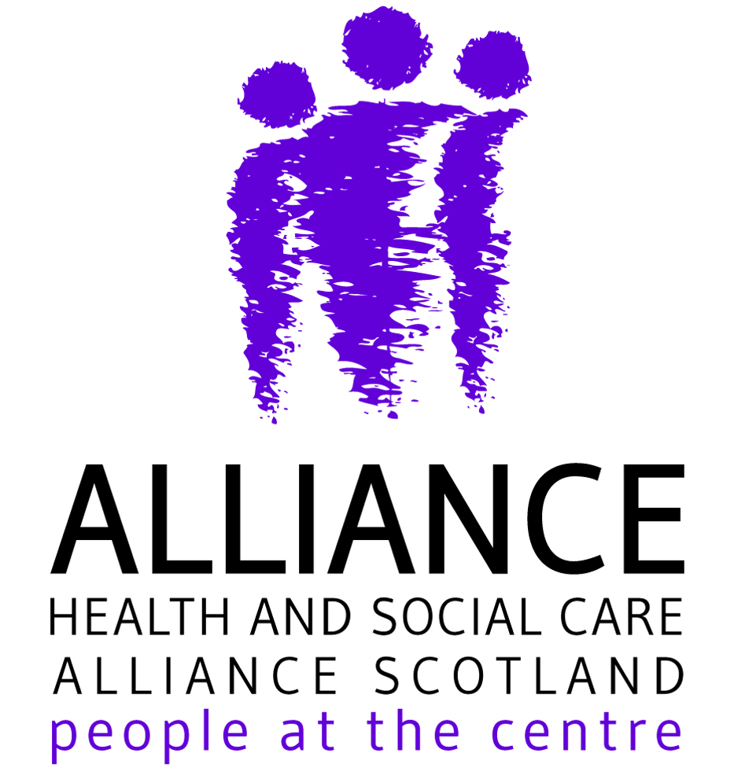
Health and Social Care Alliance Scotland (the ALLIANCE)
Call for member input – Consultation on draft Adult Disability Payment regulations

We would be grateful to get ALLIANCE members’ views on the key points we are considering making in our response, as well as whether there are any additional comments we should make on a number of other areas of the consultation. Below is a summary of the main points we are planning to make, together with areas where we would particularly welcome your comments and input. The full consultation document can be found here.

If you have any comments on the points below, or any particular views you would like the ALLIANCE to mention in our response, could you send them to Rob Gowans at rob.gowans@alliance-scotland.org.uk or Lucy Mulvagh at lucy.mulvagh@alliance-scotland.org.uk by Tuesday 9 March?

Key points

- Welcome the Scottish Government’s commitment to a full review of ADP in 2023, which we have called for as part of the Scottish Campaign on Rights to Social Security (SCoRSS). However, the review should include all of the identified principles that SCoRSS identified in the ‘Beyond a Safe and Secure Transition’ report.

- Disappointed the regulations propose to retain the ’20 metre rule’ for eligibility for the mobility component. This should be increased to at least 50 metres. (question 8)

- Disappointed the regulations propose to retain the current ‘50% rule’ for how many days a person’s condition affects them for to qualify. This should be modified. (question 8)

- Disappointed the regulations propose to retain the current ‘past presence’ test for residency. This should be removed. (question 12)

- Move to ‘light touch’ reviews, in place of the current full reassessment, with a 5 – 10 year period before review is welcome. There should be indefinite awards in cases where a person’s condition is unlikely to change or worsen. (question 24)

- Recommend an alternative to the current points system for deciding awards is developed in future. (question 8)

- Recommend a full gendered analysis is carried out on the descriptors and scoring for determining eligibility (question 8)

- Support changes to age range, but recommend this is considered further as part of future review (question 14)

- Level of payment should be adequate to ensure disabled people’s rights can be realised (question 20)

- Welcome removal of unnecessary face-to-face assessments, but replacement should be person-centred and make use of existing supporting evidence and information. (question 35)

- Emphasise the importance of independent advocacy in enabling people to claim their social security entitlements (question 35)

Further issues where we would welcome input from members

- Is there anything missing from the interpretations and definitions? (Question 2)

- Is there anything we should say about the ‘reliability criteria’ for mobility? (Question 8)

- Do you think the proposed qualifications and experience necessary for someone to carry out an assessment for ADP are appropriate? (question 22)

- Are there particular things that have not been included in the Equality Impact Assessments? (question 34)

Contact

Rob Gowans, Policy and Public Affairs Manager
rob.gowans@alliance-scotland.org.uk

Lucy Mulvagh, Director of Policy and Communications
lucy.mulvagh@alliance-scotland.org.uk

0141 404 0231
www.alliance-scotland.org.uk
@ALLIANCE Scot

