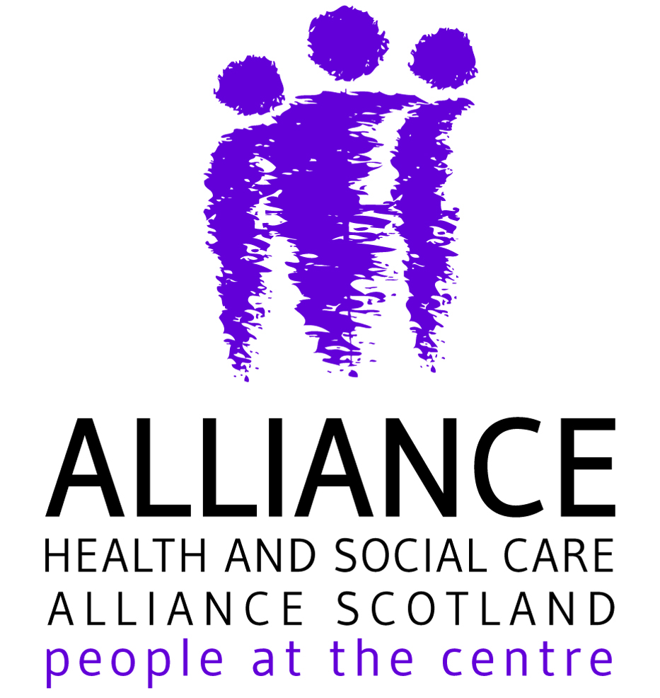
Health and Social Care Alliance Scotland (the ALLIANCE)
Equally Valued - 2021 Scottish Parliament Election Manifesto
Questionnaire for Parties
March 2021

Introduction

Last month, the Health and Social Care Alliance Scotland (the ALLIANCE) published ‘Equally Valued’, our manifesto for the Scottish Parliament elections, which can be read in full here. It contains a number of asks for all parties, based on engagement with our members.

To help us share with our members what each party’s views are of the issues that matter most to them, would you be able to arrange for a representative of your party to complete and return this questionnaire by Friday 23 April?

The questionnaire asks whether your party agrees in full, agrees in part, disagrees, or has no position, on each of the 21 asks in the ALLIANCE manifesto. There is also space for comments, if you would like to set out your position on any of the issues in more detail.

We plan to publish completed questionnaires from each party on our website – www.alliance-scotland.org.uk – and social media as they are received, for the purpose of giving our members and the wider public more information about the parties’ position on these issues. Would you also be able to send us a copy of your party’s logo for this purpose?

Thank you in advance for your party’s response. If you have any queries about the questionnaire or would like further information, please contact Rob Gowans on rob.gowans@alliance-scotland.org.uk.

Questionnaire

Name of party: Scottish Conservatives
Representative completing response (optional): Donald Cameron

Are you content for this response to be published on the ALLIANCE website and social media?
Yes ☒ No ☐
Recovery and Renewal

Commission an independent, person centred inquiry into the impact of the COVID-19 crisis on health and social care in Scotland.

Agree in full ☒
Agree in part ☐
Disagree ☐
No position ☐

Comments (optional):
We have repeatedly called for an urgent inquiry into the handling of Scotland’s care homes during the COVID-19 pandemic. We also support a broader inquiry into the COVID-19 pandemic.

Appoint an independent Scottish Commissioner for Older People.

Agree in full ☐
Agree in part ☐
Disagree ☐
No position ☒

Comments (optional):
We are thoroughly committed to tackling the issues that older people can face.

We are open to the appointment of an independent commissioner; however we would need to ensure that structural changes do not create additional bureaucracy which could ultimately hinder the speed at which any improvements to the lives of older people could be made.

Create a rolling Community Wellbeing Fund in every Integrated Joint Board area for third sector health and care organisations to reduce social isolation and support post pandemic recovery.

Agree in full ☐
Agree in part ☒
Disagree ☐
No position ☐

Comments (optional):
The third sector have played a vital role supporting their communities throughout the pandemic and will play a vital role in the recovery from coronavirus. We will look at the best way to involve the sector as we move forward with our recovery.

Provide additional sustainable funding to the health and social care sector to mitigate the negative impacts of Brexit on disabled people, people living with long term conditions, unpaid carers and the third sector.

Agree in full ☐
Agree in part ☒
Disagree ☐
No position ☐

Comments (optional):
We believe that it is vital that the NHS has sustainable funding, which is why we have pledged to increase the budget by at least £2 billion over the course of the next Parliament.

We welcome the Feeley Review into adult social care and support many of the recommendations within it which would deliver higher-quality care as well as improve the employment conditions of care workers. We would work with the sector, including supported people and their families, to design reforms focused on putting Scotland's social care system on a sustainable footing.

Appoint an independent panel of people with lived experience to inform and advise the Scottish Government’s work on fuel poverty.

Agree in full ☒
Agree in part ☐
Disagree ☐
No position ☐

Comments (optional):
Fuel poverty is a burden on the poorest which must be eradicated. We are committed to tackling fuel poverty, especially in rural areas, and working with those affected by it when developing policy.

People at the Centre

Adopt a Digital Choice approach to mitigate digital exclusion and guarantee people parity between digital and non-digital health and care services.

Agree in full ☒
Agree in part ☐
Disagree ☐
No position ☐

Comments (optional):
The COVID-19 pandemic has resulted in a rapid increase of the use of technology by the NHS. Positive examples of innovation should be adopted permanently but not universally. We support a ‘digital choice’ approach as accessing some health services online will be helpful for many, particularly in rural areas, but it will never be suitable for everyone.

Prioritise appointments of Community Links Practitioners to every GP practice in Scotland’s most deprived areas.

Agree in full ☒
Agree in part ☐
Disagree ☐
No position ☐

Comments (optional):
We believe that social prescribing must be fully embedded in primary care. We have called for the Community Links Practitioners programme to be expanded for some time.

Create a ‘Right to Rehab’ to ensure everyone has access to rehab when needed and no one is excluded by a ‘no rehab potential’.

Agree in full ☒
Agree in part ☐
Disagree ☐
No position ☐

Comments (optional):
We believe that it is vital that everyone who needs it has access to rehab when they need it.

That is why we repeatedly called for additional funding for residential rehab, and successfully secured £20 million from the Scottish Government.

Increase investment in community based mental health and wellbeing services and guarantee people access to timely, good quality support.

Agree in full ☒
Agree in part ☐
Disagree ☐
No position ☐

Comments (optional):
We would kickstart a permanent shift towards community mental health services, so people can access support locally within six weeks.

To deliver this, we have pledged to increase the share of health funding spent on mental health services to 10 per cent by the end of the next Parliament.

Fully incorporate housing in health and social care integration, for a more joined up approach to prevention and the right to health.

Agree in full ☐
Agree in part ☒
Disagree ☐
No position ☐

Comments (optional):
We recognise the important links between housing and health and social care and would take action to strengthen them.

Social Care

Appoint a dedicated Minister for Social Care responsible for implementing the recommendations of the independent Review of Adult Social Care and delivering an equalities and rights based adult social care reform programme.

Agree in full ☐
Agree in part ☐
Disagree ☐
No position ☒

Comments (optional):
We welcome the Feeley Review into adult social care. We would work with the sector, including supported people and their families, to design and deliver reforms focused on putting Scotland's social care system on a sustainable footing. We would consider the appointment of a dedicated Minister as part of this work.

Increase the social care budget to ensure people have meaningful choice and control over good quality support and the third sector workforce enjoy Fair Work.

Agree in full ☒
Agree in part ☐
Disagree ☐
No position ☐

Comments (optional):
We welcomed the Feeley Review into adult social care and support many of the recommendations within it which would provide choice for supported people, more sustainable social care funding and better employment conditions for care workers.

Remove all non-residential social care charges.

Agree in full ☐
Agree in part ☐
Disagree ☐
No position ☒

Comments (optional):
We would consider changes to social care charges as part of work to implement the recommendations of the Feeley Review.

Human Rights

Implement the statutory framework of the National Taskforce for Human Rights Leadership and legislate for full and direct incorporation of the UN Convention on the Rights of Disabled People into Scots law.

Agree in full ☐
Agree in part ☐
Disagree ☐
No position ☒

Comments (optional):
We would consider all options to improve the rights of and support for people with disabilities. We would establish a fundamental review of disability assistance to deliver a human rights-based system.

Reform mental health law and policy to align with international human rights standards on equality and non-discrimination, participation, accountability and transparency.

Agree in full ☒
Agree in part ☐
Disagree ☐
No position ☐

Comments (optional):
We welcome the ongoing review of mental health law in Scotland and will support recommendations which improve equality and non-discrimination, participation, accountability and transparency.

Adopt a human rights budget work approach to Scotland’s national budget, to embed fairness, transparency and people’s participation in resource allocation, financial decision making, monitoring and accountability.

Agree in full ☒
Agree in part ☐
Disagree ☐
No position ☐

Comments (optional):
We believe that budget work should be fair and transparent throughout and take account of how actions will affect those from minority and disadvantaged groups.

Social Security

Initiate an independent review of social security for disabled people and create a world leading system, according to the six principles detailed in the Scottish Campaign on Rights to Social Security’s ‘Beyond a Safe and Secure Transition’ report.

Agree in full ☒
Agree in part ☐
Disagree ☐
No position ☐

Comments (optional):
Our approach to the social security system is to target the use of Scotland’s devolved powers to help specific groups within our society. We would establish a fundamental review of disability assistance to deliver a human rights-based system.

Increase the earnings threshold and remove restrictions on full time education for unpaid carers seeking to access social security.

Agree in full ☒
Agree in part ☐
Disagree ☐
No position ☐

Comments (optional):
We support introducing a taper rate to the Carers Allowance and ensuring carers in full time education are able to access it.

We would also ensure carers are supported to remain in work wherever possible and provide dedicated employability services to support those who have had to give up work to return when they are able.

Climate Change

Create a £25m climate emergency innovation fund for third and independent sector social care organisations.

Agree in full ☐
Agree in part ☐
Disagree ☐
No position ☒

Comments (optional):
We are committed to a health and social care sector which is more sustainable and continues to deliver excellent high-quality care.

We would look at the sector as a whole to ensure that these principles are embedded throughout.

Invest in clinically safe, environmentally friendly PPE and alternatives to single-use plastics used by disabled people and people living with long term conditions.

Agree in full ☒
Agree in part ☐
Disagree ☐
No position ☐

Comments (optional):
We are committed to ensuring that all of those in the health and social care sector have access to PPE which is sustainable and clinically safe.

Guarantee sustainable investment in accessible travel for people who access and deliver health and care services is included in action to reduce the impact of transport on climate change.

Agree in full ☒
Agree in part ☐
Disagree ☐
No position ☐

Comments (optional):
We are committed to making the whole transport network in Scotland sustainable and accessible.

Additional Comments

Do you have any further comments you would like to add?

Comments (optional):

The health and social care sector has gone above and beyond in response to the COVID-19 pandemic, without always receiving the support it needs from the SNP Government. We are committed to supporting the sector to recover from the impact of the pandemic.

The passion, commitment and specialist knowledge of all those in the sector is what makes our services so special.

We must put our NHS and social care system on a sustainable footing for the future, so we will continue to work with the sector to co-design and deliver improvements.

About the ALLIANCE

The Health and Social Care Alliance Scotland (the ALLIANCE) is the national third sector intermediary for a range of health and social care organisations. We have a growing membership of nearly 3,000 national and local third sector organisations, associates in the statutory and private sectors, disabled people, people living with long term conditions and unpaid carers. Many NHS Boards, Health and Social Care Partnerships, Medical Practices, Third Sector Interfaces, Libraries and Access Panels are also members.

Our vision is for a Scotland where people of all ages who are disabled or living with long term conditions, and unpaid carers, have a strong voice and enjoy their right to live well, as equal and active citizens, free from discrimination, with support and services that put them at the centre.

The ALLIANCE has three core aims; we seek to:

- Ensure people are at the centre, that their voices, expertise and rights drive policy and sit at the heart of design, delivery and improvement of support and services.
- Support transformational change, towards approaches that work with individual and community assets, helping people to stay well, supporting human rights, self management, co-production and independent living.
- Champion and support the third sector as a vital strategic and delivery partner and foster better cross-sector understanding and partnership.

We have worked closely with ALLIANCE members, partners, and those they work for and with to develop this manifesto.

Further briefings providing more detail on the issues contained in this manifesto are available on request from:

Rob Gowans
Policy and Public Affairs Manager
rob.gowans@alliance-scotland.org.uk

Lucy Mulvagh
Director of Policy and Communications
lucy.mulvagh@alliance-scotland.org.uk

Health and Social Care Alliance Scotland (the ALLIANCE)
0141 404 0231
info@alliance-scotland.org.uk
@ALLIANCEScot
www.alliance-scotland.org.uk
The ALLIANCE is a company registered by guarantee. Registered in Scotland No.307731 Charity number SC037475.

