


a guide to digital health, care and wellbeing

Section 1 out of 7: About / How to use this guide

Foreword
The idea for this guide came from what people told us at the Discover Digital – www.alliance-scotland.org.uk/digital/digital-health-and-care/discover-digital/ – events in 2018-2019. We know that only signposting people to digital tools is not enough. To use digital tools, people also need support to develop skills, knowledge and confidence.
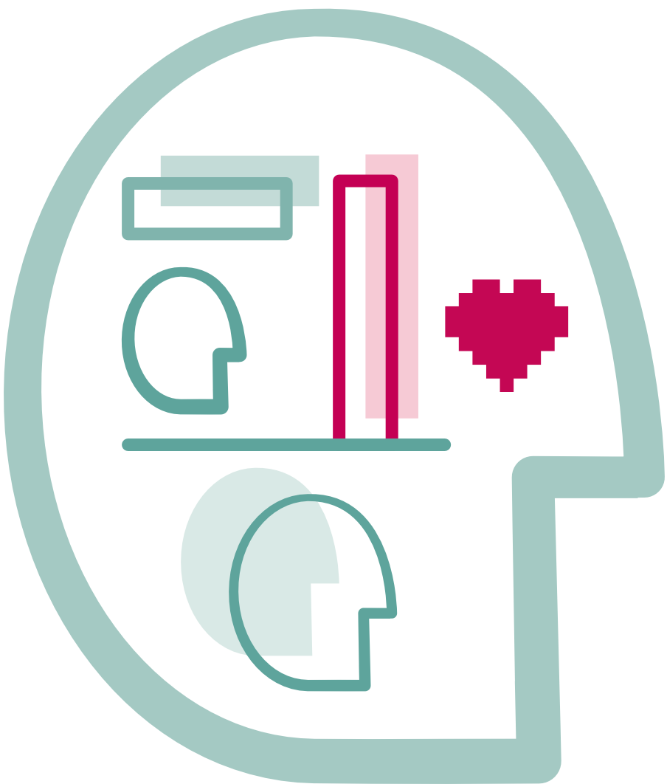
Using digital tools can be difficult, especially for health and wellbeing reasons. When things work well, they can really help; yet when they don’t, they can often cause a lot of stress.
We hope this resource can support people to understand a bit more about where digital can help. The information contained here is evolving. If you have any feedback, please get in touch. We want to improve this guide with your help.
There are three questions that we would like you to help us answer:
- How can people be best supported to use digital tools for their health, care and wellbeing?
- Does this guide provide valuable information? Does the information promote digital skills, knowledge and confidence?
- How can people be best supported to take in this information?
We hope that you will find this guide useful.
Please email us at DHCscot@alliance-scotland.org.uk with any feedback.

About Discover Digital
Discover Digital – www.alliance-scotland.org.uk/digital/digital-health-and-care/discover-digital/ – aims to highlight digital tools that promote health and wellbeing. Between 2018 – 2019 Discover Digital held events across Scotland to exhibit such tools. On show were:
- digital tools that could help us look after ourselves better (self management tools)
- digital tools that help us to look after someone else (caring tools)
- digital tools that help us access the National Health Service, or the NHS (NHS tools)

Digital technology can enable us to live better. It can help us be more connected or more informed. Digital tools are no different to any other tools: little aids to help us reach our goals.
Everyone should be able to access and use digital health and care tools. We should be able to access them in a way that works for us. These tools can help us achieve our health and wellbeing goals. Or they can help us look after someone we care for.
As a result of the COVID-19 pandemic, there have been more and more digital tools available for people to use. This increase has made it difficult to keep up to date with what tools are available and how best to use them. For this reason, the Health and Social Care Alliance Scotland has created this guide. We hope it will help people understand how such tools work and where they might find the right ones for them.

How to use this guide
We want this guide to help explain how you might benefit from digital tools and services. We tried to give an overview of how such tools could help you look after your health or that of someone you care for. You can use this guide yourself if you have little or no experience of digital tools. You can also use it to help someone else better understand what digital health and care tools are.
This guide aims to help you understand what kind of tools are available. However, it will not recommend specific tools or services. But it will let you know where you can go for specific recommendations.

This guide also aims to help you understand a bit more about these tools and services. Who created them? What are they for? What knowledge do you need to have before using them? How can you tell it they are right for you? These are some of the questions we are hoping to help you answer.
There are seven sections in this guide. You have just completed the first section:
- About / How to use this guide
- The big picture
- Digital tools for self management
- Digital NHS services
- Technology enabled care
- Safeguarding and self-evaluation
- Glossary and references
You can find the other sections on the ALLIANCE website – www.alliance-scotland.org.uk/blog/resources/discover-digital-guide/.

About the ALLIANCE
The Health and Social Care Alliance Scotland (the ALLIANCE) is the national third sector membership organisation for the health and social care sector. We bring together over 3,500 people and organisations dedicated to achieving our vision of a Scotland where everyone has a strong voice and enjoys the right to live well, with dignity and respect. Our members are essential in creating a society in which we all can thrive, and we believe that by working together, our voice is stronger.
We work to improve the wellbeing of people and communities across Scotland by supporting change in health, social care and other public services so they better meet the needs of everyone in Scotland. We do this by bringing together the expertise of people with lived experience, the third sector, and organisations across health and social care to shape better services and support positive change.
The ALLIANCE has three core aims.
We seek to:
- Empower people with lived experience: we ensure disabled people, people with long term conditions, and unpaid carers are heard and that their needs remain at the heart of the services and communities.
- Support positive change: we work within communities to promote co-production, self management, human rights, and independent living.
- Champion the third sector: we work with, support and encourage co-operation between the third sector and health and social care organisations.

The ALLIANCE is committed to upholding human rights. We embed lived experience in our work and aim to ensure people are meaningfully involved at every level of decision-making.
Working together creates positive, long-lasting impact. We work in partnership with the Scottish Government, NHS Boards, universities, and other key organisations within health, social care, housing, and digital technology to manage funding and develop successful projects. Together, our voice is stronger, and we can create meaningful change.
