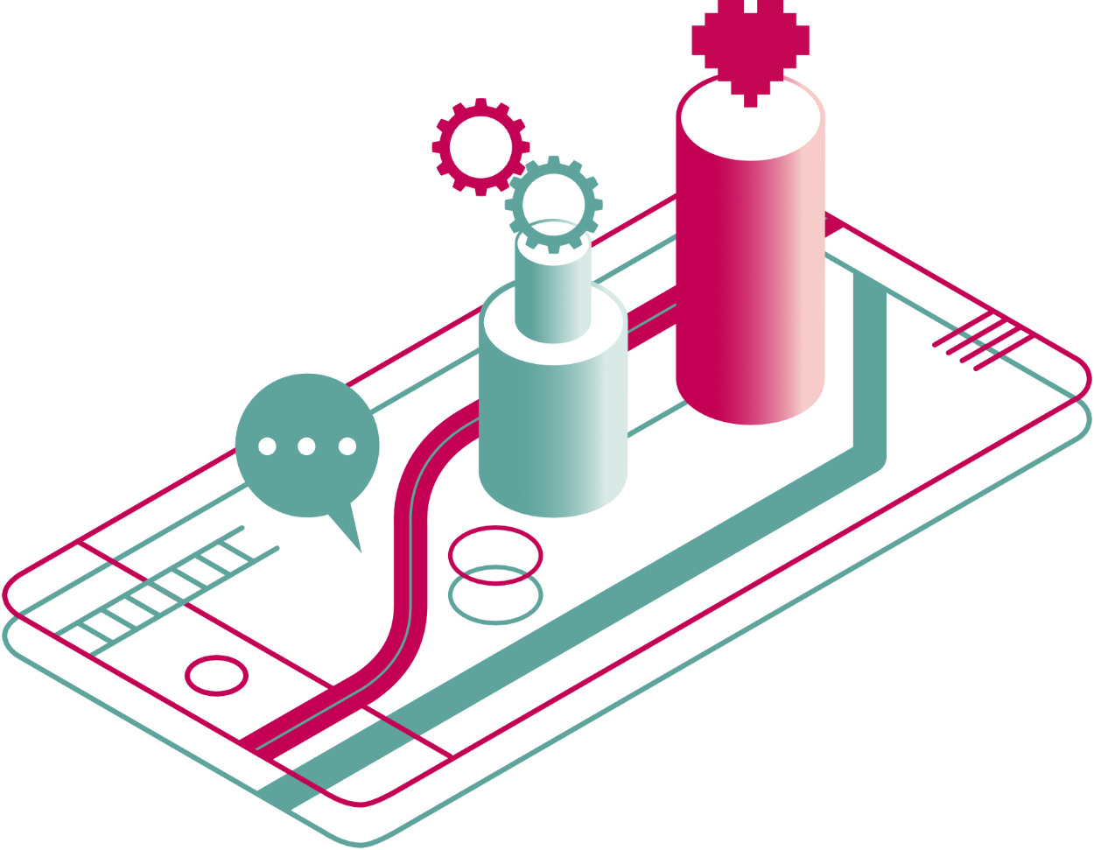


a guide to digital health, care and wellbeing

Section 3 out of 7: Digital tools for self management

Digital tools for self management

What is digital self management?

First of all, what is self management?
Self management is a lot like self care. It is made up of the different actions and decisions you take to look after yourself. The only difference is that self management is talked about in the context of managing a long term condition.
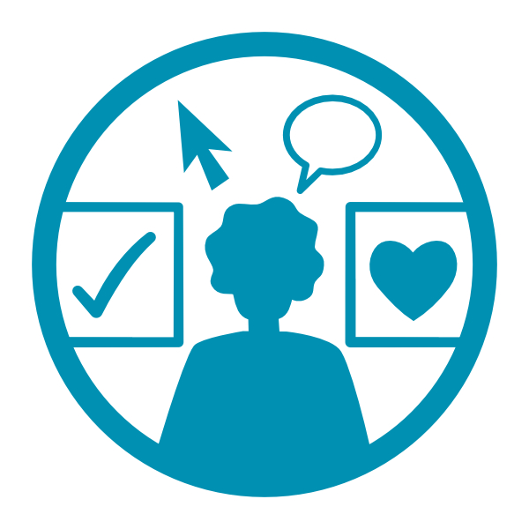
Long term conditions are health conditions which last for a long time or indefinitely. Long term conditions come in all shapes and sizes. They can include depression, dermatitis, diabetes, chronic pain, and many more. What connects them all is that there is no simple cure. The actions you take in your everyday life can make the condition better or worse.
So self management refers to those actions that you take to make yourself better. Whether it’s being careful about what you eat, being more active, taking your medicine regularly or even ensuring you spend enough quality time with family and friends. It can be about knowing your symptoms and your triggers, as well as what helps. Whatever helps you cope, or even thrive, can fall under self management.
Self management doesn’t mean managing by yourself. Self management is most effective when it’s done with the support of health professionals and others that can help. You could be working with a health coach to achieve better wellbeing. Attending support groups or going for organised walks to manage your health better. You could also be accessing more specific support, from peers or professionals, that is related to your condition.
So self management is a partnership, but it equips YOU with the skills and knowledge to be in the driving seat. On average, people who have one or more long term conditions spend less than 3 hours a year with their healthcare provider. The rest are spent self managing.
Self management can mean people being:
- better informed about their condition(s)
- better prepared for everyday challenges
- better supported when they need it

How is self management using digital tools different from everyday, non-digital self management?
As we’ve explored in the previous section, self management can take various forms. There are different technologies that can potentially help too, but the concept is not that different.
You might use a paper calendar to keep track of your symptoms or triggers. Or you might go to a community notice board to find out about support groups in your area. You might also write in a diary to keep track of your sleep and activity patterns. Digital self management means taking the same type of actions, but with the help of technology. You might use an app to track symptoms, an online search engine to find out what is available around you or an activity tracker to track your sleep.
These technologies, devices and digital services do some of the hard work for you, so you can focus on what matters to you.

What tools are available for self management?
There are a lot of online tools available for self management today. Some have been developed in collaboration with the NHS, some have been developed by charities and some are from private companies. Some tools are free and others will incur a cost.


How can I choose the right tool for my needs?
There are various places online where you can go to find some recommendations as to what digital tool might be of benefit to you.
ALISS (A Local Information System for Scotland) is a web-based information platform. It can help you find information on local and national services that might help you to live well. Using ALISS, you can search for the services, groups, activities, and resources available in your area by using your postcode. You will be offered a list of suggestions, both local and national. Some of the national services might include digital tools. Go to ALISS at www.aliss.org.
NHS inform is Scotland's national health information service. Its aim is to provide the people in Scotland with accurate and relevant information. That can help them make informed decisions about their own health and the health of the people they care for. It provides a list of self-management tools and apps that have been developed or approved by NHS Scotland. Go to NHS inform at www.nhsinform.scot/care-support-and-rights/tools-and-apps. It also provides self-help guides for mental health and other conditions. Go to NHS inform at https://www.nhsinform.scot/symptoms-and-self-help/self-help-guides.
ADAM (About Digital and Me) is a platform provided by Alzheimer Scotland. It can help you to find the right pieces of technology at the right time. It is intended for families and carers who would like to try using digital products and services to look after their health and wellbeing. Go to ADAM at https://meetadam.org.
ORCHA is an organisation that reviews commercial health, care and wellbeing apps to ensure they are safe and effective. Digital Health & Care Innovation Centre (DHI) has partnered with ORCHA to create a health apps library where you can discover trusted apps trusted apps to support a wide range of health and wellbeing goals. These include apps for mental health promotion, managing long term health conditions, and achieving healthy lifestyle goals. Go to DHI app library at https://dhi-scotland.orchahealth.com/en-GB. ORCHA have also partnered with Mind where you can access a mental health apps library to discover trusted apps to support your mental health and wellbeing goals. Go to Mind app library at https://mind.orchahealth.com/en-GB/topic/all-mind-approved-apps?&sortBy=AccreditationScoreDesc.
Aye Mind is a website that has been created by NHS Greater Glasgow and Clyde alongside local partners with the purpose of supporting anyone who works with children and young people to confidently use digital technologies to support their mental health and wellbeing. Go to Aye Mind at https://ayemind.com/useful-tools/.
#TryATool is a Discover Digital initiative. It started on social media by sharing trusted tools, websites and resources related to health and wellbeing every Tuesday. Some of these have been collated into a list and published in our #TryATool resource guide. These are split up into different categories: mental health, health information, managing health conditions, carers, healthy lifestyle and children and young people. Go to the #TryATool resource guide at www.alliance-scotland.org.uk/blog/resources/try-a-tool-resource-booklet/#.

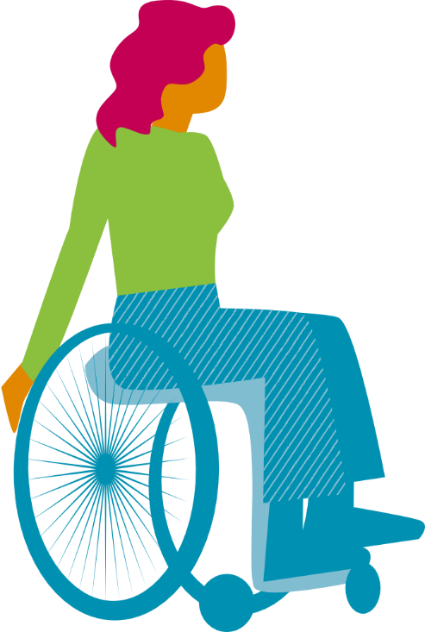
What are occupational therapists? How can they support the use of digital technologies?
Occupational therapists are interested in occupations (activities and tasks). They focus on tasks that are important to you and how you manage these every day. For example, for one person the task of online shopping on a computer might feel like a chore. To another, it might be enjoyable and for another it might be second nature.
An occupational therapist works with an individual. They help identify what really matters to this individual. They also help them to carry out everyday tasks. An occupational therapist may suggest trying digital devices to assist with these tasks. For example, to enable control of a TV, access a computer or to connect with friends and family. Digital devices can also help a person navigate safely and independently around an area. They may also support an individual in their workplace by using specialist equipment.
An occupational therapist will help assess a person’s abilities and disabilities. This can include mental ability, hand dexterity, vision and hearing ability and posture. The person's home is also assessed. This is to help find support and adaptations to live better. The day to day activities are also assessed to ensure that they can manage independently. For example, charging a device, updating software and connecting to Wi-Fi. These can be new skills that need training and practice.
Occupational therapists are also able to teach new and individualised skills. They will review a person’s progress to ensure that the best outcomes are achieved for that person. This may take a few sessions or quite a long period of time to acquire.
To find an occupational therapist go to the Royal College of Occupational Therapists at www.rcot.co.uk/about-occupational-therapy/find-occupational-therapist.

Find out more:
You have just completed the third section of this guide:
- About / How to use this guide
- The big picture
- Digital tools for self management
- Digital NHS services
- Technology enabled care
- Safeguarding and self-evaluation
- Glossary and references
Find another section on the ALLIANCE website – www.alliance-scotland.org.uk/blog/resources/discover-digital-guide/.

About the ALLIANCE
The Health and Social Care Alliance Scotland (the ALLIANCE) is the national third sector membership organisation for the health and social care sector. We bring together over 3,500 people and organisations dedicated to achieving our vision of a Scotland where everyone has a strong voice and enjoys the right to live well, with dignity and respect. Our members are essential in creating a society in which we all can thrive, and we believe that by working together, our voice is stronger.
We work to improve the wellbeing of people and communities across Scotland by supporting change in health, social care and other public services so they better meet the needs of everyone in Scotland. We do this by bringing together the expertise of people with lived experience, the third sector, and organisations across health and social care to shape better services and support positive change.
The ALLIANCE has three core aims.
We seek to:
- Empower people with lived experience: we ensure disabled people, people with long term conditions, and unpaid carers are heard and that their needs remain at the heart of the services and communities.
- Support positive change: we work within communities to promote co-production, self management, human rights, and independent living.
- Champion the third sector: we work with, support and encourage co-operation between the third sector and health and social care organisations.

The ALLIANCE is committed to upholding human rights. We embed lived experience in our work and aim to ensure people are meaningfully involved at every level of decision-making.
Working together creates positive, long-lasting impact. We work in partnership with the Scottish Government, NHS Boards, universities, and other key organisations within health, social care, housing, and digital technology to manage funding and develop successful projects. Together, our voice is stronger, and we can create meaningful change.
