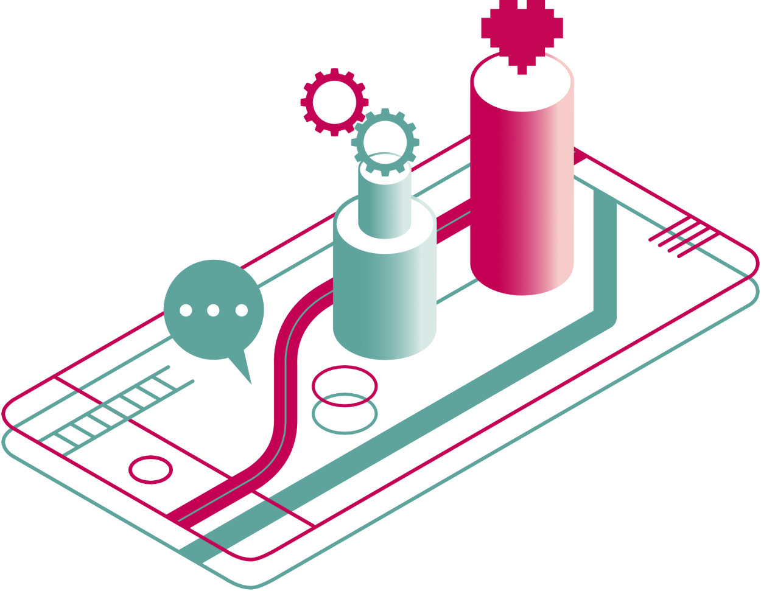


a guide to digital health, care and wellbeing

Section 5 out of 7: Technology Enabled Care (TEC)

Technology enabled care

What is technology enabled care?
Technology enabled care refers to the use of telehealth, telecare and telemedicine. These services can help provide care that is convenient, accessible and cost-effective. They use technology to support people to live safely in their own homes. (NHS Inform)
So, Technology Enabled Care (TEC) is an umbrella term for the following:
- Telehealth: technology that aims to help you with your health needs.
- Telecare: technology that can help with your wider needs.
- Telemedicine: technology that focuses on helping you take medicine correctly.

How are telecare, telehealth and telemedicine different to receiving care in my home?
The aim of TEC is to help you to live at home and stay safe. You might benefit from TEC if you live with a long term condition or disability. You might also benefit from TEC if you have started to feel frail or at risk of falls. Or, it might be that you are temporarily unable to do certain things in your home. This could be because of an injury or other life circumstances.
Whichever the case, TEC aims to help you overcome daily barriers. This is so that you can stay safe, independent and in control. TEC is not intended to replace the support you receive from carers or support workers. Instead, TEC aims to help both yourself and your carers be more informed and in control.


What technology enabled care tools are available?
There are a lot of online tools available through TEC packages today. Some are being offered through the NHS or local councils. Some tools will be free and others will incur a cost. There are also tools aimed specifically at carers.
TEC can also make use of technologies you might already have. These can be phones, tablets, computers and even TVs or smart speakers.
You might want to choose a TEC tool or package for yourself or someone you are looking after. But it is a good idea to take some time first to understand the different tools that are available. This could help you avoid feeling overwhelmed by the multitude of tools available.

What is the difference between different types of TEC tools?
Basic or enhanced TEC?
TEC can range from basic equipment to more developed technology. Basic options include emergency pendants or smoke detectors that can raise alarms. Developed technologies can include anything from medication dispensers to infra-red sensors.
Basic TEC equipment works great for those who are mostly independent. It can provide extra security and peace of mind.
Enhanced TEC is aimed at individuals with more complex needs. These technologies can target these needs specifically.
Which needs are you looking to address?
Carers UK – www.carersuk.org – have created a great list to categorise TEC. It summarises technologies according to the health and lifestyle needs that they target:
- Everyday needs: there are many various apps and online websites available. They can help with daily tasks such as shopping or looking after money. They can also help you keep in touch with friends and family.
- Environmental monitoring: some technology can help you manage your home. You can do this using many devices, apps, smart home controls or even your voice. They can help you manage your heating, lighting or even door entry. There are also specialist systems called environmental control systems. These can help with more complex needs.
- Remote alerts: this technology can help check whether a person at risk is safe in their own home. If something goes wrong, automated alerts can be raised. These are sent to carers or to 24-hour alarm and response centres.
- Monitoring vital signs: technology can measure health signs. This includes blood pressure, blood glucose, heart rate or even sleeping patterns. This can be done through apps or bespoke devices. Some tools can even raise alarms. Others can help avoid lengthy hospital visits for routine checks.
- Accessing remote healthcare and advice: some technologies can help you access services remotely. This means that you might be able to receive advice via telephone, email or video sessions online.
- Medication management: some devices that can help keep track of medications. They can remind you when you need to take prescribed medicine and offer reassurance.
- Self-enhancement: some tools you can use to improve your skills and abilities. These range from hearing aids to fitness apps.
Who are the tools for?
TEC offers benefits to both people receiving support and their carers. If you are a carer yourself, finding the right TEC for the person you support can help them stay independent. But it can also give you peace of mind.
There are also a lot of tools that aim to make caring easier. So, when you’re looking for a tool, consider your needs alongside those of the person you support. You might be able to find some technologies that tick both boxes.
Some apps aim to help families organise care or manage emergencies. They can also provide an overview of the wellbeing of the person they look after. There are also tools aimed at the person receiving support. Sometimes, these can be provided through housing associations or care providers.
Everyday tools or bespoke devices?
You might already own a tool such as a smart phone, a tablet, a computer or other types of electronic devices. With the rights apps or software, they can function as TEC tools.

How can I find out what is available in my local area?
The Telecare Self-Check Online tool is available for anyone in Scotland to use. The tool allows you to check if telecare would benefit you. It can also recommend specific types of equipment that might help.
The services offered will depend upon where you live. Select the area in which you live and click the 'Go to local area' button. This will take you directly to the relevant local service who will help you work out what to do next.
The tool will also offer you helpful advice based upon your answers. Go to Telecare Self-Check Online tool at www.telecareselfcheck.scot.
Charges and type of equipment available will vary by health board and service provider.

How can I choose the right tool for my needs?
The Telecare Self-Check tool should be your first stop. But there are other useful sources of information you can try.
- ADAM (About Digital and Me) is a tool developed by Alzheimer Scotland. It can help people living with dementia and those around them find the technology they need. It is free to use by anyone and can offer very useful prompts and advice. To use it, answer some questions about what you would like help with. In return, ADAM will offer recommendations tailored to your needs and preferences. Go to ADAM at www.meetadam.org/.

- Care Technologists were part of a project by Scottish Care. The project worked with people in care homes and care services. The aim was to use technology to increase independence and improve lives. You can access the ‘Care Tech Catalogue’ on the website. This includes a list of the technologies used in the project. Read the list at https://scottishcare.org/wp-content/uploads/2023/05/Care-Tech-Catalogue-May-2023-compressed.pdf.

Find out more:
You have just completed the fifth section of this guide:
- About / How to use this guide
- The big picture
- Digital tools for self management
- Digital NHS services
- Technology enabled care
- Safeguarding and self-evaluation
- Glossary and references
Find another section on the ALLIANCE website – www.alliance-scotland.org.uk/blog/resources/discover-digital-guide.

About the ALLIANCE
The Health and Social Care Alliance Scotland (the ALLIANCE) is the national third sector membership organisation for the health and social care sector. We bring together over 3,500 people and organisations dedicated to achieving our vision of a Scotland where everyone has a strong voice and enjoys the right to live well, with dignity and respect. Our members are essential in creating a society in which we all can thrive, and we believe that by working together, our voice is stronger.
We work to improve the wellbeing of people and communities across Scotland by supporting change in health, social care and other public services so they better meet the needs of everyone in Scotland. We do this by bringing together the expertise of people with lived experience, the third sector, and organisations across health and social care to shape better services and support positive change.
The ALLIANCE has three core aims.
We seek to:
- Empower people with lived experience: we ensure disabled people, people with long term conditions, and unpaid carers are heard and that their needs remain at the heart of the services and communities.
- Support positive change: we work within communities to promote co-production, self management, human rights, and independent living.
- Champion the third sector: we work with, support and encourage co-operation between the third sector and health and social care organisations.

The ALLIANCE is committed to upholding human rights. We embed lived experience in our work and aim to ensure people are meaningfully involved at every level of decision-making.
Working together creates positive, long-lasting impact. We work in partnership with the Scottish Government, NHS Boards, universities, and other key organisations within health, social care, housing, and digital technology to manage funding and develop successful projects. Together, our voice is stronger, and we can create meaningful change.
