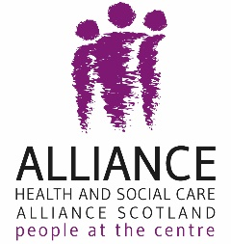
Health and Social Care Alliance Scotland
VOX Scotland

Shaping New Mental Health Standards:
A lived experience perspective

September 2022

Summary

The Health and Social Care Alliance Scotland (the ALLIANCE) and VOX Scotland engaged with 177 people with lived experience and nine organisations from February 2022 to May 2022 to collect their experiences of adult secondary mental health care in Scotland. A further nine individuals participated in adjacent engagement on experiences of Psychological Therapies. As further background and context a literature review was undertaken of recent ALLIANCE/VOX activity around mental health priorities.

This work was conducted to support the development of Mental Health Standards by the Scottish Government Mental Health and Wellbeing Standards Working Group and National Standards for Psychological Therapies by the Scottish Government Psychological Services and Therapies Policy team. In supporting this work, the ALLIANCE and VOX Scotland are committed to ensuring that the voice of people with lived experience, their families and/or unpaid carers are centred within Standards development. Further to this, partners from the Quality and Safety Board will also contribute to wider context including workforce, engagement and wider evidence review.

Findings and Recommendations

Through an online survey and several virtual focus groups, the ALLIANCE and VOX Scotland heard from people and organisations about what worked well when accessing services, where barriers existed, and what was important to them.

Foundational principles for adult secondary mental health services and psychological therapies.
People with lived experience of accessing services highlighted a number of key principles that they felt should underlie all service development and delivery.
In considering both the volume and range of evidence collected the ALLIANCE and VOX suggest that the UN PANEL approach informs the following foundational principles.

- Person centred and collaborative care
- Holistic approach that recognises a range of strategies
- Individuals have control and self management of their mental health care
- Human rights based and trauma informed practice
- Equal and non-discriminatory access to services
- Empathy, kindness, compassion and respect as a framework of practice
- Openness, honesty and transparency are key principles of delivery
- Empower people with lived experience and carers to make decisions about their care
- Destigmatisation of mental health in Scotland, including for professionals and people with lived experience
- Understanding of health as being socially determined, including an awareness of the impacts of discrimination and economic deprivation on mental health

By conducting analysis across the feedback from our varied engagement approaches, several consistent themes emerged around people’s experiences of adult secondary mental health services, and areas of attention for future Standards.

Access
- Shorter waiting times between referral and treatment
- Stop divergence between health boards and ‘postcode lottery’ by ensuring good practice is extended nationally
- The first point of contact should always engage and signpost i.e. a ‘no wrong door’ approach
- More access to rehabilitation and meaningful therapies is needed
- Empower and enable patients to choose and access the right services at the right time based on their needs, and not only when people are in crisis
- Provide more opportunity for people with lived experience to choose appointment styles that suit them
- Increased funding and staffing to enable more people to access services
- There is often a lack of consistency in criteria used to assess access to services
- Flexibility of opening times for services that provide support out with office hours
- Ensure that people can re-enter services if initially discharged but support is needed again for example step up and step down approaches

Attitudes
- Supportive and helpful care should be a key principle of mental health services
- People accessing services should always be treated with dignity and respect
- Staff should be comprehensively trained on human rights and trauma informed practice
- Carers should be viewed as having valuable insights into a person’s care and experience
- Efforts amongst services to actively mitigate any power imbalances so people with lived experience can be equal partners in their own care.
- Respect for diverse communities, and for individuals experiences and culture

Accountability

- Standards should be produced in tandem with a clear and transparent process of accountability and monitoring
- Establish a clear complaints process to ensure that anyone who had a grievance about how the Standards were/were not applied could have that addressed
- Coproduce monitoring process with people with lived experience, including carers
- Establish a monitoring body, including people with lived experience

Information and Support
- Clear information on all services that are available and details on how to access these and the criteria that people may be judged against. This information should also include expected waiting times
- More accessible information is needed - in plain English and in other formats and languages too
- Establishing a national support helpline that is appropriately resourced
- Clarity around complaints process
- Performance information of local mental health services
- Clear progress reporting to service users on their treatment
- Signposting to community support and third sector actors, rehabilitation, including peer support networks and local advocacy

Consistency of Care & Treatment
- Access to early intervention and self management support to ensure that people do not only receive care when acutely unwell
- Ensure ongoing support and options for people to engage with services without predetermined end date
- Consistency in professionals. Seeing someone new every time means no continuity of care and constantly retelling experiences which can provoke retraumatisation
- Ensure all services are equally accessible between service types
- Design holistic care packages to ensure that people move seamlessly between services

Communications
- Real choice around digital (online or telephone) consultations and communication vs face to face options
- Better communication between services and professionals, about a person’s individual care and also about what is available to people across the system
- Efficient, clear and available communication channels that support their journey through the system
- Communication between professionals and people with lived experience should be inclusive of carers and family members

- Introduction

As members of the Scottish Government Mental Health and Wellbeing Standards Working Group, the Health and Social Care Alliance Scotland (the ALLIANCE) and VOX (Voices Of eXperience) Scotland have taken a lead role in engaging with people with lived experience to support in the development of future Mental Health Standards and Standards for Psychological Services and Therapies.
Both organisations share a commitment to ensuring that people with lived experience, their families and carers, and the third sector organisations that support them are at the centre of policy design and service development. To support the coproduction of National Standards that are grounded in people’s own priorities, the ALLIANCE and VOX Scotland undertook a mixed-method approach to lived experience engagement.
Creating spaces for people with lived experience to participate in decisions around adult secondary mental health care and future Standards ensures that future policy can be reflective of the needs of people who access this care.
- Method and approach

Developing the proposed Mental Health Standards requires a multifaceted approach that engages people with lived experience, their families and the third sector organisations that support them. In order to ensure that people had sufficient opportunities to input their views and experiences in ways that suited their preferences for engagement and personal commitments, the ALLIANCE and VOX Scotland delivered a number of engagement opportunities.

These approaches provided scope for both quantitative and qualitative data collection about people’s experiences of adult secondary mental health care, as well as equality monitoring information that aimed to determine the intersections of protected characteristics in relation to lived experiences.

From February 2022 to March 2022 the ALLIANCE and VOX Scotland engaged with 177 people and nine organisations to support the development of Mental Health Standards via:

- An online survey, opened from 15 February to 25th March. The analysis of the survey data was undertaken by National Services Scotland (NSS)
- A focus group with ALLIANCE and VOX member organisations working in the field of mental health and/or with unpaid carers
- A focus group with people from across Scotland with lived experience of accessing secondary adult mental health care, or the carers of people with lived experience
- A focus group hosted with Sharpen Her: African Women’s Network, with women living in Glasgow or Lanarkshire, most having settled refugee status and one in the process of attaining refugee status. The women originally come from Uganda, Nigeria, Malawi, Pakistan, Algeria and Azerbaijan.
- Literature review collating findings from previous ALLIANCE and VOX Scotland engagement on mental health

The opportunity to participate in these engagement opportunities was distributed via direct emails to ALLIANCE members and stakeholders, ALLIANCE e-bulletins, social media, and through cascading the information through partner organisations’ own networks.

A facilitation guide was also distributed to partner organisations to encourage independently hosted discussions with their own members. We received feedback from Flourish House, a mental health recovery community based in Glasgow, on the findings from a session delivered in March 2022 with four individuals from their own network.

In delivering these various opportunities for lived experience engagement, the ALLIANCE and VOX Scotland were directed in their work by a number of key objectives:

- Engage ALLIANCE and VOX Scotland members within the co-production of Mental Health Standards
- Centre lived experience within the development and distil these into key themes and priorities
- Understand what matters to people and families in relation to Adult Secondary Mental Health care
- Collaborate with other working group members to ensure maximum reach to those who currently use services
- Collaborate with other lead organisations for workforce and organisation engagement to remove duplication and co-ordinate delivery of work

Parallel to this piece of work, the ALLIANCE and VOX Scotland held two focus groups in May 2022 to bring together individuals with lived experience of accessing Psychological Therapies or carers of people with lived experience. This was complemented by three questions specific to Psychological Therapies within the online survey. The feedback from this work, and the perspectives of nine focus group participants, will inform the National Quality Standards for Psychological Services and Psychological Therapies.

- Evidence base

The ALLIANCE and VOX Scotland are well placed to input the voice of lived experience into new Mental Health Standards. Both organisations seek to ensure that people are at the centre, that their voices, expertise and rights drive policy and sit at the heart of design, delivery and improvement of support and services.
With regards to mental health support specifically, the ALLIANCE has vast experience in supporting people to share their experiences and influence the design and delivery of services. This experience informs our understanding of people with lived experience’s perspectives on adult secondary mental health care.
In 2018, the ALLIANCE supported the Independent Inquiry into Mental Health Services in Tayside, producing a report which summarised the views of those accessing mental health services in the area. A Grampian System Wide Mental Health and Learning Disability Services Review provided a similar platform for people to share their lived experience of mental health services in their area in 2019.
Following this engagement work, the ALLIANCE has continued to promote mental health and wellbeing through the Self Management Fund for Scotland. The Self Management Fund for Scotland is administered on behalf of the Scottish Government by the ALLIANCE with support from the William Grant Foundation. In Tayside, the Self Management Fund recently funded Deaf Links and Dundee Volunteer and Voluntary Action Plan. Whilst in Grampian, funding was awarded to Aberdeen Foyer and Moray Wellbeing Hub. All projects support people with lived experience to seek support and advice on mental health. In addition, the ALLIANCE’s Living Well: Emotional Support Matters programme, delivered in partnership with the Mental Health Foundation, is working with 8 ALLIANCE members to protect and support the mental health and emotional wellbeing of people living with long term conditions.
Following the COVID-19 pandemic outbreak in Scotland, the ALLIANCE’s People at the Centre programme led engagement work with people to ensure the voice of lived experience was heard and was able to inform short and longer term reform of the health and social care system. The learning from this engagement was wide ranging and included people’s experiences of mental health services during the pandemic.
- 30.1% shared that mental health services had worked well for them during the pandemic
- 30.9% shared that mental health services did not work well for them
- 39.0% shared that they had been unable to access mental health services

The report concluded that the pandemic had exposed limitations and weaknesses within our current health care structures. But that the pandemic had also shone a light on the ability of services to adapt, innovate and deliver high quality care. Lessons can be learned from the experiences shared as to what people fundamentally need to live well. The prioritisation of mental health support and increased investment into prevention and early intervention is a key aspect of this. As the delivery of mental health services and the wider health care system are considered, people should be involved as active and equal partners in every step of this process, informing and contributing to the development of a healthcare system with people at its centre.
Similarly, VOX Scotland has ensured that people with lived experience of mental health conditions are influencing a number of key policy areas, such as the Review of Mental Health Law in Scotland, engaging with 90 individuals to have their voice heard on mental health law, gathering views from 25 people currently in forensic care to help shape the Review of Forensic Mental Health Services in Scotland (The Barron Review), and most recently engaging with over 40 people with lived experience on the National Care Service consultation.
VOX Scotland’s recent Access to Services report highlighted access, information and support, consistency of care and treatment, communications and attitudes as central themes that people cited in relation to their experiences of mental health care. VOX Scotland also carried out two “Deep Dive” sessions in January 2022, which looked in depth at peoples’ experiences of accessing mental health services. In addition to accessing services, discussions took place about what would make services work more effectively, and what a “good service” looks like.
In total, this extensive work from both the ALLIANCE and VOX Scotland contain the views of over 2,000 people collected over the past four years. This gives a good indication of their needs and desires from mental health services and of their priorities for the future. From these pieces of work key thematic areas emerged highlighting people’s experiences and priorities for the future of mental health care, key barriers, aspects of service provision that were particularly valued, desires for improvement or expansion and thoughts on principles that should underpin mental health service provision. These areas act as an existing evidence base for considering the feedback from the ALLIANCE and VOX Scotland’s engagement to support the work of the Standards.

3.1. Themes and feedback from the evidence base
Access
A large number of comments relate to people’s ability to access mental health services. Some of these refer to difficulties in engaging with specific services, while others are more general and identify system design issues.
Specific comments noted include:
• The first point of contact should always engage and signpost, not dismiss concerns
• More access to advocacy, rehabilitation and peer support is needed
• Greater access to Psychological Therapies is needed
• There is often a lack of support given by A&E
• There are long waiting lists and access issues across the system. It feels like services are only for people in crisis
• There is often a lack of consistency in criteria used to assess access to services
• Geography can be an issue – centralisation of services is very common; and
• Too many services are nine to five only, with no support outside office hours

Information and Support
Comments express frustration at the complexity of the system and the difficulty of knowing where the “front door” is. There were also frequently raised points made regarding the need for more non medical or social/ community supports.
Specific comments noted included:
• There is a lack of information. It is difficult to find the right service or support
• More accessible information is needed - in plain English and in other formats and languages too
• Information on services available, including all options, is needed. This should include how to access different services and the likely waiting times
• There can be inconsistent messages, with services sometimes referring to each other, resulting in the person being passed back and forth between them
• There is not enough independent advocacy support available, and we are not always signposted or directed to it
• There is not enough community/ social support available. These can make a real difference to staying well. We need help to find them, e.g. the role of Links Worker; and
• Unpaid carers need to be more involved. They can provide information, but their needs must also be met

Consistency of Care & Treatment
Many comments relate to the scope and design of services, with a general feeling emerging that care and treatment is only given when acutely unwell, rather than on an ongoing basis. There were also comments around consistency of care and support for self management to enable people to remain well.
Specific comments noted included:
• There is no access to early intervention support – it felt like I was being told to come back when I was more seriously ill
• Community Psychiatric Nurses (CPNs) are withdrawn when you are judged to be well. This can lead to relapse
• Support for self management is missing. Some conditions come and go and the support to stay well just isn’t there
• There is no ongoing support – we are discharged when judged well rather than supported to stay well; and
• There is often a lack of consistency in professionals. Seeing someone new every time means no continuity of care and constantly retelling experiences

Communications
Comments around communications ranged from different preferences over the medium by which services are delivered, poor communications between professionals and patients and also between services.
Specific comments noted included:
• “Digital (online or telephone) consultations are great for many, but not for everyone. Real choice is required”
• “Human contact is important. Many people need face to face services”
• “Services work too often in silos. They can be unaware of what else is there, and don’t communicate well with each other”; and
• “Better communication is needed at all levels – between services, and between services and patient at key points like referral and discharge”

Attitudes
There were repeated comments related to the attitudes that patients perceive from professionals and services. These are generally not directed towards a particular person but are more related to the culture of services.
Specific comments noted included:
• “You have to push hard and argue for support rather than feeling welcomed. This isn’t easy when you are unwell”
• “Trust and empathy should be key qualities – more caring and listening is needed”
• “There isn’t a feeling of partnership or of working with people at the centre of care”; and
• “The power imbalance must be reduced so people can become equal partners in their own care”

- Lived experience survey

The ALLIANCE and VOX Scotland published an online survey with the view to collecting both quantitative and qualitative information about people’s experiences of accessing and using adult secondary mental health care. This included positive experiences when things went well; barriers they may have encountered; and the foundational principles that they felt should be included within future Standards. A full list of survey questions can be found in Appendix One. The below survey analysis was undertaken by NSS. For a summary of the analysis refer to section 4.11.

The ALLIANCE heard from 145 individuals, who represented a range of experiences and demographics. A breakdown of demographic information can be found in Appendix Two. Out of those 143 individuals who indicated their experience 55.6% self-identified as having lived experience of mental ill health, 25.4 % care for someone with mental ill health, and 19 % identified with both.

Chart One: Respondent’s experience of mental ill health

  - Experience accessing mental health services
The majority of the respondents (129 respondents, 89.0%) had experience of accessing mental health services, either for themselves or in their role as a carer. Only 12 respondents (8.3%) did not. Four people (2.8%) did not answer the question.
Survey respondents were asked to indicate if they or the person they care for had not been able to access services that they required and desired. Of those who answered, 58.9% of respondents (83 respondents) had not been able to access the mental health support that they felt was needed to support them to manage their mental health.
Chart Three: Respondent’s experience of accessing to mental health support

Chart Two: Respondent’s experience of
mental health services

  - General feedback on accessing and using mental health services
When asked about their experience accessing mental health services, 125 respondents (86.2% of all respondents) offered detailed feedback within a free text response to an open question.
There were three key positive themes that emerged within their responses. Respondents felt that they had received supportive and helpful care when accessed, and some reported having good access to services, with the Crisis Teams called out as an important resource. See Figure One for verbatim feedback.
In terms of the negative feedback, there were 11 themes highlighted. The most common themes were difficulty in accessing services, waiting times, inconsistent/poor support, poor clinical care and the impact of the pandemic. Record sharing/cross team working, generic care, staff resources, staff attitudes, communication and the links between social and mental health were also called out as areas for development. See Figure Two for a full list of negative themes and verbatim feedback.

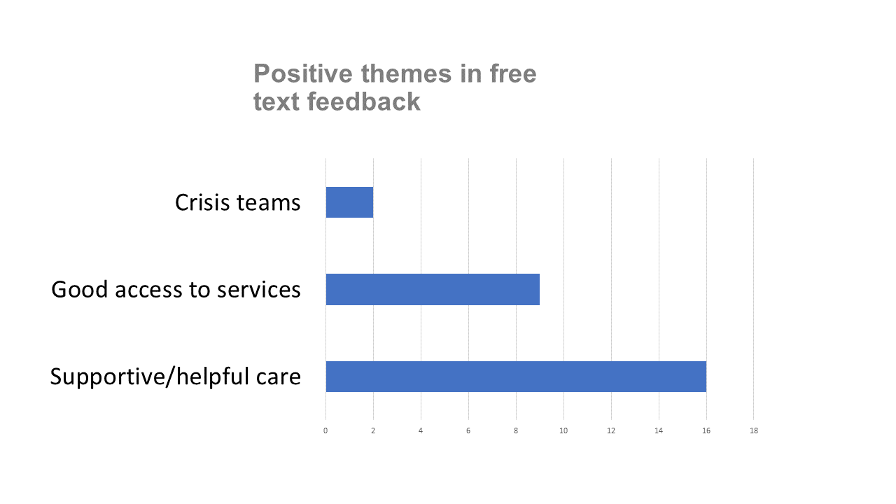
Figure One: Positive themes in accessing mental health services

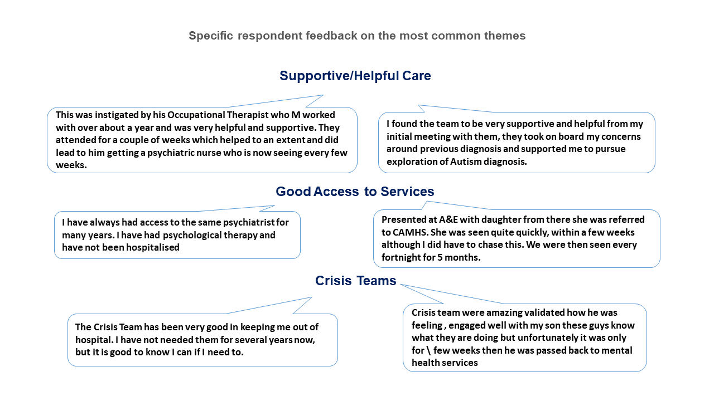

Figure 2: Negative themes in accessing mental health services

Figure Two: Negative themes in accessing mental health services
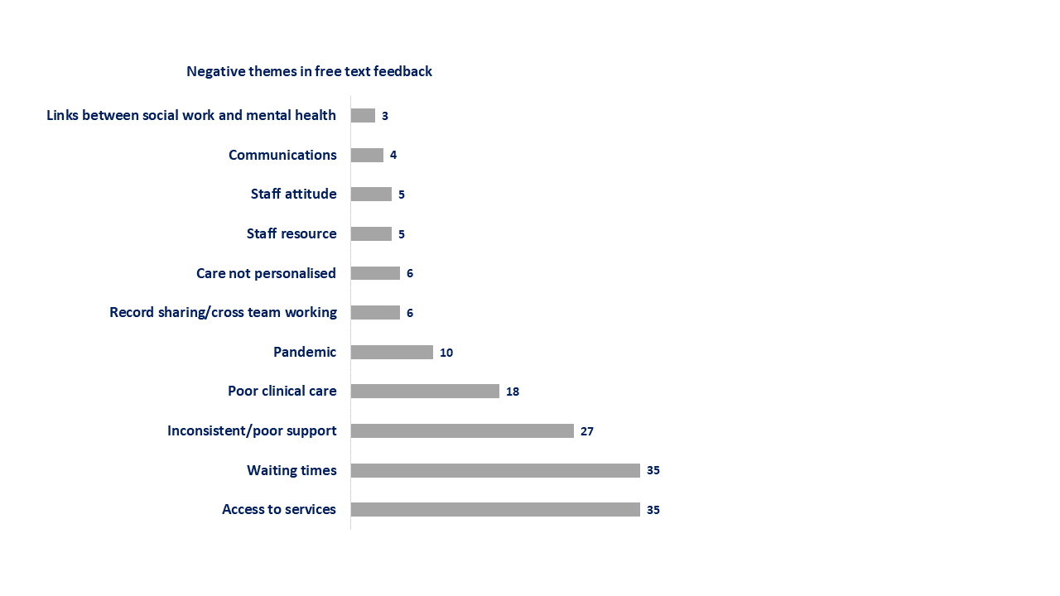

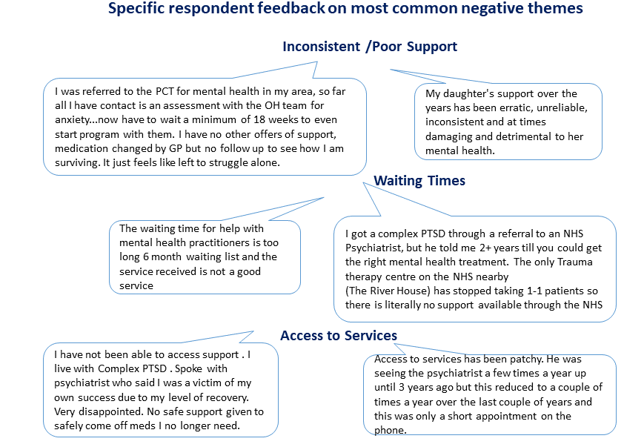

  - Positive feedback on accessing and using mental health services
When asked specifically to “describe anything positive about your experience accessing and using services” 85.5% (124 of respondents) offered feedback. Again, supportive staff and access to services were highlighted, including consistency in care and the ability to refer back into services if health changed. Additionally, the supportive role and quality of social work and CPN care was also a key theme. Please see Figure Three for a full list of positive themes and verbatim feedback.

  - Challenges and barriers to accessing and using mental health services
When asked specifically to “describe any challenges or barriers that you experienced when accessing and using services” 86.9% (126 respondents) offered feedback. It is important to note that this therefore indicates that there is a significant overlap between respondents who are giving positive feedback and respondents who are experiencing challenges accessing the services.
Access and waiting times were again highlighted as key barriers to accessing services. Respondents also called for being involved more meaningfully in their own care. Feedback highlights that a person centred approach where patients feel genuinely listened to is key. Please see Figure Four for a full list of themes and verbatim feedback.

  - Important considerations in mental health support
Participants were asked to consider what matters most to them, their family or the person they care for, when interacting with mental health services. This is in dialogue with the approaches of the What Matters to You? (WMTY) movement for person centred practice within health and social care. Feedback from participants highlighted access, supportive staff, consistency, involvement of the person with lived experience in their own care, wider support networks and reduced waiting times as key areas of importance. One respondent summarised what was important to them well when they remarked,
“A service that takes a holistic approach and sees the person as a whole. Not just diagnoses. Treat them with respect and dignity, like a human being. Involve them in their care plan and decision making. Above all - show kindness at all times.”
For a full list of consideration from respondents please see Figure Five.

Figure Three: Positive themes in accessing and using mental health services
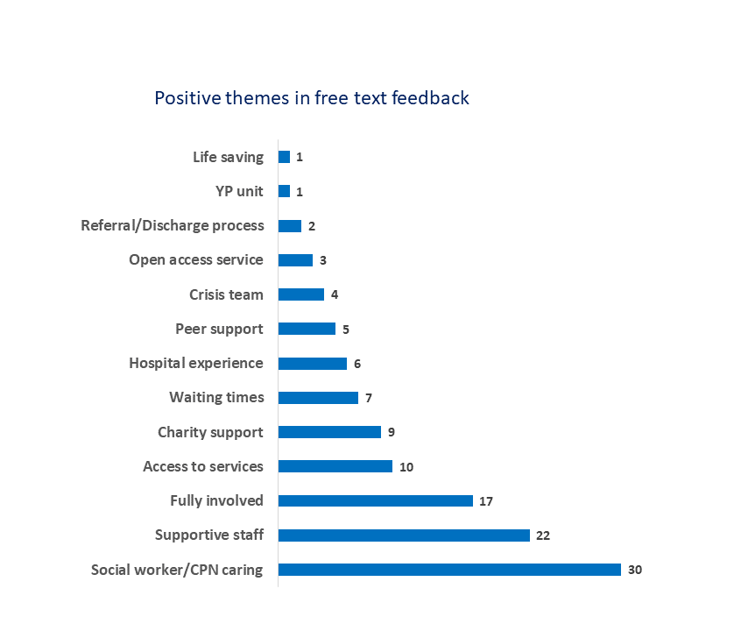

Figure Four: Challenges or barriers experienced when accessing mental health services
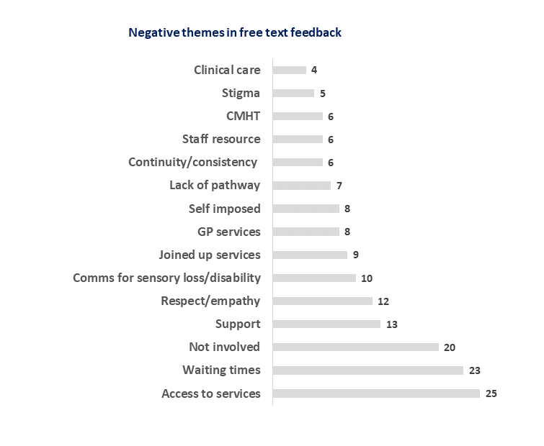
Figure Five: Important considerations in mental health support
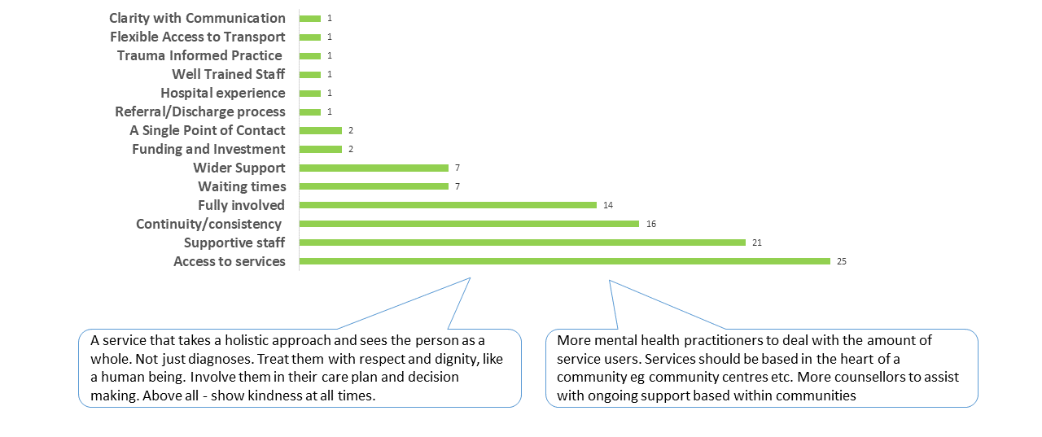
4.6. Type of information required to support people with lived experience and carers
Similar to the themes emerging from ALLIANCE and VOX’s Scotland’s existing evidence base, increased access to comprehensive information was integral to survey respondents view of required developments in mental health services. Respondents indicated that a definite need exists for clear information on the various services that are available and directions in how to access these. It is also important for both people with lived experience and unpaid carers to have regular information on the progress of their treatments and the decisions that have been made to drive this.
Please see Figure Six for a full list of the types of information indicated by respondents.

4.7. External drivers of positive mental health
Access to mental health services to support people with lived experience to receive quality care from professionals is fundamental, but participants also indicated where they had found help and advice out with the system. These external sources of support were detailed as major drivers in positive mental health for participants. Some examples included family networks and peer support, as well as exercise and community resources. This demonstrates that there are a range of strategies which people often employ to support them with their lived experience of mental ill health and reinforces the points above about the importance of services taking a holistic approach
Please see Figure Seven for a full list of sources of external support indicated by respondents.

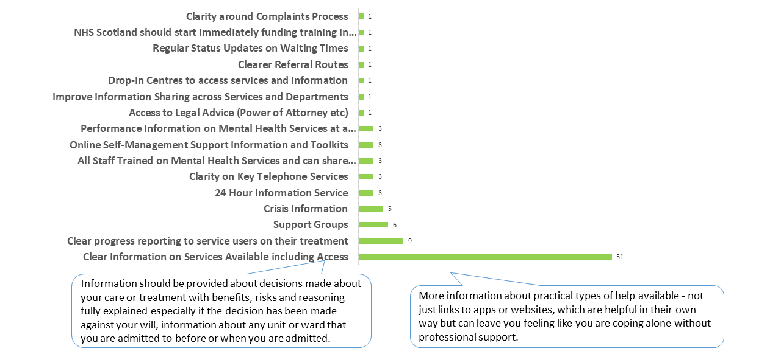
Figure Six: Types of information required to support people with lived experience and carers

Figure Seven: External drivers of positive mental health
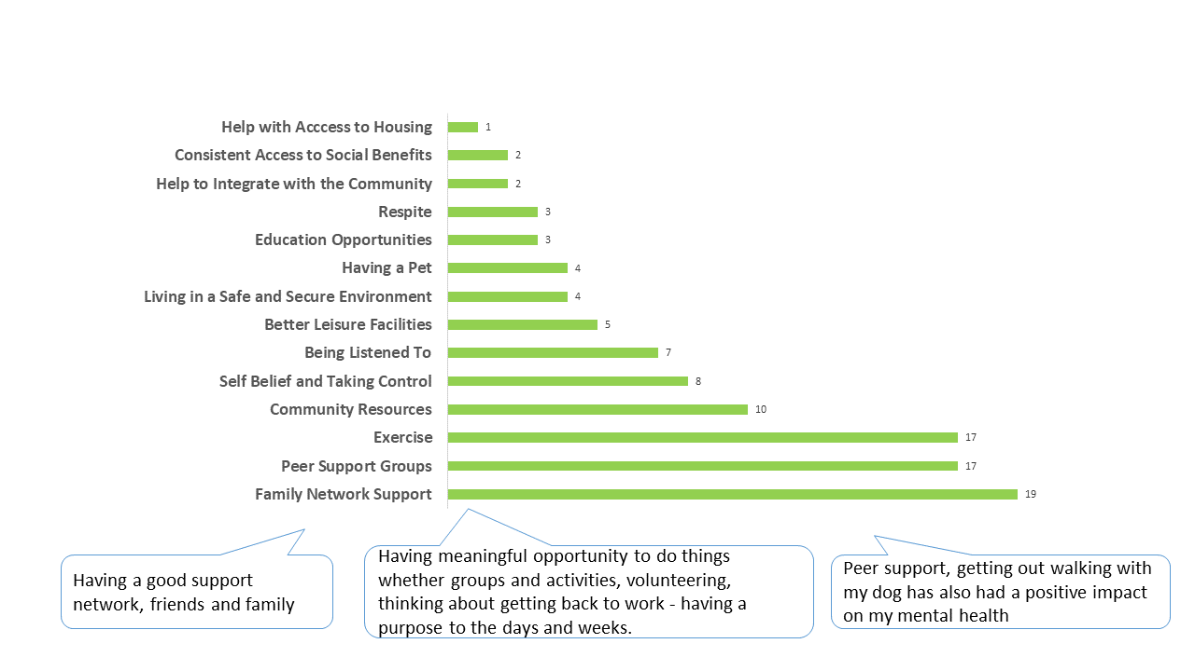

4.8. Standards for mental health treatment and support
68.9% (93 respondents) were in favour of a set of standards for mental health treatment and support. Only 6.7% (9 respondents) were against the idea. Nearly a quarter of respondents (33 respondents) were unsure. There were also 10 people who did not answer the question.
Chart Six: Respondent’s stance on set of Standards

4.9. Key principles for Mental Health Standards
For those that indicated that they supported a set of Standards, it was important to understand what principles should underlie them. Understanding people with lived experience’s priorities for the framework in which Standards would be developed is critical in creating Standards reflective of people’s priorities. From responses, person centred decision making was the most common theme across the 123 respondents (84.5%). Respondents underlined that in order for Mental Health Standards to work effectively, professionals must listen and work with individuals to agree a holistic approach.
Equal access, empowerment, dignity and respect, and open and honest communication were also fundamentals. Please see Figure Eight for a full list of themes and verbatim feedback.

Figure Eight: Principles for mental health standards or a charter

4.10. Additional Comments
Respondents had the opportunity to provide final comments via a free-text box at the close of the survey.
Within these responses, access to services and consistency emerged as key themes again. Differences between various services and teams - i.e between the hospital/ crisis support and community support – were highlighted as examples of inconsistency in care and treatment that can be detrimental to individuals’ wellbeing.
“We need to carefully work out the balance between 'least restrictive' practice and keeping people safe when they are at risk. There is a huge step down between the support in hospital and the support in the community resulting in unacceptable suffering, self-harm and suicide”
“In my experience if help was available earlier, i.e. before a crisis, many situations could be avoided. We can now see the signs when my family member’s mental health is declining but any attempts for help at that point is met with obstruction, as in no appointments available. The only option at that time is the crisis team but if you've not quite reached that point but trying to avoid it, again there's no help”
Respondents also suggested that this service could be improved if staffing levels were increased.
“The services I have encountered are mostly staffed by good people, there just are not enough people to meet the needs.”

4.11. Summary of survey feedback
Overall, there were five overarching themes that can be drawn from feedback from survey respondents: access, attitudes, person centred care, consistent support and waiting times.
Access
- Access was the most commonly reported theme across the entire survey
- Access was often ranked as the most important theme with individual questions
This is not surprising when considering that 58.9% of respondents remarked that they had tried and failed to access mental health services. Despite some respondents providing positive feedback on their ability to access mental health services, the free text feedback frequently highlighted access as a key area for development. However, respondents did recognise that limited access was driven by a lack of resources.
Respondent requirements/ suggestions:
- Accessible mental health services
- Clear information on the services that are available and details on how to access these
- Increased funding and staffing to enable more people to access services
- Empower and enable people to access the right services at the right time based on their needs.
- Ensure that people can re-enter services if initially discharged but support is needed again
Attitudes
For mental health services and psychological therapies to be successful respondents highlighted that care needs to be supportive and helpful, and that attitudes of staff should be encouraging to the person with lived experience.
When positive feedback was given, the nature of the care and staff behaviours were commonly reported. Whilst for others these elements had been drivers of negative experiences.
Respondent requirements/ suggestions:
- Supportive and helpful care should be a key principle of mental health services
- People accessing services should always be treated with dignity and respect

Person centred care
Respondents would like a holistic approach to their care, centred around their needs as individuals. People with lived experience and carers called for involvement in decisions about their care and to be kept up to date with progress.
Respondent requirements/ suggestions:
- Person centred care should be a key principle of mental health services
- Openness, honesty and transparency are key principles
- Ensure processes and practices are in place to empower people with lived experience and carers to make decisions about their care
- Ensure processes and practices are in place to keep people with lived experience and carers informed
- Empower and enable people with lived experience to access the right services at the right time based on their needs
- Improved joined up services including specialist mental health specialist services

Consistent support
At present support is perceived to be inconsistent. Inconsistencies were noted between the types of services (for example crisis units vs community support), the staff behaviours and in accessibility.
Respondent requirements/ suggestions:
- Ensure all services are equally accessible between service types
- Design holistic care packages to ensure that people move seamlessly between services
- Ensure people are always treated with the same level of dignity and respect by all staff
- Implementation of Mental Health Standards
- Addition targeted funding required to ensure equity between services
- Clear routes for escalating concerns if expectations or standards are not met
Waiting times
Long waiting lists and delays in care were a key theme within negative feedback from respondents. Limited resources and staff are seen as a key driver for delays.
Respondent requirement/ suggestions:
- Shorter waits between referral and treatment
More staff and resources to enable the staff to support more patients

- Events

The ALLIANCE and VOX Scotland hosted two virtual engagement sessions to further explore the discussion areas raised within the online survey.

The first event, held in February 2022, brought together nine ALLIANCE and VOX Scotland member organisations working within the area of mental health and/or with unpaid carers. Most organisations brought perspectives from the third sector, each representing hundreds of members and service users and bringing a prolific history of working within mental health. A full list of organisations present at the event can be found in Appendix Three.

The second event, held in March 2022, was attended by 22 people with lived experience of accessing secondary mental health services in Scotland, carers of people with lived experience, and people that identified with both experiences. For those that had accessed services, participants specified their experiences with CPNs, psychiatrists, psychologists, bereavement counselling, counsellors, and various mental health charities and day services.
VOX Scotland also attended a session with the Sharpen Her: African Women’s Network, in Glasgow on the 3rd May 2022 with ten women. Most of the women live in Glasgow or Lanarkshire, most have settled refugee status, while one woman is still in the process of attaining refugee status. The women originally come from Uganda, Nigeria, Malawi, Pakistan, Algeria and Azerbaijan.
Based on previous engagement and relationships these groups were content to participate. There was a wider open call but regrettably it wasn’t taken up. It would be important for future engagement and discussion when the full recommendations go to consultation to increased engagement with ethnic minorities and communities with protected characteristics to sense check results.
All events facilitated the opportunity for a further deep dive into the discussion areas and emerging themes that were evident from the online survey and from the existing evidence base. The feedback from both events have been organised thematically and point to key priority areas for consideration within the Standards.

Further notes from an independent engagement sessions by Flourish House, hosted in accordance with an ALLIANCE/VOX Scotland facilitation guide have been included in this analysis.

  - Access
In engagement with both organisations and people with lived experience, the accessibility of mental health services emerged as a major theme, reinforcing the survey findings. Concerns were raised that the barriers that some face in accessing services in the first instance are leading to many individuals “falling through the cracks”.
Timeframes within adult secondary health care were raised as a critical element that many felt could be addressed. All participants remarked that they had experienced long waiting times for/between appointments, with one carer indicating that their family member had been waiting upwards of 15 months to be seen by a specialist. There was a general feeling that long wait times meant that people were not able to access the care and treatment that would support them to stay well, and that instead they became increasingly unwell in anticipation of their appointment.
“It is so hard to be seen that by the time they are seen the patients are very ill. This means that they spend more time in hospital trying to get better, which makes discharge even harder” – carer

“Some disorders are episodic. Every time I have been referred to psychiatrists the waiting list is so long that it goes into remission, but it is disruptive to my life” – person with lived experience

At sessions with both people with lived experience and with organisations, the tension between being seen as ‘capable’ vs being at a ‘crisis point’ was highlighted as a means by which people were withheld the care they required. One organisational representative remarked that a number of their clients had not been able to access mental health services as they were seen as “well enough[…]to ask for what they need”. Participants therefore felt that they had to evidence that they had reached a point of “crisis before being taken seriously”.
“There is something about the term capacity that is used as an excuse. Well they’ve got capacity so we don’t need to do anything. It’s like passing the buck.” –organisation

“People with serious mental have should be automatically given a CPN instead of having to be interrogated to convince them they need one” – person with lived experience
At the engagement session facilitated by Flourish House, multiple participants pointed out that it can take many phone calls and attempts at contact to arrange appointments, even from professionals that the person has an existing relationship with.
“Our members want better access, better contact. When they phone or speak to someone, they want their phone calls returned, and it rarely happens” –organisation

A recurring comment about access to services was the importance of choice for the person with lived experience or their carer. For example, that they had the ability to choose the service that they felt was right for them, and be seen in an appropriate timeframe; or that they had the choice of selecting a style of appointment (telephone, Near Me, face to face) that was preferable to them. Participants felt that ensuring people with lived experience have choice in accessing services would support people to feel less vulnerable in doing so.

“Give the help to the people who want it, and not force it on the people that don’t” – organisation

“There’s a balance between prescribing something that a person needs and wants and just being prescribed something because the Dr doesn’t know what else to do, or the solution you need isn’t available or linked in with” – person with lived experience

Participants from all focus group activity represented a geographical spread of Scotland, and it was generally felt that there was too much divergence in the levels of accessibility in services across the country. Participants spoke of a “postcode lottery” that determined the success people had in receiving good quality support. It was a shared opinion that a priority of the Standards should be to ensure that good practice is extended nationally.

  - Attitudes
Throughout the ALLIANCE and VOX Scotland’s engagement, and in line with the evidence base, participants felt that at its foundation future Standards should seek to provoke an attitudinal shift and culture change in relation to how mental health is viewed – by professionals, wider society, and in some cases by the person with lived experience.
There was a shared feeling amongst people with lived experience that all staff working in mental health settings must receive comprehensive training in human rights, and that empathy, compassion and kindness should be key principles of practice. For participants this was critical in ensuring that people accessing services were listened to, that their concerns were seen as valid and that power imbalances between professionals and people accessing services could be somewhat mitigated. It was felt that this approach would also ensure that carers were recognised as having legitimate input. Participants from Sharpen Her: the African Women’s Network also raised the point of respect for diverse communities, and for individuals experiences and culture as being important.
“I don’t understand in this day in age how people are allowed to work in services when they are not trauma informed” – person with lived experience
“People want to be listened to, and they are not being listened to, what they say isn’t heard, they feel they are not taken seriously and no one takes any notice of them.” - organisation

Participants called for a system-wide culture that operates with respect for the dignity of the person with lived experience. For participants this meant tackling prevailing stigma around mental health in Scotland, for professionals and people with lived experience alike. Stigma was cited as a major challenge for people with lived experience within services, as well as a barrier for people pursuing support. For participants attending the session with Flourish House, self-stigma and the difficulty in accepting that they were unwell meant that participants found it confusing to navigate the system. Participants therefore called for more support in tackling self-stigma and supporting people to make sense of their situation and future.
“Patients here don't just want safety and to be looked after, they want to be supported to be free, autonomous and self-managing.” – organisation

“Believe that people can recover” - organisation

To support a shift in attitudes across mental health services, and a change in how mental ill health is perceived, some participants called for more training for professionals and more dialogue around social determinants of health and wellbeing. Participants raised issues of racism and economic deprivation as some experiences that professionals should be attuned to in considering someone’s mental ill health.

  - Information and support
Due to the diversity of mental health services available, there was a shared indication across organisations and people with lived experience that an increase in information would be useful in ensuring that people are able to seek the support they feel they require or be signposted appropriately. People spoke of not knowing where to turn to when they required help, or being bounced between various points of contact. Information that highlighted the routes to accessing selected services, as well as the criteria that people may be judged against in order to receive support, were seen as useful information that should be readily available.
Participants felt confused by the range of various charity helpline numbers, sometime unobtainable, and frustrated by the long waiting times on NHS 111. It was generally felt that there was a need for one clear approach to telephone support that was easy to access.
Across all engagement including the online survey, peer support emerged as a valuable asset to supporting people in their mental health journey. In some cases, participants highlighted that accessing peer support networks had been invaluable in helping them understand their experience and helped to augment professional services which were experiencing lengthy waiting times.
Although peer support was recognised as a practical way for people to have regular access to a supportive environment, especially in rural areas, there was an acknowledgment that peer support needed to be seen as a valued option that is suitably resourced. This was especially true for peer support workers:
“[Peer support workers] are given token money to do a highly significant role. They are treated as add-ons, which devalues the whole peer support potential. Give peer support a much higher profile and support its development” - organisation

  - Communication
It was important for people that when accessing mental health services there is efficient and available communication channels that support their journey through the system. A number of people with lived experience pointed to their good communication and consequent trusted relationship with CPNs as an example of a productive and supportive practice. Participants from the session with Sharpen Her: the African Women’s Network felt that good communication allowed people with lived experience to have autonomy, of knowing what is needed and being in control.

In general, all participants felt that communication between professionals and people with lived experience should be inclusive of carers and family members. Participants recognised the practicalities of patient confidentiality, but raised the concern that at the minimum professionals should listen to carers and family members to gain critical perspectives about the person with lived experience’s care.
In addition, one organisation pointed specifically to young carers in this instance, who in their experience reported being routinely sent out the room on home visits with their parents and caregivers and not treated as equal partners.

  - Consistency of Care and Treatment

Consistency of care and treatment was raised often as a marker of a good experience, when they felt comfortable and supported by professionals that knew them, or of a bad experience, when their care was inconsistent and engagement with professionals sporadic.
For people with lived experience, having a trusted professional who knew their story and what was important to them was very advantageous to their journey and supported a holistic approach to their care. Participants mentioned regular CPN visits as particular examples of when this consistency worked well.
Having to retell their story to different professionals was noted as a concerning issue by participants, who reflected on the re-traumatisiation that this can provoke, on top of the risk of things being misinterpreted or issues missed. In response to this, some participants called for direct access to their own records so that they can share them with a new professional or new service.
“I was really very ill and got support from the community mental health team, however, after they retired the support left too.” – person with lived experience
During the session facilitated by Flourish House, participants spoke of the value of day services, in particular those with no pre-determined end date, as very helpful in allowing people to move through a service at a consistent pace that suited them best. Most had experienced challenges related to services coming to an end sooner than desired.

5.6. Accountability
Throughout the ALLIANCE and VOX Scotland’s engagement events, most participants were supportive of the need for Mental Health Standards. However, many raised the point that Standards should be produced in tandem with a clear and transparent process of accountability and monitoring. This was seen as a foundational area to ensure that Standards were actively engaged with by professionals.
Some participants felt that Standards should be enforceable in order to support true culture change at all levels, while others were keen to understand if a clear complaints process was to be developed if they had a grievance about how the Standards were/were not applied.
It was suggested by some participants that the monitoring process for the application of the Standards should be carried out through a panel of people with lived experience, including carers.

- Psychological Therapies

In parallel with the development of Mental Health Standards for adult secondary mental health services, the ALLIANCE and VOX Scotland were tasked with supporting the development of National Quality Standards for Psychological Services and Psychological Therapies (PT). The Standards for PT will be distinct from Mental Health Standards, but it is understood that the two shall complement each other.

PT are talking therapies which can help with common mental health problems like stress, anxiety and depression. These are delivered by trained staff one-to-one, online or in groups. They are delivered in a range of settings and can support low to complex needs.

In order to ensure that the views of lived experience were also incorporated into the development of Standards for PT, the ALLIANCE and VOX Scotland undertook specific engagement on PT.

Two virtual engagement events were held in May 2022 with people with lived experience of PT, carers of people who have accessed PT, and individuals who identified as both.

The aim of the engagement sessions was to understand people’s experiences of accessing PT in order to ensure that future Standards consider a holistic model of delivery. Feedback has also been drawn from the online survey, where three questions were particular to experiences of PT.

6.1. Feedback from online survey
Within the online survey, 86 respondents out of 132 reported having experiences of accessing PT.
For respondents with experience of PT, interaction with helpful staff and engaging within services that supported their particular situation were positive aspects of PT. For more detail on the positive experiences of PT, please see Figure Nine.
Respondents did however stress that there were areas for development within PT that future Standards should consider. This includes a focus on accessibility of services, communication, and person centred care. For more detail on the improvements that respondents called for, please see Figure Ten.
“I can't describe anything positive about accessing psychological services as I've only been able to access them by ending up in hospital”.

Figure Nine: Respondents’ positive feedback on psychological therapies
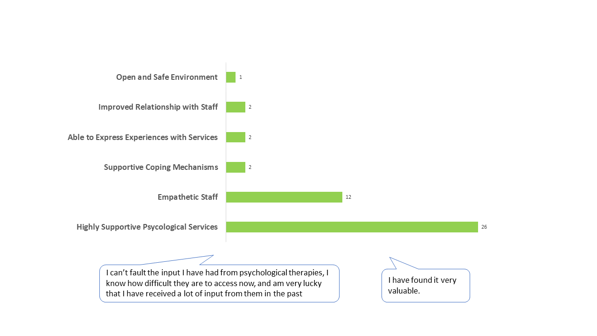

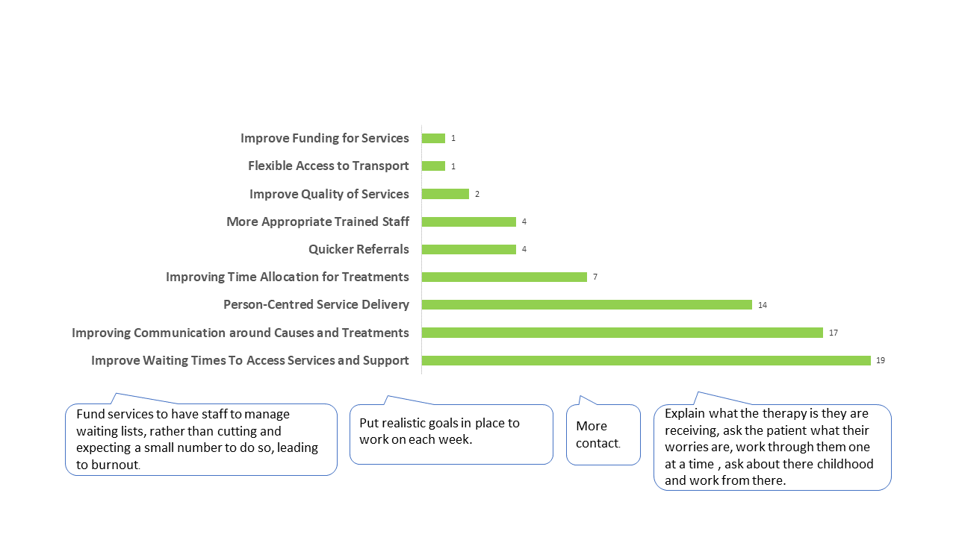
Figure Ten: Respondents’ feedback on potential improvements to psychological therapies

6.2. Psychological therapies events

The ALLIANCE and VOX Scotland met with nine individuals who had experience of accessing PT, were a carer, or identified with both experiences over two virtual focus groups held in May 2022. Participants reported a mix of positive and negative experiences of psychological therapies. A thematic analysis of participants views and experiences from both sessions is detailed below.

Holistic and multidisciplinary care
Within the ALLIANCE and VOX Scotland’s engagement, for some participants PT services become too diagnostic. Participants felt that pathways and services that are too focused on specific conditions (i.e anxiety or depression) may block people’s access to holistic care that will address their problems as a whole person with often complex needs.
There was also a broad concern that rather than trying to take into account all aspects of an individual and construct an appropriate care pathway, people are put into boxes, and receive insufficient care as a result.
“I was bounced around as was told I was too complex to treat – they finally referred me but not supplying what was adequate – meeting me halfway and properly assessing me and giving that time to share my story so that the support can be about me.”
There was a general feeling that PT should feel less like an enclosed NHS service.
Accessibility and continuity of care
Some participants expressed their concern with accessing PT. For many, self-referral pathways were limited, or there was not enough information about the options for self-referral and how to identify professionals that would be best suited to their needs. One participant felt they were left to work things out for themselves. They suggested that professionals should be advising on the right level of professional need that person with lived experience would require and that this would change over time – this is the concept of ‘stepped and matched’ care.
Participants were keen to stress that PT care is sought when care is needed, but that often by the time the person sees a professional the crisis point has passed. One participant told of waiting 10 weeks for an appointment in their rural community, while another detailed the endless process of being bounced between different pathways and clinicians before the person they cared for were able to receive a diagnosis and then support.
Participants noted that even their first referral to PT took many months. Another participant stated that once they had their foot in the door, the care got a lot better and they were more listened to but waiting for their assessment was lengthy.
“We are on a waiting list for assessment. I hear the assessment waiting time is 5 years. We need the interventions and then assessments will come. We can see our lives are changing due to interventions put in place and I want people to know that it can work even if a bit broken.”

One participant was concerned that attempting to access PT via a GP would lead to a medication route, which they didn’t want. They therefore avoided what should be an important care pathway as they didn’t trust that their GP was aware of the correct psychological services that she needed. There was an agreement that access to services should not be seen as secondary to medication.
One unpaid carer also spoke of accessing counselling, but feeling that the professional wasn’t the right match and didn’t understand the complex needs of a carer for someone with mental ill health who was accessing support themselves.
There was general agreement that access to PT should follow a ‘no wrong door’ principle, where access and referrals to services that suit the needs of each individual can be seamlessly navigated from the first point of contact with a professional. This in turn would promote continuity of care which participants felt was lacking within PT. Without a consistent point of contact, or named individual, to support your care, participants spoke of the difficulty in building a relationship with a professional who you know and trust, who can support you in a crisis and knows your lived experience. For participants with PTSD and complex PTSD, the retraumatisation that is prompted by continuously retelling experiences to new professionals was particularly troubling.

Creating meaningful culture change in PT services
One participant shared that when they read about patient-centred, trauma-informed care, they see it as a buzzword, as they’ve experienced a broad culture of PT care being done “to you rather than with you”. Genuine commitment to and awareness of human rights based and trauma informed practice was seen as fundamental.
“Person centred sometimes is done very well, sometimes it feels a bit like a sticker put on top of things. We are now person centred. You say you are person centred but what has changed and how do I as the person at the centre see that practically.”

Some participants felt they didn’t have the control they wanted in their own care pathway, and for this to change, staff attitudes must shift. There was a call for people with lived experience to be treated as equals within care, and that the knowledge they have about their own position and experience is valued and listened to.
Participants at both sessions also reported a need for professionals and services to view all people as having a right to care when they ask for it, rather than judging whether or not they really ‘need’ it. A common experience shared was how ‘high-functioning’ people are called a “victim of their own success”, and that due to so-far successful self-management strategies for their mental health they remain low on the priority list for support.
“If I hit a crisis, as someone who is high functioning, I’m at the back of the queue.”

Difference between health boards
Differences between health boards are a key issue that participants raised. For participants, Standards for PT should ensure that there is consistency in good practice across the country. For example, if one pathway works for people in Glasgow, or if there is a specialist service in Edinburgh that supports complex needs then they should be extended across Scotland. One participant spoke of changing health boards and their experience with PT being like “night and day”.

Role of external support mechanisms
All participants were passionate about ensuring that access to PT that suit each individual is prioritised so that everyone receives the support they require. However, similar to experiences shared in relation to adult secondary mental health care, participants within the PT focus groups reported the importance of receiving support from numerous actors beyond formal services.
Participants mentioned the role that various third sector and community organisations played in supporting them to manage their mental health while waiting for PT treatment. This included peer support networks and local advocacy, which were reported as a “life saver” by one participant and created opportunities for individuals to support one another. One participant expressed how contact with professionals too soon after trauma can re-traumatise, whereby contact with peers may provide better outcomes at that point in time. It was noted however that external mechanism such as peer support should not be viewed by the system as a “cheap alternative” to providing PT.
“Peer support has helped me to discover I have intrinsic value inside myself. The more people are seen together as collective, we become a signpost for life and living. Gives the authenticity and power to people’s experiences. When I get further down the line I can pass that on to someone else”
It was expressed that PT professionals should have an awareness of the support existing in the third sector, so that they can ensure the person with lived experience can be connected into supportive environments that can be additional points within their pathway.
“Self support is ok when the person is well, but the service needs a lot of research into local third and voluntary services so as to be inclusive. Organisations linked to the ALLIANCE could be approached.”
Some participants also agreed on the value that public spaces like libraries and community spaces can have for people struggling with their mental health, as the social support that these provide is an important aspect of recovery.

Accountable framework for PT Standards
There was agreement amongst participants across both focus groups that future Standards for PT need to be developed in parallel with an accountability framework to ensure that they are appropriately applied. This would clearly detail what people with lived experience can expect from their care, what happens if they don’t receive this, and what they can do about it. It was felt that this accountability framework should also produce an efficient and simplified complaints process. Participants expressed concern that they will experience further trauma through the complaints process; there is also the concern that they will be labelled ‘difficult’ due to mental health problems, affecting the quality of care received in future; and at worst, sectioned as a response to complaint. For participants, there currently exists an inherent power imbalance to this relationship that discourages complaints.
“People are not psychologically well and not really in a place where they are able to complain. That complaints process has to be simpler or less lengthy.

“In psychiatry if you make a mess of things there is no accountability[…]There should be a bit of tolerance but […]we need to enforce good care. We are talking about life and death and there is no safeguards”

For PT services to be accountable, participants supported a body that would monitor and evaluate the progress of the Standards. It was critical that ongoing evaluation also considers regular feedback from people with experience of accessing PT. Co-production of service redesign as a result of the Standards was essential for people with lived experience to feel confident that the Standards were a live document that were responsive to the needs of people with lived experience. One participant suggested creating a body of people who are experts by experience, who are invited to board meetings and review sessions around the Standards.
One participant also called for a system along the lines of accreditation in relation to PT Standards that would promote trust in services.
“If a specialist domain there is no outward body that says yes you are a specialist service. As far as I'm aware there is not an awarding body that checks that you are following up to date guidelines or standards written. Needs a more rigorous check.”

- Conclusion and recommendations

Throughout the ALLIANCE and VOX Scotland’s history of engaging with people with lived experience on their own mental health, people have spoken candidly about both positive aspects to the system and the barriers that they feel remain.

In consideration of both organisations’ past engagement work, which set a precedence for understanding what is important to people when accessing mental health care, and our recent work with regards the Standards, it has been evident that although every individual’s experience is distinct there are a number of key thematic overlaps. As both survey and event participants highlighted, people’s complex experiences and specificities of their mental health requirements means that services must be highly attuned to individual need, but there are some central principles and recommended areas of focus that would benefit all within the development of Mental Health Standards, and Standards for Psychological Therapies.

  - Foundational principles for adult secondary mental health services and psychological therapies
In considering both the volume and range of evidence collected the ALLIANCE and VOX suggest that the UN PANEL approach informs the following foundational principles.
- Person centred and collaborative care
- Holistic approach that recognises a range of strategies
- Mental health care has the options to be self-directed by the individual
- Human rights based and trauma informed practice
- Equal and non-discriminatory access to services
- Empathy, kindness, compassion and respect as a framework of practice
- Openness, honesty and transparency are key principles of delivery.
- Ensure processes and practices are in place to empower people with lived experience and carers to make decisions about their care and to stay informed
- Destigmatisation of mental health in Scotland, including for professionals and people with lived experience
- Understanding of health as being socially determined, including an awareness of the impacts of racism and economic deprivation on mental health

  - Recommended areas for development

Within the existing evidence base, survey and events participants spoke of a number of examples when their experience of services was positive and supported their journey. These included helpful and considerate staff, regular check ins, being kept informed of their care and journey, a flexible and ‘whole-person’ approach and quality of care and treatment. However, the data collected provides an honest picture, which is not universally positive or negative. As our survey noted there was a significant overlap between respondents who gave positive feedback and respondents who experienced challenges and barriers.

Therefore the ALLIANCE and VOX Scotland’s engagement highlights a number of recommended areas for development that people with lived experience would appreciate recognition of within future Standards for adult secondary mental health care, and for Psychological Therapies.

Access
- Shorter waiting times between referral and treatment
- Stop divergence between health boards and ‘postcode lottery’ by ensuring good practice is extended nationally
- The first point of contact should always engage and signpost i.e. a ‘no wrong door’ approach
- More access to rehabilitation and meaningful therapies is needed
- Empower and enable patients to choose and access the right services at the right time based on their needs, and not only when people are in crisis
- Provide more opportunity for people with lived experience to choose appointment styles that suit them
- There is often a lack of consistency in criteria used to assess access to services
- Flexibility of opening times for services that provide support out with office hours
- Ensure that people can re-enter services if initially discharged but support is needed again

Attitudes
- Supportive and helpful care should be a key principle of mental health services
- People accessing services should always be treated with dignity and respect
- Staff should be comprehensively trained on human rights and trauma informed practice
- Carers should be viewed as having valuable insights into a person’s care and experience
- Efforts amongst services to actively mitigate any power imbalances so people with lived experience can be equal partners in their own care.
- Respect for diverse communities, and for individuals experiences and culture

Accountability

- Standards should be produced in tandem with a clear and transparent process of accountability and monitoring
- Establish a clear complaints process was to be developed if they had a grievance about how the Standards were/were not applied
- Coproduce monitoring process with people with lived experience, including carers
- Establish a monitoring body, including people with lived experience

Information and Support
- Clear information on all services that are available and details on how to access these and the criteria that people may be judged against. This information should also include expected waiting times
- More accessible information is needed - in plain English and in other formats and languages too
- Establishing a national support helpline that is appropriately resourced
- Clarity around complaints process
- Performance information of local mental health services
- Clear progress reporting to service users on their treatment
- Signposting to community support and third sector actors, including peer support networks and local advocacy

Consistency of Care & Treatment
- Access to early intervention and self management support to ensure that people do not only receive care when acutely unwell
- Ensure ongoing support and options for people to engage with services without predetermined end date
- Consistency in professionals. Seeing someone new every time means no continuity of care and constantly retelling experiences which can provoke retraumatisation
- Ensure all services are equally accessible between service types
- Design holistic care packages to ensure that people move seamlessly between services

Communications
- Real choice around digital (online or telephone) consultations and communication vs face to face options
- Better communication between services and professionals, about a person’s individual care and also about what is available to people across the system
- Efficient, clear and available communication channels that support their journey through the system
- Communication between professionals and people with lived experience should be inclusive of carers and family members

  - Next steps

The ALLIANCE and VOX Scotland’s engagement work was driven by key objectives of understanding what was important to people with regards their mental health, and creating platforms for people to share their experiences.

Our engagement work provided spaces for people to participate in discussions around how they envisaged future adult secondary mental health services and psychological therapies. In doing so, many people expressed the wish to be able to continue this conversation as the Standards progress, are implemented and are monitored.

The ALLIANCE and VOX Scotland therefore call for a continued dialogue with people with lived experience, so as to ensure that their priorities remain connected to service development and policy, and that avenues for coproduction are available.

The organisations note the success of the UN PANEL approach in addressing the need for a human rights based approach which builds on key themes identified – sigma, involvement, accountability – all areas identified by participants as essential foundation on which to build mental health standards.

This work alongside the views of the workforce and other information gathering will inform the drafting of Mental Health Standards. The ALLIANCE and VOX would like to thank all of those who have participated in giving a strong voice to those who experience and have experienced mental health challenges.
Appendix One: List of survey questions

1. About the survey
The Scottish Government are looking to develop Quality Standards for Adult Mental Health Secondary Services. The Quality Standards will set out what you can expect from services and the principles on which they will be delivered.
2. Questions
1. Are you:
- Someone with lived experience of mental ill health?
- Someone who cares for someone with mental health problems?
- Someone who both cares for someone and has personally experienced mental health problems?
2. Have you or the person you care for had experience of accessing mental health services?
- Yes
- No
3. Have you or the person you care for tried to access services but did not receive support?
- Yes
- No
4. Can you tell us a bit about your experience in accessing and using services? You are welcome to detail the types of services you have accessed (e.g CPN, psychiatric hospital care, crisis team support) but this is not required.
5. Can you describe anything positive about your experience accessing and using services?
6. Can you describe any challenges or barrier that you experienced when accessing and using services?
7. Would you, and if applicable, your family, be in favour of a charter or set of standards that covered your mental health treatment and support?
- Yes
- No
- Unsure
8. What is important to you, and if applicable, your family, in relation to mental health services?
9. What information do you feel is important that would help and support you in relation to mental health services?
10. What principles should mental health standards or a charter be founded upon? For example, support to make you own decisions etc.
11. Beyond mental health services, what has had, or might have, a positive impact on your mental health?
12. The next section of the survey will be about ‘Psychological Therapies’.
By this, we mean talking therapies which can help with common mental health problems like stress, anxiety and depression. These are delivered by trained staff one-to-one, online or in groups.
Have you, or someone you care for, received a Psychological Therapy from a Mental Health Service? If No, then please proceed to question 15.
- Yes
- N
13. Can you describe anything positive about your experience accessing and using Psychological Therapies, or in supporting the person you care for in accessing or using Psychological Therapies?
14. Can you describe anything that could have been done differently to improve your support when accessing and using Psychological Therapies, or in supporting the person you care for in accessing or using Psychological Therapies?
15. Which age group are you in?
- 18-29
- 30-39
- 40-49
- 50-59
- 60-69
- 70-80
- 80 +
- Prefer not to say
16. Which Health Board area do you/they live in?
- NHS Ayrshire and Arran
- NHS Borders
- NHS Dumfries and Galloway
- NHS Western Isles
- NHS Fife
- NHS Forth Valley
- NHS Grampian
- NHS Greater Glasgow and Clyde
- NHS Highland
- NHS Lanarkshire
- NHS Lothian
- NHS Orkney
- NHS Shetland
- NHS Tayside
- Prefer not to say
17. How would you describe your/their gender identity?
- Male
- Female
- Non-binary
- Other (please specify):
- Prefer not to say
18. Do you consider yourself to be trans, or have a trans history?
- Yes
- No
- Prefer not to say
19. What is your/their ethnic group?
- White – White English/Welsh/Scottish/Irish/Northern Irish/Gypsy or Irish Traveller or any other white background
- Mixed – any mixed or multiple ethnic groups
- Asian – Indian, Pakistani, Bangladeshi, Chinese or other Asian background
- African, Caribbean or any other Black/African/Caribbean background
- Prefer not to say
- Other (please specify):
20. Please use this space for any additional comments

Appendix Two: Survey data – demographic information

Gender
Overall, 89 women (63.6% of respondents), 39 men (27.9% of respondents), zero transgender individuals (0.0% of respondents) and zero non-binary individuals (0.0% of respondents) participated in the survey (see chart 1). A further seven individuals (5.0% of respondents) preferred not to disclose their gender, five (3.6% of respondents) individuals classified themselves as other and five individuals did not answer the question.
Chart 1: Respondents’ Gender

Age
134 people who chose to disclose their age and 11 chose not to answer. The age ranges varied from 18 years old to 80+ years old. The highest number of respondents (38) were in the 50-59 years old category (28.4%). There were few respondents (two respondents, 1.5% of respondents) that were over 70 years old or under 29 years old (10 respondents, 7.5% of respondents).

Age Group | Response Percent | Response Total
18-29 | 7.5% | 10
30-39 | 17.9% | 24
40-49 | 22.4% | 30
50-59 | 28.4% | 38
60-69 | 18.7% | 25
70-80 | 1.5% | 2
80 + | 0.0% | 0
Prefer not to say | 3.7% | 5
Total | 100% of responses | 134
Table 1: Percentage and numbers of respondents in each age band
Ethnicity
As table 2 shows, the majority (135 respondents, 96.4%) identify as white, one respondent described themselves as “mixed or multiple ethnic groups”, one respondent identified as “Asian – Indian, Pakistani, Bangladeshi, Chinese or other Asian background” and one person stated that they were part of an “other ethnic group”. A further two respondents chose not to specify their ethnicity and five did not answer the question.
The overall spread of survey respondents is accordingly slightly less ethnically diverse than is typical for Scotland.
Ethnic Group | Response Percent | Response Total
White – White English/Welsh/Scottish/Irish/Northern Irish/Gypsy or Irish Traveller or any other white background | 96.4% | 135
Mixed – any mixed or multiple ethnic groups | 0.7% | 1
Asian – Indian, Pakistani, Bangladeshi, Chinese or other Asian background | 0.7% | 1
African, Caribbean or any other Black/African/Caribbean background | 0.0% | 0
Prefer not to say | 1.4% | 2
Other (please specify): | 0.7% | 1
Total | 100% of responses | 140
Table 2: Respondents’ Ethnic Group
Health board area
As chart 2 shows, 37 respondents (26.4%) lived in NHS Ayrshire and Arran, 25 respondents (17.9%) lived in NHS Greater Glasgow and Clyde, 17 respondents (12.1%) lived in NHS Tayside, 15 respondents (10.7%) lived in the NHS Highland, 11 respondents (7.9%) lived in NHS Lothian, nine respondents (6.4%) lived in NHS Forth Valley, nine respondents (6.4%) lived in NHS Lanarkshire, four respondents (2.9%) lived in NHS Fife, four respondents (2.9%) lived in NHS Grampian, three respondents (2.1%) lived in NHS Dumfries and Galloway, one respondent (0.7%) lived in NHS Borders, one respondent (0.7%) lived in NHS Western Isles, one respondent (0.7%) lived in NHS Shetland and there were no responses from NHS Orkney.
A further three respondents (2%) selected “prefer not to say” and five people did not answer this question.
Chart 2: Survey Respondents’ Health Board Area

Appendix Three – List of organisations at engagement event

- Bipolar Scotland
- Carers Trust Scotland
- Edinburgh Patient’s Council
- Ewen’s Room
- Glasgow Association for Mental Health (GAMH)
- Healing for the Heart
- Mental Health Rights Scotland
- Mindspace Limited
- SPIRIT Advocacy – HUG

About the ALLIANCE
The Health and Social Care Alliance Scotland (the ALLIANCE) is the national third sector intermediary for a range of health and social care organisations.
The ALLIANCE has over 3,000 members including large, national support providers as well as small, local volunteer-led groups and people who are disabled, living with long term conditions or providing unpaid care.
Many NHS Boards, Health and Social Care Partnerships and Primary/Community Care practices are associate members and many health and social care professionals are Professional Associates. Commercial organisations may also become Corporate Associates.
Our vision is for a Scotland where people of all ages who are disabled or living with long term conditions, and unpaid carers, have a strong voice and enjoy their right to live well, as equal and active citizens, free from discrimination, with support and services that put them at the centre.
The ALLIANCE has three core aims; we seek to:
• Ensure people are at the centre, that their voices, expertise and rights drive policy and sit at the heart of design, delivery and improvement of support and services.
• Support transformational change, towards approaches that work with individual and community assets, helping people to stay well, supporting human rights, self management, coproduction and independent living.
• Champion and support the third sector as a vital strategic and delivery partner and foster better cross-sector understanding and partnership.

About VOX

VOX is a national charity of, for, and by people with mental health problems. We represent the views individual, group, and associate members to politicians and health professionals – making sure that Scotland’s laws and mental health services reflect their needs and interests.

VOX ensures that people with lived experience of mental can:
- Shape Scotland’s laws
- Influence service design and delivery
- Promote a better understanding of mental illness in wider society
- Advance the general interests of people with mental health issues
We provide collective advocacy
VOX Scotland provides collective advocacy at the Scottish national level, representing groups and communities with lived experience of mental health difficulties and shaping policy and practice. We exist to represent our members’ views at the national level to health professionals and politicians. As we are not a service provider, we can represent our members’ views without being influenced by any set agenda or goal other than to understand our members experiences.

We run events for members to connect and learn
VOX holds two national members’ meetings per year, including our Annual General Meeting. These meetings establish VOX priorities and we capture views through inclusive methods to ensure that all work is driven by our members. Throughout the year, we also host a range of events on issues that matter to our members – including opportunities to shape the latest developments in Scottish Government mental health policy and practice.

We support local groups and partners
Building capacity is a key part of the VOX mission, and we also support individuals to form their own groups to express their experiences in their own words. VOX represents at the national level across all mental health issues and works in partnership with local and regional groups and thematic mental health organisations.

We are led by our members
VOX members decide VOX priorities at our two national members’ meetings per year and VOX staff implement these priorities on a day-to-day basis. Our Board consists of VOX members with a lived experience of mental illness plus nominated members with special expertise in mental health issues.

The Equality Act 2010 recognises 9 Protected Characteristics: age, disability, gender reassignment, marriage and civil partnership, pregnancy and maternity, race, religion or belief, sex and sexual orientation. The act protects people from being discriminated against because of any of these characteristics.

