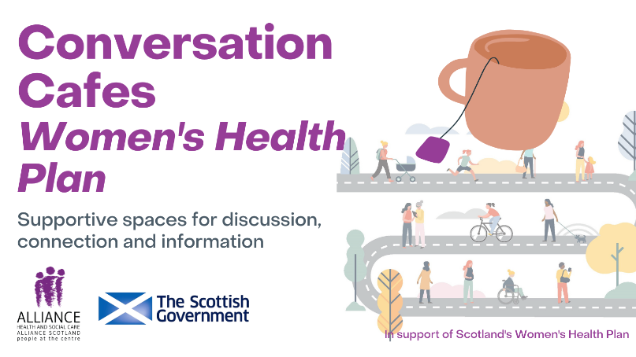

**Guidance for case studies**

Thank you for using the Conversation Café for Women’s Health toolkit with your group or organisation.

The toolkit has been designed in support of the Scottish Government’s Women’s Health Plan, and aims to support people to host independent Conversation Cafes to discuss and explore aspects of women’s health experiences.

The ALLIANCE would like to create an **evidence-base** that highlights the effectiveness of the Conversation Café model for empowering women with information about their health and encouraging positive attitudes.

In writing a short case study on your work using the Conversation Café for Women’s Health toolkit, you will be helping us to share stories about the value of furthering women’s access to information and support for their health.

**What to include in your case study**:

* Brief outline of your organisation
* Information about the Conversation Café group – *what brought everyone together? Why did people want to join?*
* Experiences of using the toolkit to set up the Cafe – *how did you use the toolkit? what worked well and why?*
* The topics of conversation covered – *did the Cafe members steer the conversation?*
* Any learning gained from the process – *was there barriers or challenges to overcome? What resources worked best?*
* What impact has the Conversation Cafes had on members of the group – *did it make a difference?*
* Your thoughts on creating supportive spaces for discussion, information and connection for women’s health.

**You may also find it useful to use the evaluation questions found within the toolkit to collect feedback from participants in order to help inform your case study.**

**Case study tips**

* 500-800 words
* Narrative format – tell a story
* Include relevant photos, requesting permissions where necessary;
* Include quotes from individuals relating to their experiences of the sessions;
* If appropriate, include any quantitative data that has been collected demonstrating impact, need, reach or any other relevant statistical data;
* Insert observations made by those writing the case studies.

To discuss further, or to submit your draft copy, please contact us at [whp@alliance-scotland.org.uk](mailto:whp@alliance-scotland.org.uk)

If you include any case study examples regarding individuals please **maintain anonymity**, do not include names or identifying factors.

The final case study will be published on the ALLIANCE website and shared via social media, e-newsletters and in reporting. It will be publicly accessible.

For the ALLIANCE’s full privacy policy see here: <https://www.alliance-scotland.org.uk/privacy-policy/>

End of document.