













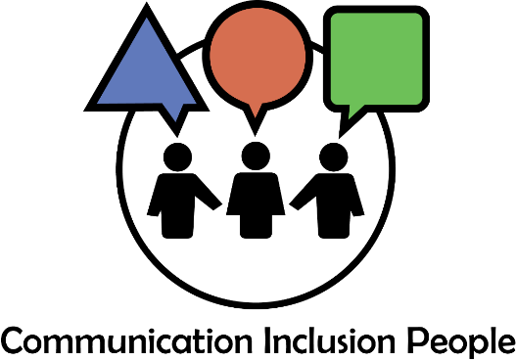

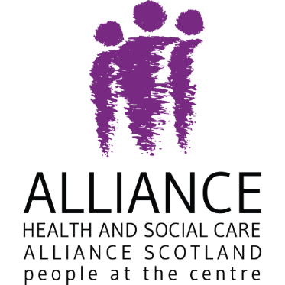
The ALLIANCE member workshop with
Communication Inclusion People

Call 0141 404 0231
The ALLIANCE, the Venlaw Building, 349 Bath Street, Glasgow G2 4AA

Or Email membership@alliance-scotland.org.uk
Developing your communication inclusive practice

Easy Read and Large print
Lunch and drinks
Parking
3,18,77,4,4A, 6
Charing Cross
Physical access
BSL interpreter / Sign language
 For more information and a registration form
Visual support
Hearing support

Wednesday 24th May 2023
12.30-3.30pm

