National Collaborative – Community Conversation Small Grants

Introduction

The National Collaborative’s vision is to integrate human rights into drug and alcohol policy leading to better outcomes for people affected by substance use.

The purpose of the National Collaborative is:
- To empower people affected by substance use to enable their voices – and, critically, their rights - to be acted upon in policy and decision-making concerning the design, delivery and regulation of drug and alcohol services at a national level.
- To set out how the rights to be included in the forthcoming Human Rights Bill can be effectively implemented to improve the lives of people affected by substance use.

Further information on the National Collaborative, including the Roadmap, is available on the ALLIANCE's website.

The National Collaborative has developed an approach that brings together:

- A Change Team of people affected by substance use and their families (rights holders), independent advocates (rights defenders), service providers (duty bearers) and regulators to co-design an Action Plan.
- A Learning and Leadership Network of organisations involved in connecting the National Collaborative with wider communities, groups, and existing networks.
- Reference Groups of communities and groups identified as underrepresented on the Change Team to provide advice and extend the reach of the National Collaborative.

The Action Plan for the National Collaborative will include:

- A Charter of Rights, co-designed between people affected by substance use, service providers and government.
- An Implementation Framework, to ensure these rights are made real in everyday life.
- A Monitoring and Evaluation Framework to measure the on the ground impact of the Charter of Rights.

To reach its objectives, the National Collaborative is applying a human rights-based approach. This approach places people and their human dignity and rights at the centre of all policy and decision-making.

The National Collaborative is using the FAIR Model of a human rights-based approach.
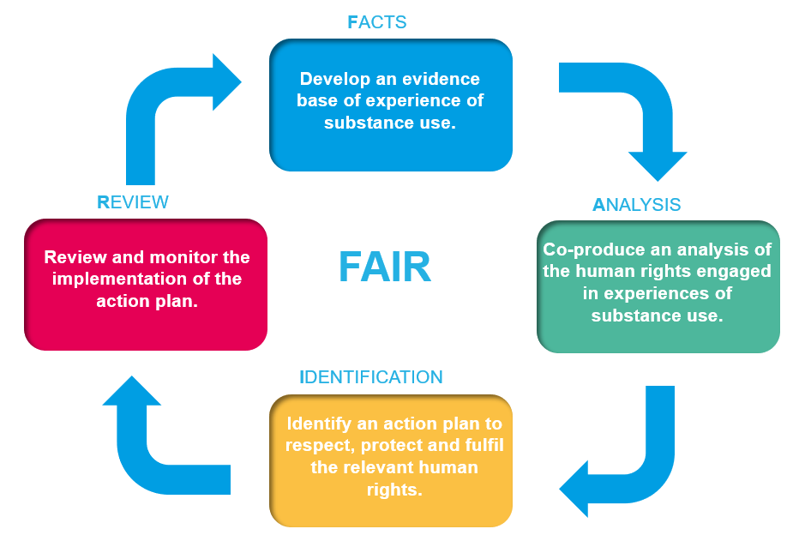

As part of the IDENTIFICATION stage in the FAIR Model, we are issuing this consultation on a draft Charter of Rights for people affected by substance use.

This draft Charter of Rights was informed by the Call for Evidence which took place in May - Aug 2023.

The draft Charter of Rights aims to:
- directly support people to know and understand their rights in order to access drug and alcohol services.
- directly support service providers and government to continuously improve the availability, accessibility, acceptability and quality of such services. And
quality of such services.
Community Conversation Small Grants

As part of the consultation on the draft Chart of Rights, the National Collaborative are inviting partners to facilitate a conversation with their communities and people they support.

To support this, the ALLIANCE, are making available small grants of up to £250 per community conversation. It is recognised that in some circumstances, particularly in remote and rural areas, expenses might exceed this. It is intended that a flexible approach will be taken to any circumstances requiring additional funding. Additional information with regards to this should be supplied on pages 4 - 5. A flexible approach will be taken that will ensure a wide range and reach across both geographic and thematic communities.

Grants will be administered on a first come first served basis, with 37.5% of the total grants reserved for community conversations taken forward with:
- communities with protected characteristics
- rural communities

Once submitted, applications will be reviewed to confirm they meet the criteria of the community conversation and we will be back in touch.

A Facilitation Guide is available with more information on how to take forward a community conversation.

When to submit:

The final deadline to submit a completed Community Conversation Outline is the 3rd June 2024.

Please submit completed applications to:

people@alliance-scotland.org.uk

Your organisation

Organisation name
Address
Telephone number
Website
Address for correspondence
(if different from above)

Legal status of organisation

(if a registered charity please

state charity number)
e – Your Organisation

Main Contact

For on-going communication please provide a main contact who will be responsible for the Community Conversation.

Name of main contact

Position

Contact number

Contact email address

Community Conversation Outline

Please summarise in 150 words the community conversation you would like to use this small grant for.

Amount requested (up to £250)*

Please describe what you will use this money for.

What area(s) of Scotland will this work cover?

What community(s) will this work connect into? (e.g. living experience, rural, women, young people etc.)

* in exceptional circumstances and budget permitting higher amounts may be available to meet specific requirements.

Part Four - Budget – Budget

Please list how you plan to use the Community Conversation Small Grant.

Proposed Expenditure  (please detail) | Amount
Total Expenditure

Part Six - Signatures

I confirm that the information provided for this application is true and accurate.

Name

Signed

Date

Position in Organisation

Privacy Statement

The personal data on this form is being collected by the ALLIANCE for the following reason: to effectively process your application for the National Collaborative community conversation and to carry out due diligence checks. The ALLIANCE and its sub-contractors will not distribute or disclose your personal information to third parties unless we have your written permission or are required by law to do so. We comply with the Data Protection Act 2018 and GDPR 2013 when handling your personal information. If you have any concerns about how we use your personal information contact DPO at: DPO@alliance-scotland.org.uk. Alternatively, you have the right to complain to the ICO https://ico.org.uk/concerns/. For our full privacy policy, which provides detailed information regarding your rights and how we will process your information and for how long we will retain it, please read https://www.alliance-scotland.org.uk/privacy-policy/ By signing this form you are confirming that you have read and understood our privacy policy and are consenting to us processing your personal information for the above purposes in line with this policy, which is our legal basis for processing your personal information.

