"articulate

Digital Discoveries Evaluation Report"

Then images below 12 clouds in three rows of four. Each cloud has a face with a different expression including happy, sad and laughing. 



**Contents:**

1. **What did we do?**
2. **Digital Discoveries in numbers**
3. **Co-design**
4. **What did we learn?**
5. **Recommendations to take forward**
6. **Development opportunities**

**5. Next steps for participants**

**8. Questions**

**9. Thank you**

1. **What did we do?**

Digital Discoveries was a short series of interconnected participatory action research workshops that explored how existing and emerging digital tools can support the wellbeing of children, young people and adults with lived experience of care.

Funded by Alliance Scotland’s Discovery Grant, Digital Discoveries was made up of three creative explorations that connected trauma-sensitive tools and techniques and the skills of quality teaching artists in collaboration with care experienced young people and professionals who work within the ﬁeld of arts, health and wellbeing. Participants worked together using existing and new ideas to ﬁnd meaningful wellbeing tools that provide respite, support and care through times of change, stress, anxiety and isolation.

At Articulate, we deliver both face to face, online and digital, as well as hybrid activity depending on the preferences of the young people and the potential or characteristics of each initiative. We are currently developing a new secure space called *The Vault*, which is a curated online app for keepsakes, treasured memories in digital forms, key data and information that the young people value as well as a space for ongoing journaling and reflection. The learning from the Digital Discoveries creative explorations will now feed into *The Vault*, Articulate’s ongoing creative life stories work, as well as the second iteration of our larger-scale learning platform called *The Hub*.

Digital Discoveries encouraged care experienced young people and children to:

* 1. connect and engage with trauma-sensitive digital wellbeing tools.
  2. collaboratively discuss and explore existing, pioneering and imaginative digital wellbeing tools.
  3. engage with creative and playful technology to tell their life stories with conﬁdence, self-expression and self-governance.
  4. to re-engage with familiar digital technology and see it in a different light.
  5. to be listened to and valued in an action research environment that considers and responds to their direct needs and interests.

1. **Digital Discoveries in numbers:**

* 100% of participants felt included and listened to during the Digital Discoveries workshops held in the studio
* 78 participants attended
* 67 hours paid employment for care experienced young people
* 10 hours of studio workshops

+ 5 day residential delivered

1. **Co-design**

Articulate aims to always provide co-designed and youth-informed creative activities that have young people with experience of care at the heart of everything. The Vault and The Hub are no different. Articulate’s youth board (the Creative Changemakers) and care experienced staff members have been pivotal in the development and design of these digital platforms and have supported all three creative explorations to date.

Digital Discoveries worked closely with fantastic practitioners from across the disciplines to create diverse and multidisciplinary learning opportunities which will inform Articulate’s wellbeing service both physically and digitally. Digital Discoveries brought together:

* Kinship carers and families
* Young people with lived experience of care
* Creative Assistants with lived experience of care
* Practising artists
* Professionals working within the ﬁeld of health, wellbeing and the arts
* Quality teaching, trauma-informed practitioners

Digital Discoveries programme of events was as follows:

3rd - 6th April: Residential trip with Articulate’s [Dot to Dot](https://www.articulatehub.com/dot-to-dot#%3A~%3Atext%3DDOT%20to%20DOT%20%2D%20Our%20creative%20parenting%20project%26text%3DWe%20provide%20opportunities%20for%20families%2Cwith%20other%20like%2Dminded%20parents.%26text%3Dwith%20our%20Producer%2C%20Laura%20Frood) families to visit [Abriachan Forest](http://www.abriachan.org.uk/) [Trust](http://www.abriachan.org.uk/) accompanied by [trove](https://studiomeineck.com/trove/) and researchers Lisa May Thomas and Dr Stewart Gray from Bristol University.

22nd April: Exploring digital and social design for wellbeing with [Chloe Meineck](https://studiomeineck.com/), supported by responsive drawing workshops with illustrators [Molly Hankinson](https://www.mollyhankinson.com/) and [Michaela McManus](https://www.michaelamcmanusartist.com/).

29th April - Ethical digital storytelling and photography approaches with [PhotoVoice](https://photovoice.org/)’s CEO, Tom Elkins.

1. **What did we learn?**

**Digital Discoveries One:**

During the ﬁrst creative exploration, families who are part of Articulate’s long-term project called Dot to Dot worked closely with *trove*, a digital and physical wellbeing tool that encourages participants to tell their own life story with dignity and self-governance. Young people in care often lead transient lives, and trove provides a platform with greater agency around the narrative of experiences and can link these experiences to physical items that hold meaning and value to the storyteller. At Abriachan, trove created space for the children and young people to reflect on their experiences and they really enjoyed being able to document their day by telling stories using their own creations or natural found objects from the forest and creative and outdoor play activities scheduled.

“To ‘trove it’ became a saying over the week. When the children did something new or exciting they would say ‘lets trove it!’, for example: *Pizza trove* and *Tree trove*”. A few of the older children loved looking after trove and acted as trove champions, enjoying the responsibility it offered as they explained its use and value to others.

*The young people connected to trove and made it their buddy. It was relatable because it felt like a living thing, you would hear ‘take trove here, take trove there!’*

Trove broke down barriers to using digital tools because the children and young people were part of the process and could use trove with autonomy. The trove team from Bristol University had expected that the use of trove might feel prescriptive but trove organically became a reciprocal relationship during the residential. Trove looks after the young people by collecting and caring for their precious memories, stories and experiences and in turn trove was cared for by the group and became almost humanised as a member of the team.

*“It is di erent from using a camera because they are included in the experience.”*

Taking trove to Abriachan allowed time and space to compare the experience of using trove in a solitary environment and in a group dynamic. Peer use of trove can spark rich evaluative conversation with sensory and physical elements to support children and family recall, memories and reflections. Trove does encourage peer learning but it was important to be mindful of chaotic recordings when large and complex family groups and dynamics are involved. Staff supporting trove needed to be cautious of speed when documenting oral and visual information so that the children and young people could represent themselves authentically without being rushed or performative.

At Abriachan, trove felt like a rich experience for documenting storytelling in a way that integrates a multi-layered experience. Researchers, Lisa and Stuart spoke about an experience of recording the sound of a small river. The physical task of recording the river can store a digital memory but also as a memory stored internally within our physicality. The sound of the river could remind the adventurers of the forest and become a multi sensory experience. Trove worked in a rural environment and the juxtaposition of digital technology being surrounded by nature enhanced both technology and the beauty of the outdoors.

Everything we learned from trove will also now inform how Articulate frames and makes accessible The Vault app and supports.

**Digital Discoveries Two:**

The ﬁrst of the studio-based workshops was with Chloe Meineck who works in collaboration with the trove team and holds her own practice as *Studio Meineck*, a social design studio that creatively combats real issues and daily challenges by using co-designed physical and digital technologies.

Chloe held round-table discussions and presented various examples of different digital wellbeing tools before making space for group conversations and questions. To underpin the learning we creatively responded to this dialogue and as a group worked with two quality teaching artists, Molly Hankinson and Michaela McManus. Interchange organically flowed throughout the day. The visual/digital art practitioners embraced movement techniques, using the floor and drawing on the walls to hold critical dialogue and encourage side-by-side communication. The unison of collectively creating, keeping our hands and bodies busy, and using different studio zones allowed informal yet rich learning experiences where participants could relax and share freely within a non-hierarchical and non-judgemental environment.

Collaboration with practitioners with different skill sets was beneﬁcial too and everyone held the space with various trauma-informed approaches and perspectives. For example, Chloe showing visual examples of existing digital wellbeing tools grounded the day and supported participants to visualise wellbeing scales that negate traditional, clinical agency and linear aesthetics.

*“I think creating the wellbeing spectrum went well: the young people engaged in conversations about their feelings and emotions and were able to translate this into their own visual language.”*

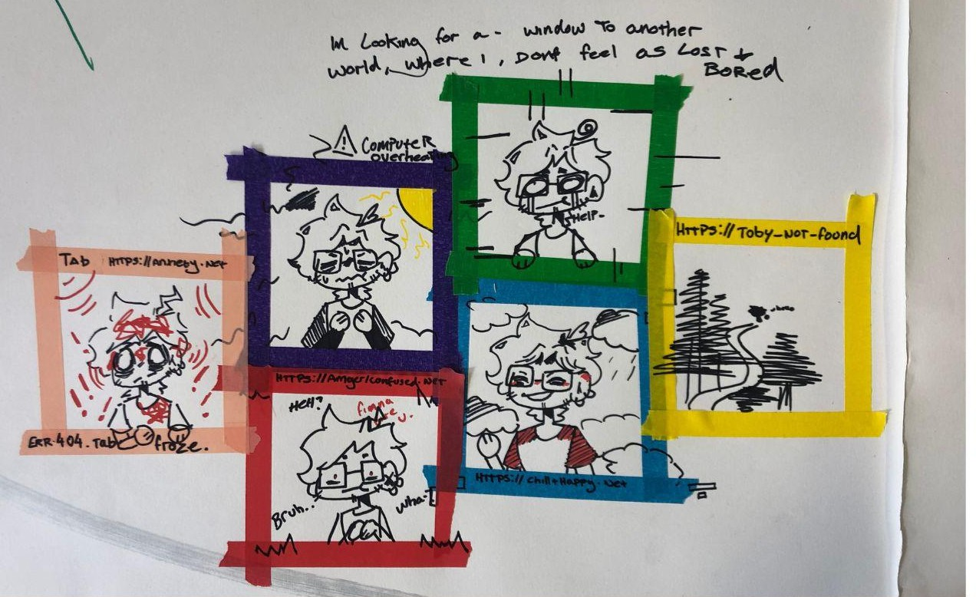

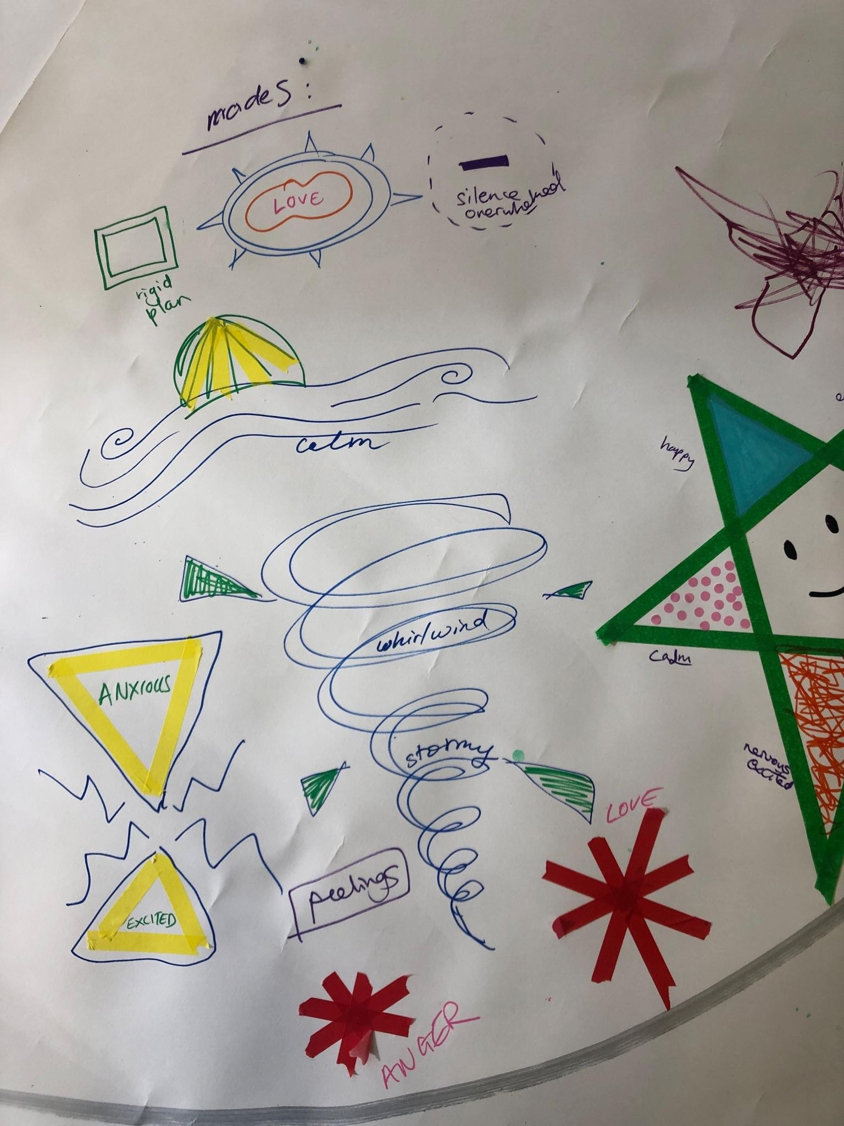 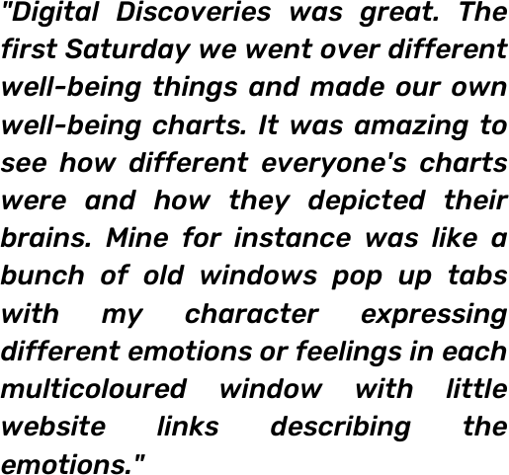

Having access to appropriate digital tools that can support and improve young people’s overall wellbeing and mental health is incredibly important to combat the UK’s current youth mental health epidemic. Throughout the day it was clear from discussion that young people need technology that can recognise and document patterns of behaviour and that can empower young people to hold the intrapersonal skills to acknowledge their state of wellbeing and action change. When asked ‘what technology do you wish existed?’, young people answered:

- an app to help me manage my emotions and help me understand what I am feeling

-mini management box of tools online

-I wish a space/app for managing feelings and relationships and consent and heartbreak and growing up and wellbeing management (emotional literacy is not taught in schools)

-a ‘feelings printer’, printing out weird substance/smell or blobby object that could represent my feelings - then I would have an archive of feelings that would change over time

A portion of the day focussed on trauma-informed digital identity and representation. Children and young people access digital tools and online spaces very differently to adults

and technology evolves quickly. We know at Articulate it is fundamental to learn how young people want to be represented online and support how they feel safe, comfortable and able to express themselves freely. Below is participant artwork representing how people might self express their personality online, artwork is by both adults and young people.

*“I learned how I want to be represented on online platforms!”*

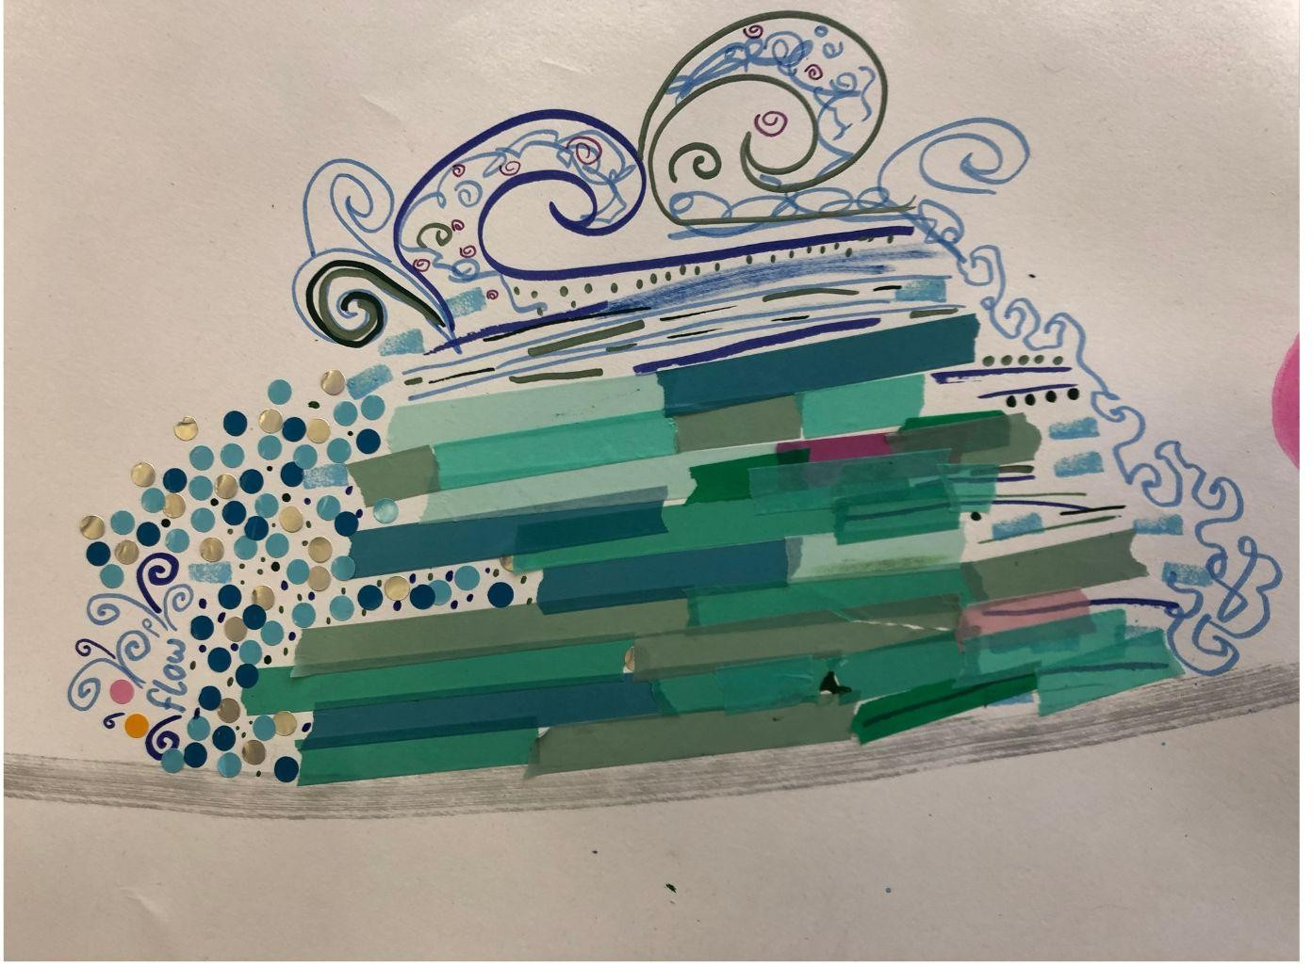*“Feeling more confident in how to express my presence and personality for an online platform.”*

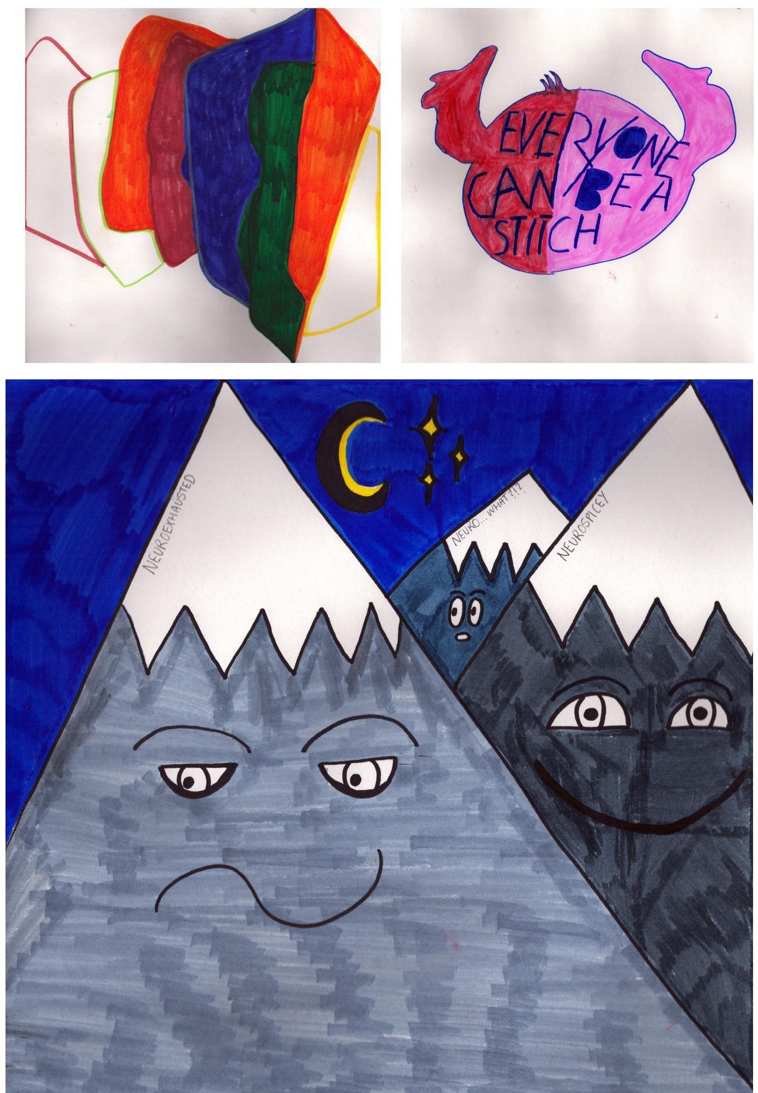

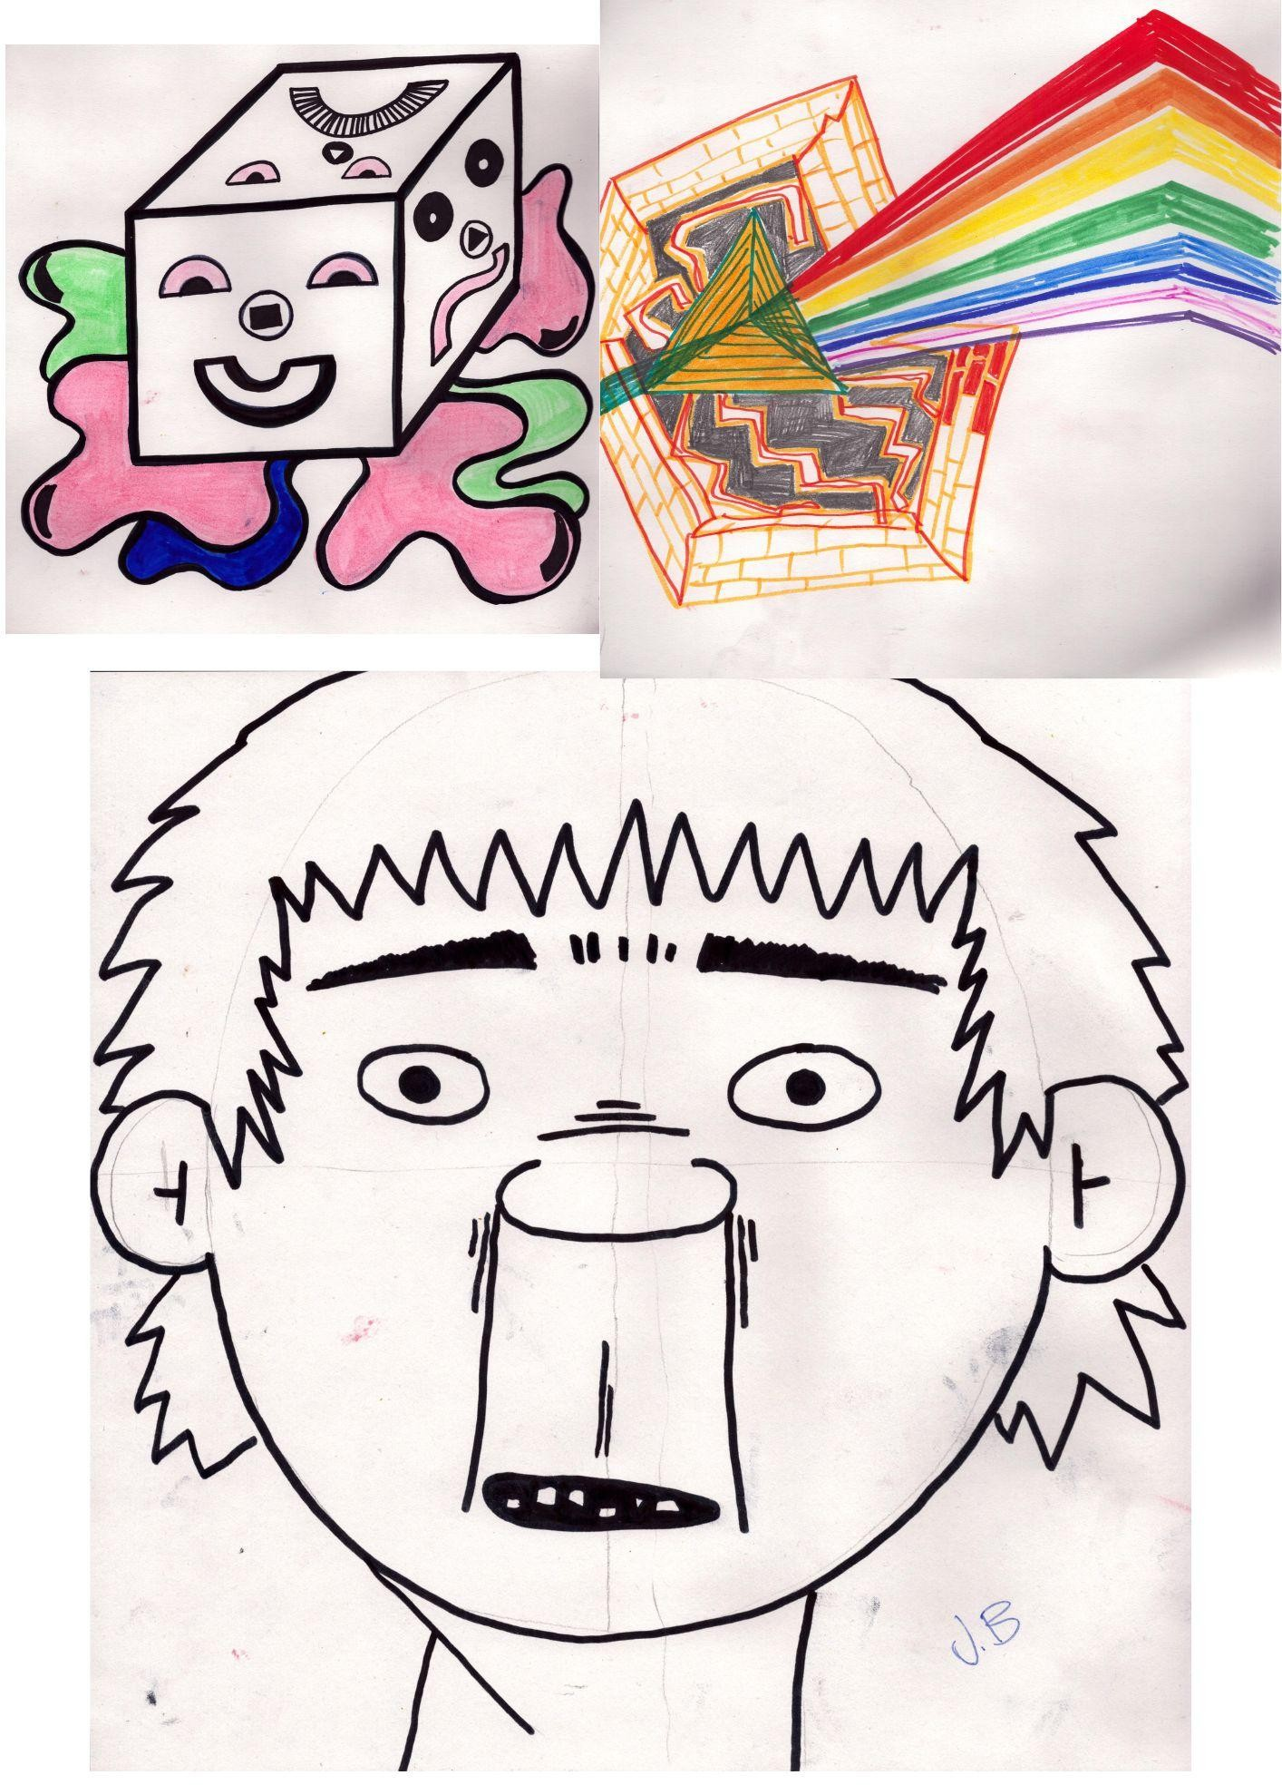

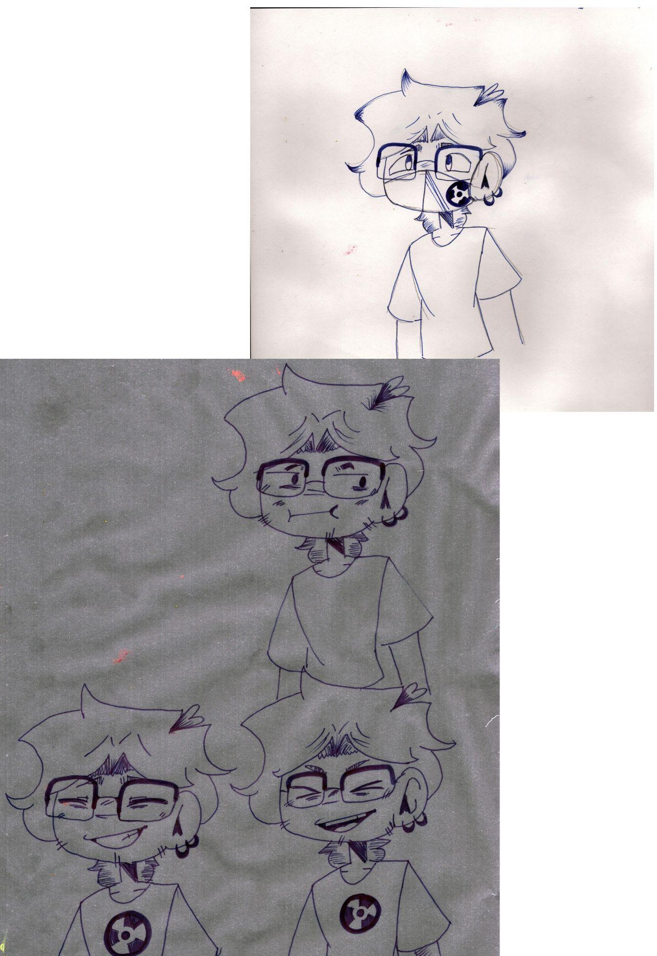

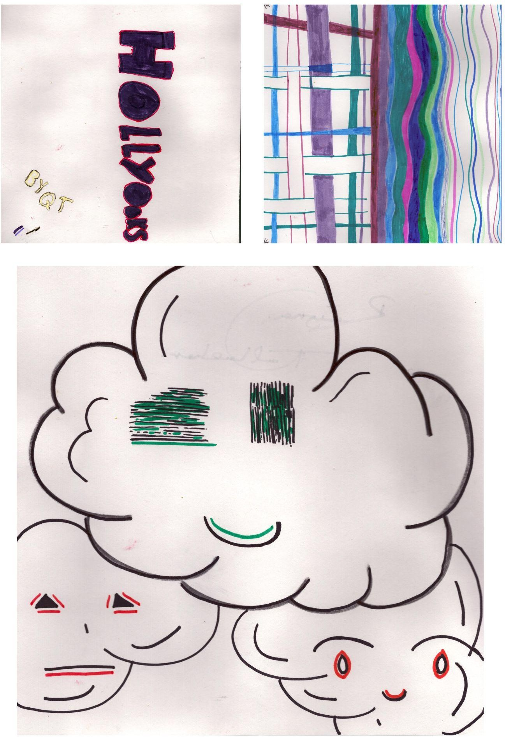

**Digital Discoveries Three:**

Articulate hosted Tom Elkins from PhotoVoice, a London-based organisation that uses digital photography to create real social change and ethically share and celebrate people’s life stories. PhotoVoice holds the ethos of using photography as an ethical storytelling tool for personal reflection, self-expression, identity and belonging.

Together in the session we harnessed action research, lived experience and embodied knowledge to consider photography, storytelling and wellbeing in a playful and hands-on manner. During the session Tom Elkins held space for *deep dives,* exploring photography and wellbeing as a group as well as individually. Workshop participants were provided with their own camera for the day and documented their creative expressions, and opinions to share as they felt able. Photography and digital imagery are linked closely with The Vault’s purpose and the workshop sparked new ways of thinking about imagery, expression and communicating emotions.

Photography, storytelling and capturing memories with autonomy is what links trove and The Vault and PhotoVoice. Below is the collated feedback from workshop participants.

***Why is photography good for your wellbeing?***

-displaying your perspective/perception on something/everything

-can help change or alter perspective (positively)

**-can help you explore new ideas and share them**

-helps display natural beauty in things

-it can be a nice hobby you enjoy and makes you happy

**-as a form of self-expression using ways to portray emotions, likes and dislikes, thoughts, opinions, etc.**

**-a distraction from daily life, allowing someone to see something from different views and angles**

**-to share photos with others, sharing work can make others feel the same way**

-understanding the schema and perceptions of people to understand their wellbeing

-having insight into people’s mindsets whether or not they are open to new ideas on how they view themselves

**-it allows for critical and creative thinking. The activity of taking photos and finding things can be creative, and the discussions allow for thought and self reflection.**

-good for giving people distraction and potentially inspiring new interests

-can help you explore new perspectives

-can help you appreciate small things

-could make you happy to show them to others

-could be something you start to look forward to

**-something that no-one else notices…your sadness and trauma, you can express it**

-forces you to talk about how you feel - you have to describe your photo - why you took it, how you felt when you took it

-you cannot hide behind your photographs

**-allows you to focus on yourself and express that feeling**

-promotes conversation

-expressing emotions/feelings by photographing objects, dark cloud = sadness / sun = happiness

**-memories to look back at happy moments on down days**

-pictures of food, dogs, friends make me happy

**-sharing images and stories with others make me feel closer to others**

**-share culture and heritage through imagery**

**-non verbal expression helps/supports communication**

**-diary making, record keeping, story telling**

-allows for reflective thinking or narrative building by making sequences linear and nonlinear

-photography can be relaxing/calming

-photography can help people go outside and explore

-photography can help people notice/focus on the world around them

-photography can be done with friends

-encourages you to ﬁnd the detail and beauty in things

**-gives you the opportunity to explore**

-a sense of satisfaction in learning new skills

The participants were all at different ages and stages of development yet through the medium of photography they could share their opinions with freedom, in a creative, equitable and playful manner. Photography celebrated the participants' diverse creativity and provided an accessible tool including participants who may struggle with their literacy skills.

*“It is not diNcult to take a photograph but there is something really incredible in not needing any prior skills to leap into something.”*

*“The only thing you need is something to take a photograph and an idea.”*

Participant feedback shared from PhotoVoice shows that 25% strongly agreed and 75% agreed that they feel more conﬁdent in their ability to use photography to tell their story and 50% strongly agreeing and 50% agreeing that they understand how photography can help with their well-being and self-expression.

Participants also stated that they enjoyed *“taking the pictures and having a deeper meaning to them*” and *“being creative in many ways, learning new things, having fun.”*

*“I liked the photography workshop where we got to take loads of cool photos and went on a photo scavenger hunt, where we had a list of prompts to photograph. We learned about lighting and described photos to each other. Overall such a great experience, food was great, people were lovely and it was a very laid back and educational session."*

1. **Recommendations to take forward**
   1. For online spaces to provide a trauma-sensitive, holistic and wrap-around service they need to be co-designed with people that have lived experience and embodied knowledge.
   2. Holding space for professionals and academics to work alongside children and young people to share ideas negated hierarchy, with everyone’s opinions included and valued and created space for dynamic dialogue and shared ideas.
   3. Harnessing photography to generate and capture digital memories is an inclusive tool to convey emotions, self-expression, identity, heritage and culture.
   4. There is a fundamental need for digital wellbeing tools that are focused on supporting and recognising patterns of behaviour that can empower young people to hold the intrapersonal skills to acknowledge and understand their emotions and take steps to action change.
   5. Digital platforms can’t replace human connection but they can be a reliable and trusted tool that can travel with young people. This is especially important for those who experience transient childhoods and can provide a consistent foundation of support.
   6. In times of change, technology can provide strategies for self-care and increased resilience.
2. **Development opportunities**

The development opportunities from Digital Discoveries span the Articulate pillars with arts and wellbeing and creative life stories work being the central thread that runs throughout.

Throughout Digital Discoveries, Articulate has strengthened its working relationship with trove and Articulate now has two trove’s in the studio for the children and young people to access. These are the only troves in north of the border and we feel very lucky to have them as well as permission of Bristol University to share what we now know with others in Scotland.

Articulate hopes to work in collaboration with PhotoVoice in the future, engaging with their Care Leavers in Focus (CLiF) project and translate it into the relevant legislations and policies that make sense in Scotland. By doing so, we will be providing Scotland’s young care experienced population a much-needed platform for their voices to be heard as well as to share guidance and best practice about how to bring about transformational change.

The next step is for Articulate to hold a youth-informed Design Sprint on 27 June 2023 to enhance the development of The Hub’s 120 creative learning short courses for the beneﬁt of care experienced young people.

1. **Next steps for participants**

Participants who took part in Digital Discoveries One have engaged in ongoing communication with each other and Articulate staff and are looking forward to their next Dot to Dot adventure with trove this summer!

Older participants who were involved with Digital Discoveries Two and Three have continued to access the Articulate studio and have attended other Articulate projects.

As a response to Digital Discoveries, Articulate has reconnected with Derby Theatre and is planning a residential trip this summer to explore the award-winning digital project, *Odyssey*, a virtual reality live audio experience that works in collaboration with young people and families with experience of care. Articulate young people will be able to watch the re-staging of Odyssey, engage in peer to peer sessions with Odyssey participants and practitioners and establish discourse around the ethics of creative and digital autobiographical work with lived experience of care.

1. **Questions**

Across the studio sessions we asked participants three linking questions:

**What does wellbeing mean to you?**

-having my own space

**-expressing how I feel**

-to feel whatever you want without judgement

-feeling content

-take each as it is

-feeling free and comfortable

-quiet mind

**-be my authentic self by myself**

-being silly

-to be yourself even if people don't like it

-feeling conﬁdent and capable

-being in the gym or nesting on sofa watching the simpsons

-feeling good about myself

-not being worried that i'm not doing well - centred in myself - plan/who I need to go to for support

-being good to myself

-cheesy self love

-doing little tasks for future/present me that impact me positively

**-coping well when things are too hard, having the tools to overcome these challenges**

-inner feeling and acknowledging when something disrupts your inner peace

-normal routine, good processes

**What technology do you wish existed?**

-none

-bring back the house phone and fax machine

-man robot for a cuddle - no feelings

-outﬁt chooser - clueless style

-when you're feeling a certain way you're matched with someone who is feeling the same

-an app that ﬁlls a room with summer sunshine and bird song

-an app/mandatory training for every young person on the online space and exposure/how to conduct social media and safety

-shape shifter to lose weight, different body for each day

-food falling from the sky

**-an app to help me manage my emotions and help me understand what I am feeling**

-mini management box of tools online

-I wish a space/app for managing feelings and relationships and consent and heartbreak and growing up and wellbeing management (emotional literacy is not taught in schools)

**-a ‘feelings printer’ printing out weird substance/smell or blobby object that could represent my feelings - then I would have an archive of feelings that would change over time**

-mini unicorns to help you make rational decisions

**What technology do you use to support your wellbeing?**

-podcasts and the simpsons on tv

-my laptop

-my SAD lamp

-Disney plus

-podcasts x 2

-Spotify

-Whats App support / care groups

-Headspace

-listen to podcasts

-none (self connect and knowledge)

-The Sims

-audiobooks

-music! Spotify

-music/Minecraft/Twitch

-YouTube for yoga, relaxing music, distraction

-PS 4, PC, COD

-dog TikToks

-Amazon Prime

-online banking

-live aquarium feed on youtube

-window swap, very calming

-my phone

-music

-Switch

-Instagram videos that describe how I feel

-PS4

-funny memes

-Evolve app

-Candy Crush

1. **Thank you**

We want to share a huge thank you to all the wonderful people who attended, contributed to, informed and supported Digital Discoveries.

A special thanks to Susie Buchan (a creative producer based in London who works across a variety of areas including the arts, culture, esports and digital experiences) who supported Digital Discoveries and helped Articulate to consider and design thought-provoking ways to explore digital play, creativity and collaborative approaches within the project.