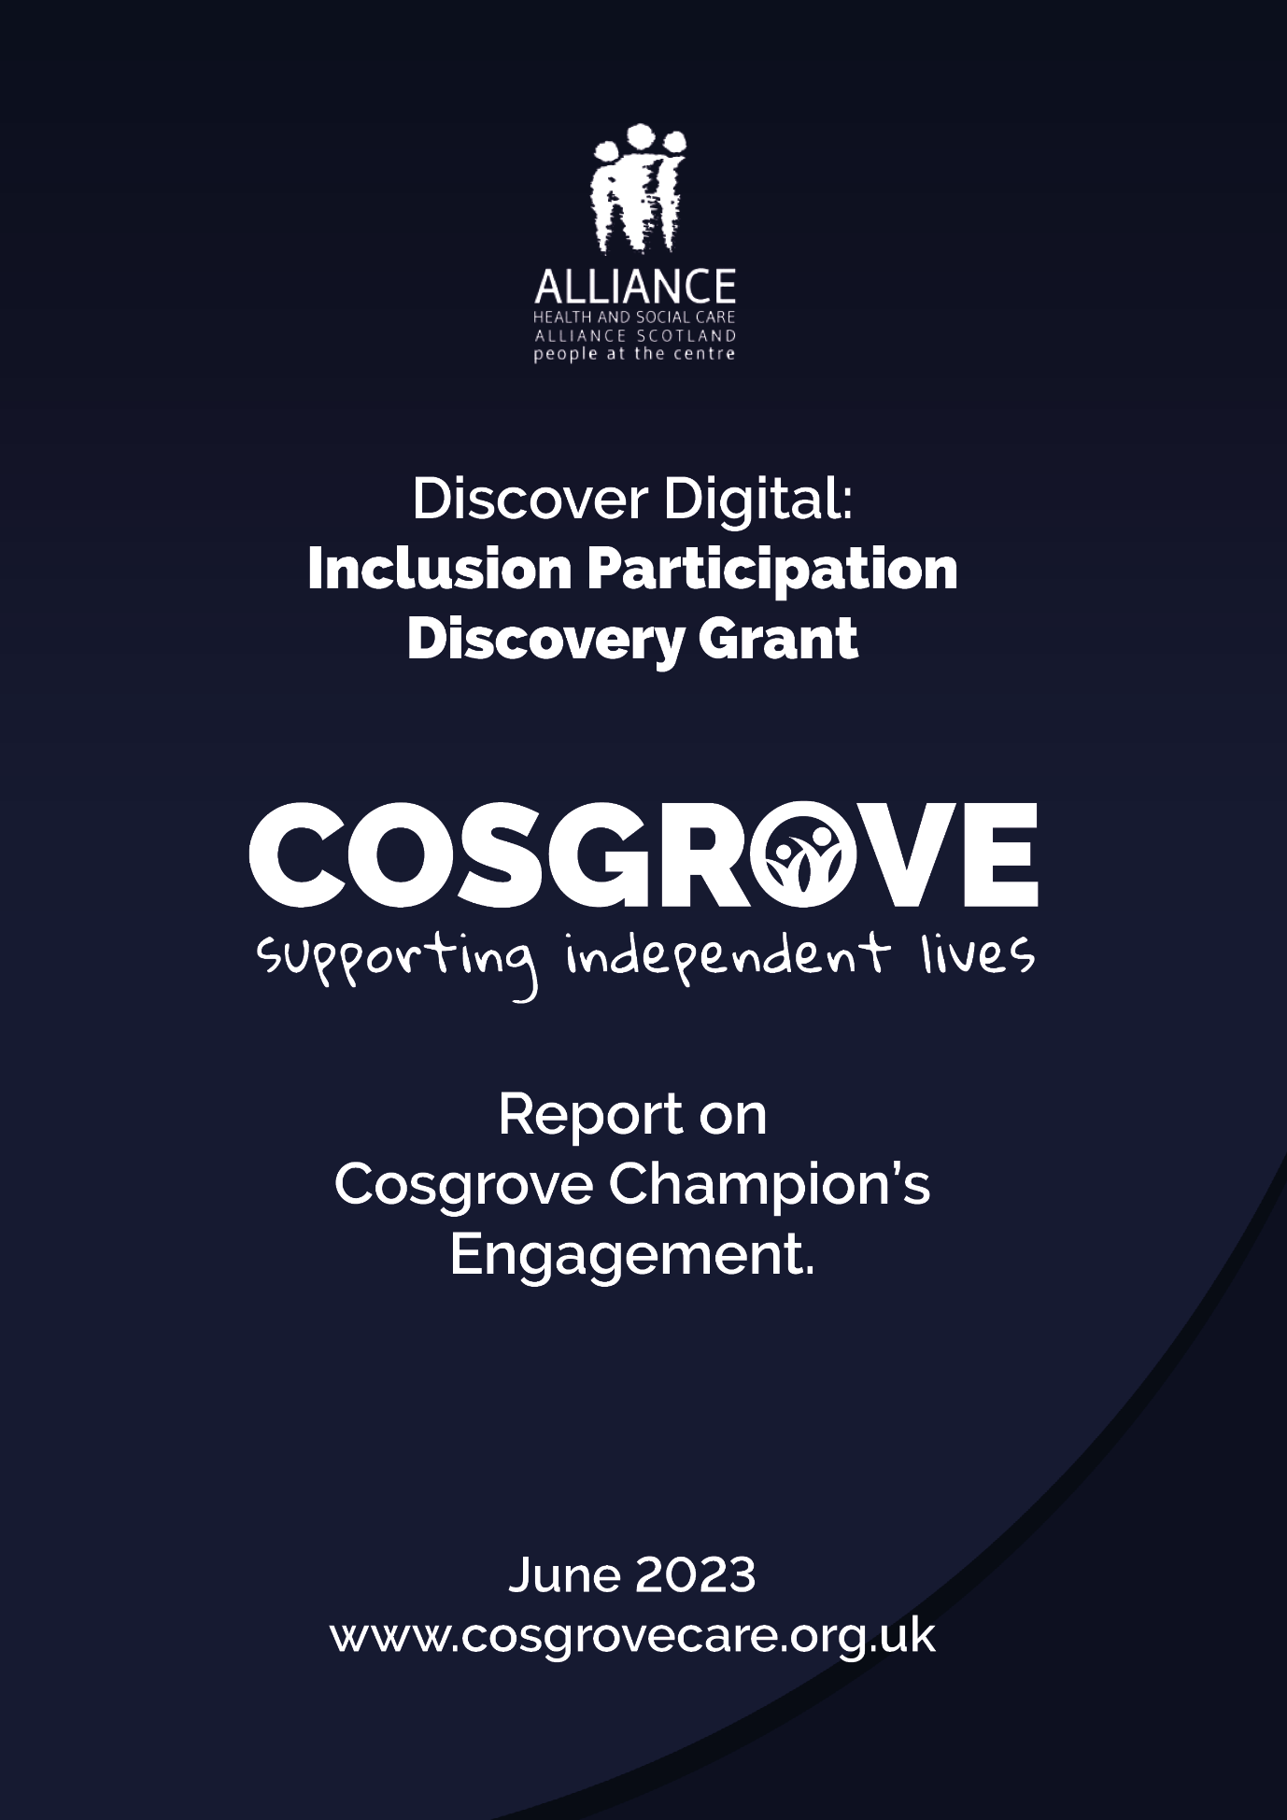



Cosgrove Care
Report- Discover Digital: Inclusion and Participation Discovery Grant
End of Grant Report
June 2023

Summary
Cosgrove Care set out to work with our service user engagement group- the Cosgrove Champions- to identify what support they needed to help them engage with digital tools as part of managing their health and wellbeing. This was important work as we were introducing a new system of support planning and communication- Tagtronics- to help ensure that supported people, their families and staff are able to work together, interact and have control over health plans and outcomes. The people that Cosgrove Care supports have learning disabilities, autism and additional needs and many require additional support to build skills and confidence. The engagement work that we were able to do with our Discovery Grant was to help us understand what support people needed to remove barriers to engaging and get targeted support right. The group met six times- once per month for six months support by our Project Lead and Participation Officer.
About Cosgrove Champions
Cosgrove Champions is a group of 15 people who use Cosgrove’s Services who receive a wide range of support from Cosgrove Care and who we engage and work with to make sure that the voice of people we support is at the centre of everything we do. Cosgrove Champions met 6 times during the past year to help us ensure that understood the support they needed to fully engage with the new digital tools we are introducing, help us design training and support to remove barriers and help people we support take control over their lives and digital data.
The Challenge
We know from research that the health outcomes for people with learning disabilities are poorer than the non-disabled population. The difference according to Mencap of the median age of death is 23 years for men and 27 years for women. The LeDeR found that 38% of people with a learning disability died of an avoidable cause when compared with 9% of the general population. We know that a number of barriers exist and we used our discovery grant to understand these barriers directly from people we work with to help us inform how we support people to have more control and how we assist people with learning disabilities to safely access and interact with digital resources to directly influence and take control over their data.
We considered how we can ensure data and information is more visual, how support needs to change to incorporate assistance to interact and how we keep people safe when accessing digital tools.

What we learned
- People we support need support to build their digital skills and have digital information in accessible formats to help them grow in confidence.
- People we work with require support to understand screening and preventative actions to keep them well.
- Some supported people need access to digital resources that will help them interact fully in a meaningful way.
- There are challenges relating to online safety and cyber security that we need to address through a next stage of development.
- We learned that only 40% of supported females had had breast screening when compared with 68% of women without a learning disability.
- We learned that only 30% of eligible women had received a cervical smear when compared with 73.3% of women without a learning disability.
- We earned that support staff lacked confidence to assist supported people to build their digital skills and knowledge.
- We learned people we support want to take control and need targeted support to allow them to interact fully.
- We learned that there is gap in care plans relating to preventative action and visual targets that help people keep on track- weight, blood pressure, exercise and wellbeing being part of everyday plans.
- We understood some changes to Tagtronics to improve accessibility to support next steps.

Actions
We now have 10 digital health champions within Cosgrove Care who assist others to build their skills and confidence.
We have introduced a new visual chart for each supported person which allows them to see where they are in terms of improved health outcomes. This relates to weight, exercise, blood pressure and wellbeing.
We have made amendments to tagtronics with both supported people being able to access their care plan and contribute to their outcomes and planning.
We have produced a Digital Action Plan which set out a number of steps for Cosgrove Care to improve digital engagement.
For More Information: hgray@cosgrovecare.org.uk

