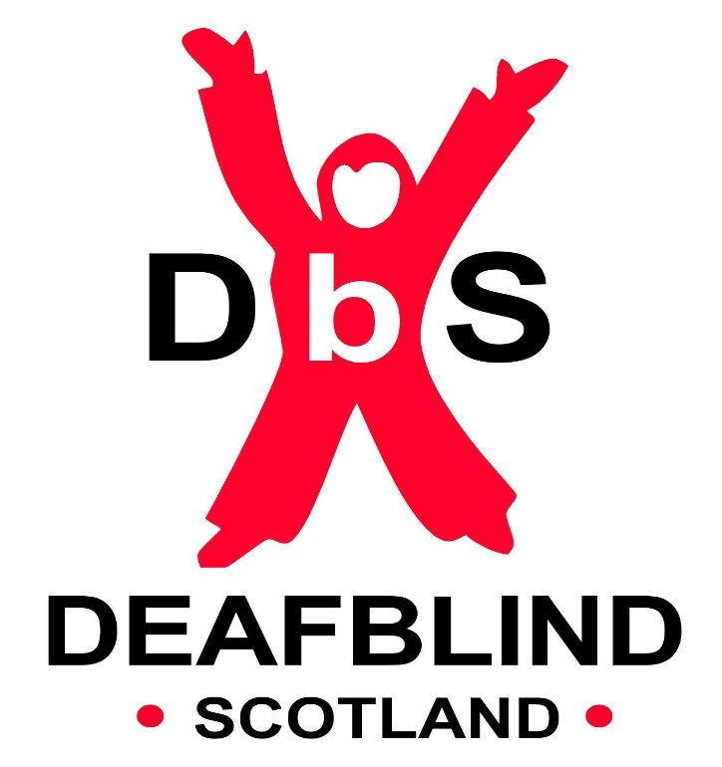

DIGITAL DISCOVERY – TELECARE SAVVY PROJECT REPORT 2023

PROJECT SUMMARY

The move to telecare and other online approaches to accessing health and social care are causing DbS’ member’s real concern. We wish to improve the accessibility to telecare and remove barriers for deafblind people.
To support our members to access telecare/online health/social care approaches confidently, through the Telecare Savvy Project we will
1) facilitate round table discussions exploring with our members the barriers to using Contact Scotland, online medical appointments, telecare etc
2) Train staff who understand the guiding/navigational/communicating challenges of deafblind people on telecare training New Telecare eLearning Module - Health and Social Care Alliance Scotland (alliance-scotland.org.uk).
3. Provide access to telecare support sessions for our members.

SUMMARY OF ACTIVITIES

We encouraged staff who regularly interact with our service users to complete the new Telecare eLearning module. This e-learning module has been created to increase the awareness, knowledge, and confidence of the health and social care workforce to better understand the role of telecare in assessment and support planning. The training was completed by 9 members of staff including our Wellbeing Team, Welfare Rights Team, Senior Guide Communicators, Digital Champions, Service Co-ordinator, Senior Development Leader and Service Manager. Staff can now confidently communicate with service users about the different types of telecare that can support health and wellbeing.

We held two round table discussions exploring barriers to using Contact Scotland, online medical appointments, telecare etc. The first session was held online via zoom, and the second was in-person at our Learning and Development Centre in Kirkintilloch. Both sessions had BSL interpreters in attendance.

A third session was held in a hybrid format in partnership with GCC HSCP showcasing the telecare system and highlighting the benefits of their new Technology Enabled Care Service (TECS). This information was well received, and the introduction of TECS clinics was highlighted to members. Once the TECS clinics are up and running, they will be widely promoted to our members through our newsletters and other social media channels.

FEEDBACK FROM THE ROUND TABLE DISCUSSIONS

At each round table discussion, a series of questions was asked. For each question, we have provided a summary of the participants’ responses.

- Have you ever used Contact Scotland for on-line medical or social care appointments?

There were mixed views in relation to on-line appointments. It was felt that on-line appointments are not as accessible as they should be, and it can be difficult to hear what is being communicated.
Contact Scotland BSL works well when making appointments with GP, School, Insurance Companies etc. The group were happy with the service but had not used it for making on-line appointments.
There are a lot of wait times. When calling the GP surgery, a call back is often required and as Contact Scotland BSL can’t do this, it’s only suitable for outgoing calls. The GP surgery frequently forgets that a text message not a phone call is required.

- Have you ever used a telecare service?

None of the first group (5 members) had used the Telecare Service. The main reason being accessibility issues as there was no BSL option available when using this technology.
One member had experienced a call being made to emergency services at 4am when he mistakenly pressed his buzzer. His sister was immediately alerted, which he was grateful for as this gave him confidence in the reliability of the service and made him feel safe.
Another member commented “it is a good system however staff have no way to advise what is happening and emergency services arrive with no BSL interpreter. Front line staff should have basic BSL training and know how to book interpreters.”

- Have you ever used another service for online health or social care appointments?

The groups were worried about security/online safety. Most were reluctant to use on-line services because of communication difficulties. However, the groups were aware of: -
999 BSL services for emergencies
NHS Near Me

- What do you feel are the barriers to these online services?

Hospital WIFI is not strong enough to support online BSL consultations.
Face to face, in person appointments were considered best for anyone with communication difficulties.
Concerns raised regarding whether you would hear/understand properly and potential difficulties expressing yourself and whether a GP could make an accurate diagnosis online.
Technology issues could cause problems.
Being asked to take photographs and send them to the GP was not considered a viable option for people with sensory loss.
Participants felt unclear whether information for these services were accessible for a visually impaired person to use independently and had little confidence that they would be.
Apps and information not always accessible to screen readers/ voice over etc.
Info not always readily available in all formats LP – XXXXLP, Braille, Moon, Audio, BSL video

- What do you feel would make these services more accessible?

General feedback received was there was a need for more awareness of the requirements of deafblind people amongst health professionals and front-facing NHS staff.
BSL interpreter must be booked for BSL users. It would be helpful to have confirmation in advance of the appointment that an interpreter has been booked and whether they have the necessary skills such as for those requiring Deafblind Manual or Tactile BSL.
Receptionists need awareness of how to communicate clearly with those with a hearing loss of who are Deaf. For example talking slowly and clearly, not just raising their voice.
Masks make communication more difficult. Although there was recognition that this situation is improving with reduced mask wearing in clinical settings.
Receiving an appointment reminder by text or letter would be helpful if in the right format as it can be difficult to write it down while on the telephone.

PROGRESS TOWARDS OUTCOMES

The Telecare Savvy Project outcomes are:-
- Deafblind people increase their understanding/confidence in accessing telecare/online medical appointments
- There is increased awareness of the barriers to using Contact Scotland, online medical appointments, telecare etc
- Deafblind people’s health and wellbeing improves

We are pleased to report that the project has made considerable progress towards these outcomes. From our Telecare access confidence questionnaires, feedback showed that:
- Confidence in accessing remote/digital appointments was at an average of 6.3/10, however 100% of participants felt they had raised issues and increased awareness to the barriers they faced in using Contact Scotland, online medical appointments, or Telecare. Importantly people told us they felt heard.
- The average score in ‘how likely would you be to join another Telecare Savvy activity’ was 9/10.
- Confidence in accessing information members previously had difficulty with was still relatively low at an average of 4/10. This score together with the high score for joining another activity indicates further awareness sessions would be beneficial.
- The average score for ‘how you would rate your mood after attending the activity’ was 8.6/10.
- When asked ‘has attending the activity improved your mood and if so, what helped’ members commented, ‘hearing from others’, ‘being around people to share experiences, I enjoyed it’.

Additional Comments
- One member gave an update on a project he is subsequently involved in with Strathclyde University looking at enlarging signage in GP surgeries and the possibility of staff receiving BSL training even some basic skills. They are also working on improvements for taking medication, how, where, when. Signage improvements in pharmacies and also reducing the background noise in pharmacies.
- Members conveyed they felt it should be flagged on the GP/SW/NHS system what communication method is preferrable for the individual.

Budget

Guide Communicators | £1,125
Senior Development Leader | £1,581
Accommodation | £ 250
Total | £2,956

We can confirm the budget of £2,956 was fully spent as per these budget headings. There was a requirement for Interpreting support which was funded by Deafblind Scotland’s charitable funds.

