Digital Support Sessions.

Supported by Wildsmith Training with

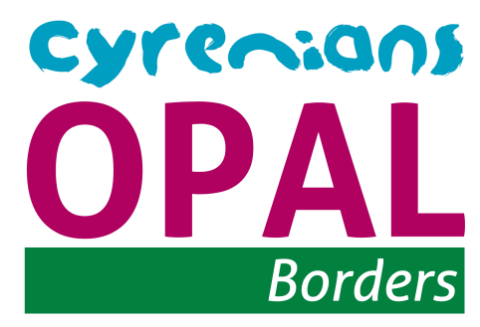

# Project overview

* OPAL Borders aims to work with service users. To help target older adults embracing digital technology through digital learning sessions.
* The aim of the engagement will be to run sessions for older adults. By involving a dedicated digital trainer to oversea sessions we can focus on how we can use the internet to help combat social isolation. We can use the Internet to share stories, create searches, and further link to other ideas. By using a communal interest as a starting point this can lead on to many other uses for daily activities and tasks.
* Sessions will be run in small groups we would aim to run 4 weekly sessions in each of the 6 locations identified. The aim would be to have 6-8 people in each session.
* We are also planning to partner up with the local high schools and colleges for students to become involved in training sessions.
* Feedback would be gathered weekly with a written summary and feedback from service users saying what worked well and what could be improved for further sessions.

# Grant Funding

* We were allocated £1000 to deliver the sessions.
* Each 1 hour session with the digital trainer was £40 • Initial 4 sessions in each development
* 6 developments in total.
* £40 left over from sessions to cover tea and coffee.

Digital Support Activities.

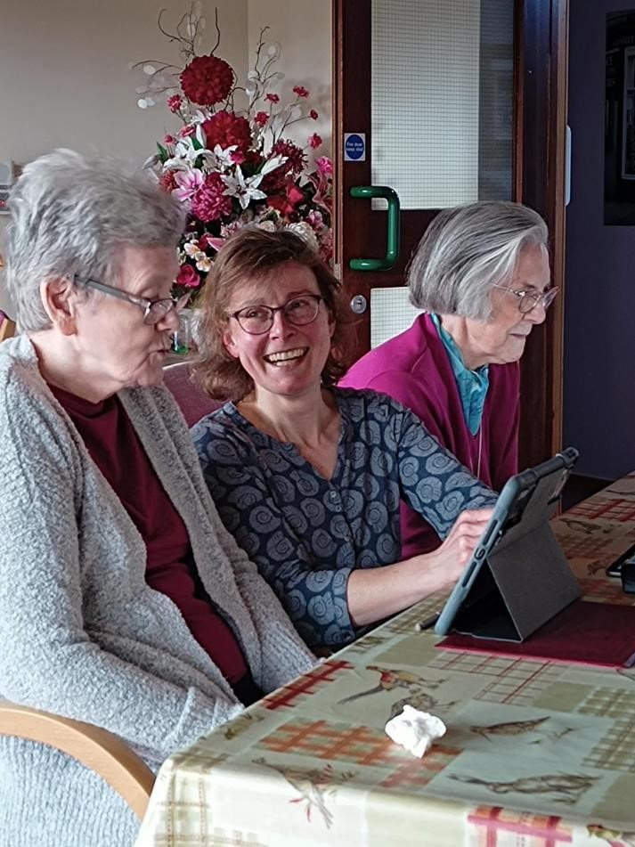

# Course Content

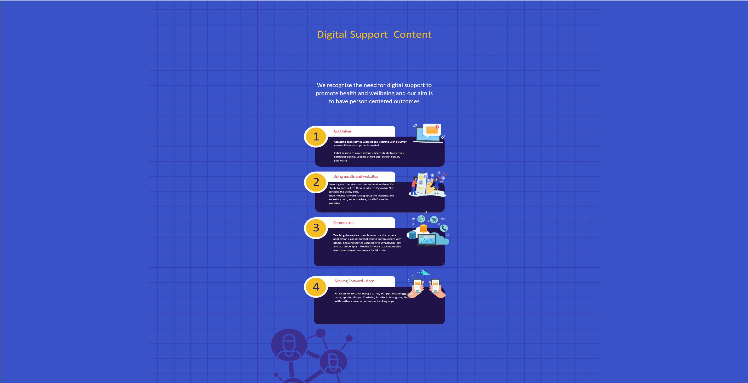

# Results and Impact

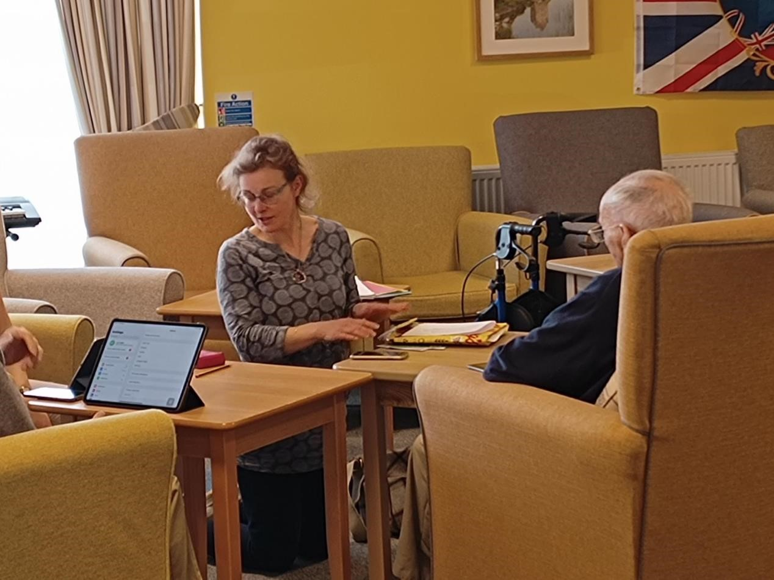“Hadn’t known what WiFi is or what the checkered boxes were about. I now know about QR codes

“Such a relief to be able to view the screen more easily” - on adjusting the settings for a user with sight loss

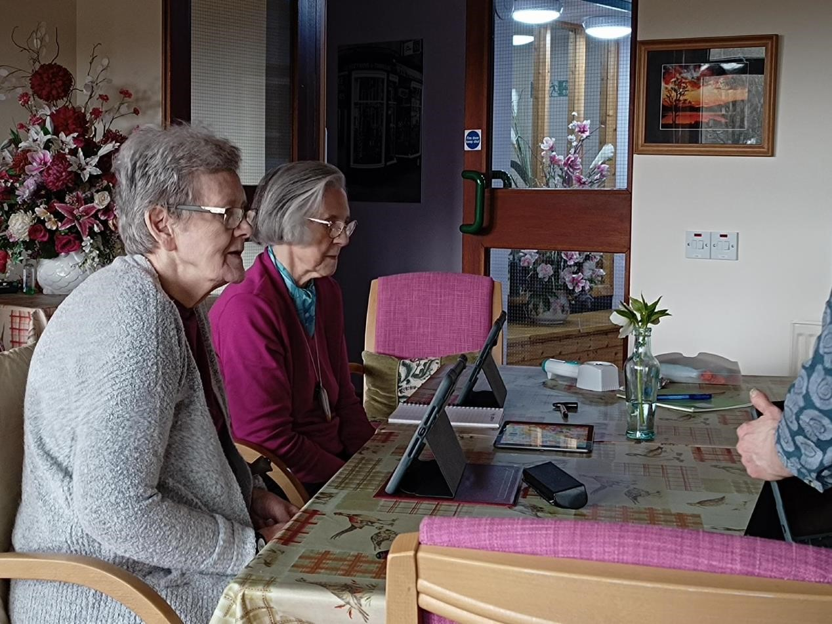“Really helped

me brush up on Tears of joy

some of the and emotion basics”at showing a

* on managing lady how to the apps and access music how to tap on she hadn’t the ‘keyboard’ heard for

and search years facility on Safari

“Now I just need to find time to go on every day so that I can remember. I am much more confident now”

“Lovely to have someone have the time to help show me what to do”

* searching the internet

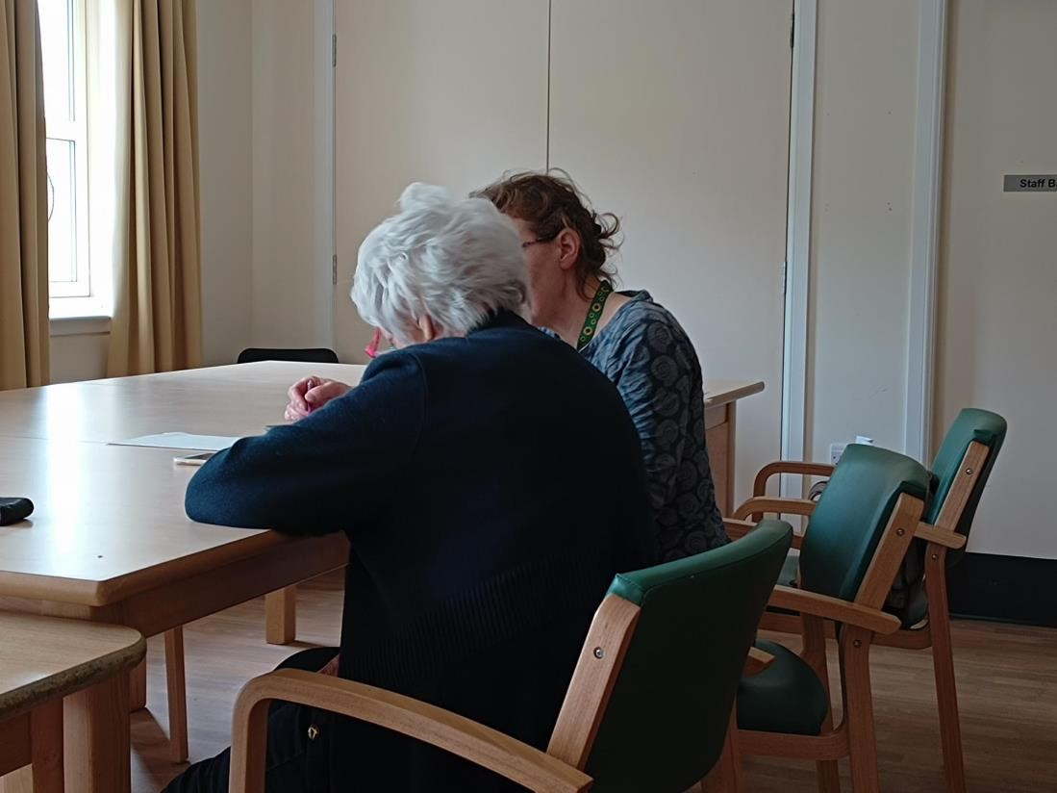Brilliant! Ive learnt loads today and now I can do more.

That’s all been very helpful today. I hope I manage to remember at least a quarter of it.

Case Studies.

* Margaret is rapidly losing her sight but greatly enjoys reading and using her ipad to find out about local interests. She has been using a magnifying glass but even that is troublesome. She has attended the digi support groups and has found lots of new ways of using her ipad. Her comment on the final session was ‘learning about dark mode, that alone was worth coming for’
* Ilene has attended every session that we have run and has brought her ipad along. She is a keen reader and also loves to know about what is happening in the town she lives. She has since coming become an avid Facebook user, now able to follow all the locale groups to find out what is happening in the town.

She loves looking at the old photographs.

* Evelyn didn’t have a device but was keen to experience using an ipad. She had some help from the sessional tutor who allowed her to explore an ipad. We were able to apply for Evelyn to have her own ipad. She is now using it daily to communicate with her family and is exploring using it for streaming services. Although there is still scepticism about entering bank details she is enjoying using you tube to find out all sorts! She would like more sessions.
* Elizabeth is 95 and uses her ipad to talk nightly with her daughter via facetime. But she often finds it difficulty to search for items and then loses her place on how to close tabs down and understand the various digital jargon that she is unfamiliar with. Elizabeth has attended the digi support sessions at Dovecot, Peebles. Her comments this week make running these sessions so rewarding. ‘Ive learnt so much today thankyou so much I feel much more confident’

Margo felt that at her ‘grand old age of 84 that she was past it for learning new things.’ We quickly realised that Margo was well aware of digital jargon and was already understanding of the uses of various apps.

She lost her husband a year ago and has struggled with social isolation, not feeling confident to attend other groups as she is a bit delicate. The digital sessions were kept small to allow the sessional trainer to deliver in an intimate setting without large amounts of folks. This gave Margo the confidence to attend and to open up. She spoke eloquently about her feelings of loss and how this had let to her feeling isolated.

We spent time with Margo working on her confidence and giving her the space to say what she needed. During our sessions we found that Margo was a huge fan of classical music but that she had been unable to set up her record collection in her flat so she hadn’t listened to the music that meant so much to her and her late husband.

We applied for an ipad through live borders for Margo and we were successful. We began by showing Margo how to access You Tube, this led to us all singing and crying alongside Margo while we listened to Pavarotti. Margo has since been practicing her basic digital skills getting to grip with how to use the settings and various other apps on the ipad.

Lessons Learned.

This was a first for us in OPAL Borders and we worked hard to make sure we were understanding of the needs of the service users. We knew that there was several factors and timescales to coordinate it all coming together.

We very quickly realised that small groups worked best. Due to folks sight and hearing loss it was felt that to keep groups to a maximum size of 3 made them a much more valuable learning experience.

We experienced several set backs and worked hard to overcome the hurdles adapting our project to make it work.

Our digital trainer had been due to deliver to 6 different developments that are situated throughout the Borders. She came to us to say that she felt she would be unable to deliver the session in Hawick due to the distance she would need to travel and that for her to do this she would need to ask for her hourly rate while travelling for it to be economical. As we had an incredibly strict budget we were not able to accommodate this request.

We put out to local companies and individuals in Hawick to see if we could find a local trainer to deliver these sessions. Unfortunately this did not come to fruition. So we adapted out original plans to increase the sessions at the other 4 developments. This meant that 4 developments received 6 sessions each instead of the original planned 4. These extra sessions were then delivered later in the project. The bonus of doing this was that we were able to revisit previous service users and check that they were still continuing to explore what they had learnt at the initial sessions. So, this became a valuable learning tool for service users and us as trainers to see the impact of the sessions.

We had a previous relationship with a local High School and had hoped to utilise this further. This had been a previous successful relationship with students who were school refusers. Speaking to the teacher in charge we had been keen for them to attend our digital support sessions as a support for the service users. Unfortunately our sessions due to timings began later in the school calendar than our original plan and the students were no longer available to help with the session. This though is something we will explore again. Coordinating everyone to be available at the same time was our hurdle and one we were not able to overcome. We have since though continued our relationship with the school and have students joining us for other OPAL groups in the future.

## Future Plans

Above all we have learnt from this project that relationships continue to be at the heart of what we at OPAL Borders, Cyrenians do.

Our main aim of all OPAL projects is reducing social isolation. We achieve that in varying ways. The digital support sessions allowed us to show service users how they could connect with people that lived far away and those closer to home also in a different way.

It also allowed us to show the service users how much more is out there that they can access. From looking at places from their childhood which then moved into looking at maps and then pictures from yesteryear to then jumping into the music they listened to during that time. The ability to jump from one subject tot another with ease and adding so many elements to their experiences.

We also allowed people to realise how their lives could be simplified by using devices, from contacting their GP to organising their shopping.

Moving forward we would like to offer further sessions. We feel that those that have attended would benefit from further top up sessions. Our hope is that we can do a once every couple of months drop in session to further help service users. This is where we want to further the relationship with the High School students and have them come in to help deliver sessions.

In conclusion what has been a difficult project to get off the ground has shown us that there is a real need for people to further enhance their skills and we hope to be able to help facilitate that.