The Care Technologist Project – end of funding report for the Discovery Grant, ALLIANCE Scotland 2023
December 2023
The Care Technologist project received a £3000 grant to work within and alongside the existing Scottish Care Partners for Integration team in D&G, supporting digital aspects of the teams’ wider D&G workplan.

Agreed outcomes for the project were:

- Independent sector Care and Support at Home and Care Home providers are engaged, inspired and informed around the potential for digital health and care solutions in their service.
- The partners (Care providers, Scottish Care, The ALLIANCE, DGHSCP and others) understand the barriers to adopting digital health and care approaches that care providers face in a local context in Dumfries and Galloway.
- The support care providers need to remove the barriers to integrating digital health and care approaches is mapped.

Outputs and activity to achieve these outcomes included:

- Care Technologist Roadshow/s across Dumfries and Galloway, open to staff and members of the public
- Bespoke learning and exchange sessions/days with individual services, tailored to their needs.
- Support to develop Care Technologist roles and Tech solutions within services, or to adapt existing roles/solutions
- Contribute to design of the Scottish Care Care Technologist Legacy Service, to increase nationally available resources from January 2024.
- A project report, including the project experiences and outcomes.
- Contribution to other Scottish Care work in D&G in the digital space

The Care Technologist team worked over six months with individuals, services, the public and providers to meet these outcomes. Two roadshows were hosted in Dumfries and Stranraer, and bespoke 1-2-1 sessions were delivered to care at home providers, housing providers and care homes. What we heard from the conversations had in Dumfries and Galloway contributed to the design of the Care Technologist Legacy Service “Help Desk”, due to be made available in January 2024. This report details a review of the above outputs and activities which met the outcomes.

Output 1 - Roadshows
Dumfries Roadshow

The Dumfries Roadshow on 15th September gathered the attendance of over 30 members of the public, social care workers, local care providers and more.
Taking place from 11am-2pm, we exhibited five stalls with the contributions from Lilli, D&G HSCP, Dumfries and Galloway Carers Centre, and Third Sector Dumfries and Galloway.
In conversations with attendees, we heard that many interested in technology were looking to support the needs of other people. This was sometimes a family member, a client, or a group of people being supported through their service. We heard that common barriers associated with engaging people with technology included confidence building, digital literacy, and resistance to technology.
A commonly referenced challenge for older people receiving care was the desire to maintain a degree of independence in their own lives.
When showcasing the technology the team displayed at their stall, often attendees were surprised at the range of technology available that suited all levels of digital literacy, interest, and access. For example, non-digital devices such as flood-prevention plugs, and sensor lights sparked interest as low level technology. Many believed that to be ‘technological’ was to mean advanced, sophisticated, or complicated devices that require internet, training, or management.
The Care Technologist Catalogue was popular, and we ran out of copies as many wanted to take a copy away to showcase varying degrees of technology to suit all people’s needs. An awareness of what is available and suitable for individuals seemed to be takeaway gap in knowledge from the event.
From this session, the team have identified the following barriers in rural care and support provision for people with long-term conditions and age-related frailty:
- Awareness of what technology is available, specifically simple devices that can be used by anyone to improve independent living and self-management
- Access to the above information in non-digital format
- Capacity and access to build digital literacy, confidence, and commitment

The Care Technologist Team are following up conversations with those who attended, getting in touch to provide more information on available technology and offer 1-2-1 support to offer tailored recommendations on technology that improves independent living.

Stranraer Roadshow

The Stranraer Roadshow took place on Friday 22nd September and gathered around 7 guests. This was markedly less than the Dumfries show which was anticipated, however it gave us the opportunity to provide more in-depth support to the visitors. Stall holders included the Care Technologist Team, Lilli, Young Carers Centre, and D&G HSCP.
Hosting the roadshows in a community venue with public footfall proved to be a successful way of bringing in visitors and interested parties. The Care Technologist team have hosted drop-in sessions in the past at the host services offices and have received limited attendance due to the location and reach. It has been beneficial to evidence the impact of hosting events in community spaces.
We heard from members of the public that the town is digitally excluded, in terms of accessing support to develop with digital devices, and we heard from local care providers that internet connectivity and digital literacy in the rural areas and homes they reach is limited. Alongside this, staff awareness of digital opportunities and capacity to become trained in digital is limited.
The team engaged with a member of the public who lives with sight loss, who had challenges with their smartphone functionality. They had a particular challenge accessing their voicemail via voice-activation software Siri, which meant they were unable to use their phone properly and felt uneasy being out and about by themselves in case of any arising issues where they couldn’t use their mobile effectively. We heard from them that they were not alone in feeling ‘digitally excluded due to geographical limitations’ and felt seldom heard in their community due to a lack of access to digital support in their area. In addition to this, suffering from sight loss restricted their ability to travel independently to access digital support elsewhere.
Care Technologist Dan was able to spend time with them and fix the accessibility issues with their phone. The attendee left the event with a sense of achievement for having their issue resolved, and a boost in confidence to go out and about by themselves again. The team were pleased to deliver support directly at the event that increased the ability for individuals to live more independently with assistance of their technology and devices.
From this session and conversations with the attendees the team determined the following barriers to adopting digital health and social care approaches:
- Lack of in-person support to adopt technology and digital into everyday lives in rural communities
- There are hurdles to using digital in health and social care practices that stunt the process before even beginning the journey– such as internet access and front-line staff buy-in. These must be addressed if we are to ensure a smooth digital care roll-out in rural D&G.

Output 2 – Bespoke sessions
Output 3 - Support to develop Care Technologist roles and Tech solutions within services, or to adapt existing roles/solutions

Three 1-2-1 support sessions were delivered over the duration of the project. Each session varied in support required, ranging from “next steps” phone advice about digital care to home visits in rural areas to fix existing digital issues. The team drafted a set of semi-structured questions to guide the sessions and establish what challenges were faced by those taking part.
The first 1-2-1 with a Care at Home provider was a 45-minute session taking place over Teams, and involved a simple talk-through of the current existing support available for services and staff in the areas that support was being provided. An awareness of existing resources was identified as the main challenge faced by this service. The links to resources improved awareness of digital support available, and enabled staff to develop their digital skills in their own time. The outcome of this session was an indicator of success for Output three as well as Output two.

The second 1-2-1 with a Sheltered Housing service took place over Teams and lasted approximately an hour. There were various challenges faced by the service which the Care Technologist team identified through the pre-drafted question set. Upon identifying the challenges faced by the service, an email was sent after the meeting which contained a ‘Digital Prescription’, along with links and resources mentioned.
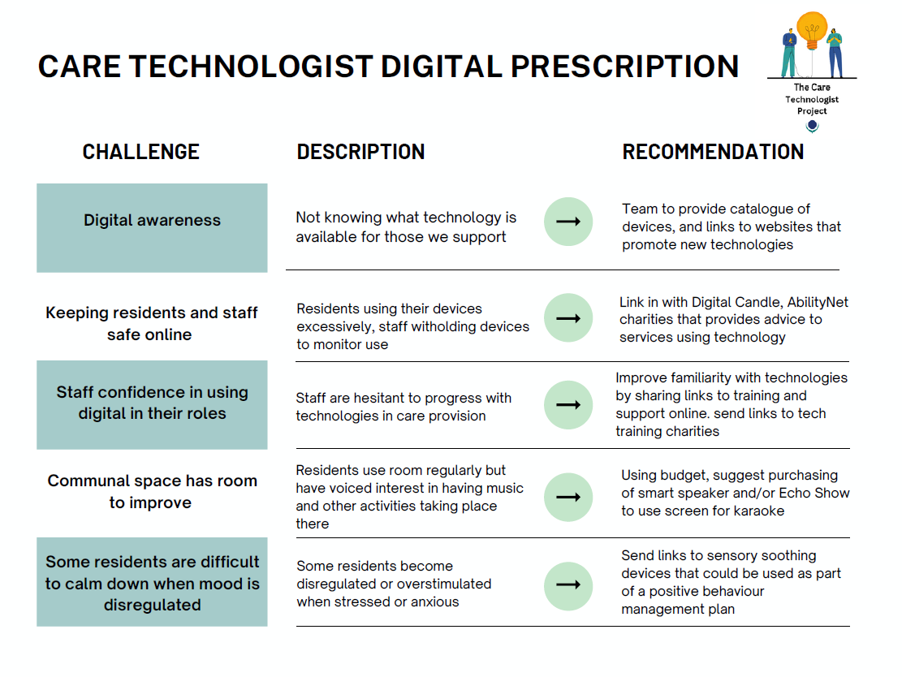
The third 1-2-1 took place with a care home experiencing specific challenges regarding existing technology within the home and a lack of resources or knowledge to fix it. The initial session took place over Teams, after which the team visited the care home to fix the technology issues being experienced. A secondary challenge identified during this support duration was the lack of local resources available to train staff and support residents to use technology - this was due to the rural location of the care home. The Care Technologist team were unable to locate any local face-to-face support available, so referred to online support services that exist. The team also linked the care home to examples of previous work where local schools had worked with care homes to deliver digital device learning, in which primary pupils visited the home to teach residents about technology. The care home manager was interested to hear about this work existing elsewhere and was looking to reach out to their local school to gauge interest.

Output 4 - Contribute to design of the Scottish Care Care Technologist Legacy Service, to increase nationally available resources from January 2024.

The Care Technologist team were able to take learning from the sessions, the roadshows and other conversations had throughout the project and design the Legacy Service with the learning in mind. The site is due to be made public in January 2024.

Output 5 - Contribution to other Scottish Care work in D&G in the digital space

Alongside the roadshows and sessions, the team were invited to join existing digital events in D&G to showcase work and provide support and join provider forum meetings to give updates on available support. This included in-person and online activities.

