Anti-Seizure Medicines in Pregnancy

April 2018 - September 2023

An Official Statistics in development release for Scotland

Publication date: 02 April 2024

Translations and other formats are available on request at:

phs.otherformats@phs.scot 0131 314 5300

Public Health Scotland is Scotland's national agency for improving and protecting the health and wellbeing of Scotland's people.

© Public Health Scotland 2024

This publication is licensed for re-use
under the Open Government Licence v3.0.

For more information, visit
www.publichealthscotland.scot/ogl

www.publichealthscotland.scot

This is an Official Statistics in development publication
Official Statistics in development are official statistics which are undergoing a development and are published in order to involve users and stakeholders in their development and as a means to build in quality at an early stage. It is important that users understand that limitations may apply to the interpretation of this data, further details of which are presented in this report.

All official statistics should comply with the UK Statistics Authority’s Code of Practice which promotes the production and dissemination of official statistics that inform decision making. Once the evaluation is completed and an enhanced report is developed that meets the needs of users and stakeholders, the 'Official Statistics in development' label will be removed.

Our statistical practice is regulated by the Office for Statistics Regulation (OSR). OSR sets the standards of trustworthiness, quality and value in the Code of Practice for Statistics that all producers of official statistics should adhere to. You are welcome to contact us directly with any comments about how we meet these standards.

Alternatively, you can contact OSR by emailing regulation@statistics.gov.uk or through the OSR website.

Visit the UK Statistics Authority website for more information about the Code of Practice and Official statistics in development.

Visit our website for further information about our statistics and PHS as an Official Statistics producer.

Planned developments
We are continuing to develop this report and currently have plans to work towards presenting the data as a dashboard. We will seek feedback from users to inform any additions to the content of this publication.

Please send any feedback on this publication to:
PHS.medicinesdevelopment@phs.scot

Contents

Introduction 7
Current clinical guidance 8
Purpose of this report 8
Key definitions used throughout this report 10
Disclaimer 12
Main points 13
Valproate 13
Topiramate 14
Results and commentary 15
Overall prescribing of anti-seizure medicines 15
Valproate prescribing in females aged 0-54 16
Overall valproate prescribing by age group 16
Starting and stopping of valproate prescribing 17
Starting of valproate prescribing by age group 19
Valproate prescribing in pregnancy 20
Overall prescribing of valproate in pregnancy 20
Prescribing of valproate by stage of pregnancy 22
Starting and stopping of valproate prescribing in relation to pregnancy 24
Topiramate prescribing in females aged 0-54 25
Overall topiramate prescribing by age group 25
Starting and stopping of topiramate prescribing 26
Starting of topiramate prescribing by age group 27
Topiramate prescribing in pregnancy 28
Overall prescribing of topiramate in pregnancy 28
Prescribing of topiramate by stage of pregnancy 29
Starting and stopping of topiramate prescribing in relation to
pregnancy 31
Glossary 32
Contact 35
Further information 35
Rate this publication 35
Appendices 36
Appendix 1 – Data sources 36
Scottish Combined Medicines Database (SCoMeD) 36
Scottish Linked Pregnancy and Baby Database (SLiPBD) 36
Cohort definitions 37
Appendix 2 – Publication metadata 38
Appendix 3 – Early access details 41
Pre-release access 41
Standard pre-release access: 41
Early access for management information 41
Early access for quality assurance 41
Appendix 4 – PHS and official statistics 42
About Public Health Scotland (PHS) 42

Introduction

Anti-seizure medicines are used to prevent seizures, primarily in patients with epilepsy. Epilepsy is a chronic condition; therefore, anti-seizure medicines need to be taken long term.

Many different anti-seizure medicines are available, and individuals with epilepsy may need to take one or more medicines to effectively control their seizures.
Determining which medicine(s) to use is particularly important for women of reproductive age who may become pregnant. This is because whilst effective control of epilepsy during pregnancy is very important for the health of the mother and the baby, certain anti-seizure medicines are teratogenic; meaning they are known or suspected to have the potential to harm the unborn baby if taken during pregnancy.

There is long-standing evidence that the use of some anti-seizure medicines during pregnancy can increase the risk of congenital conditions in the baby. Emerging evidence also suggests that the use of certain anti-seizure medicines during pregnancy may increase the risk of neurodevelopmental conditions (such as autism). For instance, valproate taken during pregnancy is known to be associated with an increased risk of both congenital and neurodevelopmental conditions. According to the Medicines and Healthcare products Regulatory Agency (MHRA), children exposed to valproate before birth have a 11% risk of a congenital condition (such as congenital heart disease), and a 30-40% risk of developmental delay or a neurodevelopmental condition. In January 2021, a report published by the Commission on Human Medicines (CHM) raised additional concerns regarding other anti-seizure medicines, with topiramate, carbamazepine, phenobarbital, and phenytoin also potentially being associated with an increased risk of congenital and/or neurodevelopmental conditions; topiramate is also known to affect the baby's growth during pregnancy. In contrast, emerging evidence indicates no increased risk of either congenital or neurodevelopmental conditions associated with the use of lamotrigine or levetiracetam. However, conclusive data on most of these medicines is still lacking.

Current clinical guidance

Valproate is licensed in the UK for the treatment of all forms of epilepsy in both children and adults, and for bipolar disorder. In 2018, the MHRA advised that valproate should not be used in patients who are pregnant; or in patients with the potential to become pregnant, unless they are supported through a Pregnancy Prevention Programme (PPP). The PPP is intended to ensure that patients are fully aware of the potential risks and the need to avoid pregnancy while on treatment with valproate. Patients are also required to be on highly effective contraception if they can become pregnant; and should be seen by a specialist at least every year.

In addition to the conditions of the PPP being met, valproate can only be used for epilepsy in patients of child-bearing potential if there is no other suitable treatment, that means, if other treatments are ineffective or not tolerated. Following further CHM advice, since January 2024 no one under the age of 55 years should be initiated on valproate unless two specialists independently consider and document that there is no other effective or tolerated treatment. Current patients should be similarly reviewed. Valproate must not be used during pregnancy for bipolar disorder.

Topiramate is licensed in the UK for the prevention of seizures in children (from the age of 2 years) and adults, and for migraine prophylaxis in adults. The MHRA advises that patients of child-bearing potential should be counselled on the importance of avoiding pregnancy due to established and emerging risks. Patients should use effective contraception if necessary and see a specialist if a pregnancy is planned. Topiramate should not be used during pregnancy for migraine prophylaxis.

Purpose of this report

In 2019, the CHM established an Expert Working Group to advise on ways to monitor the safety of medicines during pregnancy. In a January 2021 report, this group made recommendations to address existing gaps in data collection and encourage the use of routinely collected data. In July 2020, the Independent Medicines and Medical Devices Safety Review report "First Do No Harm", led by Baroness Julia Cumberlege, included examination of valproate and made a number of

recommendations for improvements. Further to this, in 2023, the MHRA in consultation with the CHM stated that current measures to reduce the risk of harm to patients and their children should be strengthened for valproate. Most recently, in October 2023, the European Medicines Agency (EMA) recommended the introduction of new measures to avoid topiramate exposure in pregnancy. In the UK, the MHRA announced in July 2022 the start of a safety review into topiramate exposure in pregnancy, the outcome of which will be communicated in due course.

Public Health Scotland is working with stakeholders, including the MHRA, to develop information and intelligence to provide a better understanding of the use, benefits, and risks of medicines taken in pregnancy across Scotland. Initial work, published in 2021, focused on valproate prescribing and pregnancy outcomes.

This report presents an overall picture of the prescribing of anti-seizure medicines in Scotland, with a focus on two of these medicines: valproate and topiramate, as informed by MHRA and CHM requirements. The aim of this report is to provide up-to- date information on the use of these medicines in Scotland in all females aged 0-54 years. While specifically highlighting pregnant women due to the medicines' harmful effects on the unborn child, choice of medicine(s) is also important for younger girls, to avoid the need to switch medicines as they approach reproductive age. Similar reports, covering the English population, are published by NHS England.

Although potential harm to the developing baby following exposure of the father to valproate in the period leading up to conception is being investigated by the MHRA, it is not possible to provide details on paternal exposure to medicines with the currently available data in Scotland.

Key definitions used throughout this report

In this report, information on prescriptions refers to 'females', as the cohort includes patients aged 0-54 years. Pregnancy-related information refers to 'women' to be consistent with other Public Heath Scotland publications.

Term | Report definition
Anti-seizure medicines (ASMs) | Medicines used to primarily treat patients with epilepsy; examples include valproate, topiramate, carbamazepine, lamotrigine, levetiracetam, phenobarbital, phenytoin
Starting (all females 0-54 years) | New prescription for a medicine: no prescription in the 12 months preceding the date of the prescription (e.g. if a person received a valproate prescription on 1 June 2019 but had no prescription since 31 May 2018 then they would be classified as having started valproate in the quarter April-June 2019)
Stopping (all females 0-54 years) | No subsequent prescriptions for a period of 12 months following the date of the prescription (e.g. if a patient had a valproate prescription on 1 June 2019 but no subsequent prescriptions between July 2019 and June 2020, they would be classified as having stopped valproate in this quarter, April - June 2019)
Pregnancy exposed to stated medicine / Pregnancy-related prescription | Prescription dispensed during the 28 days prior to the estimated date of conception or during the pregnancy (or up to the end of follow up on 30 September 2023 for recently conceived pregnancies that were still ongoing at that point). Given the typical supply per prescription (28-56 days) medicines dispensed in the 28 days leading up to conception would likely still be being taken on the date of conception
Starting during pregnancy | A prescription for the stated medicine was dispensed during the 28 days prior to the estimated date of conception or during the pregnancy (or up to 30 September 2023 for pregnancies still ongoing at that point) but no prior prescription was dispensed in the previous 12 months (i.e. between 29 days

Term | Report definition
 | and 13 months before the estimated date of conception)
Stopping prior to pregnancy | A prescription for the stated medicine was dispensed between 29 days and 13 months before the estimated date of conception, but no prescription was received during the pregnancy (i.e. no prescription was dispensed during the 28 days prior to the estimated date of conception or during the pregnancy [or up to 30 September 2023 for pregnancies still ongoing at that point])
Gestation | A measure of how far along a pregnancy is, measured in completed weeks and days. Prior to the availability of accurate ultrasound scanning, gestation was traditionally measured from the first day of the last menstrual period prior to conception, hence conception occurs at 2 weeks and 0 days (written as 2+0 weeks) gestation. Babies are 'due' at 40+0 weeks gestation
Trimester | Pregnancy can be divided into 3 broadly equal periods called trimesters. Exact cut offs vary but in this report we have defined the first trimester as from conception to 11+6 weeks gestation; the second trimester as from 12+0 weeks to 23+6 weeks; and the third trimester as from 24+0 weeks to the end of pregnancy
Teratogen | A teratogen is something that is known or suspected to have the potential to harm the unborn baby (e.g. by increasing the chance that the baby has a congenital or neurodevelopmental condition) if the mother is exposed to it during pregnancy
Congenital condition | A congenital condition refers to a difference affecting a baby's body structure or function which results from a variation in the process of development before birth. There are many different types of congenital conditions, for example spina bifida, congenital heart disease, cleft lip and palate. As all of a baby's organs develop during the first trimester, exposure to teratogenic medicines during this period carries the highest chance of the baby having a congenital condition
Neurodevelopmental condition | A neurodevelopmental condition refers to a condition affecting the development of a baby's brain and hence their cognitive and social development as they grow up. Examples of neurodevelopmental conditions include autism and

Term | Report definition
 | attention deficit hyperactivity disorder. As a baby's brain continues to develop throughout pregnancy (and beyond), exposure to teratogenic medicines during any trimester may increase the chance of a neurodevelopmental condition

A complete set of definitions can be found in the Glossary.

For detailed information on the data sources see Appendix 1. Data on all individual medicines as well as more detailed analyses can be found in the data tables.

Disclaimer

It is important that individuals with epilepsy receive effective treatment to control their seizures wherever possible. Women using anti-seizure medicines should speak to their GP or consultant if they have questions about the possible impact of their medicines on pregnancy. Individuals should not stop using anti-seizure medicine without medical advice.

Main points

Of the 146,632 females prescribed an anti-seizure medicine between April 2018 and September 2023:

- 58,329 females were prescribed an anti-seizure medicine in the most recent quarter reported (July – September 2023). This figure has remained stable in all quarters during the full period reported (April 2018 – September 2023).

Valproate

- 5,929 females were prescribed valproate between April 2018 and September 2023.

- 2,482 were prescribed valproate in the most recent quarter reported (July – September 2023). This figure has decreased steadily by 42% (from 4,249) since the quarter April – June 2018.

- 75 pregnancies (to 69 women) conceived between April 2018 and September 2023 had been exposed to valproate by 30 September 2023. Of these, 1 was conceived in the most recent 6-month period (April – September 2023).

- Of the 75 valproate-exposed pregnancies conceived between April 2018 and September 2023, 73 (97%) had been exposed during early pregnancy (first trimester).

- In 5 of the 75 valproate-exposed pregnancies conceived between April 2018 and September 2023, valproate was started during pregnancy after the woman had no prescription in the year before pregnancy. It is possible that some of these women had had previous prescriptions, but the prescribing record was not available for our analysis. Of these 5 pregnancies, none were a new starter in the most recent 6 months, April- September 2023

- In 55 pregnancies conceived between April 2018 and September 2023 the woman had a prescription for valproate in the year before pregnancy but none during pregnancy.

Topiramate

- 15,456 females were prescribed topiramate between April 2018 and September 2023.

- 4,253 were prescribed topiramate in the most recent quarter reported (July
– September 2023). This figure has remained level since the quarter April – June 2018.

- 268 pregnancies (to 240 women) conceived between April 2018 and September 2023 had been exposed to topiramate by 30 September 2023. Of these, 10 were conceived in the most recent 6-month period (April – September 2023).

- Of the 268 topiramate-exposed pregnancies conceived between April 2018 and September 2023, 264 (99%) had been exposed during early pregnancy (first trimester).

- In 40 of the 268 topiramate-exposed pregnancies conceived between April 2018 and September 2023, topiramate was started during pregnancy after the woman had no prescription in the year before pregnancy. It is possible that some of these women had previous prescriptions, but the prescribing record was not available for our analysis. Of these 40 pregnancies, one was a new starter in the most recent 6 months, April-September 2023

- In 572 pregnancies conceived between April 2018 and September 2023 the woman had a prescription for topiramate in the year before pregnancy but none during pregnancy.

Results and commentary

Overall prescribing of anti-seizure medicines

In the five-year period from April 2018 to September 2023, a total of 146,632 females between the ages of 0-54 years had at least one anti-seizure medicine (ASM) prescription.

In the most recent quarter reported (July – September 2023), 58,329 females were prescribed an ASM. This equates to a rate of 320 per 10,000 females aged 0-54 years during this period. This is a slight increase since the first reported quarter (April
– June 2018) where 56,884 females were prescribed an ASM, equating to a rate of 307 per 10,000 females aged 0-54 years.

Nevertheless, prescribing trends differed by individual ASM. As expected, the use of the known teratogenic medicine valproate has decreased, whereas prescribing of medicines considered to be safer during pregnancy (such as lamotrigine and levetiracetam) has increased over time.

See tabs 1 and 2 in the data tables for additional details, and for trend data for individual medicines.

Valproate prescribing in females aged 0-54

This section describes those patients who were prescribed valproate at least once between April 2018 and September 2023.

Overall valproate prescribing by age group

In the period from April 2018 to September 2023, a total of 5,929 females between the ages of 0-54 had at least one valproate prescription. 2,482 females were prescribed valproate in the most recent quarter reported (July – September 2023). This figure has decreased steadily by 42% (from 4,249) since the quarter April to June 2018.

Figure 1 shows the number of females prescribed valproate at least once between April 2018 and September 2023 by age group. In the 16-44 age group (those most likely to have their prescribing influenced by the Pregnancy Prevention Programme), there was a 46% reduction overall, from 1,853 in April – June 2018 to 992 in July – September 2023. A similar reduction of 40% can be seen in the 45-54 age group.
Further information can be found in tab 2 of the data tables.

Figure 1: Trend in valproate prescribing in females aged 0-54, April 2018 – September 2023, by quarter

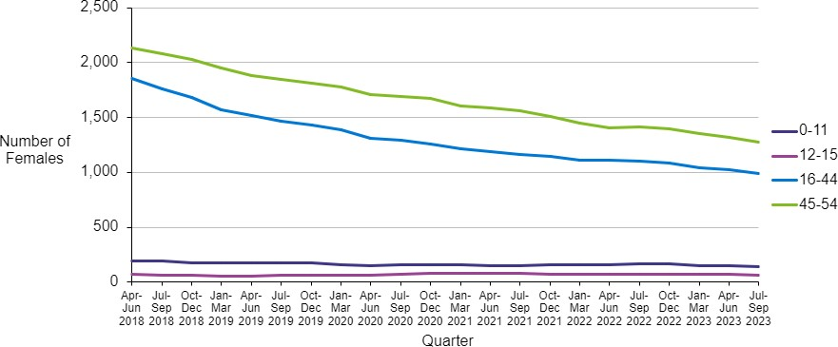

Starting and stopping of valproate prescribing

Figure 2 shows the number of females aged 0-54 who started on valproate in each quarter. It also shows the number of females aged 0-54 who stopped receiving prescriptions for valproate in each quarter. Patients with a one-off prescription would be counted as having both started and stopped in the same quarter.

Data on prescriptions stopped are not shown for the most recent four quarters as this can only be provided when there is a full twelve months of subsequent prescribing information available.

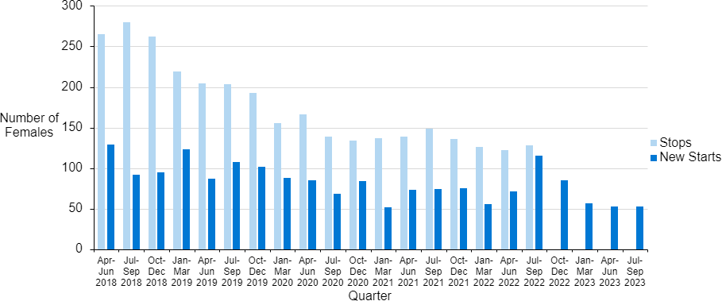
Figure 2: Trend in valproate started and stopped prescriptions in females aged 0-54, April 2018 – September 2023, by quarter

Overall, the number of females starting valproate prescriptions appears to be decreasing. In the most recent quarter, July – September 2023, 53 patients started on valproate; this is a 59% reduction from 129 new patients in April – June 2018.

Looking at the period with data available for both starting and stopping, the number of patients stopping valproate has exceeded the number of patients starting in every quarter; the difference between those starting versus those stopping has decreased over time due to the overall reduction in the numbers of patients prescribed valproate. Further information on this can be found in tabs 3, 4 and 5 of the data tables.

The number of new starts as a percentage of all valproate patients decreased from 3% in April – June 2018 to 2.1% in July – September 2023. Further information on this can be found in tab 3 of the data tables.

This chart can also be viewed for other anti-seizure medicines in tab 3 of the data tables.

Starting of valproate prescribing by age group

Figure 3 shows the trend in number of females starting on valproate by age group. In the 16-44 age group, there was a 59% reduction of patients newly starting valproate, from 56 in April – June 2018 to 23 in July – September 2023.

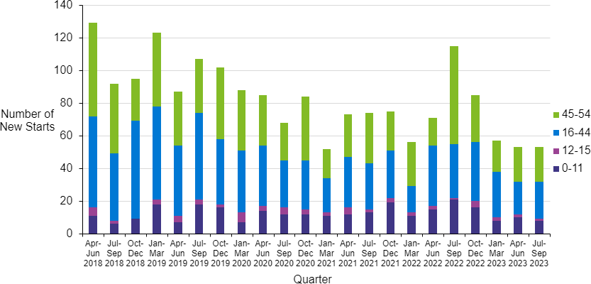
Figure 3: Trend in new valproate prescribing by age group, April 2018 – September 2023, by quarter

Further details can be found in tab 3 of the data tables.

Valproate prescribing in pregnancy

Overall prescribing of valproate in pregnancy

Firstly, all pregnancies conceived between 1 April 2018 and 30 September 2023 to women who had been prescribed valproate at any point from 1 January 2017^{i} to 30 September 2023 were identified. A total of 346 pregnancies to 270 women were identified.

Overall, 75 pregnancies conceived between 1 April 2018 and 30 September 2023 (to 69 women) were exposed to valproate; that is, the woman received at least one pregnancy-related prescription for valproate. This equates to 2.1 per 10,000 pregnancies in Scotland conceived between 1 April 2018 and 30 September 2023 being exposed to valproate. Some pregnancies that were conceived towards the end of the period would still be ongoing on 30 September 2023. It is possible that these pregnancies may have subsequently been exposed between 1 October 2023 and the end of pregnancy; the total number and rate of pregnancies conceived between 1 April 2018 and 30 September 2023 that were exposed to valproate may therefore increase when complete information on prescribing to the end of all of these pregnancies is available. Further information on exposed pregnancies can be found in tab 7 of the data tables.

Figure 4 shows the trend over time in the number of pregnancies that were exposed to valproate. Each exposed pregnancy is counted once, in the quarter when the pregnancy was conceived. One pregnancy conceived in the most recent six months (conceived between 1 April 2023 and 30 September 2023, many of which will still

i Look back to 2017 was used in this section to ensure prescribing in the year before pregnancy was captured for all pregnancies in the cohort, allowing us to identify women stopping prescribing before, and starting prescribing during, their pregnancy. Overall prescribing rates in females aged 0-54 are reported from April 2018 onwards for consistency with pregnancy-related figures.

have been ongoing on 30 September 2023) was exposed to valproate by 30 September 2023.

The quarterly average number of exposed pregnancies (based on the previous four quarters) is also shown, and this indicates that the number of exposed pregnancies has decreased over time. 26 pregnancies that were conceived in the first year studied (1 April 2018 to 31 March 2019) were exposed to valproate (an average of
6.5 per quarter), compared to 4 pregnancies conceived in the most recent year (between 1 October 2022 and 30 September 2023) (an average of 1 per quarter). Again, some of the pregnancies conceived in the most recent period will still have been ongoing on 30 September 2023.

Figure 4: Pregnancies exposed to valproate over time: Scotland, pregnancies conceived 1 April 2018 to 30 September 2023

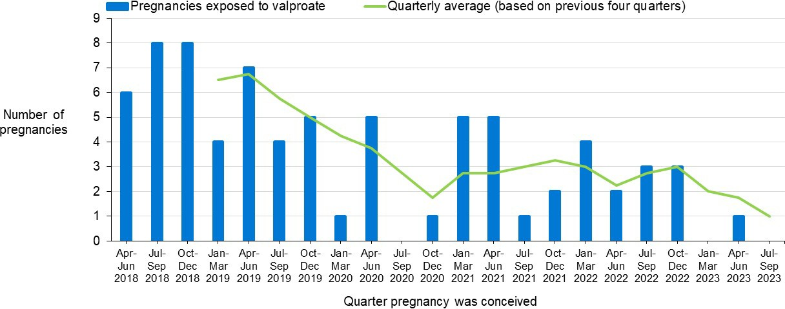
Exposure is based on prescriptions dispensed up to 30 September 2023. Pregnancy-related prescriptions for valproate may have been received in the quarter of conception, the prior quarter if a prescription was dispensed in the 28 days prior to conception, and/or subsequent quarters as the pregnancy progressed. Pregnancies conceived in the most recent quarters may still have been ongoing on 30 September 2023 and follow up to identify any pregnancy-related prescription will be incomplete

Prescribing of valproate by stage of pregnancy

Exposure to valproate during the first trimester of pregnancy (up to 11 weeks and 6 days [11+6 weeks] gestation) carries the highest risk of the baby having a congenital condition, as this is the period during which the baby's organs (e.g., spinal cord, heart) develop. As the baby's brain continues to develop throughout pregnancy (and beyond), exposures at any stage of pregnancy may increase the risk of developmental delay or a neurodevelopmental condition.

Table 1 shows exposure by stage of pregnancy for the 75 valproate-exposed pregnancies conceived between 1 April 2018 and 30 September 2023. Pregnancies vary in duration and outcome; for example, some end in the first trimester due to miscarriage or termination of pregnancy whereas others end in the third trimester in a live birth. Inevitably, exposed pregnancies that end in the first trimester can only have been exposed to valproate during the first trimester. By contrast, exposed pregnancies that end in the third trimester may have been exposed in any combination of first, second, and third trimester.

Table 1: Pregnancies exposed to valproate by duration of pregnancy and stage of pregnancy at exposure: Scotland, pregnancies conceived 1 April 2018 to 30 September 2023

Duration of pregnancy | Total number of exposed pregnancies | Exposed during first trimester | Exposed during second trimester | Exposed during third trimester
Ending in the first trimester | 35 | 35 | N/A | N/A
Ending in the second  trimester | 2 | 2 | 0 | N/A
Ending in the third  trimester | 38 | 36 | 19 | 14
All exposed pregnancies | 75 | 73 | 19 | 14

None of the 75 pregnancies conceived 1 April 2018 to 30 September 2023 that had been exposed to valproate by 30 September 2023 were still ongoing at 30 September 2023, so prescribing captured here represents complete prescribing throughout pregnancy for these exposed pregnancies
First trimester is up to 11 weeks and 6 days gestation

Second trimester is 12 weeks and 0 days to 23 weeks and 6 days gestation Third trimester is from 24 weeks and 0 days gestation to the end of pregnancy Exposure is based on prescriptions dispensed up to 30 September 2023
Exposure in the first trimester include prescriptions dispensed in the 28 days prior to the estimated date of conception

Table 1 shows that of the 75 pregnancies conceived between 1 April 2018 and 30 September 2023 that had been exposed to valproate by 30 September 2023 (all of which had ended by 30 September 2023), 35 (47%) ended in the first trimester; 2 (3%) ended in the second trimester; and 38 (51%) ended in the third trimester. Of the 38 exposed pregnancies ending in the third trimester, 36 (95%) were exposed in the first trimester and 14 (37%) were exposed in the third trimester. As prescribing can start and stop in any pattern throughout pregnancy, the 14 pregnancies exposed in

the third trimester are not necessarily a subset of the 36 exposed in the first trimester.

The 1 pregnancy conceived in the most recent 6 months (1 April 2023 to 30 September 2023) that had been exposed to valproate by 30 September 2023 (which had ended by 30 September 2023), was exposed in the first trimester. Further information on exposed pregnancies by trimester can be found in tab 8 of the data tables.

Starting and stopping of valproate prescribing in relation to pregnancy
Of the 75 valproate-exposed pregnancies conceived between 1 April 2018 and 30 September 2023, in 5 cases, valproate was started during pregnancy. In the 1 valproate-exposed pregnancy conceived in the most recent 6-month period (1 April 2023 to 30 September 2023), valproate was not started during pregnancy. As we currently do not have information on date of immigration to Scotland, or on receipt of private prescriptions, it is possible that some 'new starts' had in fact received valproate in the year prior to pregnancy.

In 55 (44%) of the 125 pregnancies conceived between 1 April 2018 and 30 September 2023, where valproate was prescribed in the year before pregnancy, valproate was stopped prior to pregnancy. That is, a prescription for valproate was dispensed between 29 days and 13 months before the estimated date of conception, but none was dispensed during the 28 days before the estimated date of conception or during the pregnancy (or up to 30 September 2023 for pregnancies still ongoing at that point). In the 1 pregnancy conceived in the most recent 6-month period (1 April 2023 to 30 September 2023), where valproate was prescribed in the year before pregnancy, valproate was not stopped prior to pregnancy. As overall prescribing of valproate (particularly among women of reproductive age) goes down, the number of women eligible to stop taking it prior to pregnancy will reduce over time. Further information on starting and stopping prescribing of valproate in relation to pregnancy can be found in tabs 9 and 10 of the data tables.

Topiramate prescribing in females aged 0-54

This section describes those patients who were prescribed topiramate at least once between April 2018 and September 2023.

Overall topiramate prescribing by age group

In the period from April 2018 to September 2023, a total of 15,456 females between the ages of 0-54 had at least one topiramate prescription.

Figure 5 shows the number of females prescribed topiramate at least once between April 2018 and September 2023. These figures have remained steady for all age groups over this time period, with 4,253 females prescribed topiramate in the most recent quarter (July – September 2023). Further information can be found in tab 2 of the data tables.

Figure 5: Trend in topiramate prescribing in females aged 0-54, April 2018 – September 2023, by quarter
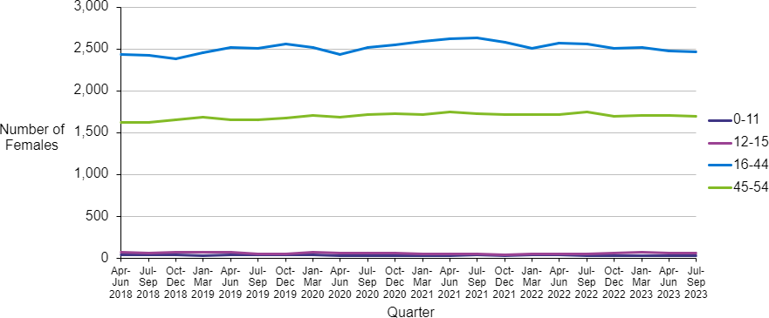

Starting and stopping of topiramate prescribing

Figure 6 shows the number of females aged 0-54 who started on topiramate in each quarter, alongside the number of females aged 0-54 who stopped receiving prescriptions for topiramate in each quarter. Patients with a one-off prescription would be counted as having both started and stopped in the same quarter.

Data on prescriptions stopped are not shown for the most recent four quarters as this can only be provided when there is a full twelve months of subsequent prescribing information available. Further information on females starting and stopping prescriptions for topiramate can be found in tabs 3,4 and 5 of the data tables.

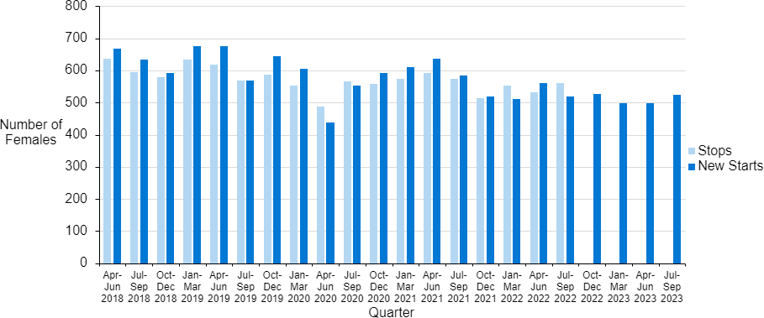
Figure 6: Trend in topiramate started and stopped prescriptions in females aged 0-54, April 2018 - September 2023, by quarter

The number of patients who started topiramate reduced overall by 21% from 667 in April – June 2018 to 524 in July – September 2023. In the same period, the number of patients who stopped receiving topiramate prescriptions reduced by 12% from 636 in April – June 2018 to 562 in July – September 2022. Both of these trends show some fluctuation over the time period shown in figure 6 above. This chart can also be viewed for other anti-seizure medicines in tab 3 of the data tables.

The number of new starts as a percentage of all topiramate patients decreased from 16% in April – June 2018 to 12% in July – September 2023. Further information on this can be found in tab 3 of the data tables.

Starting of topiramate prescribing by age group

Figure 7 shows the trend in number of females newly prescribed topiramate by age group. In the 16-44 age group this has reduced by 19% from 450 in April – June 2018 to 363 in July – September 2023.

Figure 7: Trend in new topiramate prescribing by age group, April 2018 – September 2023, by quarter

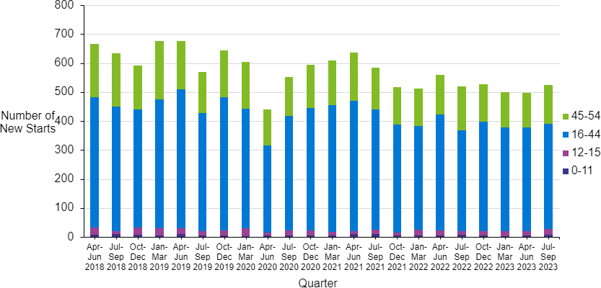

Topiramate prescribing in pregnancy

Overall prescribing of topiramate in pregnancy

Firstly, all pregnancies conceived between 1 April 2018 and 30 September 2023 to women who had been prescribed topiramate at any point from 1 January 2017 to 30 September 2023 were identified. A total of 2,888 pregnancies to 2,148 women were identified.

Overall, 268 pregnancies conceived between 1 April 2018 and 30 September 2023 (to 240 women) were exposed to topiramate; that is, the woman received at least one pregnancy-related prescription for topiramate. This equates to 7.5 per 10,000 pregnancies in Scotland conceived between 1 April 2018 and 30 September 2023 being exposed to topiramate. Some pregnancies that were conceived towards the end of the period would still be ongoing on 30 September 2023. It is possible that these pregnancies may have subsequently been exposed between 1 October 2023 and the end of pregnancy; the total number and rate of pregnancies conceived between 1 April 2018 and 30 September 2023 that were exposed to topiramate may therefore increase when complete information on prescribing to the end of all of these pregnancies is available.

Figure 8 shows the trend over time in the number of pregnancies that were exposed to topiramate. Each exposed pregnancy is counted once, in the quarter when the pregnancy was conceived. 10 pregnancies conceived in the most recent six months (conceived between 1 April 2023 and 30 September 2023, many of which will still have been ongoing on 30 September 2023) were exposed to topiramate by 30 September 2023.

The quarterly average number of exposed pregnancies (based on the previous four quarters) is also shown, and this indicates that the number of exposed pregnancies averaged between 12 and 15 per quarter (48 to 60 pregnancies per year) until the end of 2021, and has since decreased, with the quarterly average below 12 pregnancies per quarter from April to June 2022 onwards, and an average of 9

pregnancies per quarter exposed between October 2022 and September 2023 (some of which will have still been ongoing on 30 September 2023).

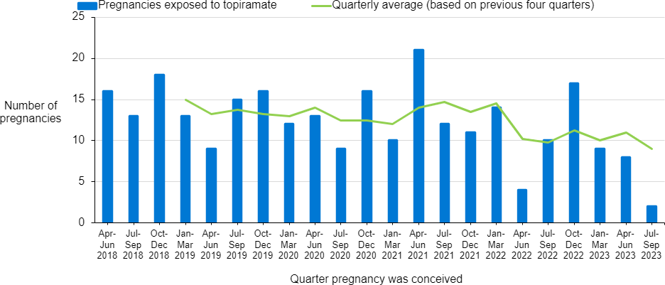
Figure 8: Pregnancies exposed to topiramate over time: Scotland, pregnancies conceived 1 April 2018 to 30 September 2023

Exposure is based on prescriptions dispensed up to 30 September 2023. Pregnancy-related prescriptions for topiramate may have been received in the quarter of conception, the prior quarter if a prescription was dispensed in the 28 days prior to conception, and/or subsequent quarters as the pregnancy progressed. Pregnancies conceived in the most recent quarters may still have been ongoing on 30 September 2023 and follow up to identify any pregnancy-related prescription will be incomplete.

Prescribing of topiramate by stage of pregnancy

Table 2 shows exposure by stage of pregnancy for the 268 topiramate-exposed pregnancies conceived between 1 April 2018 and 30 September 2023.

Table 2: Pregnancies exposed to topiramate by duration of pregnancy and stage of pregnancy at exposure: Scotland, pregnancies conceived 1 April 2018 to 30 September 2023

Duration of pregnancy | Total number of exposed pregnancies | Exposed during first trimester | Exposed during second trimester | Exposed during third trimester
Ending in the first trimester | 100 | 100 | N/A | N/A
Ending in the second  trimester | 6 | 6 | 0 | N/A
Ending in the  third trimester | 162 | 158 | 34 | 30
All exposed pregnancies | 268 | 264 | 34 | 30
7 of the exposed pregnancies in the table above were still ongoing at 30 September 2023 and may have gone on to have exposure in later trimesters.
First trimester is up to 11 weeks and 6 days gestation

Second trimester is 12 weeks and 0 days to 23 weeks and 6 days gestation Third trimester is from 24 weeks and 0 days gestation to the end of pregnancy Exposure is based on prescriptions dispensed up to 30 September 2023
Prescriptions dispensed in the first trimester include those dispensed in the 28 days prior to the estimated date of conception

Table 2 shows that of the 268 pregnancies conceived between 1 April 2018 and 30 September 2023 that had been exposed to topiramate by 30 September 2023 (7 of which were ongoing on 30 September 2023), 100 (37%) ended in (or were ongoing and still in) the first trimester; 6 (2%) ended in (or were ongoing and still in) the second trimester; and 162 (60%) ended in (or were ongoing and still in) the third trimester. Of the 162 exposed pregnancies ending/ongoing in the third trimester, 158 (98%) were exposed in the first trimester and 30 (19%) were exposed in the third trimester.

Of the 10 pregnancies conceived in the most recent 6 months (1 April 2023 to 30 September 2023) that had been exposed to topiramate by 30 September 2023 (9 of which had ended by 30 September 2023), all 10 were exposed in the first trimester. Further information on exposed pregnancies by trimester can be found in tab 8 of the data tables.

Starting and stopping of topiramate prescribing in relation to pregnancy
Of the 268 topiramate-exposed pregnancies conceived between 1 April 2018 and 30 September 2023, in 40 cases topiramate was started during pregnancy. Of the 10 topiramate-exposed pregnancies conceived in the most recent 6-month period (1 April 2023 to 30 September 2023), in one case, topiramate was started during pregnancy. As we currently do not have information on date of immigration to Scotland, or on receipt of private prescriptions, it is possible that some 'new starts' had in fact received topiramate in the year before pregnancy.

In 572 (72%) of the 800 pregnancies conceived between 1 April 2018 and 30 September 2023 where topiramate was prescribed in the year before pregnancy, topiramate was stopped prior to pregnancy. In 20 of the 29 pregnancies conceived in the most recent 6-month period (1 April 2023 to 30 September 2023), where topiramate was prescribed in the year before pregnancy, topiramate was stopped prior to pregnancy. Further information on starting and stopping the prescribing of topiramate in relation to pregnancy can be found in tabs 9 and 10 of the data tables.

Glossary

Anti-seizure medicines (ASMs)
Medicines used to primarily treat patients with epilepsy; examples include valproate, topiramate, carbamazepine, lamotrigine, levetiracetam, phenobarbital, phenytoin.

British National Formulary (BNF)
A standard classification of medicines into conditions of primary therapeutic use. Its purpose is to provide prescribers, pharmacists and other healthcare professionals with up-to-date information about the use of medicines.

Congenital condition
A congenital condition refers to a difference affecting a baby's body structure or function which results from a variation in the process of development before birth. There are many different types of congenital conditions, for example spina bifida, congenital heart disease, cleft lip and palate. As all of a baby's organs develop during the first trimester, exposure to teratogenic medicines during this period carries the highest chance of the baby having a congenital condition.

Estimated date of conception
Estimated from gestation recorded at end of pregnancy, or at antenatal booking for ongoing pregnancies and those with unknown outcomes.

Gestation
A measure of how far along a pregnancy is, measured in completed weeks and days. Prior to the availability of accurate ultrasound scanning, gestation was traditionally measured from the first day of the last menstrual period prior to conception, hence conception occurs at 2 weeks and 0 days (written as 2+0 weeks) gestation. Babies are 'due' at 40+0 weeks gestation.

Neurodevelopmental condition
A neurodevelopmental condition refers to a condition affecting the development of a baby's brain and hence their cognitive and social development as they grow up.
Examples of neurodevelopmental conditions include autism and attention deficit hyperactivity disorder. As a baby's brain continues to develop throughout pregnancy

(and beyond), exposure to teratogenic medicines during any trimester may increase the chance of a neurodevelopmental condition.

Pregnancy-related prescription
Prescription dispensed during the 28 days prior to the estimated date of conception or during the pregnancy (or up to the end of follow up on 30 September 2023 for recently conceived pregnancies that were still ongoing at that point). Given the typical supply per prescription (28-56 days) medicines dispensed in the 28 days leading up to conception would likely still be being taken on the date of conception.

Scottish Combined Medicines Database (SCoMed)
SCoMed is a database containing all available patient level medicines data for Scotland. For details on the included data, see appendix 1 (data sources).

Scottish Linked Pregnancy & Baby Database (SLiPBD)
SLiPBD is a dynamic cohort of fetuses and births from all pregnancies to women in Scotland. For details on the included data, see appendix 1 (data sources).

Starting (all females aged 0-54 years)
New prescription for a medicine; no prescriptions in the 12-months period preceding a quarter with a prescription (e.g. if a patient had no valproate prescriptions between April 2018 and March 2019 but received a first prescription in the quarter April – June 2019, they would be classified as having started valproate in this quarter, April – June 2019).

Starting (during pregnancy)
A prescription for the stated medicine was dispensed during the 28 days prior to the estimated date of conception or during the pregnancy (or up to 30 September 2023 for pregnancies still ongoing at that point) but no prior prescription was dispensed in the previous 12 months (i.e., between 29 days and 13 months before the estimated date of conception).

Stopping (all females aged 0-54 years)
No subsequent prescriptions for a period of 12 months following a prescription (e.g. if a patient had a valproate prescription in the quarter April – June 2019 but no

subsequent prescriptions between July 2019 and June 2020, they would be classified as having stopped valproate in this quarter, April – June 2019).

Stopping (during pregnancy)
A prescription for the stated medicine was dispensed between 29 days and 13 months before the estimated date of conception, but no prescription was received during the pregnancy (i.e., no prescription was dispensed during the 28 days prior to the estimated date of conception or during the pregnancy [or up to 30 September 2023 for pregnancies still ongoing at that point]).

Teratogen
A teratogen is something that is known or suspected to have the potential to harm the unborn baby (e.g. by increasing the chance that the baby has a congenital or neurodevelopmental condition) if the mother is exposed to it during pregnancy

Trimester
Pregnancy can be divided into 3 broadly equal periods called trimesters. Exact cut offs vary but in this report we have defined the first trimester as from conception to 11+6 weeks gestation; the second trimester as from 12+0 weeks to 23+6 weeks; and the third trimester as from 24+0 weeks to the end of pregnancy.

Contact

Lynne Jarvis | Principal Information Analyst | phs.medicinesdevelopment@phs.scot Leanne Hopkins | Principal Information Analyst | phs.medicinesdevelopment@phs.scot

For all media enquiries please email phs.comms@phs.scot or call 0131 275 6105.

Further information

Further information and data for this publication are available from the publication page on our website.

The next release of this publication will be October 2024.

Rate this publication

Let us know what you think about this publication via. the link at the bottom of this
publication page on the PHS website.

Appendices

Appendix 1 – Data sources

Scottish Combined Medicines Database (SCoMeD)

SCoMeD is a data resource aimed at collating patient level data pertaining to medicines prescribed, dispensed, and/or administered to patients across Scotland in both primary and secondary care settings. It combines data from three existing sources: the Prescribing Information System (PIS), the Hospital Electronic Prescribing and Medicines Administration (HEPMA) system, and Home Care Medicines (HCM). Information is available on all NHS prescriptions dispensed through community pharmacies / dispensing doctors in Scotland since 2010; privately paid-for prescriptions are not included. Information on medicines prescribed and administered during hospital stays is currently available for six Scottish health boards, covering ~65% of the Scottish population, whereas medicines supplied through Home Care Services, i.e., medicines prescribed in secondary care and delivered directly to a patient's home, are captured from two providers, covering
~90% of the Scottish population. In-hospital and home care medicines are available from July 2022 and January 2019, respectively.

Scottish Linked Pregnancy and Baby Database (SLiPBD)

SLiPBD is a dynamic cohort of all fetuses and births from pregnancies to women in Scotland. SLiPBD brings together data from a range of existing national databases on a monthly basis to provide timely data on new/ongoing and completed pregnancies. Source databases include those on antenatal booking; general and maternity inpatient hospital discharge records indicating care for an end of pregnancy event such as a miscarriage or delivery; termination of pregnancy notifications; and statutory live and stillbirth registrations. Following each month's refresh, SLiPBD includes broadly complete information on new pregnancies conceived, and pregnancies that have ended, up to 3 months prior to the refresh. Whilst SLiPBD includes information on the substantial majority of pregnancies, it will not include

information on early pregnancy losses that are not recognised by the woman, or those treated by a GP or an early pregnancy clinic without requiring admission to hospital. SLiPBD is the preferred source of information for all recognised pregnancies in Scotland.

Cohort definitions

Medicines cohort

The medicines cohort was created from the SCoMeD database described above. The cohort consists of:

- All females (as defined by CHI number) aged between 0-54 prescribed any medicine within BNF chapter 4.8 (anti-epileptic drugs) or valproate within any other BNF chapter.

- Prescription dates between 1 January 2017 and 30 September 2023.

Pregnancy cohort

To create the pregnancy cohort, the CHI numbers from the SCoMeD medicines cohort were selected from the SLiPBD database, and all records of these individuals having a pregnancy that was conceived between 1st April 2018 and 30th September 2023 were identified. This will include pregnancies that were conceived in the time period but ended after 30th September 2023 (latest conception date is 30th September 2023).

All pregnancies are included, regardless of the outcome. Where pregnancies have no known outcome, only dates from estimated conception to booking are included in terms of medicines exposure. This is to avoid including medicines being prescribed to women who are no longer pregnant and therefore potentially counting exposures to medicines as being pregnancy-related when they were not.

Appendix 2 – Publication metadata

Publication title
Anti-Seizure Medicines in Pregnancy

Description
Anti-seizure medicines prescribed in females aged 0-54 and exposure to these medicines in pregnancy.

Theme
Health Services

Topic
Pharmacy and Prescribing, Pregnancy

Format
PDF report and Excel tables

Data source(s)
Scottish Combined Medicines Database (ScoMeD) and Scottish Linked Pregnancy and Baby Database (SLiPBD).

Date that data are acquired
February 2024

Release date
2 April 2024

Frequency
Biannual

Timeframe of data and timeliness
Data presented covers April 2018 to September 2023. This reflects the most up to date data available.

Continuity of data
This is the first time this data has been published.

Concepts and definitions
See glossary and appendix 1.

Relevance and key uses of the statistics
Understanding and monitoring trends in prescribing of anti-seizure medicines and exposure to these in pregnancy.

Accuracy
Quality checks are conducted by Public Health Scotland.

Completeness
See Appendix 1

Comparability
Similar data is published for NHS England. There are some small differences in data definitions and methodology.

Accessibility
It is the policy of Public Health Scotland to make its websites and products accessible according to published guidelines. More information on accessibility can be found on the PHS website.

Coherence and clarity
Detailed data and charts are also accessible via the PHS website.

Value type and unit of measurement
Numbers and non-standardised rates are presented.

Disclosure
Applied as per PHS Statistical Disclosure Control Protocol.

Official statistics accreditation
Official statistics in development

Last published
This is the first release of these statistics.

Next published
October 2024, covering data from April 2018 to March 2024

Date of first publication
2 April 2024

Help email PHS.medicinesdevelopment@phs.scot

Date form completed
16 February 2024

Appendix 3 – Early access details

Pre-release access

Under terms of the 'Pre-release Access to Official Statistics (Scotland) Order 2008', PHS is obliged to publish information on those receiving pre-release access ('pre- release access' refers to statistics in their final form prior to publication). The standard maximum pre-release access is five working days. Shown below are details of those receiving standard pre-release access.

Standard pre-release access:

Scottish Government Department of Health and Social Care (DHSC) NHS board chief executives
NHS board communication leads

Early access for management information

These statistics will also have been made available to those who needed access to ‘management information’, i.e. as part of the delivery of health and care:

Early access for quality assurance

These statistics will also have been made available to those who needed access to help quality assure the publication:

Teratogenic Medicines Advisory Group - Valproate subgroup

Appendix 4 – PHS and official statistics

About Public Health Scotland (PHS)

PHS is a knowledge-based and intelligence driven organisation with a critical reliance on data and information to enable it to be an independent voice for the public’s health, leading collaboratively and effectively across the Scottish public health system, accountable at local and national levels, and providing leadership and focus for achieving better health and wellbeing outcomes for the population. Our statistics comply with the Code of Practice for Statistics in terms of trustworthiness, high quality and public value. This also means that we keep data secure at all stages, through collection, processing, analysis and output production, and adhere to the Office for National Statistics ‘Five Safes’ of data privacy.

Translations and other formats are available on request at:
phs.otherformats@phs.scot or 0131 314 5300.

This publication is licensed for re-use under the Open Government Licence v3.0. For more information, visit www.publichealthscotland.scot/ogl

