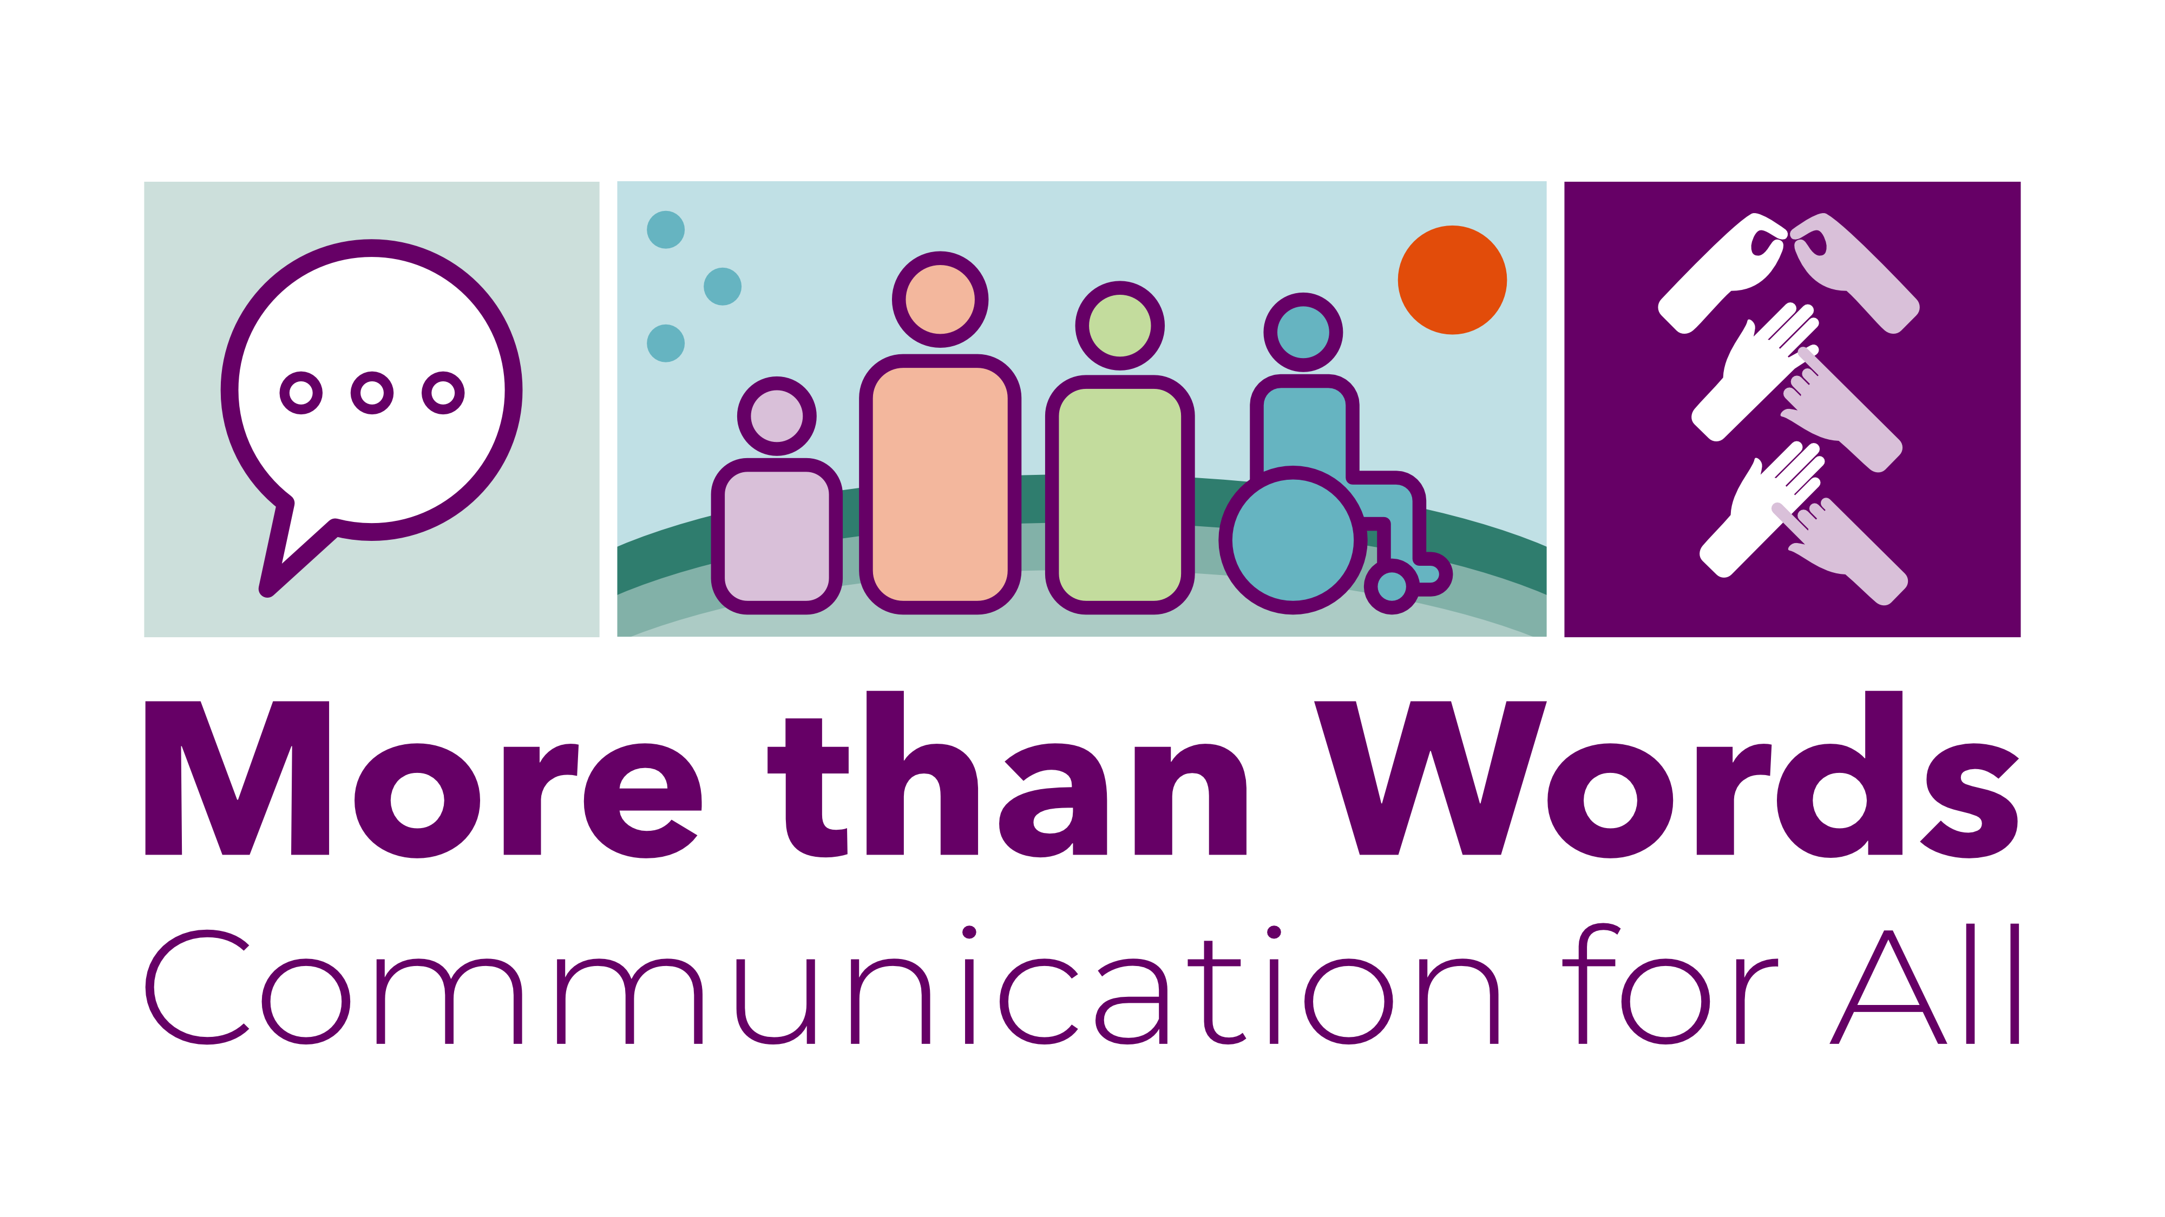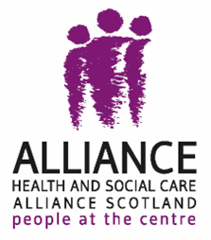

**The Health and Social Care Alliance Scotland**

**(The ALLIANCE)**

**More than Words**

**How inclusive communication is provided by public bodies in Scotland**

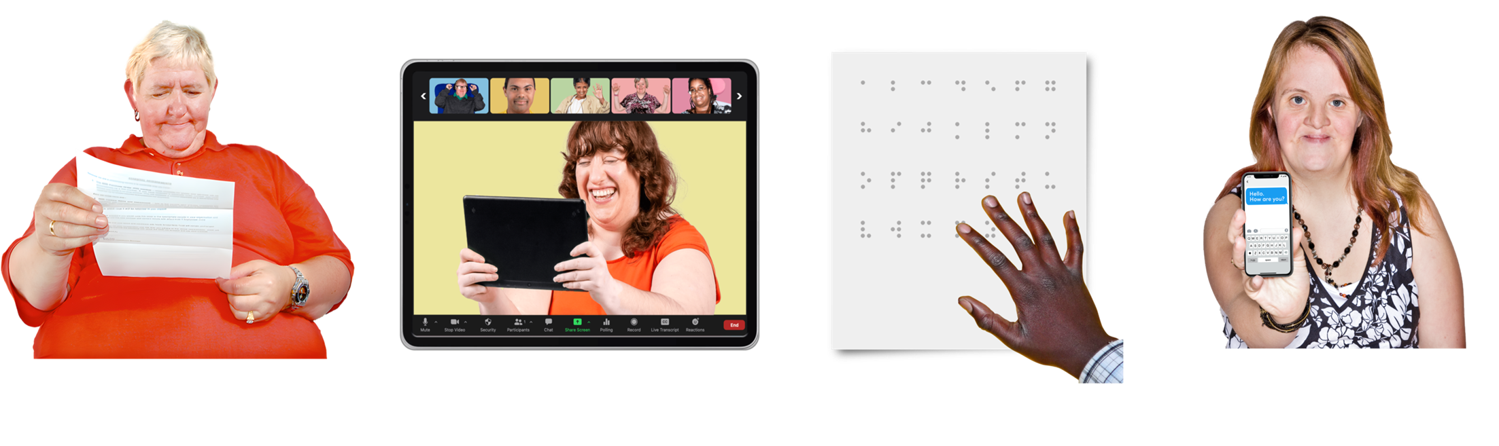

**Easy Read**



## a pink rectangle with the Disability Equality Scotland logo in white, inside it - a white outline of a speech bubble, with an equals sign inside it, next to the words 'Easy Read made by Disability Equality Scotland. It is next to a turquoise rectangle with a white tick on it and the words 'made with photosymbols'.

## Introduction

|  |  |
| --- | --- |
| a group of disabled people  3 smiling people giving the thumbs up | **Inclusive communication**:   * means everyone gets information in a way that meets their needs * means everyone feels included and able to understand the information * makes services more accessible for everyone * supports people to live more independently and to take part in everyday life |
| a smiling man handing paper information to another mana student outside a school, NHS staff in a hospital, and council staff in a council building | **Public bodies** are organisations that work for the Government and provide services we all use like schools, hospitals and councils.  [Inclusive communication](https://inclusivecommunication.scot/what-is-inclusive-communication) means communication for all - sharing information in a way that everybody can understand. |
| a woman holding a letter  people on an online meeting  a hand feeling a paper with Braille dots on ita woman holding up the screen of a mobile phone to show a text | Communication for all includes:   * written * online * phone calls * face to face   It makes sure everyone can get and use different ways of communicating like:   * **BSL** - British Sign Language interpreters * **captions** – words on the screen that show what people are saying * **Braille** - raised dots you read by touch, for people who are blind * being able to text instead of phoning for an appointment |
| a group of people next to the Human Rights Act law document | The ALLIANCE believe that inclusive communication is a way to making sure people get their human rights. |
| a frowning woman giving the thumbs down and holding a sign with a red cross on ita man next to the Equality Act law document | Scotland does not have clear laws about inclusive communication although it is included in:   * the Equality Act 2010 * the BSL (Scotland) Act 2015   People with communication support needs are not treated equally. |
| a woman holding a list of 3 things | This report:   * checks if inclusive communication is provided by public bodies * gives examples of when it has been provided well * shows what could be done better |

## Response rate – how many replies did we get?

|  |  |
| --- | --- |
| 2 people looking at the screen of a computer | A **FOI** is a Freedom of Information request.  This means a person or organisation has a legal right to get information from a public body. |
| email on a computer screen  3 people on an online call | In March and April 2025 we:   * sent FOI requests to 101 Scottish public bodies - 84 replied * had 3 interviews with equalities leads:   + 2 from local councils   + 1 from a college   **Respondents** are organisations that replied to the FOI request. |
| email on a computer screen with a red line through ita smiling woman giving the thumbs up and holding a clipboard with a green tick on it | Before the legal limit of replying before 20 working days had passed,17 public bodies had not replied.  It is worrying that many Health Boards did not reply, including the 4 that represent most of the Scottish population.   * 64 per cent of Health Boards replied * 81 per cent of local authorities replied * 90 per cent of universities and colleges replied * 87 per cent of other public bodies replied |
| 2 people either side of a flipchart on a stand showing 2 people using different types of communicationa thinking woman with a green tick and red cross in a thought bubble above her head | Departments and staff who manage FOI requests should:   * get inclusive communication training * have ways to check if online systems work well particularly for:   + screen reader accessibility   + the use of online forms |
| a website on a computer screen, behind a woman giving the thumbs down and holding a clipboard with a red cross on ita frowning man giving the thumbs down and holding a sign with a red cross on it with 3 red dots leading to a smiling man giving the thumbs up and holding a sign with a green tick on it | No respondents’ websites gave information about how to:   * put in an FOI request in alternative formats * get information in ways that meet your communication needs – like Large Print or BSL   We recommend that public bodies make their FOI process more inclusive and offer alternative formats. |

## Keeping information about support requests

|  |  |
| --- | --- |
| a thinking man with a thumbs up and thumbs down in thought bubbles above his heada confused woman shrugging her shoulders with a question mark beside her head | **We asked -** **do you keep information about requests for communication support?**  Of the 84 organisations that replied:   * 63 per cent do not keep information * 15 per cent keep information * 21 per cent keep some information |
| a frowning woman holding a list with red crosses on it | Without collecting and checking data on inclusive communication requests it is impossible for public bodies to check:   * if they are supporting people to take part in public life * if some groups of people can access their rights less than other groups |
| A thumb down next to the Scottish Parliament building and council staff in a council building | It is worrying that:   * only 15 per cent of respondents collect all the information they need about accessible information requests * the Scottish Parliament and many Health Boards and councils do not collect information |
| a confused woman shrugging her shoulders with a question mark beside her head | Many local councils, universities and colleges do not keep their information on a central database.  This means they could not easily check the information we asked about. |
| an interpreter supporting a woman  a frowning man giving the thumbs down and holding a sign with a red cross on it with 3 red dots leading to a smiling man giving the thumbs up and holding a sign with a green tick on it | BSL translation and interpretation was the most mentioned type of inclusive communication recorded by public bodies.  The BSL (Scotland) Act and local BSL plans has meant that tracking of this information has got better. |
| A law document and a judge's wooden gavel. | We think this shows that:   * laws about inclusive communication do work– in this case about BSL * there should be laws about inclusive communication |
| a smiling woman giving the thumbs up next to a list with green ticks on it | We recommend that all public bodies:   * keep inclusive communication request information in one central place * check their support for people to take part in community life and get services * report information so anyone can see how work on accessible information is getting better * share information with lived experience panels and networks |
| a thinking woman next to a law document  A law document and a judge's wooden gavel. | We believe there should be clear rules:   * in guidance * in any new laws   to make sure everyone is included in communication. |

## Number of support requests

|  |  |
| --- | --- |
| a thinking person with a question mark in a thought bubble above his head | **We asked -** **how many requests for inclusive communication support did you get in 2020 to 2024?** |
| a pie chart with a 57 per cent section with a thumbs down, and a thumbs up in the smaller section of 43 per cent | Of the 84 organisations that replied:   * 48 (57 per cent) said they do not have this information * 24 (29 per cent) gave information * 12 (14 per cent) gave information on:   + some inclusive communication support requests   + requests in a shorter time period |
| a worried woman with a question mark beside her head | It is worrying that:   * more than half of respondents do not keep data on inclusive communication requests * they do not know if support is provided or improvements made |
| a woman with a list with green ticks on it | It is good that nearly half of respondents collected some form of data.  Some organisations gave very detailed information like:   * the University of Edinburgh * City of Glasgow College * Edinburgh City Council * Social Security Scotland |
| a woman at a podium next to a presentation on a screen in front of an audience of people | The Improvement Service and Scottish Government should share examples of guidance and what works well on inclusive communication data collection and provision. |
| a weblink on a computer screen  A law document and a judge's wooden gavel. | The ALLIANCE recommends that:   * public bodies have a single place to collect and keep track of information * there should be a new law to give everyone in Scotland a right to inclusive communication support if they need it |

## Number of requests that were given information

|  |  |
| --- | --- |
| a woman with a question mark beside her head  a pie chart with a blue section showing 48 per cent with a thumbs up in it and a slightly larger grey section with a thumbs down in it | **We asked - how many requests for inclusive communication support made to you in 2020 to 2024 were given information?**  Of the 84 respondents:   * 43 (51 per cent) did not keep this information * 28 (33 per cent) gave full information * 13 (15 per cent) gave some information   It is not good that more than half of respondents do not have information on how many support requests were given information. |
| a frowning man giving the thumbs down and holding a sign with a red cross on it with 3 red dots leading to a smiling man giving the thumbs up and holding a sign with a green tick on it | Organisations must have better ways to collect information about inclusive communication to make sure that people’s support needs are met. |
| a group of people meeting around a table  A law document and a judge's wooden gavel. | We think there should be inclusive communication networks across each sector:   * to share problems and solutions * to improve:   + how work is checked   + how information is shared   + how services are given   There should be a law that public bodies must report information about inclusive communication requests. |

## Types of support requests

|  |  |
| --- | --- |
| a pie chart with a blue section showing 51 per cent with a thumbs down in it and a slightly smaller grey section with a thumbs up in it | **We asked - what types of inclusive communication support request did you get from 2020 to 2024?**  Of the 84 organisations that replied:   * 43 (51 per cent) do not keep this information * 31 (37 per cent) gave information * 10 (12 per cent) gave some information |
| money - coins and notes - and a finger pushing buttons on a calculator  a man holding a list with a green tick on it | Knowing the types of inclusive communication support requests made to each public body means:   * organisations can make sure there is enough money for inclusive communication support * the right services can be provided |
| 2 men signing BSL | 90 per cent of organisations that collected data said they provide BSL interpretation and translation. |
| a hand feeling a paper with Braille dots on it  a large print document | There was a lot less awareness about other kinds of support:   * 56 per cent of respondents said they provided alternative formats * 44 per cent provided Braille * 39 per cent provided Large Print * 25 per cent had requests for assistive reading and listening technology, captions, and electronic notetakers |
| 2 groups of people meeting and talking | Universities and colleges collected more detailed information than most other respondents.  Some respondents said councils, universities and colleges working together gave good support and better inclusive design and planning. |

## Complaints that organisations get and resolve - deal with

|  |  |
| --- | --- |
| a man complaining to a woman who is writing information down | **We asked: How many complaints did you get about a lack of inclusive communication between 2020 to 2024?**  Of the 84 organisations that replied:   * 56 (67 per cent) gave full information * 6 (7 per cent) gave some information * 22 (26 per cent) gave no information |
| a pie chart showing three quarters with a thumbs up in it | It is good that nearly 3 in 4 respondents collect some complaints data.  It is worrying that 1 in 4 could not give any information. |
| a pie chart with a thumbs up in a blue section of 55 per cent.  It is in front of an image of a hospital building.A group of students in front of a college building next to council staff in a council building  a frowning man giving the thumbs down and holding a sign with a red cross on it with 3 red dots leading to a smiling man giving the thumbs up and holding a sign with a green tick on it | Health Boards have the lowest rate of data collection on complaints.  Just over half (55 per cent) of responding Health Boards collected any information.  Universities, colleges and councils keep the most detailed information about inclusive communication complaints.  Complaint information is kept by:   * 78% of universities and colleges * 77% of councils * 69% of other public bodies   Having this information means they can use it to make services better. |
| a man complaining to a woman who is writing information down  a smiling woman giving the thumbs up and holding a sign with a large green tick on it | **We asked - how many complaints about inclusive communication made between 2020 and 2024 have been resolved?**  All 16 council complaints (from 3 councils) were resolved.  NHS Fife reported that all complaints were resolved.  NHS Western Isles reported that both the number of complaints and resolutions was less than 5 but gave no more information. |
| A group of students in front of a college building | Across the universities and colleges that reported inclusive communication complaints:   * 16 complaints (62 per cent of all complaints) were dealt with * 3 complaints (12 per cent) were partly dealt with * 7 complaints (27 per cent) were not dealt with |
| a man with a lightbulb 'thought' beside his heada smiling man holding a list with green ticks on it | It is good that:   * most recorded complaints were dealt with * several respondents had information about the supports that were then put in place after complaints were made   This showed they learned from complaints. |

## Staff training

|  |  |
| --- | --- |
| a woman talking to groups of people seated at tables  a pie chart with a hand with a thumb up in the blue section of 64 per cent | **We asked: do you offer your staff training on inclusive communication?**  Of the 84 respondents to this question:   * 32 (38 per cent) offer training * 22 respondents (26 per cent) offer training on some kinds of inclusive communication * 30 respondents (36 per cent) do not offer any training |
|  | It is good that:   * nearly 2 out of 3 respondents offer training around some types of inclusive communication * most training is open to all staff   Respondents who run training every 2 months collected better data and had less complaints. |
| a frowning woman giving the thumbs down and holding a sign with a red cross on it | It is not good that several respondents thought that inclusive communication was the same thing as BSL, captions or visual impairment awareness training. |
| 2 groups of people meeting and talking | Several respondents said it was important to do the training in partnership with accessibility working groups.  Very few respondents said that most staff had completed training offers. |
| 2 men standing in front of a white board showing an image of 3 people using British Sign Language | **We asked – can all staff get your training on inclusive communication?**  83 per cent of respondents offer inclusive communication training to all staff. |
| a frowning man holding a sign with a red cross on ita smiling man giving the thumbs up next to a list with green ticks on it | Some organisations had high completion rates for inclusive communication training, for example:   * 100 per cent - Police Investigations and Review Commissioner and Standards Commission for Scotland * 93 per cent - Dundee and Angus College * 91 per cent - West Lothian College * 63 per cent - Social Security Scotland   Some respondents said less than 2 per cent of their staff have done any inclusive communication training.  Very few respondents said that most staff had completed training offers. |
| a small group of people having a meeting around a table | It is probably easier for smaller organisations to make sure their staff complete training.  Most staff in public bodies had not had any training. |

## Conclusion

|  |  |
| --- | --- |
| A law document and a judge's wooden gavel.a group of people celebrating with their arms in the air | We want there to be a law about inclusive communication for public bodies, including data collection and staff training.  There should be laws to protect people’s right to inclusive communication so their human rights are protected.  Good inclusive communication is good for everyone. |

