
Integration in Action event report:
Leading Courageously
July 2025

The Health and Social Care Alliance Scotland (the ALLIANCE)



Table of Contents

Introduction 2
Event Summary 3
Presentations 4
Group activities 9
Contact 14

Introduction

On June 26th 2025, the Health and Social Care Alliance Scotland (the ALLIANCE) and the International Foundation for Integrated Care (IFIC) Scotland hosted the fifth event in our Integration in Action series exploring the Academy’s Leading Courageously ambition.
We heard from five speakers from different organisations highlighting examples of what courageous leadership looks like in practice, and how that has had a significant impact on the progression of integration.
The presentations were followed by dynamic group discussions that explored courageous leadership more deeply and what it meant to attendees, providing space for reflection and connection.
This event aimed to inform, inspire and empower whilst fostering connections between current and future leaders in health and social care. The event was chaired by Professor Anne Hendry, Director of IFIC Scotland, and Sara Redmond, Chief Officer for Development at the ALLIANCE, and was attended by 38 people.

Event Summary
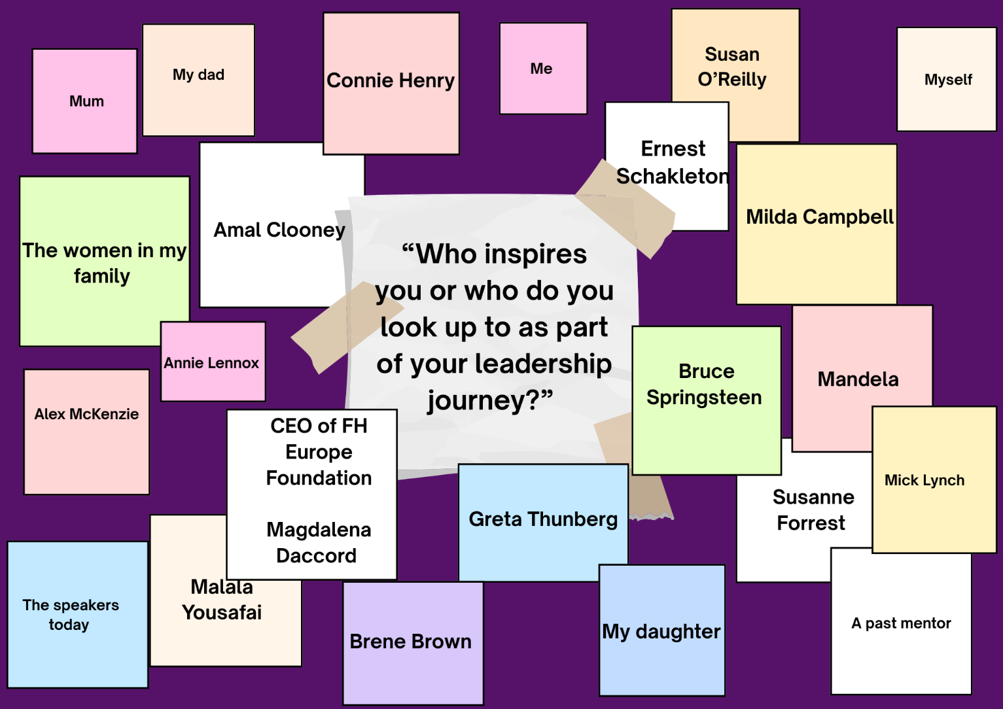
Upon arrival attendees were asked to consider the following question, “Who inspires you or who do you look up to as part of your leadership journey?” Answers and reflections to this question can be found below.

The event began by hearing from a range of speakers on the topic of courageous leadership from personal and professional perspectives. We heard from Sean Mackaskill, co-founder of Autistic Knowledge Development (AKD), Tim Eltringham, Chief Officer, South Ayrshire Health and Social Care Partnership, and Kaya-Megan Burns a neurodivergent entrepreneur, podcast producer, and Founder & CEO of Podplistic.

We then moved into a group activity focusing on a facilitated discussion on the values and qualities of a courageous leader.
Following a short break, a second round of speakers picked up the topic of courageous leadership where we heard from Jane-Claire Judson, CEO of Chest, Heart & Stroke Scotland and Diane Roth, member of the Organisational Development and Culture team at Fife Health and Social Care Partnership.
This was followed by a second round of group discussion centring on an exploration of the conditions that support courageous leadership, paying attention to the fact that courageous leadership does not happen in isolation. This activity also asked attendees to consider what commitments they could individually make as part of their own leadership journeys.
The event was closed by Sara Redmond where attendees were asked to quietly reflect, through a journaling exercise, on what they could do in their own roles to become more courageous.

Presentations
Sean Macaskill, Autistic Knowledge Development, Director
Sean Macaskill (AKD) discussed the purpose and role of the organisation, drawing attention to it’s think tank nature. AKD is composed of individuals with autism and together the team engage in action research, deliver training and consultancy. Diagnosed with autism later in life, Sean spoke of the strengths that neurodivergence and autism can bring to a concept such as leadership.
In addressing courageous leadership, Sean picked out the following key aspects:
- Choose community over career at every crossroad
- Just because everyone else does it does not make it OK
- If you do have to make budget cuts, think carefully about where from
- Do not mistake professionalism with “looking the other way”

Tim Eltringham, Chief Officer, South Ayrshire Health and Social Care Partnership
Tim Eltringham discussed his understanding of courageous leadership and shared that:
“Courageous leadership is the practice of leading with integrity, authenticity, and boldness—especially in the face of fear, uncertainty, or resistance. It involves making tough decisions, standing up for what’s right, and inspiring others through action, even when it's uncomfortable or unpopular”
The key traits of courageous leadership were outlined according to Tim in his own work. These included integrity, vulnerability, resilience, accountability and empowerment. Tim then turned to a discussion of authentic leadership, separating out courage from authenticity. The key traits of authentic leadership were covered and included:
- Speaking out against unethical behaviour, even if it risks backlash
- Making decisions that prioritise longer-term well-being over short-term gains
- Giving honest feedback with compassion
- Admitting when you’re wrong and learning from it
- Leading change in a resistant culture or organisation
Tim ended his presentation by sharing some examples of courageous leadership in Ayrshire and Arran.
Kayla-Megan Burns, Courageous Leadership, A Personal Journey, Founder & CEO, Podplistic
Kayla began their presentation with an overview of their journey from a rural area in Northern Ireland, volunteering with youth projects all the way to today, where they are a neurodivergent leader, entrepreneur, founder and CEO. The key for Kayla was saying yes.
“Sometime the best opportunities come from saying yes”

Kayla explored that for them, saying yes had- and continues to have- a profound positive impact on their career trajectory. From winning university student elections, to designing intersectional climate strategy on an international stage, to speaking with ITV studios about the ethics in artificial intelligence for the music and creative industries. Despite this success, Kayla reflected that they felt at every point, that they ‘did not fit’ in the room.
They explained that feeling uncomfortable can at times be a very good indicator that you are doing the right thing. Kayla spoke about the importance of mentorship frameworks for cultivating future leaders and for developing the existing leaderships skills of current leaders.
Kayla spoke about the importance of kind leadership, autonomy and ownership.
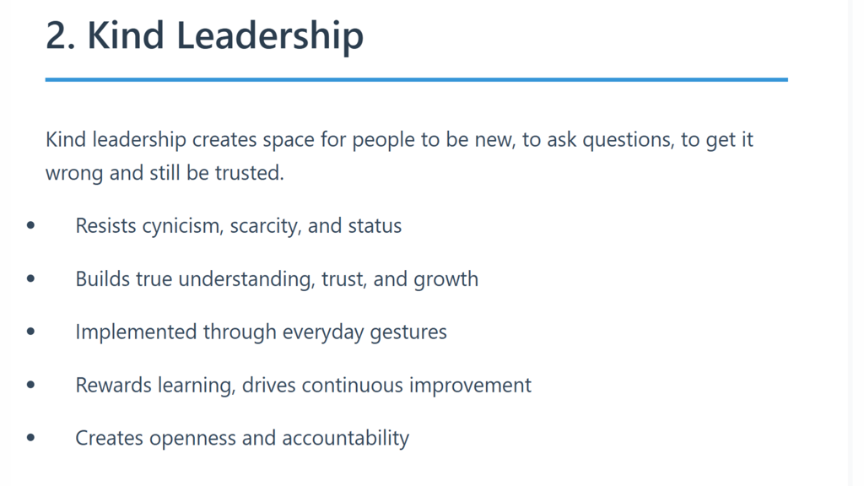
“Kind leadership creates space for people to be new, to ask questions, to get it wrong and still be trusted”
Kayla shared that being trusted to act with autonomy and having a sense of ownership over projects and workloads is essential to cultivate leadership qualities. One final aspect of leadership that was shared was

inclusivity. Moving away from tokenism and instead authentic investment in individuals was key.
“Never assume you are an expert in inclusion”
Jane-Claire Judson (CHSS)
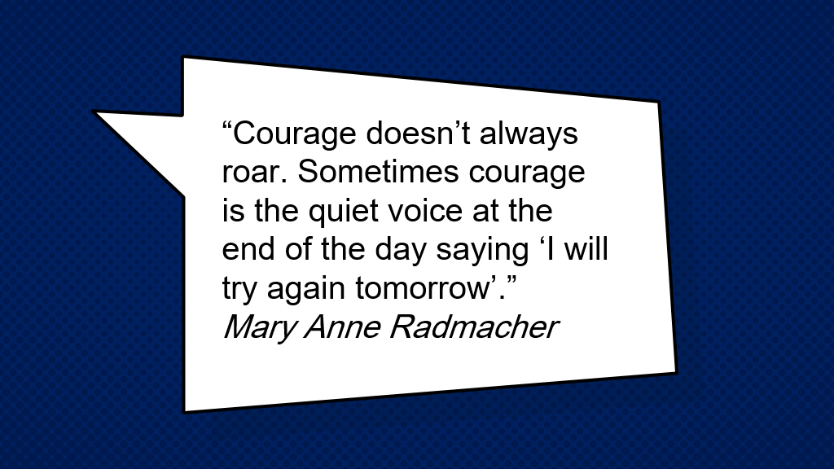
Jane-Claire discussed her courageous leadership journey where she touched upon the value of unconditional positive regard as a tool for being courageous and the importance of having hard/difficult conversations.

Jane-Claire highlighted that leading courageously requires collaborative working and the importance of knowing when to take a break whilst trusting that your organisation/strategy can go on without you. This latter point spoke to the importance of feeling a sense of safety during the leadership journey.
Finally, the speaker shared her experience of the importance of challenging the status quo in support of others. Jane-Claire highlighted that going through a 'butterflies' moment is often entirely worth the discomfort at the time.
“Just because its good doesn't mean it can't be better”

Diane Roth, Fife HSCP, What matters to you culture programme
Diane Roth reflected on her work with the ALLIANCE's Person Centred Voices programme, where she worked to embed person centred values and processes into care homes across Fife. She shared that it was not about pointing out what was bad but about being receptive to always aspiring to better services. The success of the work rested in giving power to others and bringing people with her which allowed for:
  - Creative approaches
  - Buy in from people accessing the service and staff
  - Openness
Diane highlighted the importance of consistency and leading by example, the value of taking the initiative to listen to what people want and adapting the approach to action that listening.
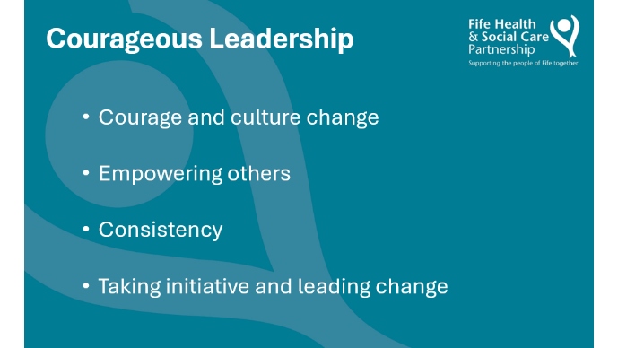

“Courage doesn't have to be expensive or high level, it can come from simple solutions that listen and adapt to need”.

Group activities
Activity one: The values and qualities of a courageous leader.
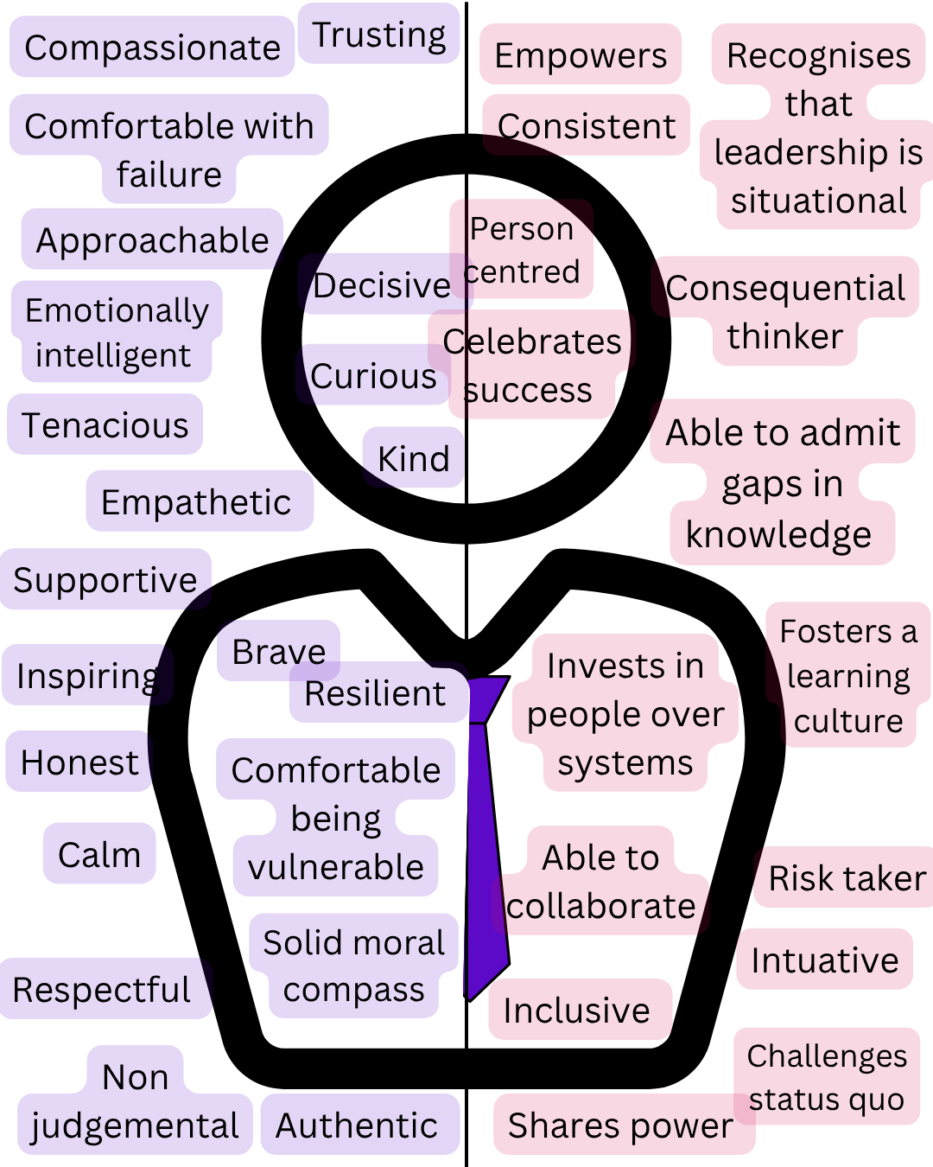
Following the presentations by Sean, Tim and Kayla, attendees were asked to consider in groups, the values and qualities of a courageous leader. Attendees identified two themes during this activity. The first theme, personal qualities, concerned the traits an individual who assumes a leadership position should have. The second theme, professional delivery, concerned how an individual in a leadership position should behave.

Within the first theme, qualities such as kindness, empathy and strong moral values were identified to be important whereas sharing power, investing in people and challenging the status quo were identified to be important for a leader when carrying out their duties.

Activity Two: Conditions and Commitments
Groups were asked to consider what conditions enable the values and qualities associated with courageous leadership which were identified in the previous activity.
Theme 1: Organisational policy and process
Attendees identified several tangible aspects that relate to organisational policy and processes. These included embedding open-door policies, embedding feedback loops to demonstrate the value of staff perspective, ensuring there is time for reflective practice, establishing a learning culture that includes access to courses and the establishment of mentorship initiatives.
Theme 2: process execution
Attendees also identified several conditions related to the manner of how processes are delivered/executed. Ensuring that organisations, teams and departments experience an environment of safety, security and belonging to facilitate empowered voices was essential.
Groups were asked to consider, as collectives, what commitments they could take forward to contribute to the establishment of courageous leadership within their own organisations. These commitments included:
- Establishing accountability mechanisms
- Investing in the skills of people and encourage the next generation of leaders
- Move recruitment methods away from traditional competency-based frameworks
- Establish a shared vision
- Measure and evaluate the rights things

Activity Three: Reflective commitments
The final activity of the day consisted of a reflective journaling activity. Attendees were asked to note down their own personal commitments around what they could do to be more courageous in their own roles.
Some example commitments are shared below
“Appreciate the power I hold and the value I bring to the table”

“Ask questions, share insights and try new things. Be willing to fail and learn”

“Be open about when I’m not feeling courageous so I can be supported to be brave”

About the ALLIANCE Health and Social Care Academy
To achieve a society where people enjoy their right to live well with dignity and respect, we must bring people together to share our learning and identify solutions for a better future. That’s why the ALLIANCE’s Academy programme offers a safe space for collaborative thinking, the sharing of evidence, and promoting the voice of lived experience, with a focus on health and social care integration. Our work is underpinned by the Five Ambitions for the Future of Health and Care (the Ambitions), which show what we need for a fairer and more sustainable society. Everyone in Scotland deserves a future where their wellbeing is at the centre. The Ambitions shine a light on successful approaches, and spotlight what we can achieve when we work together.

About the ALLIANCE Integration Support Programme
The ALLIANCE Integration Support programme aims to increase the third sector’s contribution to health and social care integration. As a team, we use our platform to promote and champion the role of the third sector and we play a role in ensuring the voice of lived experience is able to influence the design and delivery of integrated services.

About IFIC Scotland
In 2017, the University of the West of Scotland (UWS) established the International Centre for Integrated Care as a global centre of excellence in leading people-centred, integrated care, and as the home of IFIC in Scotland.
In 2020, IFIC and UWS refreshed their partnership and, with the Health and Social Care Alliance Scotland (the ALLIANCE), agreed to a new Memorandum of Understanding.
The three strategic partners bring their collective expertise to a shared mission:
Co-creating a healthier future with individuals and communities by developing courageous and compassionate leaders and practitioners

with the knowledge, skills and confidence to design, deliver and evaluate people-centred integrated care.

Contact
If you wish to find out more about this event, or if you have any questions, please contact:
Kerry Ritchie, Programme Manager – Lived Experience, Integration and Engagement Hub
E: Kerry.ritchie@alliance-scotland.org.uk
Jane Miller, Programme Manager – Health and Social Care Academy
E: Jane.miller@alliance-scotland.org.uk
Sarah Dick, Academy and Integration Development Officer
E: Sarah.dick@alliance-scotland.org.uk

About the ALLIANCE
The Health and Social Care Alliance Scotland (the ALLIANCE) is the national third sector intermediary for a range of health and social care organisations. We have a growing membership of over 3,500 national and local third sector organisations, associates in the statutory and private sectors, disabled people, people living with long term conditions and unpaid carers. Many NHS Boards, Health and Social Care Partnerships, Medical Practices, Third Sector Interfaces, Libraries and Access Panels are also members.

The ALLIANCE is a strategic partner of the Scottish Government and has close working relationships, several of which are underpinned by Memorandum of Understanding, with many national NHS Boards, academic institutions and key organisations spanning health, social care, housing and digital technology.

Our vision is for a Scotland where people of all ages who are disabled or living with long term conditions, and unpaid carers, have a strong voice and enjoy their right to live well, as equal and active citizens, free from discrimination, with support and services that put them at the centre.

The ALLIANCE has three core aims. We seek to:
- Ensure people are at the centre, that their voices, expertise and rights drive policy and sit at the heart of design, delivery and improvement of support and services.
- Support transformational change, towards approaches that work with individual and community assets, helping people to stay well, supporting human rights, self management, co-production and independent living.
- Champion and support the third sector as a vital strategic and delivery partner and foster better cross-sector understanding and partnership.

