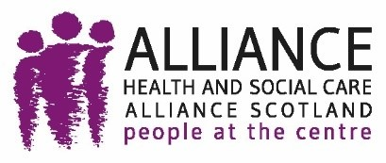
Exploring the alignment of public health and human rights legal duties in Scotland

Publication date: 09 September 2025

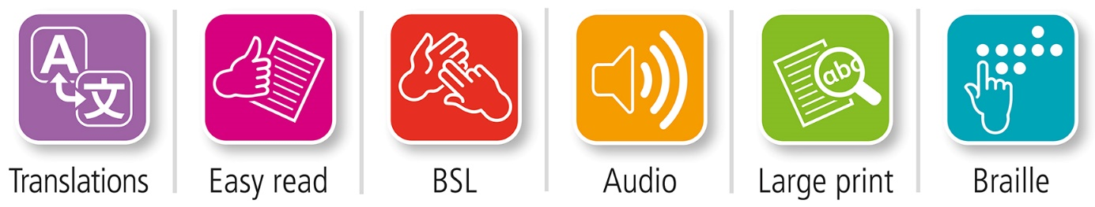
Translations and other formats are available on request at:
 phs.otherformats@phs.scot
 0131 314 5300

Public Health Scotland is Scotland's
national agency for improving and
protecting the health and wellbeing
of Scotland's people.
© Public Health Scotland YYYY


This publication is licensed for re-use
under the Open Government Licence v3.0.
For more information, visit
www.publichealthscotland.scot/ogl


www.publichealthscotland.scot

Version history
Version | Date | Summary of changes
1 | 21st Aug 2025

Add table of contents here
Table of Contents
1. Exploring the alignment of public health and human rights legal duties in Scotland 2
2. Background 2
3. Scope of public health duties selected for this project 3
4. Content of the human right to health 5
5. Proposed duties under the Scottish Human Rights Bill 7
6. Duties under the Public Bodies (Joint Working) (Scotland) Act 2014 9
6.1. Strategic planning requirements 9
6.2. Budgeting requirements 11
7. Summary 15
8. About the ALLIANCE 16
9. About the University of Strathclyde 17
10. About Public Health Scotland 19

- Exploring the alignment of public health and human rights legal duties in Scotland
The Health and Human Rights Partnership have produced this briefing paper to inform implementation planning for the Scottish Human Rights Bill (SHRB).
It aims to provide an example of mapping areas of alignment, and potential divergence, between existing public health duties and the proposed legal duties under the SHRB as these duties are currently understood.
A human rights-based approach has potential to act as a unifying framework for a number of key legislative and policy demands in the public health field, and promotes outcomes aligned with the need to tackle health inequalities.
Other papers developed by the Health and Human Rights Partnership focus on human rights-based decision making and participation of rightsholders.
This paper on legal duties is designed for senior leaders in public health and health and social care in Scotland. It is intended to support strategic decision making by helping leaders identify where existing duties may already align with proposed human rights obligations, and where further action such as policy review, training or the development of implementation tools may be needed to prepare for the Scottish Human Rights Bill.
- Background
The Scottish Government have made commitments to introduce a Scottish Human Rights Bill (‘SHRB’; ‘the Bill’) which would bring four United Nations treaties into law in Scotland, within the limits of the Scottish Parliament’s devolved powers. The Bill seeks to provide people with stronger legal protections by placing new duties on public bodies, and by helping to build a stronger human rights culture.

One of these four treaties, the International Covenant on Economic, Social and Cultural Rights includes the ‘right to the highest attainable standard of physical and mental health’ as well as other health-related rights. The other three treaties also include protection of several health-related rights of women, people belonging to ethnic minority/global majority communities, and disabled people. This is also the case for the UN Convention on the Rights of the Child, recently given effect via the United Nations Convention on the Rights of the Child (Incorporation) (Scotland) Act 2024.
To support preparation for implementation of the SHRB, this briefing paper begins to explore the extent to which new legal duties being proposed through the SHRB align with existing duties under other relevant legislation.
It is acknowledged that there is significant variation in the contexts and policy frameworks within which public health-related work takes place, but it is hoped that providing one example can be a useful contribution to support readiness for implementation of a right to health.
- Scope of public health duties selected for this project
The Faculty of Public Health defines public health as ‘the science and art of preventing disease, prolonging life, and promoting health through the organised efforts of society.’ This includes a very broad range of activity from responding to immediate crises such as pandemics, delivering health and care services, and wider activity to tackle enduring problems such as mental ill-health, homelessness and addiction.
There are a range of legislative sources that align and deliver within the aims and goals of improving public health. Many laws and policies have a powerful health impact even when this is not the primary focus. For example, immigration policy influences health and access to healthcare, and drug laws and law enforcement practices can exacerbate HIV risk and other harms for people who use drugs.
As well as the specialist public health workforce, initiatives to improve public health may be delivered by charities, community leaders, and businesses. There are many public sector duty bearers to which public health duties might apply and various functions that relevant authorities carry out. There are many different types of roles responsible for undertaking duties relating to the delivery of health and social care. These include people who provide direct care, are involved in local service planning and commissioning, regulators and inspectors, or those who make national policy and funding decisions.
For the purposes of this briefing paper, which is exploratory only, a narrow scope was agreed, to:
- target an audience of senior leaders who have responsibility, and in some cases are accountable, for decision-making at a strategic level
- focus on duties that relate to functions of planning and budgeting
- consider legislation which has a primary focus on improving the delivery of health and social care services. This example falls within the broad definition of ‘public health’ mentioned above and was chosen as an alternative to an example of ‘public health legislation’ which would be narrower in focus, i.e. the Public Health (Scotland) Act 2008 which defines public health in terms of protecting the community from infectious diseases, contamination or other hazards that constitute a danger to human health.
This paper does not cover operational level duties, the full range of public health legislation or all areas where public health and human rights duties may interact. Its scope is intentionally narrow and exploratory, providing one example to support wider implementation planning.
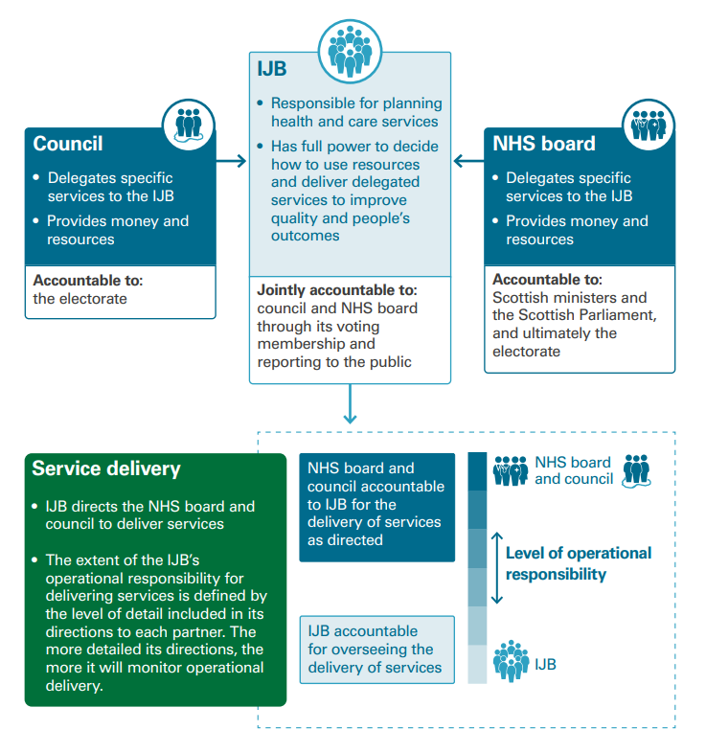
Once these parameters had been agreed the Public Bodies (Joint Working) (Scotland) Act 2014 (the ‘2014 Act’) was selected for mapping. The 2014 Act provides the legal framework to bring together health and social care into an integrated system. Under the 2014 Act, the 32 Scottish councils and 14 territorial NHS boards are required to work together in partnerships to integrate how social care and community healthcare services are provided. Whilst an explicit public health function is not delegated under the Act, the Act itself meets public health aims in line with the Faculty of Public Health definition. In addition, the significance of public health and health promotion to the duties imposed by the Public Bodies (Joint Working) (Scotland) Act 2014, in providing evidence of challenges and in helping to effectively reduce health inequalities, is noted in accompanying guidance for localities within integration authorities.

- Content of the human right to health
Outlining the content of the right to health in international law helps to make sense of the duties proposed as part of the SHRB.
In 1946, when the World Health Organisation was founded, the right to health was recognised as ‘one of the fundamental rights of every human being’ with health defined as ‘a state of complete physical, mental, and social well-being and not merely the absence of disease or infirmity.’ By 1966, Article 12 of the United Nations International Covenant on Economic, Social and Cultural Rights set out the ‘right to the highest attainable standard of physical and mental health’. Since then, many attempts have been made to concretise the core aspects of the right to health and the nature of state duties through academic scholarship and UN guidance.
An important milestone for the field of health and human rights was the adoption, in 2000, of General Comment 14 by the Covenant’s monitoring body, the Committee on Economic, Social and Cultural Rights. This authoritative document explains the meaning of the right to health and the nature of the corresponding duties on states, including public authorities delivering functions on behalf of governments.
It summarised that the right to health:
- encompasses health care and the underlying determinants of health
- does not stand alone, but is reinforced and supported by several other rights
- demands that health services are available, accessible, acceptable, and of quality, also referred to as the AAAQ framework.
It defined duties under the right to health in three categories:
- a duty to respect, meaning a duty to abstain from interfering directly or indirectly with individuals’ enjoyment of the right to health;
- a duty to protect, meaning a duty to prevent third parties from interfering; and
- a duty to fulfil, meaning a duty to adopt appropriate measures, whether legislative, administrative, budgetary, or judicial, towards the full realisation of the right to health.
- States are under a duty to take steps to progressively realise the right to health to the maximum of their available resources, using all appropriate means. Taking steps can be understood as a duty to design strategies and programmes to achieve the full realisation of a right. Steps taken must be deliberate, concrete, and targeted.
- States also have immediate duties, such as a duty to protect rights without discrimination, and so-called ‘minimum core obligations’, to secure, at the very least, the minimum essential levels of the right to health. These core obligations include: (1) ensuring non-discriminatory access to health facilities, goods and services, especially for vulnerable or marginalised people, (2) ensuring access to food, basic shelter, housing, sanitation and water, (3) providing essential drugs as defined by the WHO, (4) ensuring equitable distribution of all health facilities, goods and services and (5) adopting a national public health strategy and plan.
- There is a strong principle of non-regression, meaning measures which take a step backwards in fulfilling rights are not allowed. Any violation of a right because of a deliberate retrogressive measure can only be justified in the most exceptional of circumstances and States must be able to explain that the action is reasonable, proportionate, non-discriminatory, temporary, and that it does not breach the minimum core obligation.
- States are under a duty to provide access to an effective remedy if there is a failure to meet the duties imposed by the right to health.
- Proposed duties under the Scottish Human Rights Bill
The SHRB proposals include new duties that would apply to IJBs and their functions of planning and budgeting. These proposals are still in development and may change. The following points are based on the duties as described in the Scottish Government’s 2023 consultation paper.
There are two types of duties envisaged:
    - Procedural duties to ensure that the rights in the Bill are taken into account by public authorities, built into the fabric of their decision-making processes and adequately taken into account in the delivery of services. This could apply to policy or programme development, as well as budgetary processes and decision-making.
    - Compliance duties which require public authorities to comply with the basic minimum essentials needed to live a life in dignity (for further information see discussion paper submitted to the 2023 consultation on the link between the idea of dignity and minimum thresholds of rights) (minimum core obligations) and to progressively realise enjoyment of the rights over time using maximum available resources.
A key component of the duty of progressive realisation is that there is a plan in place to achieve fulfilment of the right to health. A violation of the right to health might amount to a failure to reasonably plan, strategise and implement policies/programmes that included deliberate, concrete and targeted measures towards the realisation of rights.
The SHRB envisages that the right to health would be protected proactively. Accountability should be built into decision making. This means that decision makers and decision making bodies, complaint review processes, regulatory bodies, inspectorates and other remedy providers, including the Scottish Public Services Ombudsman, would be responsible, along with the Scottish Government and Parliament, for proactively giving effect to the right to health. This approach means that remedies via tribunals and courts, which is burdensome for all involved, would be a last resort. While the aim is not to create litigation, access to a court is an important part of the right to access a remedy. If a claim concerning the right to health was heard by a court, they would likely consider whether a decision was in accordance with key aspects of the right to health e.g. the AAAQ framework. A remedy might amount to an order that compels the public authority to design a plan/strategy that could be viewed as reasonable.
The duty to gather and deploy the maximum available resources to achieve progressive realisation can be broken down. First, there is an expectation that States will prepare and plan budgetary allocation in advance in order to realise rights. According to the international framework, the allocation of resources must be effective (achieve its aim), efficient (achieve the highest quality with minimum waste/effort), adequate (sufficient to meet the thresholds of progressive realisation) and equitable (prioritisation of the most marginalised with the aim of achieving substantive equality). Resources should not be viewed as purely financial, but also human, social, technological, information, natural, and administrative.
- Duties under the Public Bodies (Joint Working) (Scotland) Act 2014
When duties placed on Integration Joint Boards (IJBs) are considered in light of the right to health, a number of functions are relevant, including strategic planning and strategic budgeting.
  - Strategic planning requirements
The 2014 Act places a duty on integration authorities – either IJBs or health boards and local authorities acting as lead agencies – to create a strategic plan (Section 29). The function of the strategic plans is to set out arrangements for carrying out integrated functions and outline how these will achieve, or contribute to achieving, the National Health and Wellbeing Outcomes.
In preparing a strategic plan, the 2014 Act requires that the integration authority ‘must have regard to—(a) the integration delivery principles [set out in section 31 of the Act], and (b) the national health and wellbeing outcomes [set out in section 5 of the Act)’. (Section 30). These duties relate to how plans are formulated. They are therefore relevant to the procedural duties envisaged within the SHRB.
The integration delivery principles include, for example, that services provided should ‘respect the rights of service-users’, take ‘account of the dignity of service-users’, and improve ‘the quality of the service’.
The National Health and Wellbeing Outcomes are ‘grounded in a human rights based approach’ (section 9). They state that: ‘A human rights based approach can offer a practical framework to help people to work together to achieve the national health and wellbeing outcomes.’
According to statutory guidance for the 2014 Act on strategic plans, as well as having regard to the integration delivery principles and National Health and Wellbeing Outcomes, IJBs should have regard to other duties which relate to strategic planning, including those within the following legislation:
- Equality Act 2010
- United Nations Convention on the Rights of the Child (Incorporation) (Scotland) Act 2024
- Children and Young People (Scotland) Act 2014
- Social Care (Self-Directed Support) (Scotland) Act 2013
- Climate Change (Scotland) Act 2009
- Community Justice (Scotland) Act 2016
- Community Empowerment (Scotland) Act 2015.
- Health board planning requirements, and related guidance, are primarily communicated directly to health boards through letters from the Scottish Government.
- The Housing (Scotland) Act 2001
The same statutory guidance notes that: ‘strategic planning requirements, under the 2014 Act, are set within a complex planning, delivery and reporting landscape. There are therefore a number of interdependencies, requiring alignment with other planning activity undertaken by local authorities, health boards, wider integration authorities, other public bodies and delivery partners.’ (p.2).
There are examples of where strategic planning duties under the 2014 Act are already being interpreted in alignment with human rights duties.
Stirling and Clackmannanshire and Stirling Health and Social Care Partnership – Strategic Plan and “Commissioning Consortium” provides an example of how a strategic plan can be developed using a Human Rights Based Approach aligned with equality and ethical commissioning principles. The plan provides evidence of; how communities, service users and staff have been involved from the outset; integrating principles of human rights and equality throughout; and how various legislative and policy demands have been considered.

- The proposed procedural duties under the SHRB to have regard to the right to health interact with, and add to, this multi-layered planning, delivery and reporting landscape.
- The proposed duties would require IJBs to take into account the right to health (and other relevant human rights). There is evidence of alignment between the duties as currently proposed and the existing strategic planning requirements under the Public Bodies (Joint Working) (Scotland) Act 2014.
  - Budgeting requirements
Section 39 of the 2014 Act requires the Integration Authority to publish an annual financial statement. The statutory guidance states that an ‘integration authority should draw links between its strategic plan and medium term financial plan [3 years], demonstrating how the financial resources available to it will be applied to achieve the outcomes set out in the strategic plan.’
Under section 42 of the Act, an Integration Authority is required to publish an Annual Performance Report containing information on its performance in the previous year. Regulations require that the Report includes financial information on the amount spent on achieving the National Health and Wellbeing Outcomes and the amount spent on care groups, localities and service type. The Annual Financial Statement should include information on the amounts that are included in the Strategic Commissioning Plan intended to be spent on the same categories. These duties relate to the outcomes delivered by the IJB planning and budgeting. They are therefore relevant to the compliance duties envisaged within the SHRB and the principles of progressive realisation and minimum core obligations.
The Scottish Government’s Advice Note on prioritisation, which supplements statutory guidance on strategic planning under the 2014 Act, states that ‘in developing its Strategic Commissioning Plan for the functions and budgets it controls, each Partnership has a legal duty to: Achieve best value in the use of its resources; and Report on its performance’ (p.1). It states: ‘These duties will be discharged through the resource allocation decisions [a Partnership] makes in the Strategic Commissioning Plan and its assessment in the annual performance report’ (p.1).
The Advice Note on prioritisation refers explicitly to a human rights-based approach. It states that ‘[t]aking a human rights-based approach will provide an additional supportive framework’ (p.3) However, this is not operationalised in the process overview (p.3) which focuses on the duty to demonstrate ‘reasonableness’ and conduct an ‘economic appraisal.’
Under the terms of the Local Government in Scotland Act 2003 and the Public Finance and Accountability (Scotland) Act 2000, the implementation of the duty of Best Value applies to local government bodies (including Integration Joint Boards) and, in the rest of the public sector, to individuals in their role as Accountable Officers. That duty is:
- to make arrangements to secure continuous improvement in performance whilst maintaining an appropriate balance between quality and cost;
- and in making those arrangements and securing that balance to have regard to economy, efficiency, effectiveness, the equal opportunities requirements, and to contribute to the achievement of sustainable development.
Guidance on the Local Government in Scotland Act 2003 also clarifies that best use should be made of resources which are not only financial, but includes people, land and other resources (p.5).

- The duty of best value used in budgeting and financial reporting appears to be narrower and less person-centred than the National Health and Wellbeing Outcomes which the 2014 Act requires IJBs to ‘have regard to’ when preparing their strategic plan. Guidance on the duty of best value does refer to equality and sustainable development, but not human rights. As indicated above, the proposed compliance duty of progressive realisation and minimum core obligations are more expansive. This suggests a current divergence between the requirements in relation to financial planning/reporting and the proposed SHRB duties.
- The Advice Note on prioritisation explicitly invites a human rights-based approach. Updating the guidance on prioritisation could be one way in which to achieve even stronger alignment between duties and a more consistent approach to decision-making. At the moment, this guidance indicates that decisions must be made ‘on the basis of clear criteria, a robust process and application of relevant and focused information’ – but does not indicate a specific prioritisation tool/process, range of information, or criteria which should be used. A report on the involvement of Public Health Teams in prioritisation within Health and Social Care Integration from the Scottish Public Health Network highlighted that Public Health England have a 'Prioritisation Framework' and NHS Wales had a decision-making framework. The Scottish Human Rights Commission already has a wealth of expertise and tools to support Human rights budgeting. There are also some examples of applying a human rights based approach to prioritisation decision-making in some contexts as seen in the ‘Balancing rights’ guidance for implementation of the National Collaborative charter of rights for people affected by substance use.

This figure represents the laws and accompanying guidance noted in the example. The example illustrates some of the duties applicable to the right to the highest attainable standard of health as it might interact with selected functions under the Public Bodies (Joint Working) (Scotland) Act 2014.
The green shading indicates alignment with right to health duties and the amber shading indicates potential for greater alignment with right to health duties.
- Summary
The purpose of this briefing paper has been to inform implementation planning for the SHRB by beginning to explore one example of how proposed duties relating to the right to health could be mapped against existing public health duties.
It has revealed that even within the narrow scope of the example used in this paper, of duties relating to strategic planning and budgeting within the Public Bodies (Joint Working) (Scotland) Act 2014, there is both evidence of existing alignment in one area and a need for greater alignment in another area.
The research undertaken for this paper has highlighted additional questions. For example, how should integration authorities demonstrate compliance with their multiple and overlapping duties that relate to how they form strategic plans? How do the National Health and Wellbeing Outcomes, integration delivery principles and duty of best value interact with the norms and standards that have developed in relation to the right to health? How might a court or other accountability mechanism refer to strategic plans or financial accounts when making a decision in a right to health case? The research suggests that it would be informative to map more legal duties from a variety of legislative sources against the right to health and the proposed duties under the SHRB.
In response to this paper, it is recommended that senior leaders in public health and health and social care:
- Review current planning and budgeting processes in light of the proposed duties under the Scottish Human Rights Bill and identify further opportunities to embed human rights-based approaches;
- Collaborate with partners to co-develop practical guidance for taking a human rights-based approach to planning and budgeting;
- Consider commissioning or contributing to further mapping work in relation to relevant legislation;
- Engage/continue to engage with the future development of the SHRB.
- About the ALLIANCE
The Health and Social Care Alliance Scotland (the ALLIANCE) is the national third sector membership organisation for the health and social care sector. We bring together over 3,500 people and organisations dedicated to achieving our vision of a Scotland where everyone has a strong voice and enjoys the right to live well, with dignity and respect. Our members are essential in creating a society in which we all can thrive, and we believe that by working together, our voice is stronger.
We work to improve the wellbeing of people and communities across Scotland by supporting change in health, social care and other public services so they better meet the needs of everyone in Scotland. We do this by bringing together the expertise of people with lived experience, the third sector, and organisations across health and social care to shape better services and support positive change.
The ALLIANCE has three core aims. We seek to:
Empower people with lived experience: we ensure disabled people, people with long term conditions, and unpaid carers are heard and that their needs remain at the heart of the services and communities.
Support positive change: we work within communities to promote co-production, self management, human rights, and independent living.
Champion the third sector: we work with, support and encourage co-operation between the third sector and health and social care organisations.
The ALLIANCE is committed to upholding human rights. We embed lived experience in our work and aim to ensure people are meaningfully involved at every level of decision-making.
Working together creates positive, long-lasting impact. We work in partnership with the Scottish Government, NHS Boards, universities, and other key organisations within health, social care, housing, and digital technology to manage funding and develop successful projects. Together, our voice is stronger, and we can create meaningful change.
- About the University of Strathclyde
Contributions to the Health and Human Rights Partnership have evolved from the Centre for Health Policy to also include Strathclyde's Centre for Doctoral Training in Human Rights-Based Decision Making.
The Centre for Health Policy is led by Co-Directors, Professor Kat Smith and Lee Knifton, and Associate Directors, Dr Lisa Garnham and Dr Jackie Stewart. It was established in 2014 by Lee Knifton and Professor Neil Quinn, with support from Professor Sir Harry Burns. CHP is an academic hub for fresh perspectives on healthcare and public health policy. We are firmly rooted in Scotland, but with strong international engagement generating valuable comparative insights and learning. We value relationships with policy and practice, work directly with affected communities, and protect space for critical and conceptual academic analysis. We spearhead innovative qualitative and mixed methods research into health policy, including participatory research with communities. The Centre’s current cross-disciplinary activities cover the following five broad thematic areas:
- Reducing inequalities
- Public mental health
- Participation and Engagement in Health
- Innovation in health systems, policy and practice
- Long-term perspectives in health and wellbeing
The Strathclyde Centre for Doctoral Training in Human Rights-based Decision Making, launched in 2023, is a cross-disciplinary hub for PhD researchers focused on enhancing understanding of the complex challenges and opportunities related to human rights-based decision making by a range of actors/institutions in the public, private, and third sector. Its aim is to bring together a cohort of postgraduate researchers to build interdisciplinary skills and knowledge needed to help tackle the major challenges of translating international legal protections into more just institutions, processes, and equitable outcomes for people in their everyday lives. Doctoral researchers affiliated with the Centre for Doctoral Training are trained by, and collaborate with, a broad supervisory team to grow a critical knowledge base around understanding how human rights standards can become integrated in strategic and operational decision making.

- About Public Health Scotland
Public Health Scotland (PHS) is Scotland’s national public health agency, established on 1 April 2020. It brings together the former functions of NHS Health Scotland, Health Protection Scotland, and the Information Services Division (ISD). Operating as a Special Health Board jointly sponsored by the Scottish Government and COSLA, PHS plays a central role in improving and protecting the health and wellbeing of people in Scotland.
Led by Chief Executive Paul Johnston, PHS’s vision is for a Scotland where everybody thrives. The agency works collaboratively across public, third sector, and private partners to address the wider determinants of health, reduce health inequalities, and increase healthy life expectancy through prevention and early intervention.
PHS focuses on three key areas:
Prevent disease – through leadership on immunisation, infectious disease control, and pandemic preparedness.
Prolong healthy life – by reducing premature mortality (e.g. from drugs, alcohol, tobacco) and using data to support improvements in health and care services.
Promote health and wellbeing – by tackling root causes of inequality such as poor housing, child poverty, and lack of access to greenspace, and by influencing policy and supporting local communities.
All of this is underpinned by data, evidence, and intelligence, with a strong emphasis on place-based approaches, public service reform, and human rights. The organisation is guided by the values of respect, collaboration, innovation, excellence, and integrity.

