**Information and Directions for Comely Bank Centre, Edinburgh, EH4 2LD**

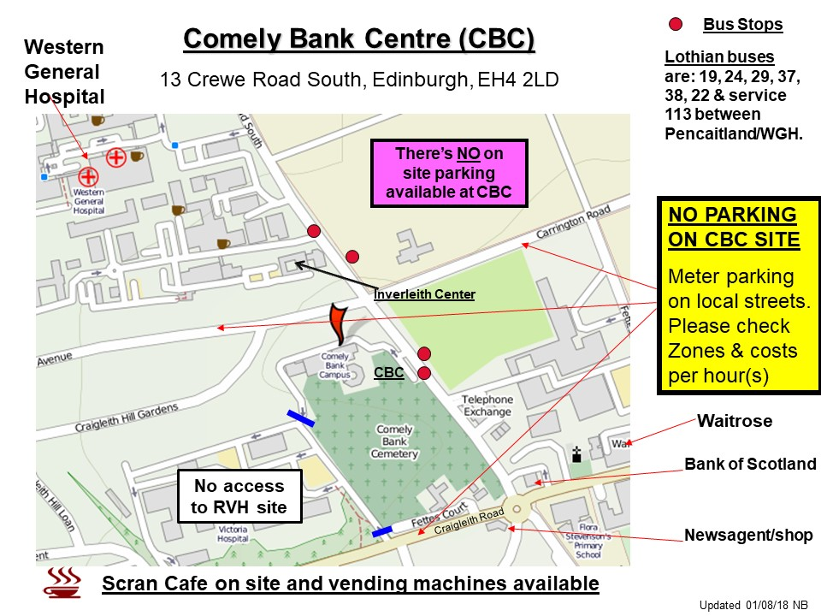

Comely Bank Centre is well served by buses from city centre and beyond.

There is no parking available on site. There is on street parking in the surrounding streets, rates vary so please check when you park.

The front door and reception are open from 8.00am.

In the Reception Area there is an electronic screen which will advise you which room training is taking place. Training rooms and offices are signposted throughout the building.

Refreshments are not provided.

* There are vending machines available in the dining area, where there are tables and chairs. You are welcome to bring your own food, however there is no fridge or microwave available.
* [SCRAN Academy](https://www.scranacademy.com/scran-cafe) café is available for drinks, baking and light lunch from mid-morning through to mid-afternoon.
* There is a local newsagent/shop and Waitrose Supermarket within 5-minute walking distance.