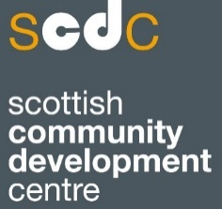
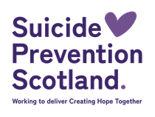
Community-led action research into suicide prevention – Year 2
Introduction
The ambition for Scotland’s suicide prevention strategy, Creating Hope Together to reduce deaths by suicide whilst also addressing the inequalities that can lead to suicidality requires exploring different approaches that work for different communities.
Building on the success and learning from the community-led action research programme delivered during 2024-2025, Suicide Prevention Scotland would like to continue this approach giving voice to the communities impacted by suicide and the inequalities that increase risk.
The groups that took part in 2024-25 were as follows:
- Shetland Linkup, a community drop-in who researched people’s experiences of accessing the right support at the right time in a small community. Two Shetland Linkup workers undertook the research, including focus groups and interviews and have been developing their services and making wider connections based on their findings.
- Rosemount Lifelong Learning, an adult education centre in Glasgow. One worker and one sessional worker used focus groups and a survey to explore the effectiveness of existing support systems for asylum seekers and refugees in Glasgow in addressing suicide prevention, and what improvements can be made to better meet their needs. Key findings include the power of community in creating a “new family”, the frustration of having to keep re-telling their story when accessing services, and the importance of having a voice.
- Tony’s Safe Place, a community group and hub in Cumbernauld. Two volunteers from TSP carried out a focus group with members to better understand which community priorities TSP should focus on and how can it better use its resources in order to do this. They have produced a report and an engaging flyer highlighting their findings for TSP and wider stakeholders.
Full learning from the existing programme will be available from late October 2025.
For 2025/ 2026, we are increasing the number of organisations Scottish Community Development Centre (SCDC) will train, mentor, and support in community-led action research approaches to 6. It is our hope that organisations will bring their expertise gained from supporting people at higher risk of suicide.
Funding of £4000 will be available to support successful applicants to participate in the programme.
Programme details including selection criteria
The community-led action research programme will support 6 community-based organisations to conduct an inquiry into suicide prevention.
Whilst the focus of research will be chosen by the groups who take part, within the broad area of suicide prevention, the research should consider:
- The quality and availability of support for people affected by suicide or who are at risk of suicide
- Awareness within communities of suicide and the inequalities that affect suicidal behaviour and ways to address these
- Understanding of whether the current learning resources meet the needs of communities and if not, how their learning needs may be better met
It should also build on what we already know and help address any gaps in our understanding on; locations of concern, access to means, help seeking, stigma, discrimination and a targeted approach to addressing the inequalities associated with increased risk of suicide.
We want to ensure that the support is directed to groups which are best suited to participate in the programme, and which will benefit from the support provided, we have developed the following criteria for assessing applications. The support team will review applications based on these criteria and so we ask that this is taken into consideration when submitting your application.

Criteria:
- Where possible, organisation should demonstrate buy in and/or connections to local strategic partnerships and networks including Community Planning Partnerships and Suicide Prevention Networks to support strategic developments in suicide prevention in the local area as a result of the action research findings.
- Groups must represent a clearly identifiable community. This might be a community of place (e.g. a community planning area, a neighbourhood, village) or a community of identity (people who share similar experiences such as LGBTQI+ members, disabled people, asylum seekers or refugees, neurodiversity etc).
- Groups must be able to demonstrate that they are community-led. By this we mean organisations which are managed by and accountable to community members, which act on issues identified by the community, and which work to benefit the whole community.
- Support will be prioritised for groups representing communities which experience disadvantage (there is a known link between suicide and different forms of disadvantage). Applicants should be able to describe how their community experiences disadvantage. This might include:
- groups with protected characteristics;
- groups experiencing economic disadvantage; and
- other indicators of deprivation such as rural isolation, age etc.
- Groups should be able to demonstrate that they have adequate capacity to participate fully in the programme for the next 12-months. By this we mean that they can commit to participate in 3 training sessions and 3 co-inquiries/shared learning and on going mentoring throughout the period of the programme; that they can carry out tasks between these sessions to progress the action research (e.g. briefing local volunteers; meeting stakeholders); and that they can identify a core group of people who will be the project team. It is important to note that there will be a requirement for participating groups to carry out research tasks (e.g. carrying out interviews, surveys, collecting photographs, carrying out desk research). SCDC will provide support and training but the practical delivery will be the responsibility of community organisations. This ensures that the community group builds their skills and capability in the longer term. Our support time is limited, therefore we will prioritise where a group can demonstrate readiness to participate. Please see the ‘timeline for the support’ graphic at the end of this document.
- Participating groups should have access to dedicated support, either within their organisation (e.g. development officer) or from elsewhere (e.g. from a local authority’s Community Learning and Development team). This support person will provide a key role in helping the group deliver their community-led action research project.
- The action research process will begin in November 2025 so groups should be able to start their project at this time. A minimum of 2 people who will carry out the action research should be available to attend the first training session on 26th and 27th November.
- The research must aim to improve outcomes around suicide and positively benefit people at risk of being affected by suicide.

FAQs:
- Who can apply?
  - We have left this undefined as we understand this could be different across areas and whether the application is for a community of interest or a community of place. Whoever applies, it is important that the application specifies a community organisation or group to participate in the programme and lead on the research. See criteria d) for more information on the communities we are prioritising for support. What we hope is that as many agencies are involved in the research as is practicable to provide learning on how suicide prevention approaches within or for that community can be improved including through the links made between organisations and sectors. It is worth noting that the overall purpose of this work is to test approaches and learn what works within and for communities therefore it is expected community organisations will have a leading and pivotal role in the work and any funding/support would be used to support their involvement and not used for statutory sector provision.
- Who will attend the training, and will the available funding be used to support this? Can you provide more details on the available funding to support the work?
  - The people who would be undertaking the research would be expected to attend the training. A total of £4,000 will be available for the 6 successful applicants to cover expenses to support participants with their research. Based on SCDC experience this could be used for the following (not an exhaustive list):
    - Volunteer expenses/ payments
    - Equipment relevant to research – eg Dictaphone
    - Vouchers for participants
    - Cost of holding focus group etc
    - Cost of some specialist support – like film editing
  - We will be as flexible as we can be and discuss details with successful applicants.
- What is the expected time commitment for successful applicants?
  - This will depend on how your ‘community’ undertakes the research which will also relate to the specifics of the research questions. The work will be split into different stages working with SCDC and Suicide Prevention Scotland including initial meetings, training days, mentoring, research time, and finally co-inquiry and shared learning meetings. See timeline below.

For more information or for any questions, please email Andrew.Paterson@scdc.org.uk or Isobel.Murray@penumbra.org.uk
To apply to be part of the programme please email completed applications to: programmes@penumbra.org.uk by Wednesday 5th November at 12pm.
The selection panel will review all applications and successful applicants will be notified by late August.

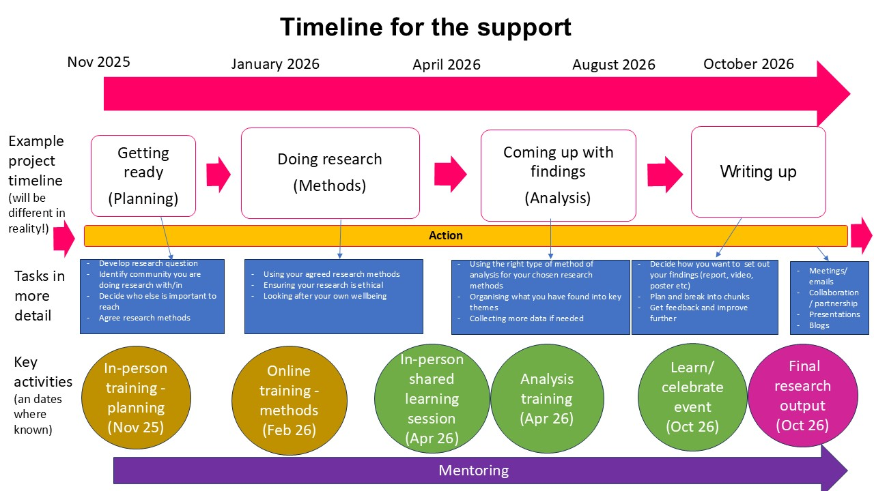

The Equality Act 2010 protects people from discrimination because of a protected characteristic, which are as follows: age, disability, gender reassignment, marriage and civil partnership, pregnancy and maternity, race, religion or belief, sex, sexual orientation

