Human Rights Day 2025
Letter to the Government

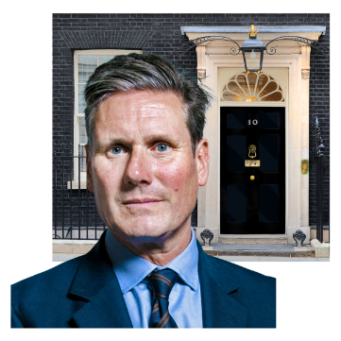   | Dear Prime Minister and political leaders,
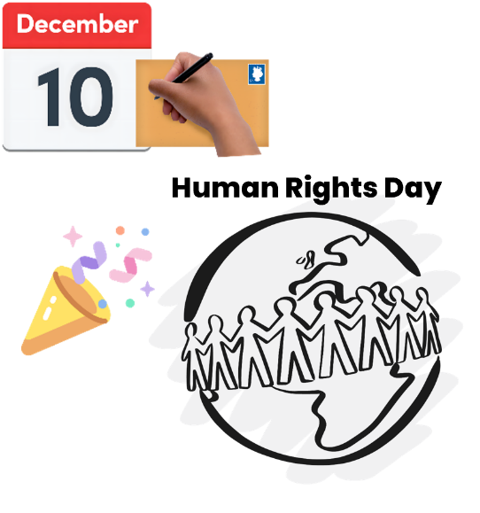 | We are writing to you because it is Human Rights Day.
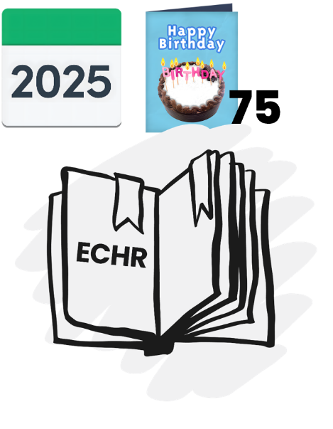 | This year is the 75th anniversary of the European Convention on Human Rights, also called the ECHR.
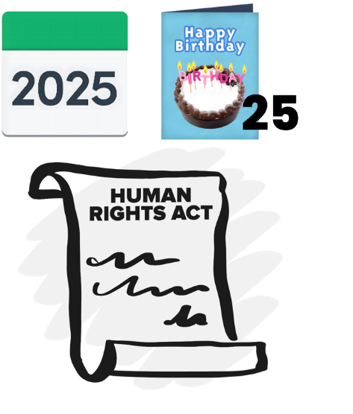 | It is also the 25th anniversary of the Human Rights Act.
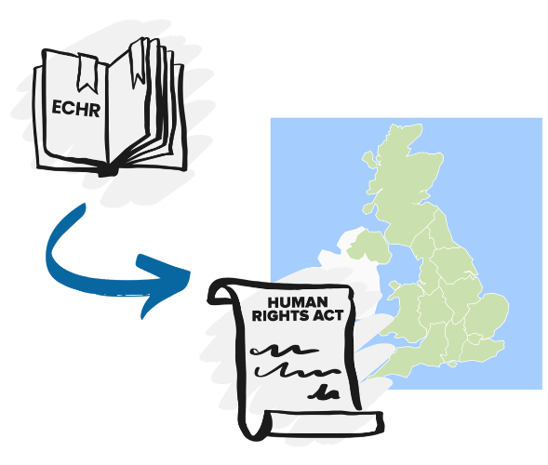 | The Human Rights Act made the ECHR part of our law in the UK.
 | Human rights stop people in power from doing harm and help everyone to be treated fairly and respectfully.
 | Human rights help people in lots of different ways, every day.
 | We can use them to make sure we are treated fairly in the places where we live and get support.
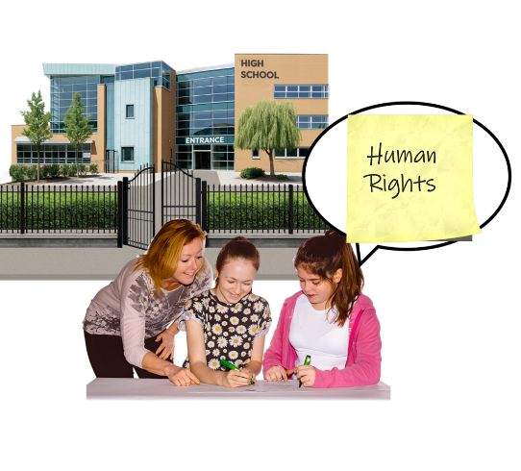 | We can use them to make sure we are safe when we go to school.
 | We can use them to make sure public services, like the police and the NHS, make good decisions.
 | And we can use them to speak up and get justice when things go wrong.
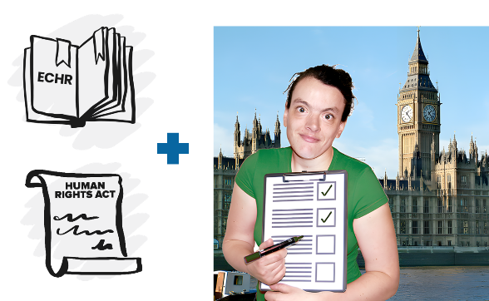 | But laws are not enough. Politicians must take action to make human rights real.
 | This year, lots of people feel worried about the future.
 | But instead, we choose to feel hopeful.
   | This year is a chance to build a better future, so we are asking you to take 4 actions:
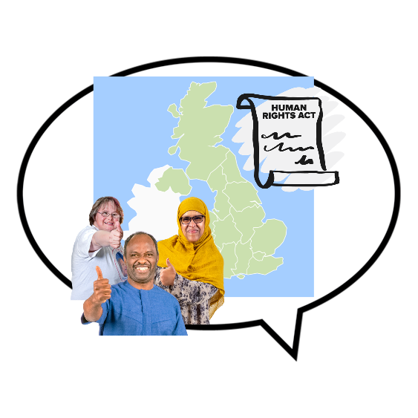 | - Say clearly that the UK supports human rights laws, especially our Human Rights Act.
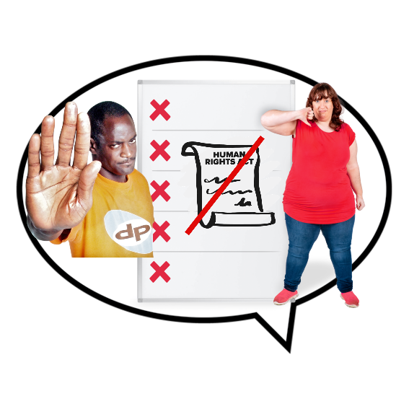 | - Say no to any plans that would make human rights laws weaker.
 | - Help people and public services to understand and use human rights.
 | - Be brave and say clearly that human rights belong to everyone.
 | This Human Rights Day, let’s stand up for human rights together.
  182 | 182 organisations have signed this letter, including groups led by and for people with learning disabilities.  The full list is available online at www.bihr.org.uk

© 2025 The British Institute of Human Rights is a registered charity (1101575) and registered company (4978121). Correspondence and registered office address: BIHR, 167-169 Great Portland Street, Fifth Floor, London W1W 5PF. Please note that we do not work at this address and the office here is not open to visitors; the address is for correspondence only. Please therefore contact us by phone (020 3039 3646) if you wish to speak to us, but keep in mind that we do not provide advice.

