Health and Social Care Alliance Scotland (the ALLIANCE)

Gambling harms and mental health

Summary of activity and findings from 2025/26 funded projects


May 2026
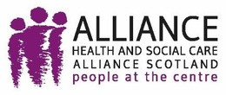

Executive summary

This report presents early findings from 16 short term, exploratory projects examining gambling related harm within disadvantaged, marginalised, and minoritised communities across Scotland. While limited by time and scope, the programme has generated valuable insights into how gambling harm is experienced, understood, and responded to across different contexts.
A consistent finding across projects is the disconnect between the normalisation of gambling and the concealment of harm. Gambling behaviours are widely embedded within everyday life, particularly in social, cultural, and online environments, yet the associated harms are rarely named or discussed openly. Instead, individuals are more likely to present with related issues such as financial hardship, poor mental health, or relationship strain, without identifying gambling as a contributing factor.
Stigma emerged as a central mechanism shaping this dynamic. Feelings of shame, fear of judgement, and the perception of gambling as a matter of personal responsibility actively suppress disclosure, limit engagement with support services, and create barriers to both research participation and service access. This contributes to significant levels of hidden or unmet need.


£74, 837 allocated to the ALLIANCE to share amongst 8 delivery partners
£109,842 provided directly from the Scottish Government to the 8 remaining partners

The findings also demonstrate that gambling harm is rarely experienced in isolation, rather, it is interconnected with a range of co-occurring insecurities, including debt, housing insecurity, mental health difficulties, and substance use. As a result, gambling harm often remains obscured within other service pathways, reinforcing the need for a more integrated and holistic response.
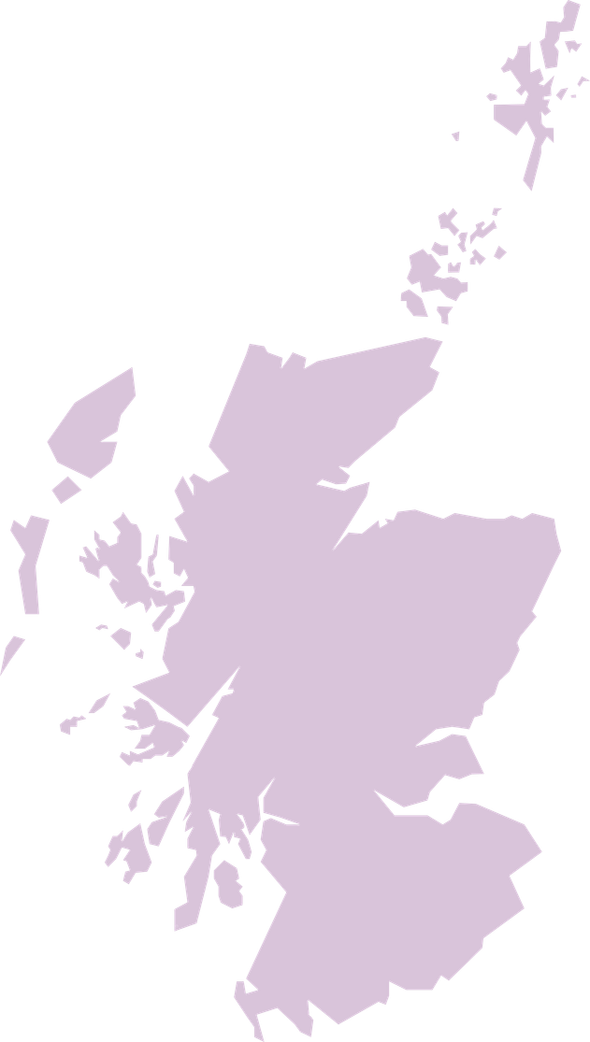
Importantly, the programme has identified clear conditions under which engagement is possible and effective. Across projects, community based approaches - delivered through trusted organisations, familiar settings, and culturally appropriate methods - were more successful in facilitating open conversations and participation. In contrast, more formal or standalone approaches to engagement were often less effective.
While longer term outcomes cannot yet be assessed, the programme has already delivered meaningful early impact. This includes identifying previously hidden harm, strengthening community capacity, and generating learning for service design and policy.
These findings support a shift towards a whole system approach to reducing gambling harm, recognising the importance of early intervention, community engagement, and embedding responses within wider services addressing social and economic inequality.

Introduction

There is substantial evidence showing links between gambling and poor mental health, with emerging evidence identifying gambling as a driver of suicide¹. There is increasing recognition that the harms caused by gambling are closely linked to other health comorbidities and co-occurring needs insecurities².
This programme is part of a larger body of work, jointly led by Scottish Government Population Health Directorate and Public Health Scotland, to deepen understanding of gambling harm amongst disadvantaged, marginalised, and minoritised communities in Scotland and to ensure that support is available to people both directly and indirectly affected by gambling harm.
Funding was allocated through the 2025-2026 levy fund, with this collection of projects conducting scoping work within four marginalised communities or groups whose health is disproportionately affected by gambling harm, whose risk of suicide is higher, and who might face additional barriers to accessing support.
This exploratory work involved 16 project partners across the third sector, local partnerships, and academia, to bolster the existing knowledge and evidence base on gambling harm in Scotland and to help identify gaps in understanding, service provision, and signposting.


- Kristensen, J.H., Pallesen, S., Bauer, J., Leino, T., Griffiths, M.D., and Erevik, E.K. (2024) Suicidality among individuals with gambling problems: A meta-analytic literature review. Psychological Bulletin, 150(1), 82-106.

- Wardle, H., Reith, G., Langham, E., and Rogers, R.D. (2019) Gambling and public health: We need policy action to prevent harm. British Medical Journal, 365(1807), 1-5.

Key findings
Gambling is normalised, but harms are hidden

Gambling was described as a normal and routine part of everyday life across projects, with participants acknowledging its presence within social activities, their homes, and increasingly within online spaces and videogames.



Young people highlighted how visible and unavoidable gambling is within football and online spaces - this reinforces the challenge of reducing harm in environments where gambling is heavily normalised.
– The Anchor



One participant reflected on third sector fundraising practices, acknowledging an overreliance of gambling practices as a means to drive engagement and participation. Given the financial pressure many charities are under, moving away from these practices that have proved successful previously, could be challenging.

We’ve always done things like last man standing and bonus balls and never really thought about it. Now you’re looking at it differently.
– Participant, The Anchor



Early exposure was a recurring theme, particularly amongst young people, many of whom reported engaging in gambling through online games and in game purchases. Peer influence - especially within male dominated spaces such as football - further reinforced participation.



I had a severe addiction to buying FIFA points and spent a ridiculous amount of money which affected my mental health.
– Participant, The Anchor
Despite this high level of visibility, many projects described difficulty in generating open discussion around harm. Participants were more likely to describe the consequences of gambling (e.g. debt, emotional distress, or relationship difficulties), than to identify gambling itself as the underlying cause. This suggests that, while gambling itself is visible and socially accepted, harm caused by gambling remains hidden and, often, unrecognised.



A key challenge identified during delivery has been the anticipated difficulty in capturing direct disclosure of gambling harm...this suggests that approaches relying on self disclosure are likely to miss a significant proportion of harm.
– Kingsway Community Connections

Stigma suppresses disclosure, engagement, and service access
Stigma emerged as a central and cross cutting theme, influencing both lived experience insights gathered and project delivery.



Shame stops you before anything else.
– Participant, SAMH
Participants frequently described feelings of shame, embarrassment, and fear of judgement associated with gambling. These were compounded by a strong perception that gambling is an issue of personal responsibility, rather than a systemic, public health concern. As a result, individuals were often reluctant to disclose their experiences or seek support.


We want those who have been affected by this to have a place to go to be supported, sometimes a big hurdle is just getting them through the door.
– Dalkeith CAB

Concerns around disclosure had clear implications for engaging those with lived experience, resulting in low attendance in group sessions across several projects and a hesitancy to engage with services perceived as ‘formal’ or intervention led.


We encountered several challenges that influenced both participation levels and the way activities were delivered. One was encouraging men to willingly take part in the focus groups. Despite interest in the topic, some men were hesitant to attend, largely due to the stigma surrounding gambling harms or seemed to think the work was an intervention style process.
– SAMH

Importantly, the findings suggest that non disclosure in such instances should not be interpreted as an absence of harm, but rather as an indicator of undisclosed need.


Many people felt embarrassed or said they could not take part because they currently gamble...this illustrates the strong stigma and shame that continue to surround gambling that may prevent people from engaging in support or research opportunities.
– BEMIS

Gambling harms are interconnected and often obscured by other issues
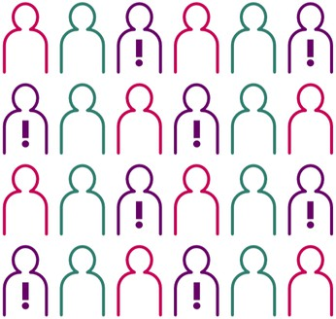
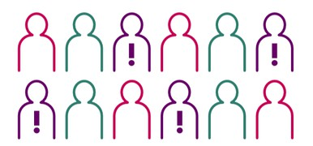
Evidence from these projects demonstrates that gambling harm is rarely experienced in isolation, but is closely intertwined with a range of other co-occuring challenges, including mental health difficulties (including anxiety, depression, and suicidal ideation), financial hardship, housing precarity, relationship breakdown, substance use, and other risk taking behaviours.

In many cases, these issues were the primary reason individuals came into contact with services, with gambling remaining unrecognised or undisclosed


Importantly, engagement levels increased [when] content focused on mental health impacts. This suggests that framing gambling harm within a wider wellbeing context may be more effective in prompting engagement than financial messaging alone.
– CHAP

This has significant implications for service design, indicating that gambling harm is often hidden within other support pathways, and interventions that treat it as an individualised issue are unlikely to identify or address the full extent of need.


Gambling harm is not absent within the community, but is often unspoken and embedded within other presenting issues. Participants consistently described the impacts of gambling - including financial pressure and emotional distress - without readily identifying gambling itself as the source...this reflects strong stigma, shame, and perceptions of personal responsibility, which act as barriers to open discussion and help seeking.
– Kingsway Community Connections

The findings therefore support a more integrated, whole system approach, where gambling awareness is embedded across services including housing, debt advice, and mental health support.






Effective engagement depends on trust, relationships, and community context

The most critical finding across all projects was the importance of trust in enabling engagement. The projects that were most successful in facilitating participation and open discussion shared the following characteristics:
- Delivery through trusted, community based organisations
- Use of familiar and accessible settings (e.g. football environments, community groups)
- A relational approach, prioritising rapport building and consistency
- Use of informal, conversational methods rather than structured interventions
- Careful use of indirect, non stigmatising language





I fell off the wagon at the start of the year […] but I’ve recovered quickly and I think that’s a lot because of Liam and, you know, meeting him every Monday. He’s kind of urging me on to get here (to the group), rather than just shut myself off from everyone like I normally do.
– Participant, Fathers Network Scotland
In contrast, approaches that relied on standalone sessions, formal group formats, or direct questioning about gambling were less effective. Projects were, however, flexible in response to this, with several adapting approaches during the period of project delivery.
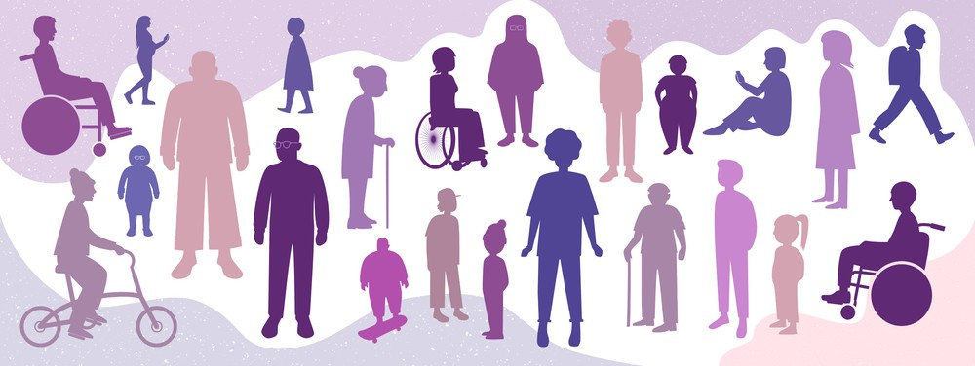

The importance of trust extended beyond initial engagement. Participants were more likely to open up when relationships were established prior, sustained over time, and preferred ongoing support from a single trusted individual. This highlights the importance of community based organisations and evidences their value as key intrinsic partners in responding to gambling harm.


People opened up more in a football related wellbeing space than they did with traditional addiction support. This suggests these kinds of ‘everyday’ environments might be where real early help happens, not formal treatment rooms.
– SAMH

Reflections from the ALLIANCE

The Scotland Reducing Gambling Harms (SRGH) programme at the ALLIANCE administered monitoring and evaluation duties on behalf of the Scottish Government for the 2025/2026 projects funded through the levy fund. By synthesising learning across projects, we have deepened our understanding of how gambling harm manifests within and across the communities engaged, including the ways in which harm intersects with broader social, economic, and health inequalities.
This work has also strengthened our insight into effective engagement strategies. In particular, it emphasises the importance of fostering trust and implementing community informed approaches when working with groups for whom gambling may be normalised and embedded within social and cultural practices.
Participating organisations have built capacity to identify and respond to gambling related harm within existing services, with several reporting that this exploratory work has already influenced ongoing delivery, including adaptations to frontline practice and staff onboarding processes. Moreover, a number of organisations have also secured additional levy funding to sustain or expand this work beyond the lifetime of these projects.
These projects have further demonstrated the critical role of the third sector. Often operating with limited resources, these organisations are pivotal in reaching those communities who experience systemic disadvantage.
Finally, the SRGH team at the ALLIANCE have facilitated new connections between organisations, creating opportunities for shared learning and collaboration to bolster efforts to reduce gambling harm in Scotland.

Overview of funded projects


The Anchor is a charity based in Greenock that supports young people, using ‘Hook’ activities, such as football, to start conversations around mental health and suicide. This project, delivered in Inverclyde, engaged 20 young people and five parents. Activities included 14 football based peer sessions and a survey of their existing userbase. The project placed particular emphasis on the impact gambling advertising has on young people, and the normalisation of gambling style behaviours in videogames and online environments.

BEMIS Scotland is a strategic national infrastructure organisation that empowers and supports the diverse Ethnic and Cultural Minority third sector. This project explored the cultural norms and attitudes around gambling and suicidality within minority ethnic populations in Glasgow and Edinburgh, delivering four consultation sessions with community groups involving 13 people across the Central Eastern European Community, Irish Community, Roma Community, and Chinese Community.
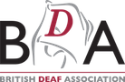
BDA Scotland is the national Deaf led organisation which represents British Sign Language (BSL) users in Scotland, advocating for Deaf equality and accessibility. This project involved administering BSL translations of existing gambling harm resources to enable accessibility for the Deaf community and producing short film clips – using Deaf actors and a Deaf led crew – to disseminate via Deaf clubs throughout Scotland.


CHAP is a charity based in Ardrossan, that supports people across Ayrshire experiencing a range of housing, welfare, and debt issues. This project examined the relationship between gambling harm and suicide risk amongst individuals experiencing financial hardship and housing insecurity. Activities included a structured mapping exercise using frontline casework data, a multi-agency stakeholder workshop, and a targeted social media campaign to raise awareness of gambling harm across the area.
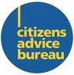
Dalkeith Citizens’ Advice Bureau provides free, impartial, and confidential advice relating to areas such as benefits, housing, employment, and debt to people living in Midlothian. Having observed an increasing number of gambling related debt cases being presented to Money Advisers, this project built upon previous work, with activities consisting of eight men only mental health group sessions, community dinners, and an online survey. A partner agency is setting up a substance misuse café and requested that the team behind this project be involved, evidencing early impact.
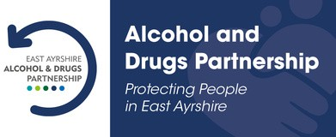
East Ayrshire HSCP are building capacity to explore what support is available in the area, to engage people on this topic, and share information of what support exists to those struggling with gambling. This project, working in partnership with Ayrshire 360 and RCA Trust, aims to spotlight the relationship between gambling and suicide. They are holding community events within NHS Ayrshire and Arran, raising the profile of the gambling harms charter, which East Ayrshire council is in the process of assigning.


East Dunbartonshire HSCP is the only Alcohol and Drugs Partnership in Scotland that has remit for suicide prevention and self harm. The project (ongoing) is conducting interviews, focus groups, as well as establishing referral pathways for gambling harm support. Acknowledging that gambling has become more prevalent, the project is doing scoping work to gauge what support is available, and what local data is available, to identify risk and gaps in provision.

Fathers Network Scotland is a charity that aims to improve children’s lives through the positive involvement of dads, father- figures, and whole families. Working in partnership with YMCA Tayside and Newfield Medical Group in Dundee, they explored gambling amongst 45 young men. Activities included focus groups, weekly group fitness sessions, and a questionnaire. Their multi agency approach integrates statutory healthcare, family services, and third sector interventions within the same building and is an example of a flexible model that responds to the needs of the community through partnership with the third sector.
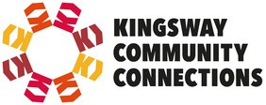
Kingsway Community Connections is a community development centre, set up and managed by locals, which provides a range of services and activities aimed at helping improve the quality of life for the Kingsway community and its surrounding areas in Glasgow. This project engaged 60 people through facilitated discussions, a welfare insight session, interviews, and the distribution of a community survey. The project highlighted the need for engagement on gambling harm to be built on understanding and established, trusted relationships withing community settings.

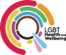
LGBT Health and Wellbeing is Scotland’s LGBTQ+ health and wellbeing charity, based in Edinburgh, that aims to improve the physical, social, and mental health and wellbeing of LGBTQ+ adults. This project (ongoing) is working in partnership with both Cyrenians (delivering tailored support to their existing peer support group) and Switchboard Brighton and Hove (delivering LGBTQ+ inclusive training to frontline staff at Gordon Moody). The project has been extended into Q1 2026 to deliver a helpline campaign and community information sessions to at risk groups including LGBTQ+ New Scots.

Men Matter Scotland is a peer based charity based in Drumchapel, Glasgow, that engages with men by facilitating weekly groups, sessions, and activities, which aim to build connections and improve mental health and wellbeing. This project engaged 61 men in total across Glasgow through a session delivered by the John Hartson Foundation, Gordon Moody, and Castle Craig, and one to one sessions with 30 disadvantaged men discussing gambling harm. In particular, the project highlighted the generational and cultural links to gambling, particularly within deprived areas in the west of Scotland.

MECOPP is a charity based in Edinburgh that provides support to minority ethnic carers and other marginalised communities. This project explored the cultural norms associated with gambling in the gypsy/traveller community, involving 40 interviews with community members, as well as case studies that are being used in future research. Findings identified generational and cultural components of gambling within this community, as well as its impacts on families and its co-occurance with other use disorders.

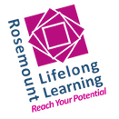
Rosemount Lifelong Learning is a community organisation based in Royston, Glasgow, which – among other duties – provides free educational courses, training, and advice to tackle poverty and social exclusion. This project focused in particular on women refugee and asylum seekers who have been affected directly, or indirectly, by gambling harm. They released a survey and conducted one to one interviews and focus groups, involving 67 people, gauging that gambling harm does affect this group and that the gambling activities practiced within these communities are broadly similar to those practiced outwith.
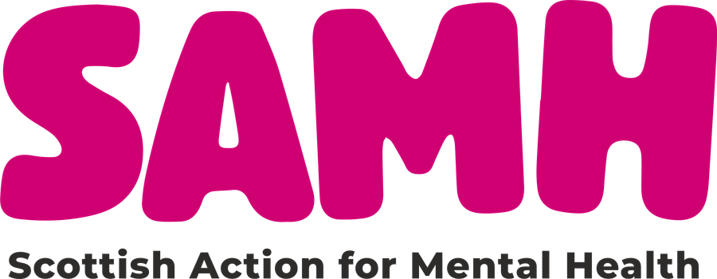
SAMH is Scotland’s national mental health charity. This project engaged 28 men in areas of high deprivation, particularly those connected to football culture, to discuss intersections of gambling harm, mental health, and suicide. Activities included interviews, focus groups, a survey, and peer support sessions involving men in their established userbase. The project has already seen impact as data captured has informed the design of a new pilot gambling harm awareness session to be delivered across football club partners.

University of Strathclyde, based in Glasgow, launched their project led by suicide prevention leads at the institution. The project (ongoing) involves the creation of a five-minute film aimed at raising awareness of gambling harm amongst students. Students with lived experienced were conducted to inform the production, promote the film, and evaluate it once produced. Once completed, the film will be promoted across the university and made accessible to every college and university in Scotland.

Challenges and changes

Gambling harm and mental health funded projects commenced in January 2026, following a kick off stakeholder event held online on 17 December 2025. Projects receiving levy funds were given until the end of March 2026 to carry out activities set out in their bids and to return reporting forms back to the ALLIANCE, outlining key learning.
This proved challenging for projects, reflected in feedback, and is important learning for future work on gambling harms. Through engagement with project leads, it was clear this was an even greater challenge for the smaller organisations involved - acknowledging the difficulty in resourcing projects in such a short period of time.
The consequence of this was several organisations flagging a potential underspend of funds (as they could not schedule activities or find participants within the designated time) or a delay to their project, with some now continuing into Q1 2026. One organisation sadly had to end their project and return funds, as the activities outlined in their bid proved infeasible to complete before the end of March. This project is outlined below:

Ewen’s Room is a mental health and wellbeing charity, based in Lochaber, that works with young people in particular to increase mental health awareness and to identify and help fill gaps in local support and provision. Ewen’s Room unfortunately had to withdraw from their project due to a lack of uptake for proposed activities and limited staff capacity. In spite of this, the team has made important links with gambling harm organisations and the discontinuation of their project evidences the difficulty in responding to gambling harm in underserved, remote areas of Scotland.

About the ALLIANCE
The Health and Social Care Alliance Scotland (the ALLIANCE) is the national third sector membership organisation for the health and social care sector. We bring together over 3,500 people and organisations dedicated to achieving our vision of a Scotland where everyone has a strong voice and enjoys the right to live well, with dignity and respect. Our members are essential in creating a society in which we all can thrive, and we believe that by working together, our voice is stronger.
We work to improve the wellbeing of people and communities across Scotland by supporting change in health, social care, and other public services so they better meet the needs of everyone in Scotland. We do this by bringing together the expertise of people with lived experience, the third sector, and organisations across health and social care to shape better services and support positive change.
The ALLIANCE has three core aims. We seek to:

Empower people with lived experience: we ensure disabled people, people with long term conditions, and unpaid carers, are heard and that their needs remain at the heart of the services and communities
Support positive change: we work within communities to promote co-production, self management, human rights, and independent living
Champion the third sector: we work with, support and encourage co-operation between the third sector and health and social care organisations
Together, our voice is stronger, and we can create meaningful change.

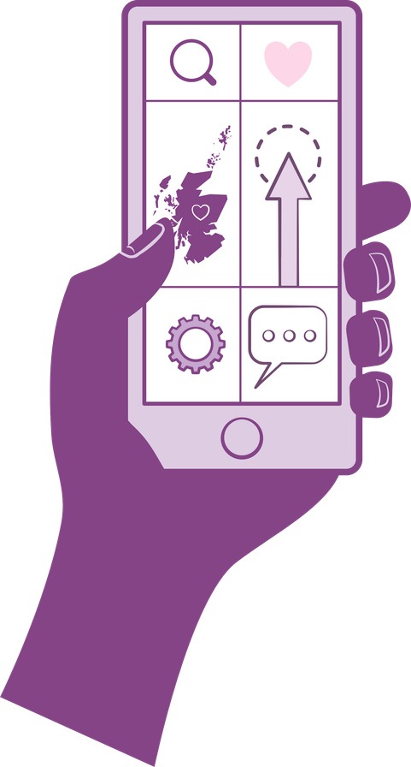

Contact:
Lauren Heaney, Programme Manager
Email: lauren.heaney@alliance-scotland.org.uk
Alan McCaskell, Development Officer
Email: alan.mccaskell@alliance-scotland.org.uk
Fay Laidler, Development Officer
Email: fay.laidler@alliance-scotland.org.uk

 0141 404 0231 info@alliance-scotland.org.uk  ALLIANCEScot
 alliance.scot  alliancescotland  alliancescotland  www.aliss.org

www.alliance-scotland.org.uk
Health and Social Care Alliance Scotland (the ALLIANCE)
310 St Vincent Street, Glasgow, G2 5RU

End of Document.
