


ALLIANCE Annual Conference 2026

Hope to
Action:
Building on
20
Years

Years of the
ALLIANCE



Foreword

This year’s Annual Conference and AGM marked a significant milestone for the ALLIANCE; twenty years of collective action, partnership and determination. As we gathered under the theme ‘Hope into Action’ we did so deliberately. Hope is not a passive sentiment for us; it is a strategic choice, a discipline, and a commitment to shaping a better future - even in the most challenging of times.
Reaching our 20th anniversary has offered a rare opportunity to look back with clarity. Over two decades, our membership has grown in breadth, diversity and strength, and remains one of our greatest assets. Together, we have advocated for policy shaped by people’s rights and lived experience. We have campaigned collectively on issues requiring urgent attention, and delivered ambitious programmes of work that have transformed the landscape of health and wellbeing in Scotland. The Self Management Fund stands as a powerful example of what we can achieve when we build capacity and capability within our communities. Notably, its strategy was shaped by lived experience and engagement with the third sector; an innovative approach for Scotland. This has strengthened the Fund’s relevance, accountability, and grounded it in what is needed in communities.
We have championed meaningful involvement of people with lived experience, not as an optional extra, but as a core principle. We have worked to provide platforms for voices too often overlooked, and we have demonstrated what co-production and human-rights-based approaches look like in practice.
But anniversaries are not only moments for reflection; they are vantage points from which to look ahead. And as we look to the future, we do so with a strong vision. We are living through a period of persistent change, uncertainty and strain. Budgets are stretched. People’s needs are evolving. Far-right rhetoric is growing, influencing democratic institutions and deepening division. In this context, a strong civil society is not simply valuable, it is essential.
The ALLIANCE has always been at its best when the system is under pressure. Our work is fundamentally about people’s lives: their rights, their dignity, their inclusion. To insist on hope is not to deny the difficulty of the moment, but to acknowledge it fully and act anyway. Hope, for us, is a strategy. It is how we create the space needed to shift systems towards prevention, equity and compassion. It is how we refuse the inevitability of division and instead build the conditions where everyone has the chance not just to survive, but to live well.
This is why alliances matter. We bring people together. We amplify stories. We challenge systems. We advocate for better. And we support communities to become even more invaluable. We shine a light on what must change, without placing the burden on any one individual or organisation.
My sincere thanks go to all our members for being part of this strong collective voice, to our dedicated staff and to our Board members - past, present and prospective - who guide, scrutinise and inspire our work. As we look ahead to the next twenty years, I am confident that, together, we will continue to turn hope into action and improve the wellbeing of people across Scotland.
Sara Redmond, Chief Officer, the ALLIANCE



Introduction
97%
said they would recommend the ALLIANCE conference to others
The ALLIANCE’s Annual Conference 2026 brought together almost 300 delegates from across Scotland’s health and social care landscape to mark a significant milestone: the organisation’s 20th anniversary. Under the theme Hope to Action, the day invited reflection on two decades of progress while looking ahead to the next twenty years, asking what kind of system Scotland needs, and how we collectively move towards it.
This post-conference report draws together the key themes, insights and ambitions shared across the day’s panels, workshops and creative sessions. It highlights the ideas that resonated most strongly with delegates; embedding lived experience and rights in policy, using stories to shape social change, prevention of health inequalities, community-led approaches, and long-term planning.
The conference programme reflected the diversity and dynamism of the sector. Workshops explored how we communicate, how we challenge stigma, how we strengthen democracy, and how we reduce inequalities. A graphic facilitator captured the energy and ideas emerging throughout the day, while the Deafblind Scotland BSL Choir closed the event with a powerful performance that embodied the conference’s commitment to inclusion. Delegates also contributed to a time capsule, sharing their hopes for the future of health and social care; messages that will guide the ALLIANCE’s work in the years ahead.
292
delegates
23
sponsors and exhibitors

10 speakers
14
workshops

93%
said the conference either fulfilled or exceeded their expectations


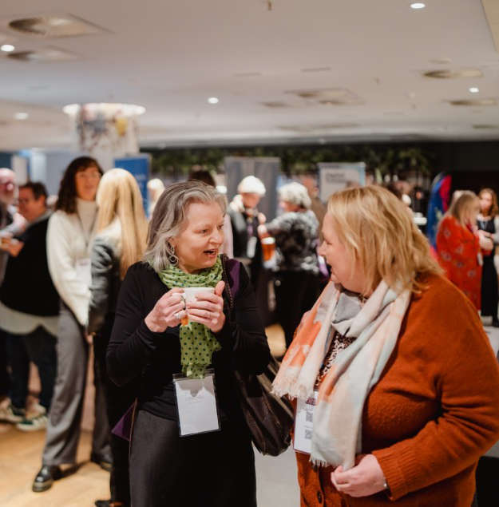
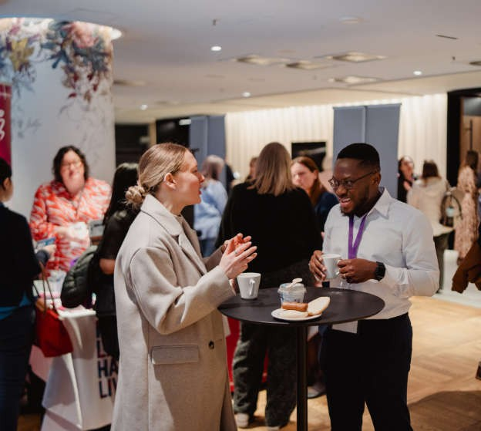
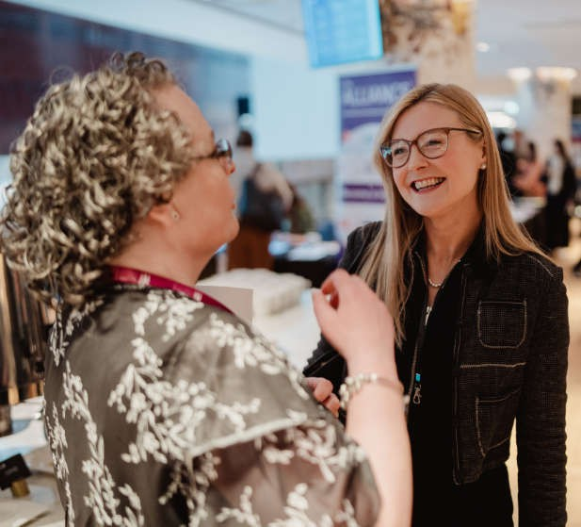

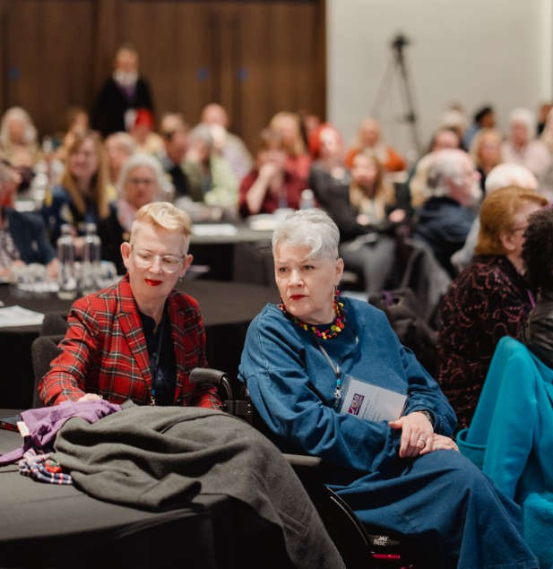



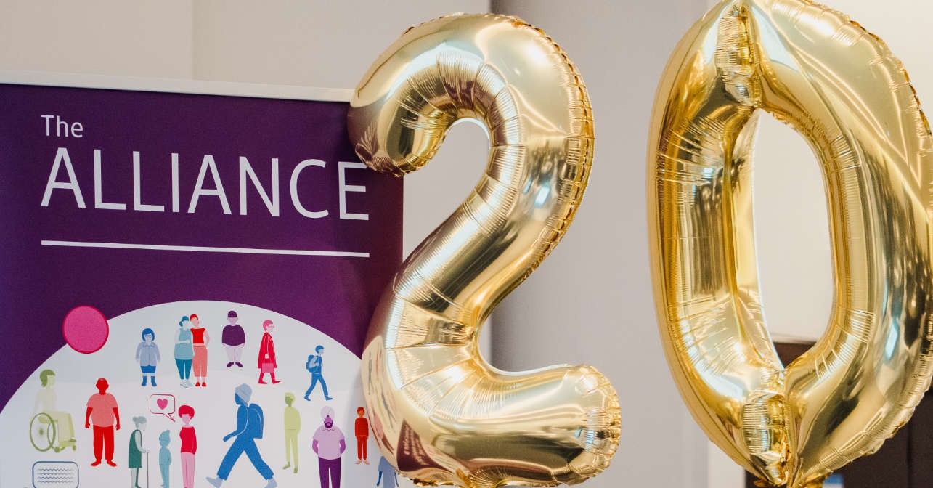

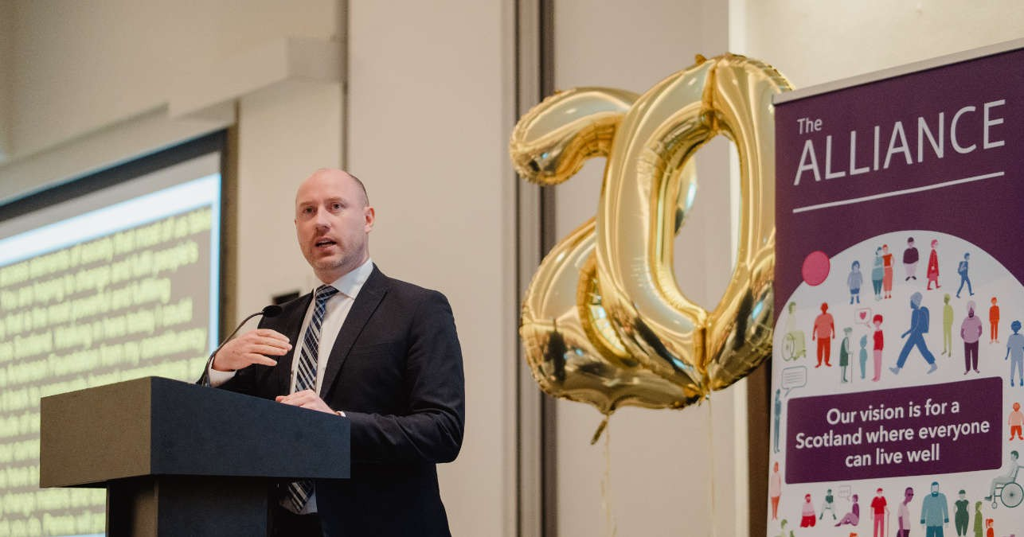

Panel sessions

Interview with Neil Gray MSP,
Cabinet Secretary for Health and Social Care at the time of the ALLIANCE conference

The conference opened with an in-depth conversation between Pennie Taylor and former Cabinet Secretary Neil Gray, setting the tone for a day focused on ambition, accountability, and the realities of system change. Marking the ALLIANCE’s 20th anniversary, the former Cabinet Secretary praised the organisation and its members as “the living embodiment of Hope to Action,” recognising the essential role of the third sector in Scotland’s social fabric.
Across the discussion, he acknowledged the persistent implementation gap between national ambitions and local realities, particularly around prevention, early intervention, and fairer funding. He reiterated his commitment to progressing social care reform and delivering greater parity between health and social care, noting that structural change remains necessary to achieve consistency and equity across Scotland. He highlighted the importance of community-based approaches, the need to utilise every “touch point” between individuals and services, and the value of redirecting resources upstream into prevention.
Gray also reflected on the pressures facing local authorities, Integration Joint Boards and Health Boards, emphasising that meaningful resource shifts are challenging but essential. He pointed to the Fairer Funding pilot and the Population Health Framework as early steps toward longer-term, multi-year investment. When asked what single action would make the biggest difference, he was unequivocal: sustained funding and structural reform must go hand in hand to deliver the change people need.

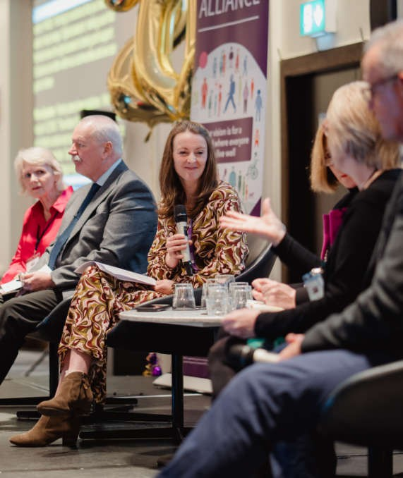
Morning panel: From Vision to Action

The first panel brought together leaders with deep experience across health, social care, and community systems to reflect on the ALLIANCE’s 20 year journey and the work still ahead.
During this session chaired by ALLIANCE Chief Officer Sara Redmond, we heard from:
- Sandra Auld, IJB Lived experience representative
- Derek Feeley, Former Director General for Health and Social Care in the Scottish Government and Chief Executive of NHS
- Eddie Fraser, Chief Executive, East Ayrshire Council
- Anne Hendry, Director, IFIC Scotland
- Jenny Miller, Chief Executive, PAMIS
Speakers acknowledged the progress made since the organisation’s founding - particularly on deinstitutionalisation, care at home, and the strengthening of collective voice - but were clear that significant challenges remain.
A recurring theme was the need to shift the balance of power. Derek Feeley and Sandra Auld both highlighted the limitations of current governance structures, with lived experience representatives still fighting for parity and influence. Anne Hendry raised concerns about what is measured, and what is not, arguing that continuity and coordination of care matter most to people, yet remain largely invisible in current performance frameworks.
“
Really important conversations recognising the importance of lived experience to inform services and strategies and the need to put the social context of our lives at the heart of health and social care - Delegate

Speakers emphasised the interconnectedness of social care with wider policy areas such as transport, housing and community planning.
Eddie Fraser stressed that progress is at risk without stronger cross-sector collaboration and a move away from blame-driven politics. Jenny Miller reflected on the ALLIANCE’s unique strength in uniting voices and connecting people across systems, describing the organisation’s collective wisdom as a vital asset for the future.
The panel closed with a shared call for hope, courage and learning; recognising that people, not structures, change lives.

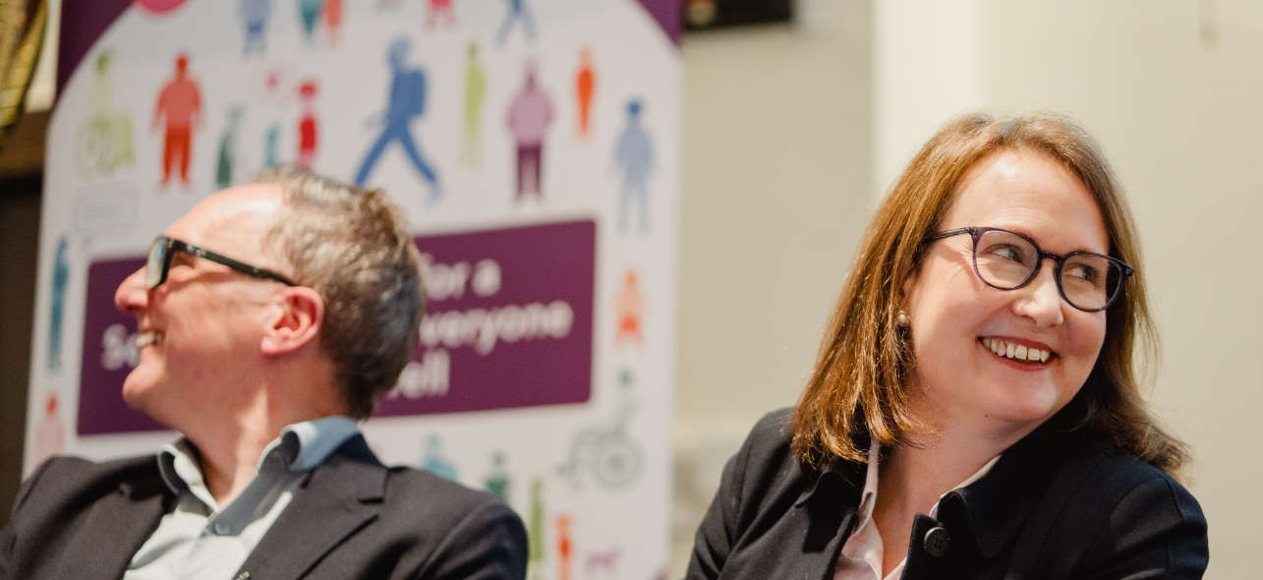
Afternoon panel: From Hope to Action
The afternoon panel shifted focus to the future, exploring how Scotland can turn collective hope into meaningful action over the next 20 years. Speakers from research, youth advocacy, community initiatives and health and social care leadership highlighted the need for deeper participation, stronger community investment, and a renewed commitment to equity.
- Mark Diffley, Founder and Director of Diffley Partnership
- Stephanie Fraser, Chief Executive, Cerebral Palsy Scotland
- Fatemah Ghanem, Member of the Scottish Youth Parliament
- Niall McShannon, Director, Clydesdale Community Initiatives
- Gareth Marr, Chief Officer, Dumfries and Galloway HSPC
We heard from:
Mark Diffley emphasised the importance of deliberative democracy - citizens’ assemblies, participatory budgeting, and structured engagement that goes beyond surface-level polling. Stephanie Fraser spoke to the power of incremental change, using the Right to Speak campaign as an example of persistence and strategic advocacy.
Youth voice was a powerful thread throughout the session. Fatima Ghanem highlighted the mental health challenges facing young people and the ongoing power imbalance that limits their influence. She described trust as the bridge between hope and action, stressing that young people must be partners, not consultees, in shaping services.
Community-led approaches were championed by Niall McShannon and Gareth Marr, who argued that hope lives in civic spaces, relationships and local initiatives. They called for a shift in what is measured, valuing qualitative outcomes and lived experience over narrow metrics. Marr’s example of the Fed Up Café illustrated how community connection can deliver better outcomes than purely medical interventions.
Across the panel, speakers agreed that national and local governments cannot deliver change alone. Alliances, shared expertise and community power are essential to building a future where everyone can live well with dignity and respect.

6

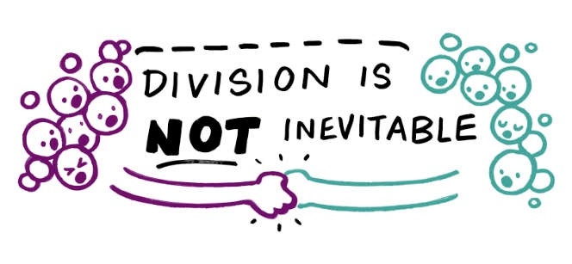
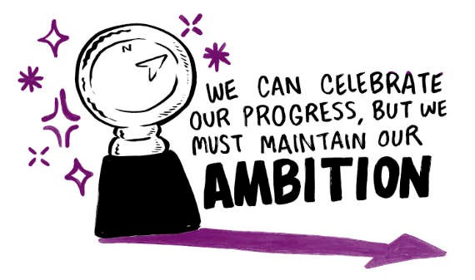

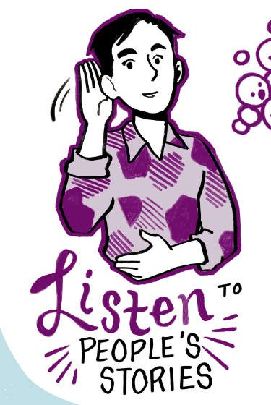
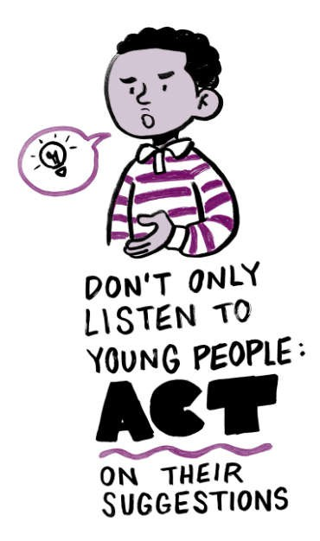
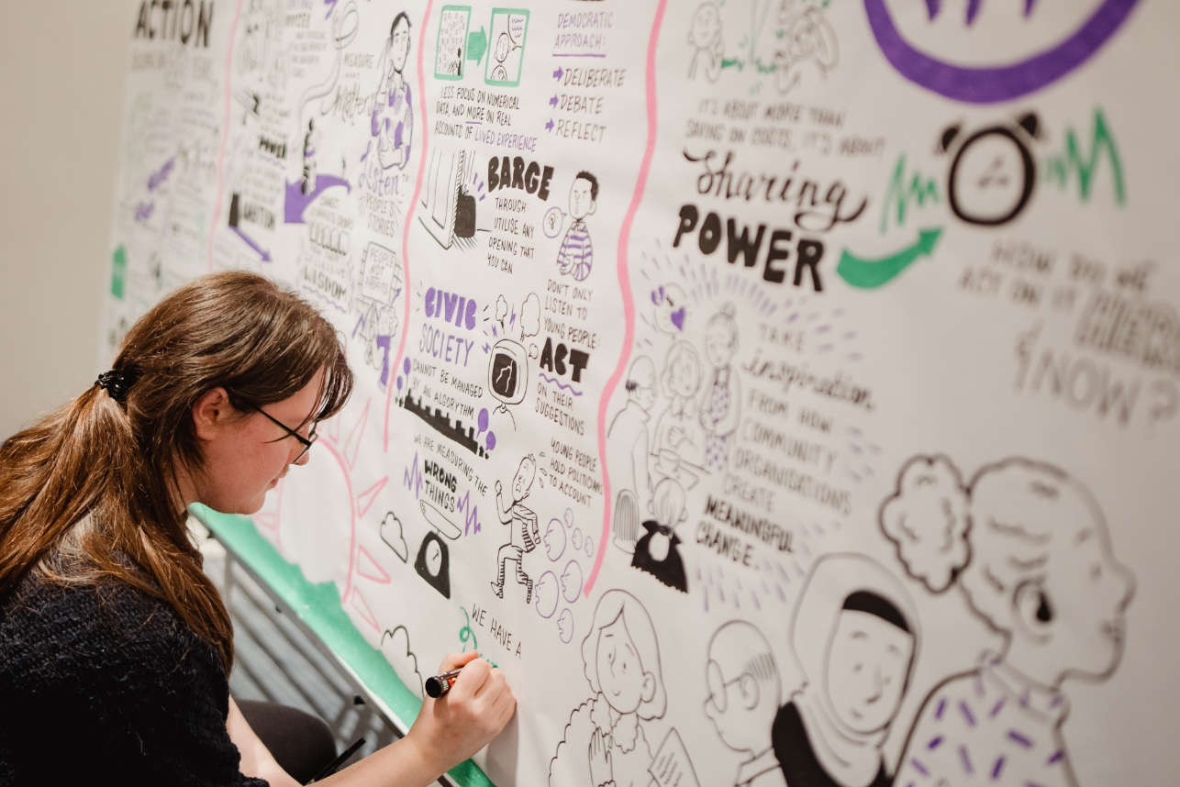
Creative contributions

Creativity played a central role throughout the conference, offering delegates new ways to reflect, express themselves and connect with the day’s themes. These creative elements were not add-ons but deliberate choices designed to deepen engagement, amplify lived experience and create space for imagination alongside analysis.

Throughout the day, illustrator and graphic facilitator Jem Milton captured the conference’s discussions in real time, creating a large-scale visual record of the themes, ideas and emotions that emerged. Their work offered delegates a dynamic, evolving reflection of the day and a way to see connections across workshops, panels and conversations that might otherwise remain separate.

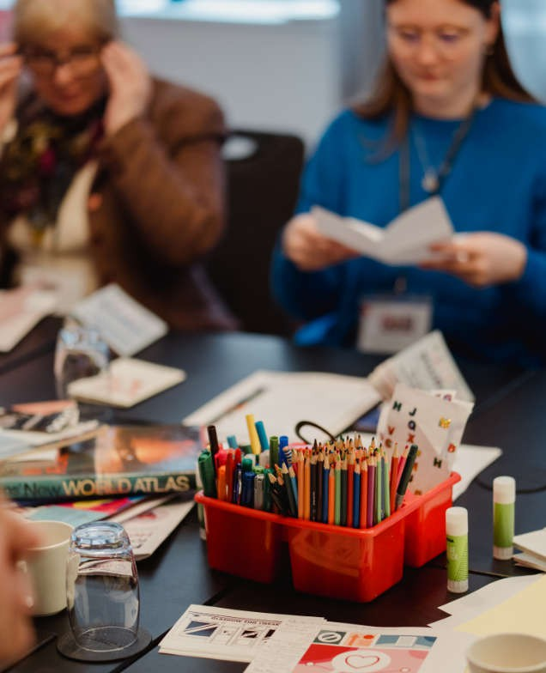








Delegates were invited to contribute to a time capsule capturing their reflections on what they want Scotland to look like in the next 20 years. Participants took Polaroid photographs and wrote messages of their hopes, frustrations, priorities and visions for change. The capsule was filled with reflections on rights, dignity, inclusion and the desire for a system that truly supports people to live well. These contributions will be preserved as a collective record of this moment in time and a guide for the ALLIANCE’s future work.
Reclaiming the Narrative:
Zine-Making with See Me and Glasgow Zine Library
This workshop invited participants to use zinemaking. Zines are a grassroot, DIY creative method, to challenge stigma and reclaim personal and collective narratives. Delegates explored prompts, to produce zines that expressed lived experience, solidarity and resistance. The session highlighted how creative tools can amplify voices, build community and shift power by enabling people to tell their own stories on their own terms.
Two creative workshops offered delegates hands-on opportunities to explore themes of stigma, power and system change through artistic practice.

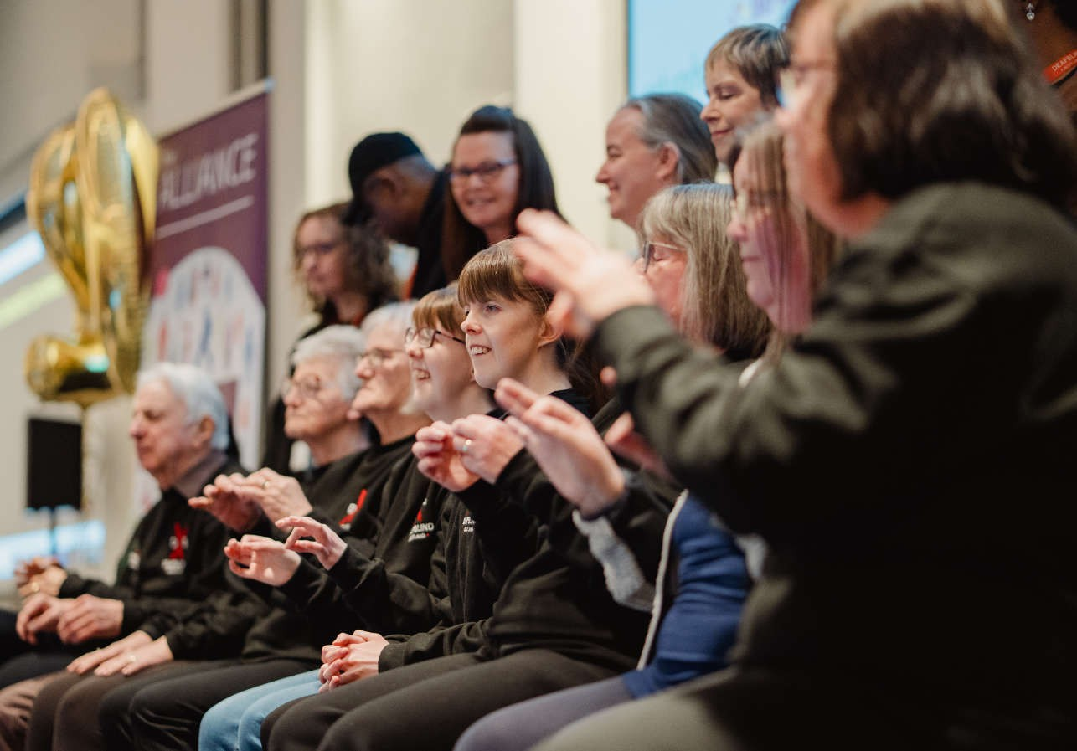

“
The Deafblind Scotland BSL Choir were absolutely inspirational and concluded the conference in the perfect way - Delegate
9
Changing the Rules:
Legislative Theatre with Active Inquiry

In this participatory workshop, delegates used drama techniques to surface the “invisible rules” that shape health and social care; the unspoken norms, barriers and power dynamics that influence everyday practice. Through image theatre and collaborative exercises, participants explored how these rules could be challenged, rewritten or replaced. The session demonstrated how creative methods can open new ways of thinking about system change, making space for imagination, critique and collective problem-solving.
The day closed with a powerful performance from the Deafblind Scotland BSL Choir. Their
Deafblind Scotland BSL Choir
“
Legislative theatre – fantastic concept, may reach out more to fellow members - Delegate

contribution brought the conference to an emotional and reflective close, embodying the values of inclusion, creativity and community that ran throughout the event. The performance served as a reminder that communication takes many forms, and that cultural expression is a vital part of building a health and social care system where everyone can participate fully.




Human rights and accountability

Human rights ran as a defining thread throughout the conference, shaping discussions on participation, prevention, inclusion and system reform. Delegates emphasised that rights must be lived and embedded in everyday practice, decision-making and service design.
The morning panel, From Vision to Action, highlighted the progress made over the past 20 years on deinstitutionalisation, care at home and collective voice. Yet speakers were clear that rights-based practice remains uneven. Sandra Auld described the barriers faced by lived experience representatives within Integration Joint Boards, noting that parity of power is still far from realised. Derek Feeley echoed this, arguing that Scotland cannot shift the balance of care without first shifting the balance of power.
The workshop Our Collective Voice: Setting the Agenda for the Next Scottish Parliament focused on the ALLIANCE’s manifesto and reinforced the centrality of rights. Delegates called for a Human Rights Bill, stronger accountability mechanisms, and better access to justice when rights are breached. They highlighted the need for rights-based public services, a Right to Palliative Care, and population-level approaches that ensure people’s rights are upheld across their lives. The workshop also emphasised the global context, rising authoritarianism, misinformation and declining trust, and the need for Scotland to remain a human rights leader.
The Challenging Toxic Narratives workshop exposed how hostile rhetoric around asylum and immigration undermines rights and fuels discrimination. Speakers described the real-world consequences of dehumanising language, from homelessness to racial harassment. They emphasised the need for rights-based integration, fair processes, and narratives that recognise the humanity, resilience and contributions of New Scots.
Neil Gray’s address underscored the Scottish Government’s commitment to rights-based reform, including the National Care Service, early intervention, and fairer funding. He described the ALLIANCE as “the living embodiment of Hope to Action,” recognising the sector’s role in advancing rights across Scotland.

Key takeaway
Human rights must be the foundation of Scotland’s next 20 years. Rights-based practice requires accountability, participation and structural reform, not rhetoric. A fairer future depends on embedding rights in every decision, ensuring people can exercise them, and creating systems that uphold dignity, equity and justice for all.

10








Key takeaway
Narrative is a powerful tool; it can divide or unite, stigmatise or empower. Delegates felt that Scotland must invest in hopeful,
values-led, accessible communication that challenges harmful narratives and amplifies lived experience. Changing the story is essential to changing the system.
Changing narratives: Reclaiming the story

A second major theme centred on narrative; who shapes it, who benefits from it, and how it can be reclaimed to drive social change. Delegates explored how stories influence public understanding, political priorities and lived experience.
The workshop Reframing for a Better Future focused on how framing can hold
decision-makers accountable while motivating action. Participants discussed how leading with values, simplifying messages and avoiding crisis-fatigue can bring wider audiences with us. The session emphasised accessibility, including acknowledging sensory impairment, and the importance of listening to opposing narratives to understand how they gain traction.
Creative approaches to narrative change were showcased in Reclaiming the Narrative, delivered with See Me and Glasgow Zine Library. Delegates explored how creative methods can challenge stigma, build community and amplify lived experience. Zine-making was used to explore prompts such as “What makes you feel hopeful?” and “What message do you want people to know?”. The workshop highlighted that stigma is rooted in power, and that creative, user-led storytelling can redistribute that power.
The Challenging Toxic Narratives workshop examined how misinformation and hostile rhetoric around asylum and immigration shape public attitudes. Speakers described the saturation of disinformation and the need for strong, evidence-based messaging that highlights fairness, humanity and the positive contributions of New Scots. They stressed that narrative change requires cross-sector alliances, strategic communication and a commitment to truth.
Panels reinforced this theme. Mark Diffley emphasised the importance of deliberative approaches that allow people to engage with evidence and shift their views. Stephanie Fraser and Niall McShannon highlighted the power of storytelling in advocacy and community-led change.




Health inequities, prevention, and inclusion

A third theme centred on the persistent health inequalities that shape people’s lives and the urgent need for prevention, inclusion and community-led approaches.
The Inclusion Health workshop highlighted the barriers faced by people who are marginalised or excluded from mainstream services, including homelessness, insecure immigration status, trauma, racism and poverty. Speakers emphasised the need for proactive engagement, relationship-based practice and approaches that recognise the complexity of people’s lives.
The Prevention workshop reinforced this message. Delegates noted the gap between policy rhetoric and practice, with community-led prevention work often underfunded despite its proven impact. Speakers emphasised that prevention is already happening effectively across Scotland through Community Link Workers, long-term relational support, and holistic approaches, but requires sustained investment and recognition.
The Prevention Through Self Management workshop added another dimension, highlighting how self management can prevent deterioration and support people to live fuller lives.
Speakers from Children’s Health Scotland and Bipolar Scotland shared examples of user-led, relational and adaptive approaches that support wellbeing and prevent crisis.
continuity, relationships, quality of life and what is currently measured. Gareth Marr argued
Panels echoed these concerns. Eddie Fraser warned that progress is at risk without sustained investment. Anne Hendry highlighted the mismatch between what matters to people;
“
I agree whole heartedly that we have to move away from the medical model and focus exclusively on self management - Delegate

that shifting what we measure is essential to shifting what we value.

Key takeaway
Scotland must prioritise prevention, inclusion and equity over crisis-driven responses. Health inequities are not inevitable; they are shaped by policy, investment and power. The next 20 years must focus on long-term, community-led,
relationship-based approaches that ensure everyone can live well.



Looking to the future

The final theme looked ahead to the next 20 years, exploring what Scotland’s health and social care system must become, and how we get there.
The workshop AI into Action brought a forward-looking lens to the day, exploring how AI can be used ethically, transparently and cautiously within the sector. Delegates discussed the need for a human-rights-based approach to AI, the risks of misinformation, and the importance of using AI only for idea generation and writing support. Speakers emphasised the “three principles of dancing ethically with AI”: embracing uncertainty, documenting transparently, and sharing reflectively. Participants also highlighted the need for digital confidence across the workforce and the importance of aligning AI use with real human need.
“
Thought-provoking AI session at the the ALLIANCE conference today [which] explored where the third sector stands with AI right now
- Delegate

Neil Gray’s address set out a vision for structural reform, parity between health and social care, and a shift towards early intervention and prevention. He acknowledged the implementation gap and the pressures facing local systems, but emphasised the need for long-term funding, community-based approaches and better integration across sectors.
Panels expanded on this future-focused vision. Speakers highlighted the importance of cross-sector collaboration, with transport, housing, education and community planning all recognised as essential to improving health and wellbeing. Jenny Miller described the
ALLIANCE’s unique ability to connect people and amplify collective wisdom. Niall McShannon argued that hope lives in civic spaces, relationships and local initiatives - and that community-led approaches must be central to Scotland’s future.
Workshops added further depth. Democracy in Practice explored how to support young people and marginalised communities to shape Scotland’s future. Active Inquiry’s legislative theatre session helped participants surface the “invisible rules” that shape practice and imagine more equitable alternatives. The My Home, My Community workshop highlighted housing as a foundation for health and the need for stronger integration between housing, health, social care and the third sector.

Key takeaway
Scotland’s future must be defined by collaboration, long-term investment and systems designed around people’s lives. The next 20 years require courage, creativity and a willingness to rethink how power, resources and relationships are structured. Hope becomes action when ambition is matched with sustained commitment.


Championing our membership

As a membership organisation, our future is shaped by our members, and our strength lies in their collective insight, experience, and leadership. Hope to Action placed members at the centre of the day through a dedicated Membership Zone, and two member-focused workshops.

Priorities in Action
In the morning, members were asked to identify key policy and practice priorities that they would like the ALLIANCE and third sector to focus on.
- Meaningful public engagement
- Long-term funding reform
- Ending the ‘postcode lottery’
- Integrated digital records to prevent re-traumatisation
These included:
The priorities identified in this workshop will feed directly into the ALLIANCE’s work and inform future priorities and strategy.

ALLIANCE Connect
This networking session strengthened relationships across the third sector, creating space for members to share challenges, opportunities and examples of innovation. Delegates emphasised the need for stronger partnerships, better communication and continued support for community-led approaches.

Key takeaway
From the learning from these workshops, we can see that members reaffirmed that they are not consultees but co-creators of the ALLIANCE’s future direction. Their insights, priorities and lived experience will shape the organisation’s strategy and Scotland’s wider health and social care landscape in the years ahead.


Click here if you want to become an ALLIANCE member and have your voice heard.
membership


“
Fabulous day, thank you. Challenging but positive connections turning hope to action
“
In Glasgow today for the ALLIANCE conference. Really important conversations recognising the importance of lived experience to inform services and strategies and the need to put the social context of our lives at the heart of health and social care














Social media engagement

The online conversations surrounding the event were just as engaging as the discussions at the conference. By leveraging our various social media channels, we extended the conferences reach and coverage to a much wider audience. Using the hashtags #ALLIANCEConf26 and #HopeToAction, attendees shared their insights, takeaways and feedback, which helped
£
to amplify key topics – you can explore and contribute to the ongoing conversations by searching the hashtags.

Social media stats:
Overall impressions across socials
10.3K
An increase of
1.6K
from our conference in 2025
We made use of LinkedIn, Facebook and Instagram stories to cover the day, posting 24 times and engaging with countless attendee posts.

Engagements by platform:

LinkedIn: Facebook: Instagram:
171 462 67

engagements engagements engagements

Feedback we received on social media channels:


16
Next steps

The ALLIANCE Annual Conference 2026 marked twenty years of collective action, advocacy and partnership and set a clear direction for the decades ahead. Across panels, workshops and creative sessions, delegates articulated a shared vision for Scotland’s future; one grounded in human rights, shaped by inclusive narratives, committed to tackling inequalities, and driven by hope, participation and community power.
The conference demonstrated there are still challenges that we must face, and that meaningful change requires more than ambition. It requires long-term investment, structural reform, and systems designed around people’s lives. It requires listening deeply, communicating with clarity, and challenging the narratives that divide us. Above all, it requires collaboration, across sectors, across communities and across Scotland.
As the ALLIANCE looks ahead to its next chapter, the message from delegates was clear; hope becomes action when we work together, when we centre people’s rights and experiences, and when we commit to building a fairer, more connected and more compassionate health and social care system for all.
Our sincere thanks go to everyone who made this year’s Annual Conference such a powerful
“
What a brilliant day I had at the ALLIANCE Annual Conference and AGM. A packed agenda, workshops and a feel of real hope for the future in health and social care - Delegate

and memorable event. To our speakers and panellists - thank you for sharing your insight, experience and the challenges you have faced. To our delegates - thank you for your energy, your contributions, and the hope you brought into every conversation. We are grateful to our photographer, Marc Millar, for capturing the spirit and energy of the day, and to illustrator and graphic facilitator Jem Milton for bringing our discussions to life through their remarkable visual storytelling. Thank you as well to the Deafblind Scotland BSL Choir for rounding the day off in such a powerful way.

And to the ALLIANCE staff team, thank you for your hard work, creativity and commitment in shaping a day that truly reflected our values. This conference was a collective effort, and its impact belongs to all of you.















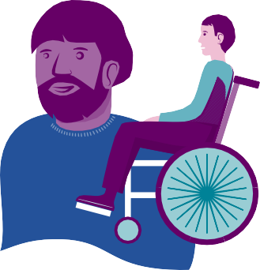





ALLIANCE at
2006
2026
As part of the ALLIANCE’s 20 year anniversary, we have been sharing content across social media platforms to highlight the work of our different programmes. Keep an eye out over the next few months as we continue to share content and celebrate the impact of our work.

Years of the

ALLIANCE

If you have any stories about the ALLIANCE’s impact that you would like to share, get in touch with us at communications@alliance-scotland.org.uk

17

About the ALLIANCE

The Health and Social Care Alliance Scotland (the ALLIANCE) is the national third sector membership organisation for the health and social care sector. We bring together over 3,500 people and organisations dedicated to achieving our vision of a Scotland where everyone has a strong voice and enjoys the right to live well, with dignity and respect. Our members are essential in creating a society in which we all can thrive, and we believe that by working together, our voice is stronger.
We work to improve the wellbeing of people and communities across Scotland by supporting change in health, social care and other public services so they better meet the needs of everyone in Scotland. We do this by bringing together the expertise of people with lived experience, the third sector, and organisations across health and social care to shape better services and support positive change.

The ALLIANCE has three core aims.

We seek to:

- Empower people with lived experience: we ensure disabled people, people with long term conditions, and unpaid carers are heard and that their needs remain at the heart of the services and communities.
- Support positive change: we work within communities to promote co-production, self management, human rights, and independent living.
- Champion the third sector: we work with, support and encourage co-operation between the third sector and health and social care organisations.

The ALLIANCE is committed to upholding human rights. We embed lived experience in our work and aim to ensure people are meaningfully involved at every level of decision-making.
Working together creates positive, long-lasting impact. We work in partnership with the Scottish Government, NHS Boards, universities, and other key organisations within health, social care, housing, and digital technology to manage funding and develop successful projects. Together, our voice is stronger, and we can create meaningful change.





ALLIANCE

Annual Conference
2026

0141 404 0231 info@alliance-scotland.org.uk

 alliance.scot  alliancescotland  ALLIANCEScot alliancescotland  ALLIANCE Live

www.alliance-scotland.org.uk

The ALLIANCE is supported by a grant from the Scottish Government. The ALLIANCE is a company registered by guarantee. Registered in Scotland No.307731. Charity number SC037475. VAT No. 397 6230 60.

