
Gambling Harm and Mental Health fund 2026/2027

Grant Application Guidance
This guidance is for new applicants and applicants who applied for the fund in 2025/2026
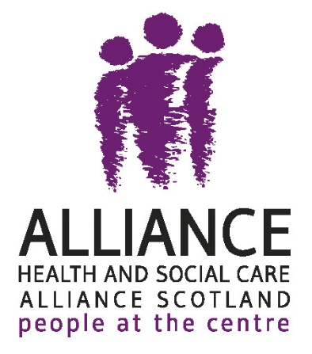
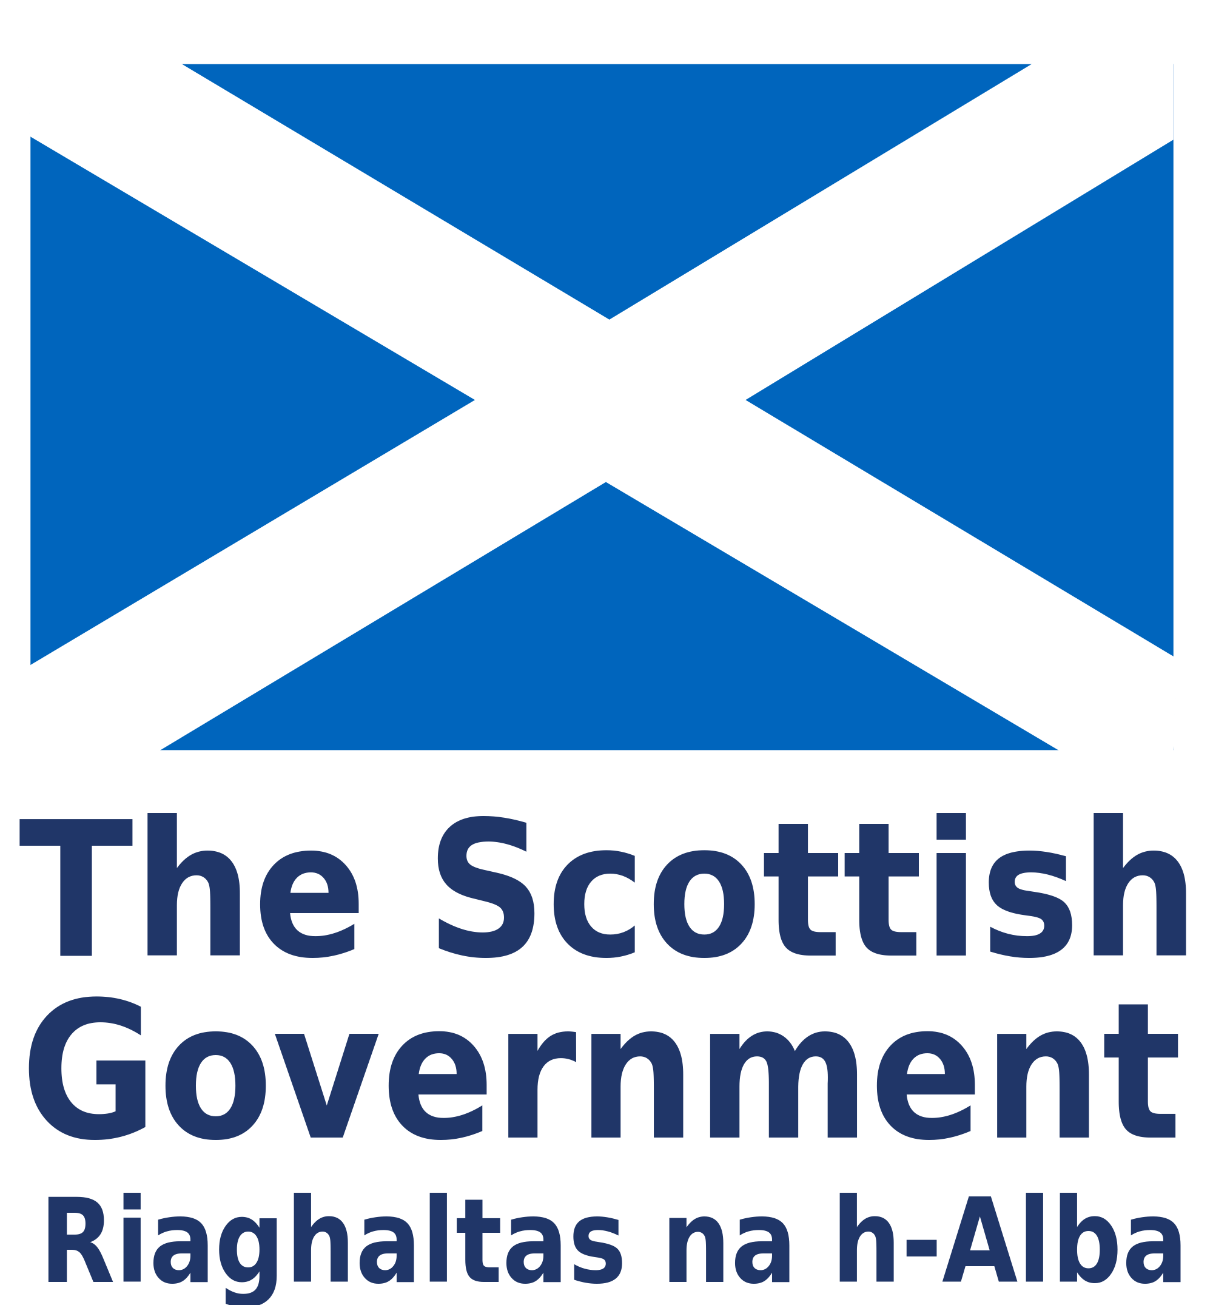

Table of Contents
What is the Gambling Harm and Mental Health fund? 2
What are the aims of this fund? 2
What will it fund? 3
Who can apply 4
What projects can be funded 4
What projects cannot be funded 5
How to apply 6
Project timeline 8
Fund key dates 8
Reporting for the fund 9
Help available 9
FAQs 9

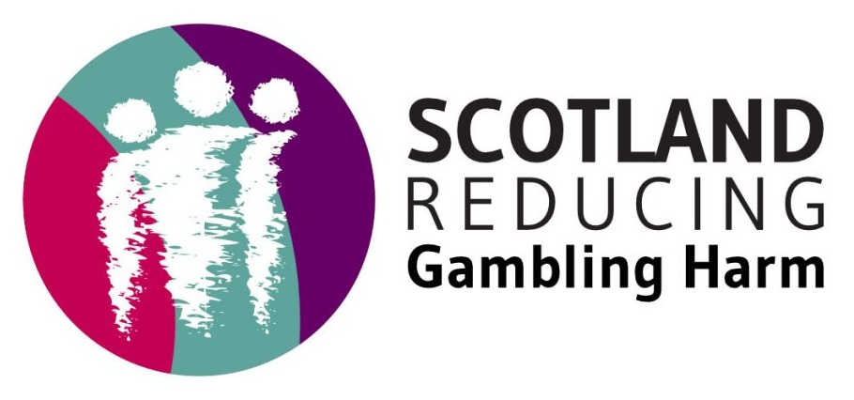

If you have any further questions, please feel free to contact us at: gamblingharm@alliance-scotland.org.uk.

What is the Gambling Harm and Mental Health fund?
The Scottish Government’s Preventing Poor Mental Health and Suicide Unit in the Mental Health and Social Care and National Care Service Directorate has secured further funding from the Statutory Gambling Levy to support community-based activity to further work on mental health and gambling harms, including a focus on suicide.
The fund will be administered by the Health and Social Care Alliance Scotland (the ALLIANCE) on behalf of the Scottish Government. The Scotland Reducing Gambling Harm (ScotRGH) team will lead this work and be the main point of contact for potential and successful projects.
Gambling harm is a public health issue that impacts people across Scotland. The purpose of this funding round is to deepen understanding of how gambling harm impacts the mental health of people in different disadvantaged, marginalised, and minoritised communities across Scotland, and explain how this harm intersects with other inequalities and contextual factors. Through this insight we can identify best practice to target prevention, intervention, and treatment within these communities.
There are two levels of grant available in this fund:
New Applicants – A single stage application process, awarding up to £20,000 for up to 6 months.
Returning Applicants – A single stage application process, awarding up to £30,000 for up to 6 months, where work is specifically building on learning from their previous Gambling Harms project.

What are the aims of this fund?
This fund aims to:
- Raise awareness of gambling harm, how specified inequalities can cause or exacerbate poor mental health and/or suicidality, and the range of support available
- Research and contextualise how specific inequalities are experienced within disadvantaged, marginalised, and minoritised communities, and their links to gambling harm, poor mental health, and/or suicidality
- Build capacity in community-based services to embed support around gambling harm, mental health, and/or suicidality

What will it fund?
This fund explores the wider social, economic, and environmental factors that shape experiences of gambling harm and its impact on mental health and suicide.
The communities this fund aims to focus on are those that research and previous work highlight are most at risk of experiencing poor mental health caused by gambling harm and who experience structural disadvantage, exclusion, discrimination, or barriers to support.
All applicants must show how their work will target one of the following communities impacted by gambling harms and poor mental health. There are no age requirements on the community you wish to engage with:
- Socioeconomically disadvantaged communities (or SIMD)
- Rural and island communities
- LGBTQ+ communities
- Racially minoritised communities
- Gypsy/Traveller communities
- Neurodivergent people
- Refugee/Asylum seekers
- People with disabilities (including physical disabilities, sensory impairments and long-term health conditions)
The mental health impacts of gambling harm do not occur in isolation and are interconnected with other inequalities. Building on the work of the 2025/2026 exploratory gambling harm and mental health projects, we are interested in funding projects that explore how wider social, economic, and environmental factors shape experiences of gambling harm and mental health within the communities identified above.
Projects should, therefore, explore gambling harm and mental health in relation to one of the following wider social, economic or environmental factors:
- Financial insecurity (including debt, food insecurity and unstable employment)
- Housing insecurity
- Substance use or other behavioural harms
- Social isolation
- Gender

Who can apply
- Constituted not-for-profit organisations, such as charities, CICs, and community groups with;
  - A minimum of three Directors/Trustees/Board Members, the majority of whom receive no payment from the organisation
  - A bank account in the name of the organisation that requires dual authorisation for transactions
  - Appropriate safeguarding policies and procedures
- A governing document which contains:
  - A charitable dissolution lock
  - Charitable objectives and powers aligned with the activity proposed
- Stipulations ensuring that no more than 49% of board members (including trustees/directors) can be paid for services either in their capacity as a board member or as a staff member

What projects can be funded
Projects that:
- Are embedded in the community or have strong relationships with those that they want to undertake work with
- Have experience working with the specific social, economic or environmental factor that they have identified their project will be exploring
- Have a focus on or understanding and/or supporting the mental health needs of individuals or communities
- Take place in Scotland
- Can start by 1 October 2026 and be completed by 31 March 2027
- Are committed to sharing their project learning

What projects cannot be funded
- Organisations who are currently funded through the Gambling Levy in Scotland
- Unconstituted groups, individuals, public sector organisations, for-profit companies (including CICs limited by shares), or groups that do not meet governance requirements; such groups can be partners in projects, but cannot hold a grant themselves
- Additionally, public sector organisations, such as the NHS, Schools or Local Authorities cannot benefit financially from projects
- Work that does not meet the core criteria for the fund
- The purchase, repair, or refurbishment of capital items such as vehicles, buildings, land, or single items of equipment exceeding £2,000
- Costs incurred, or committed to, before a decision on the application is reached
- Speculative costs such as contingency
- Costs related to the sale or purchase of alcohol or gambling products
- Activity taking place outwith Scotland, including overseas trips
- The repayment of loans or payment of debts
- The advancement of religion or politics; faith-based organisations that meet eligibility criteria are welcome to apply for activity, provided the proposed activity is sufficiently separate from their faith promotion and can demonstrate both engagement and benefit beyond their existing faith community
- Work that focusses on or promotes a specific medication
- Work that takes place within school curriculum time or that is used to evidence pupils’ meeting outcomes under curriculum for excellence
- Projects in which the funded activity will not be able to start on 1 October 2026 and be completed by 31 March 2027
- Organisations who do not have a track record of meaningful work in the community where they are proposing their project takes place
- Organisations that do not want to share learning from their project

How to apply
We recommend that applicants attend one of our two online Information Sessions which will be held on:
Wednesday 15 July, 2pm – 3pm
Tuesday 28 July, 1pm – 2pm
These sessions will be hosted by our ScotRGH team and provide you with information about the grant and provides a space to ask any clarifying questions.
If you are unable to attend these sessions, and have any questions regarding the fund, please reach out to us at: gamblingharm@alliance-scotland.org.uk
Grant application forms can be found at smfscotland.grantplatform.com and you will be required to create an account with Good Grants to be able to proceed.
If you lack regular internet access or have other reasons for requiring an offline version of the application form, please contact Lauren Heaney on 0141 404 0231 to discuss alternatives.
We understand that funding applications can be collaborative between colleagues and partners. Please find a word document of the application that you can form your responses on and then copy and paste the wording into the Good Grants application.
To complete your application, you will be required to attach your organisation’s governing document and:
- For groups which have been running for over two years
Your last two sets of annual accounts.
- For groups which have been running for two years or less
Three months of bank statements. If you are unable to provide three months of statements, please contact fund@alliance-scotland.org.uk to discuss prior to making an application; and organisational management accounts or equivalent document.
Next steps
After your application is received, ALLIANCE staff members will review the information to ensure it is complete.
A panel consisting of ALLIANCE and Scottish Government staff will review applications to consider the project’s fit with the fund criteria.
Applications can expect a decision by Friday 4 September 2026.
We would expect successful applicants to meet the Scottish Government Fair Work First Criteria. If you foresee any issues with this please get in contact to discuss.
Please note, the online portal will close automatically after the fund deadline has passed. Applications still in process will remain visible, but cannot be submitted.
The online form is hosted on Good Grants, an online application portal used by a number of grant administrators across the world. If you experience any issues, please contact Lauren Heaney on gamblingharm@alliance-scotland.org.uk to discuss the problem. It is important we hear about any problems people experience.
There are several points which, while hopefully intuitive, we wanted to take space within this guidance to explain:
- The email address you use to sign up with will be the email address that receives any relevant notifications
- You should be prompted to provide a phone number as part of signing up. If this does not happen, or if you need to update your contact details, this can be done in your account
- On the first page of the form, you will be promoted to provide an Application Name, this should be treated as the Project Name field in previous forms
- Applicants must confirm their eligibility before the full application is visibly; this can be done by clicking the Purple ‘Check Eligibility’ button
- To submit your application, you must click the Dark Blue ‘Submit Application’ button; clicking the Purple ‘Save and Next’ button when at the end of the form will take you to the start of the form, it will not submit your application
- You are unable to transfer your application to a different user
- After you submit your application, it will be locked for editing. If this happens before the application deadline has passed an ALLIANCE staff member will be able to change the status of your application for you

Project timeline
Successful projects will have six months to complete their activities, from:
1 October 2026 to 31 March 2027
The ScotRGH team will be available to support organisations throughout these projects with:
- Introductory in-person event
- Support to complete a Theory of Change for the project
- Tailored one to one online support
- Online group support session
- Impact and Learning Evaluation Event (in-person)

Fund key dates
- Fund opens to applications: 2 July 2026
- Fund closes to applications: 14 August 2026
- Application decisions: 4 September 2026
- Introductory event (in person): 21 September 2026
- Projects officially start: 1 October 2026
- Theory of Change due: 30 October 2026
- Online (group) supporting event: 18 November 2026
- Three-month financial report due: 15 December 2026
- Final report due: 24 February 2027
- Impact and learning event 12 May 2027

Reporting for the fund
As part of the evaluation of this fund, we require all projects to create a Theory of Change for their project. The ALLIANCE will share a template at the introductory event and detail how to complete this document. Further one to one sessions will be provided for projects who request support.
As this is a six month project, we do not want reporting to feel too intensive. We request that projects complete a 3 month financial review in November detailing their spend to date, including any discrepancies and associated reasons. A final report is then due at the end of February detailing project findings, highlights, challenges, and expenses.
The ALLIANCE will be creating a Case Study for each project. The ScotRGH team will meet with each project in a one-to-one setting to interview participants from their project – the interviewee can be someone who has been supported by the organisation or a staff member or volunteer who has been involved in the project in some capacity. These case studies will highlight the importance of community-based practices and work when supporting people or opening dialogue with people affected by gambling harm. We aim to facilitate these interviews between December 2026 – February 2027.

Help available
ALLIANCE staff are on hand to discuss any aspect of the application process, project ideas, and/or criteria with you. Email gamblingharm@alliance-scotland.org.uk to set up a chat.
We will also be hosting two online Information Sessions on:
Wednesday 15 July, 2pm – 3pm
Tuesday 28 July, 1pm – 2pm
To register, please click on the session you would like to attend. If you have any issues, please contact gamblingharm@alliance-scotland.org.uk

FAQs
Must all funds be spent by 31 March 2027?
Yes. All funds must be spent by 31 March 2027.
Will there be a future round of funding for the next financial year?
There may be further funding available to support work on mental health and gambling harms in the next financial year. Therefore, you may wish to consider how you would want to develop your project beyond 2026/27.
Can the work take place outwith Scotland?
This fund has been secured through Scotland’s Gambling Levy. The work and activities must take place in Scotland.
Is there a different application form if our organisation was funded on the Gambling Harm and Mental Health fund in 2025/26?
No. All applicants must complete the same application form.
Why does the final reporting form have to be complete before the end of the project?
The Scottish Government require the final report from the ALLIANCE on this fund by the end of the financial year: 31 March 2027. To accurately synthesise the findings from the delivery partners, we require all projects share their final report by 24 February 2027. ScotRGH will be hosting an Impact and Learning Evaluation event on 12 May 2027 which is an opportunity for projects to share any further findings that they were unable to share in their final report.
Why do organisation need to have established relationships with the communities they want to work with?
Gambling harm is a hidden harm that can affect a person’s health, resources, and relationships. It is associated with feelings of shame, stigma, fear of judgement, and the perception of gambling as a matter of personal responsibility which can suppress disclosure. There is a disconnect between the normalisation of gambling and the concealment of harm. Gambling behaviours are widely embedded within everyday life, particularly in social, cultural, and online environments, yet the associated harms are rarely named or discussed openly.
We understand that trusting, truly trauma-informed and non-judgemental relationships take time to foster. As all projects are only six months, we believe it is important to the success of the work that organisations have already established these relationships and be a known voice and space in communities they wish to undertake this work with.
What do we mean by substance use and behavioural harms?
Substance use refers to alcohol and drug use. This also includes drugs that have been prescribed by a medical professional. Behavioural harms are actions or a pattern of actions that cause physical, psychological or emotional distress to the person applying them. Behaviour harms include, but are not limited to, hoarding, phone use, social media or internet use, pornography use, excessive shopping or disordered eating.
The community or people you are connecting with can be in recovery from their substance use or behavioural harm or still actively engaging with the substances or behaviours.
What do we mean by a public health approach?
A public health approach is a prevention led, system wide strategy designed to improve the health and wellbeing of the entire population. It examines the foundations of health with a focus on a whole system approach examining poverty, housing, education, fair work, and service design to prevent harms from happening in the first instance.
Why does this fund have a particular focus on the mental health impacts of gambling harms?
Evidence shows the significant impact that gambling harms can and do have on people’s mental health. This fund will help us to understand more about the mental health impacts of gambling harms in Scotland’s communities and to help ensure people and families affected can be supported in the right way.
Where can I find out more about gambling harms work in Scotland?
The ALLIANCE’s Scotland Reducing Gambling Harm homepage includes links to previous reports from various Roundtable events which have been hosted, consultations that have helped shape Scotland’s gambling harm landscape, other pieces of knowledge work, and insights from people with lived experience of gambling harm.
Where can I find out about last year’s projects?
Please read our Flash Report from the and Gambling Harm and Mental Health fund in 2025/26.
What is the Scottish Government Preventing Poor Mental Health and Suicide Unit?
The Preventing Poor Mental Health and Suicide Unit is part of the Mental Health, Social Care and National Care Service Directorate within Scottish Government. The Directorate leads on mental health policy and on the delivery of mental health aspects for the Scottish Government.
What is the ALLIANCE?
The Health and Social Care Alliance Scotland (the ALLIANCE) is the national third sector intermediary for a range of health and social care organisations. We have a growing membership of over 3,600 national and local third sector organisations, associates in the statutory and private sectors, disabled people, people living with long term conditions, and unpaid carers. Many NHS Boards, Health and Social Care Partnerships, Medical Practices, Third Sector Interfaces, Libraries, and Access Panels are also members.
The ALLIANCE is a strategic partner of the Scottish Government and has close working relationships with many national NHS Boards, academic institutions, and key organisations spanning health, social care, housing, and digital technology – several of which are underpinned by Memorandum of Understanding.
Our vision is for a Scotland where people of all ages who are disabled or living with long term conditions, and unpaid carers, have a strong voice and enjoy their right to live well, as equal and active citizens, free from discrimination, with support and services that put them at the centre.

What is a Theory of Change and why are we required to complete one?
A Theory of Change is a framework that is used to plan, implement, and evaluate social change work. It outlines how and why desired outcomes are expected to happen by mapping the steps, activities, and resources needed to achieve a result.
We are asking all successful projects to complete a Theory of Change so that ScotRGH can introduce projects with similar activities or outputs to enhance and further learning, provide a comprehensive overview of the change work that is occurring through this fund, and evaluate longer term goals or thinking across Scotland.
All successful projects will be provided with a short training session at the Introductory Event and a Theory of Change framework document to complete. Additional support will be provided to those projects who request it.
Can my budget include a contribution to overheads?
Yes, it is wholly appropriate to include a proportional contribution to your core running costs that are necessary for the project. There is a very strong preference for applicants to do this using a Full Cost Recovery approach as opposed to a flat percentage management fee, as a management fee is based on an understanding of your project costs, not your overhead cost and may not be reflective of the actual cost incurred. However, the fund does recognise that there can be circumstances where a management fee is a less time intensive approach to a similar outcome. The fund will consider supporting management fees on a case by case basis where they are seen as fair and reasonable within the context of the work proposed but will cap management fees at 10% of total request, and would expect any organisation seeking a greater contribution towards overheads to use a Full Cost Recovery approach.
My application is a partnership between multiple organisations, who should be the applicant?
Applications should be made by the lead partner, in the majority of cases the lead partner is obvious, but questions to consider would be:
- With which organisation did the idea originate?
- Who has been the driving force behind the plan to date?
- Who will be leading work if the application is successful?
- Which organisation’s safeguarding or grievance policy would cover activity?
- Which organisation is responsible for paying invoices?
- Which organisation is responsible for monitoring, evaluation and reporting?
What if I am unsatisfied with the outcome?
Outcomes are final and there is no facility for appealing a decision.
What if my project involves multiple communities and/or multiple social, economic or environmental factors?
A public health approach recognises the intersection of different inequalities. It is, therefore, likely that your project and work will involve multiple communities and social, economic and environmental factors.
We ask that your application focus on one primary community and one primary wider social, economic and environmental factor to tailor your project’s engagement, support, and findings.
This does not prevent you from exploring gambling harm more widely during, including other communities that you interact with, or examining and other intersecting inequalities in your final reporting.
What is the gambling Levy?
Section 123 of the Gambling Act 2005 (‘the Act’) provides powers to impose an annual levy on the holders of operating licences issued under the Act. The Gambling Levy Regulations 2025 has brought forward a statutory levy, which applies to all classes of operating licence issued by the Gambling Commission. Money from the levy (available from 2025/26) can only be used for projects relating to:
- addiction to gambling.
- other forms of harm or exploitation associated with gambling.

Conflict of interests
It is important that each bid declares where previous funding has been received and any previous direct links with industry. This includes Lottery funding, industry funding, Gamble Aware funding, GREO funding or Regulatory Settlement Funding.
Declaring that your organisation has accepted funding from the gambling industry directly or indirectly does not mean that you cannot be in receipt of the Gambling Harm and Mental Health Funding. Our panel will review each conflict of interest on a case by case basis.
What if I miss the deadline?
Deadlines play an important role in managing our work to be able to effectively administer the fund. We understand that there are a variety of reasons why an application deadline might be missed, and while we would like to provide a level of flexibility, it is also important that the process is fair to all applicants.
If you have missed the deadline, please email gamblingharm@alliance-scotland.org.uk as soon as possible, but no later than 09.00AM on Monday 27 July. Your email should confirm that you still wish to progress an application and provide a brief reason the deadline was missed. Staff will make a determination on whether late applications will be permitted dependent on the volume of requests for late submissions and staff capacity at the time.
It is likely that requests for late submissions will be permitted or declined as one single group, but If demand is particularly high, we may only accept late submissions from people with applications already in process, so it is recommended that you start an application in the portal even if you plan to draft it offline. The reasons applicants have missed the deadline will not influence the decision, our only reason for requesting this information is to better understand the reasons deadlines have been missed, so you need tell us nothing further than a single sentence factual statement.
If you are afforded the opportunity to make a late submission you will be informed of a deadline by which your application should be received. Your application must be complete and submitted with all relevant attachments by this revised deadline. No further extensions will be granted.
End of document.

