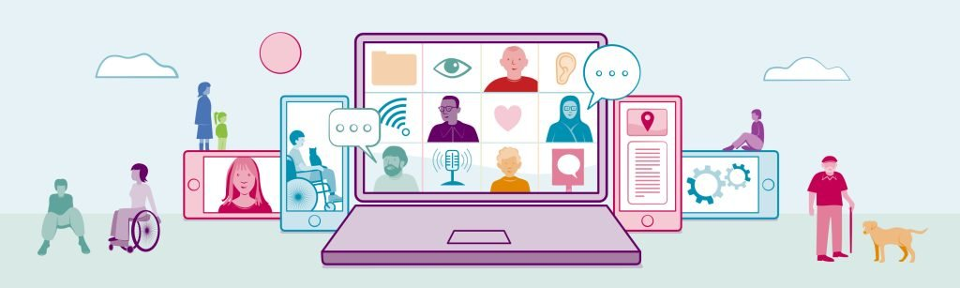
Being Human: Building a human rights culture in Scotland

August 2026
The Health and Social Care Alliance Scotland (the ALLIANCE)

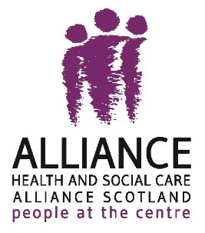
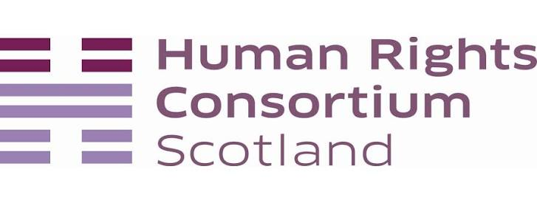

Table of Contents

Introduction: a human rights-focused Scotland 2
A shared vision 3
Key priorities for building a human rights culture 3
The next five years 5
The role of a Human Rights Bill for Scotland 6
Using storytelling to raise awareness ……………………………………... 6
Get involved 7
About the ALLIANCE 8

Introduction: what would a human rights-focused Scotland look like?

On 14 May 2026, a collective of people came together at the Boardwalk, Glasgow to explore a simple but powerful question:

What would a human rights culture in Scotland look like for individuals, communities and society?

The event provided a space to share experiences, discuss challenges, and identify the human rights priorities that should shape the next five years of the Scottish Parliament.

Speakers included representatives from:

- Aiteal Trust
- Environmental Rights Centre for Scotland (ERCS)
- Care Inspectorate Scotland
- Third Sector Human Rights and Equalities (THRE)

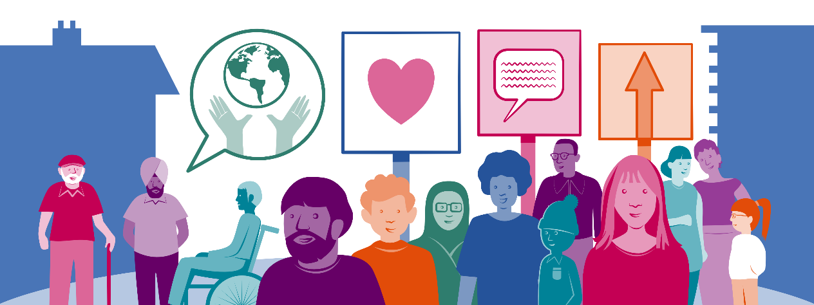

A shared vision
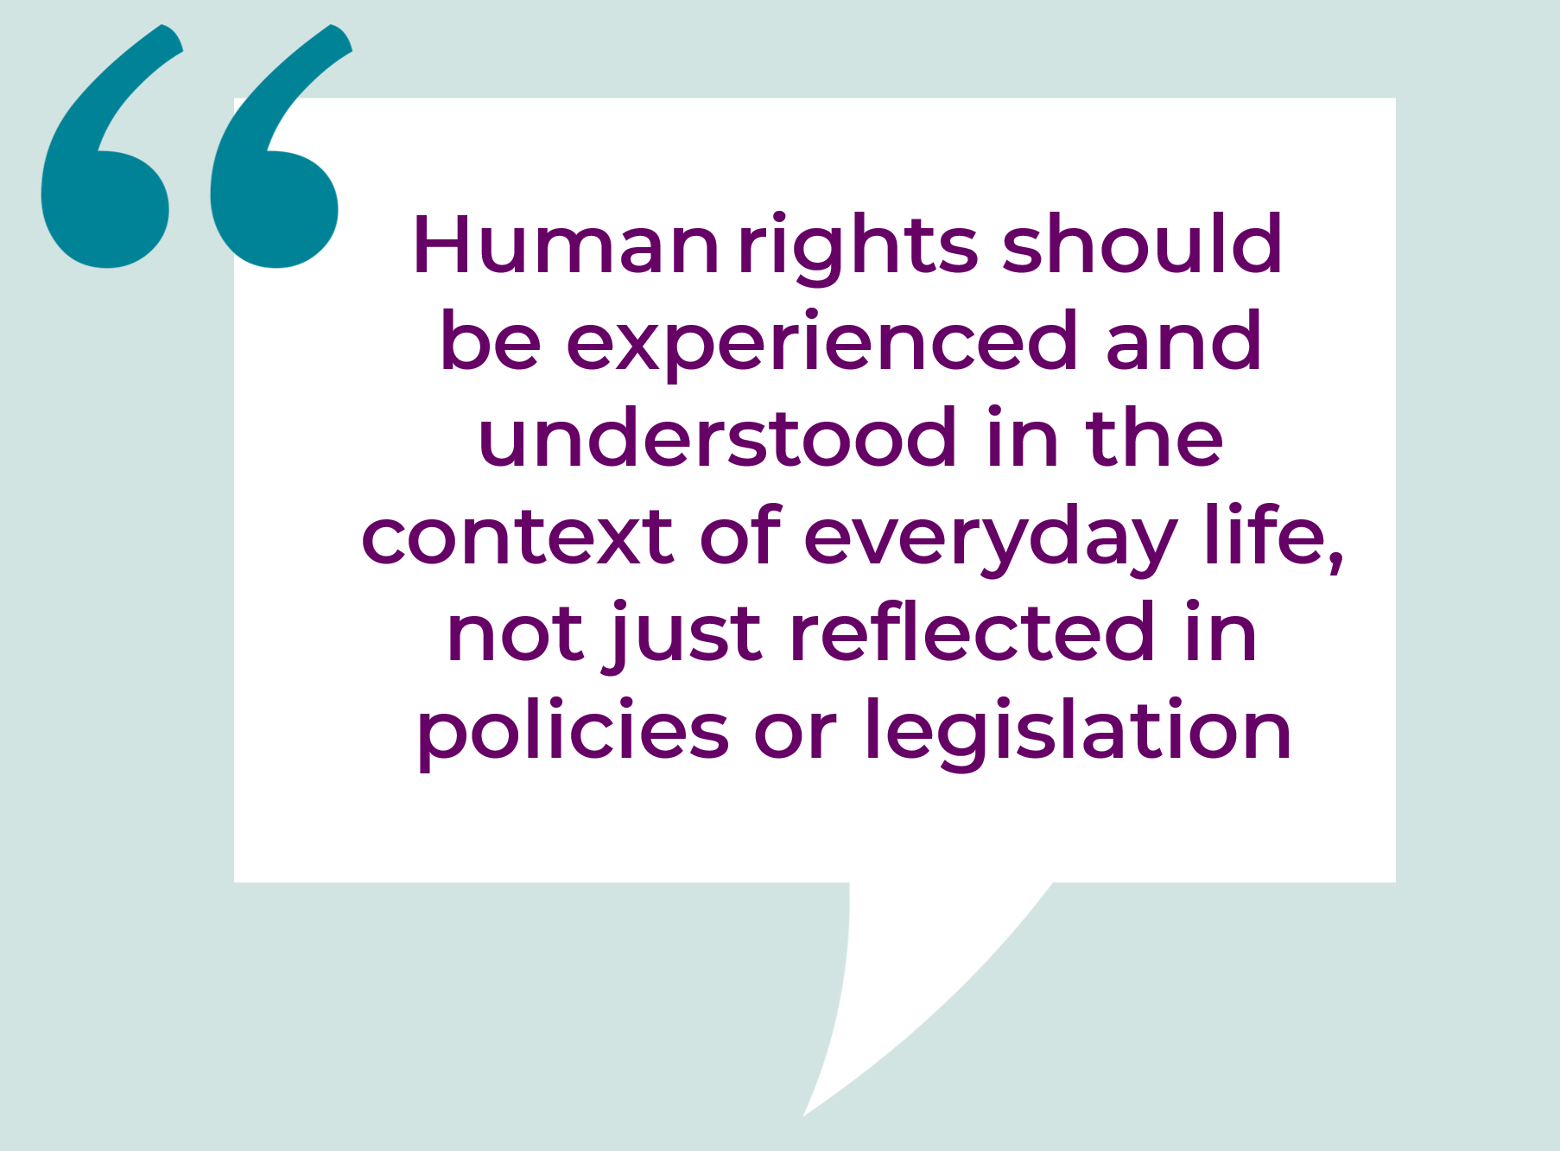
Participants described a vision
of a Scottish culture rooted in:

✔ Dignity
✔ Empowerment
✔ Meaningful participation
✔ Accountability

The discussions highlighted the need to move beyond seeing human rights as principles or aspirations and instead make them a part of everyday life.

A human rights culture means creating the conditions that enable everyone to:
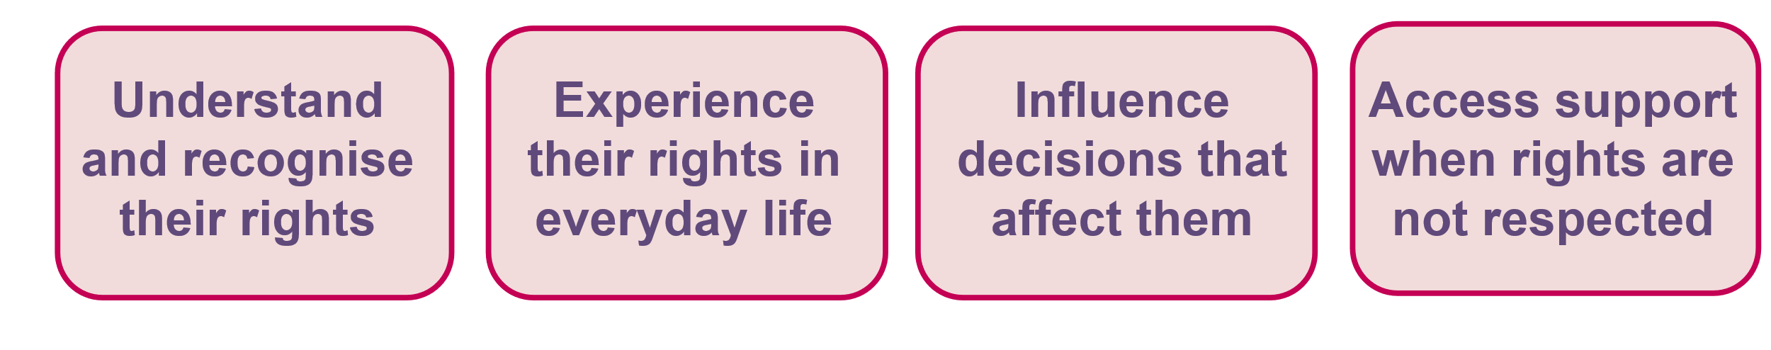

Key priorities for building a human rights culture

The participants shared what they want to see being prioritised over the next five years, which came under these three main themes:

1. Empowerment and inclusion

Human rights should be at the heart of everyday life, ensuring everyone feels safe, respected, included and able to make choices about their lives.

What needs to happen?

- Put lived experience at the centre of decision-making, including the voices of children.
- Ensure communities have genuine opportunities to shape services, policies and decisions.
- Move beyond tokenistic consultation towards meaningful participation, co-design and shared decision-making.
- Prioritise the voices of people most affected by inequality and human rights breaches.
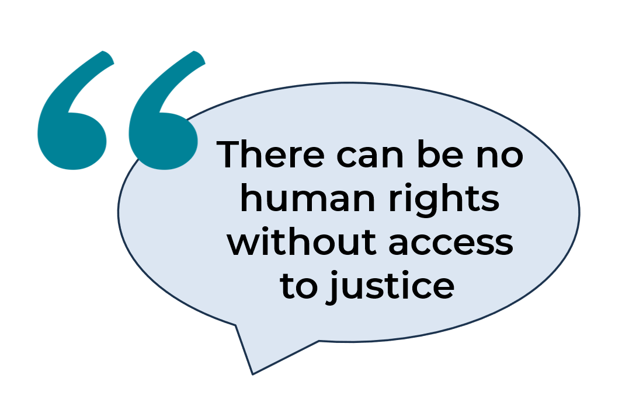

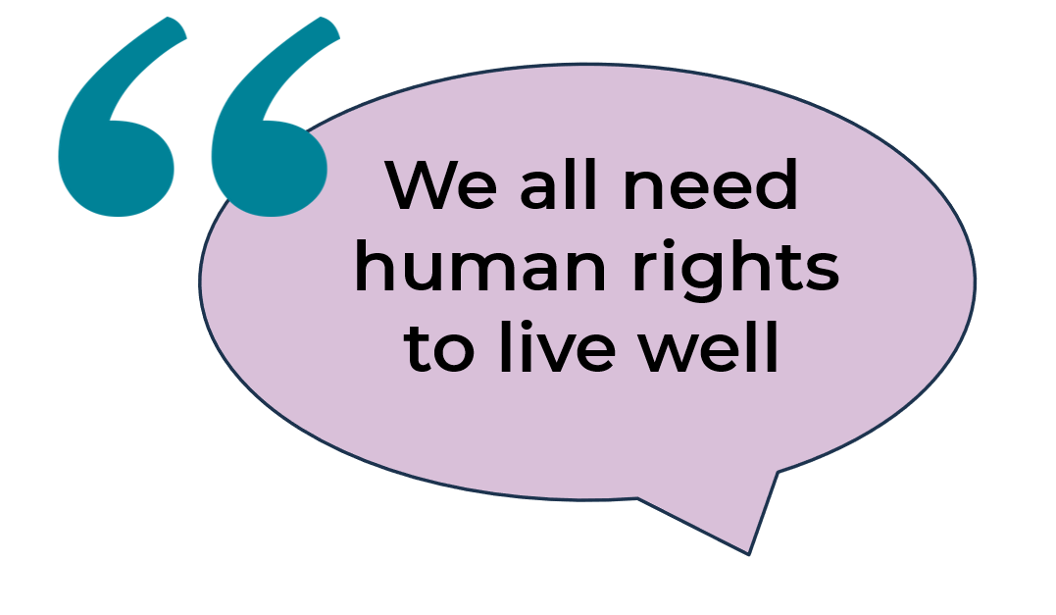

2. Accountability and accessibility

A human rights culture depends on people knowing their rights and being able to access support when those rights are not upheld.

What needs to happen?

- Strengthen accountability mechanisms so institutions uphold rights in practice.
- Improve access to:
  - justice and redress
  - advocacy and Legal Aid
- Provide clear and accessible information about rights and how to claim them.
- Improve training and awareness for public service staff so they can effectively uphold human rights in their day-to-day work.

3. Stronger collaboration

Embedding human rights is everyone's responsibility.

What needs to happen?

- Ensure human rights are embedded across government and public services, not confined to one department.
- Strengthen collaboration between:
  - government
  - people with lived experience
  - public services
  - communities and third sector organisations
  - other key partners
- Create better integrated and properly resourced systems that support consistent implementation of rights.
- Develop a shared vision for delivering human rights across all areas of public life.

The next five years
Participants agreed that Scotland's priority should be to deliver on existing commitments through action. Rather than creating new frameworks, the focus should be on:

- consistent implementation
- long-term investment
- partnership working
- genuine shared power and decision-making

Together, these actions can help build a society that is:

Rights-based • Wellbeing-focused • Equitable • Accountable

The role of a Human Rights Bill for Scotland

A Human Rights Bill for Scotland was recognised as a key step towards achieving this vision. The Bill could:

✔ strengthen accountability
✔ support consistent delivery of human rights
✔ place legal duties on public authorities and government bodies to protect and fulfil rights
✔ improve transparency and decision-making
✔ make it easier for people and communities to challenge systemic failures and rights breaches

Using storytelling to raise awareness
Creative communication can be an effective way to bring human rights to life. Participants highlighted the power of arts, storytelling and culture.

These approaches can help more people understand human rights, connect with lived experiences, and engage in conversations about progress and change.



Get involved
Interested in this work or want to find out more? Get in touch with us at The Health and Social Care Academy:
E: academy@alliance-scotland.org.uk
T: 0141 404 0231
W: http://www.alliance-scotland.org.uk/

The Academy works with people who use health and social care services to influence positive and significant change across Scotland.
By working together, we can help to build a Scotland where human rights are understood, experienced and realised by everyone.

About the Being Human series

The Being Human series is part of the programme of work of The Academy. It explores why embedding human rights in health and social care policy and practice matters. The series shines a light on the stigma, discrimination and inequality experienced by disabled people, people living with long term conditions and unpaid carers across Scotland. Being Human is delivered in partnership with Human Rights Consortium Scotland.

About Human Rights Consortium Scotland
The Human Rights Consortium Scotland is Scotland’s civil society network. We have over 500 members (both organisations and individual supporters) from across Scotland and across a wide range of human rights issues. We work towards two outcomes: Scotland has a strong collective civil society voice which is able to defend and promote human rights; and, civil society is able to use human rights as a tool to strengthen democracy and deliver social justice in Scotland.

About the ALLIANCE
The Health and Social Care Alliance Scotland (the ALLIANCE) is the national third sector intermediary for a range of health and social care organisations. We have a growing membership of over 3,500 national and local third sector organisations, associates in the statutory and private sectors, disabled people, people living with long term conditions and unpaid carers. Many NHS Boards, Health and Social Care Partnerships, Medical Practices, Third Sector Interfaces, Libraries and Access Panels are also members.

The ALLIANCE is a strategic partner of the Scottish Government and has close working relationships, several of which are underpinned by Memorandum of Understanding, with many national NHS Boards, academic institutions and key organisations spanning health, social care, housing and digital technology.

Our vision is for a Scotland where people of all ages who are disabled or living with long term conditions, and unpaid carers, have a strong voice and enjoy their right to live well, as equal and active citizens, free from discrimination, with support and services that put them at the centre.

The ALLIANCE has three core aims. We seek to:
- Ensure people are at the centre, that their voices, expertise and rights drive policy and sit at the heart of design, delivery and improvement of support and services.
- Support transformational change, towards approaches that work with individual and community assets, helping people to stay well, supporting human rights, self management, co-production and independent living.
- Champion and support the third sector as a vital strategic and delivery partner and foster better cross-sector understanding and partnership.

