A joint statement on prevention: Where are we now for Scotland’s health and wellbeing?
September 2026
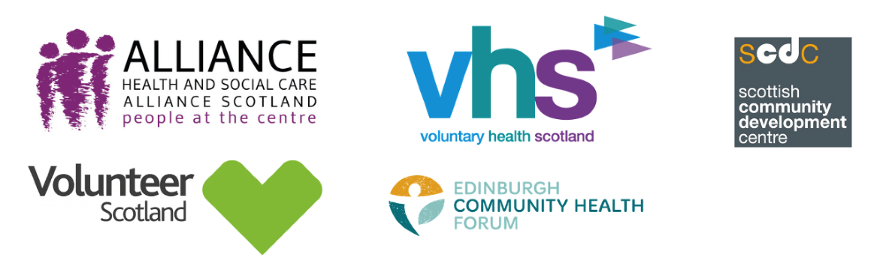
A year ago, our partnership published a joint statement on prevention, setting out urgent actions we believe are vital to effectively implement prevention policy for addressing health inequalities and improving health outcomes in Scotland.
We are now entering a critical period, with a new five-year Programme for Government and budget decisions on the horizon, as well as local government elections in May 2027. This update reflects on the current progress as we understand it, as well as key measures we think are essential for prevention to take root in Scotland. We are also delighted to welcome Volunteer Scotland and their perspective and contributions to our partnership.
Below we have outlined progress against our initial three urgent actions.
Action one: We need a clear definition and understanding of prevention
We have seen important work around prevention carried out over recent months and the continued commitment to prevention was further signalled in the Scottish Government's Programme for Government 2026-31.

However, we believe a greater emphasis is required on the central ambition to improve health and wellbeing outcomes and reducing health inequalities.

It’s vital we frame prevention in ways that can be applied system-wide, including by and with communities, with a focus on improving Scotland’s health and wellbeing.
We have seen, however, how Primary Prevention has been detailed in the 'Defining Prevention' resource as population-level activity without acknowledging the essential localised primary prevention activity third sector and community organisations provide, often targeting those at greatest risk of inequality.
The risk of framing prevention policy around reducing pressure on public services is that it will see prevention activity carried out in ways which lead to shorter term impacts on services, instead of meaningful change for people and communities who face the impact of Scotland’s unfair and avoidable health inequalities.
Clarity in how we talk about prevention is key if we are to see this approach delivered consistently, with a focus on improving lives by preventing negative health outcomes.
Action two: We must put the hard-to-do parts of policy into practice
We know that shifting the way we work is a challenge that will take shared vision, courage, and leadership from all of us, and that such a shift won’t happen overnight.
We also know we’re not starting from scratch. Huge amounts of positive work is already underway, like the work to implement the Population Health Framework and high-quality evaluations of long-term community-led interventions which identify the key enablers of effective practice.
We continue to urge decision-makers to focus first and foremost on building with, and learning from, existing well-established and high-quality work in and with communities, which is under increasing threat and pressure every year.
A shift to prevention in how we support health and wellbeing will not be achieved with a solely top-down approach. The Programme for Government places a focus on “identifying, assessing and prioritising investment in prevention and early intervention, helping direct resources towards actions that improve outcomes for people and reduce future demand on public services.”
We must be clear that these actions should be based on meaningful engagement with those who use services, communities, and the public and community and third sector practitioners that deliver frontline, local solutions.
We need a clear focus on doing the hard work: Co-production and power-sharing with people and communities; long-term investment in the community and third sector; true transparency and accountability; and collaboration and integration across silos and sectors.
Together, these ways of working will help build the infrastructure and enablers for prevention that will ensure we see deep rooted, positive outcomes in health and wellbeing across Scotland’s communities of place, interest, and identity.
Action three: We need a whole system approach with a properly resourced third sector
Last year we warned that without immediate action Scotland risks losing groups, organisations, volunteers and practitioners with the skills, experience and capacity to implement prevention policy which actively supports health creation, as well as targeting health inequalities.
Today, this situation hasn’t changed, in fact it has become worse. We have witnessed the ongoing loss in our networks of people, posts, teams and services, the fracturing of cross-sectoral trust and partnerships, as well as the closure of many projects and whole organisations upon which so many of our communities depend.
Organisations which remain operational are reporting increasing pressure on preventative, and upstream approaches to addressing health inequalities which are often first in line for cuts.
These organisations rely on volunteers in a time when volunteer recruitment and retention remain a significant challenge for many organisations. Widening inclusion gaps mean that the people who could see the greatest wellbeing gains from volunteering are currently benefiting the least.
Simply put, we can’t go on like this. We must accelerate long term Fair Funding, enabling sustainable investment in people, services and organisations to help keep their doors open and lights on.
The newly announced Scottish Prevention Investment Framework, building on the preventative budgeting pilot, is a positive step towards this. If we’re to create a sense of national, collective endeavour around resourcing prevention in health, we need to ensure that the practitioners and organisations already delivering in this way are valued.
These community and third sector organisations must have the stability and resource to continue their work so communities can trust that this support will be there for them when they need it.
Our actions and next steps
Since the publication of our statement, we have worked collectively with national and local partners and with our networks to make a practical and useful contribution to the implementation of prevention policy across our wider health system.
Over the coming months, our organisations will each be publishing new resources that provide insights around our conversations and learning around prevention from the people and organisations we work with.
We look forward to continuing to work in a constructive way to support the next stages in enabling prevention policy implementation across Scotland’s policy and practice landscape.

This statement has been jointly published by Edinburgh Community Health Forum, Health and Social Care Alliance Scotland (the ALLIANCE), Scottish Community Development Centre (including CHEX), Voluntary Health Scotland, and we are delighted to welcome Volunteer Scotland to this partnership.

